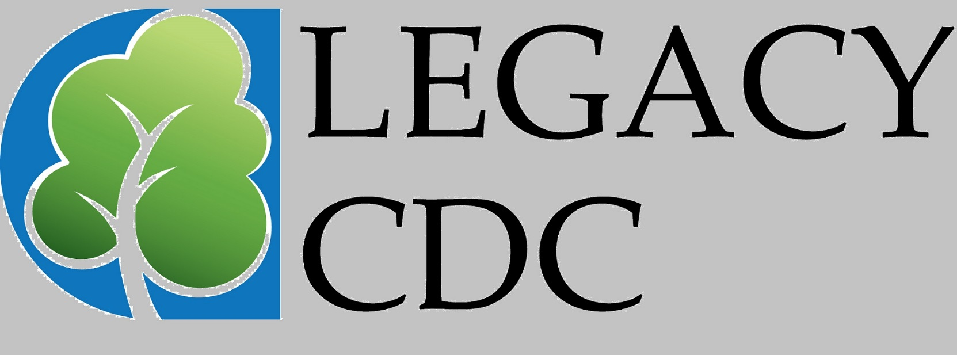

COMMON GRANT APPLICATION FORM
- Applications must be accompanied by a cover letter (no more than one page) in which you state your request and proposed use of funds. This letter should generally be signed by your executive director and your board president.
- Fill out the application form completely.

APPLICATION MADE TO: LEGACY CDC DATE:

APPLICANT ORGANIZATION

NAME: Year organization incorporated:

ADDRESS: (included street address if different)

Is the name at left the same as it appears on the IRS Letter of Determination?
____YES ___NO

If not, explain: _________________________________________________________________
_______________________________________________________________________________

CHIEF EXECUTIVE’S NAME & TITLE:__________________________________________________

CONTACT’S NAME AND TITLE (if different):_______________________________________________

TELEPHONE NUMBER:___________________ FAX NUMBER:______________________________

ORGANIZATIONAL DEMOGRAPHICS:
Number of full time staff:________________________
Number of part time staff:______________________ Number of volunteers:_______________________

GEOGRAPHIC AREA:

OPERATING BUDGET TOTAL FOR CURRENT FISCAL YEAR:
Fiscal Year:
From  SOURCES OF INCOME: |  |  | To
Government Federal |  | ______% | Fees/Earned Income | ______%
State |  | ______% | Individual Contributions | ______%
County |  | ______% | United Way | ______%
City |  | ______% | Workplace Campaigns | ______%
 |  |  | (not United Way)
 |  |  | Corporate and/or Foundation Grants | _____%
 |  |  | Special Events | _____%
 |  |  | Memberships | ____+%
Other ______%

PROPOSAL

AMOUNT OF THIS REQUEST: $ FUNDS NEEDED BY:
TIME FRAME IN WHICH FUNDS WILL BE USED:

From To

Check one of the following:

GENERAL OPERATING SUPPORT PROJECT SUPPORT

If for project support, complete the following:

PROJECT NAME:

TOTAL PROJECT COST: $ PERCENT THIS REQUEST OF PROJECT TOTAL: ____ %

PROJECT COST PER CLIENT (if applicable): $

PROJECT TYPE:
______Capital
____Construction
____Renovation
____Equipment
____Endowment
____Specific Program
____Other (describe)

- WHO WILL PROJECT SERVE:

- HOW MANY WILL PROJECT SERVE:

- WHAT GEOGRAPHIC AREA WILL PROJECT SERVE:

FUNDERS REQUEST THAT YOU LIMIT THE LENGTH OF YOUR ANSWERS FOR THE FOLLOW-ING QUESTIONS TO NO MORE THAN A TOTAL OF FOUR PAGES.

- APPLICANT ORGANIZATIONAL BACKGROUND
Include organizational mission statement and purpose, organizational qualifications, history of accomplishments, governance, area and population served, role or volunteers. (If this is a collaboration, describe the lead agency and its relation to others involved.)

- NEEDS STATEMENT
Identify the needs your agency or this proposal will address. Acknowledge similar existing projects or agencies, if any, and explain how your agency or proposal differs, and what effort will be made to work cooperatively.

- PROPOSAL
  - How will your proposal address identified needs?
  - Projected goals, objectives, timeline, anticipated impact.
  - Expected role of volunteers.*
  - Number and types of people who will benefit from your proposal.
  - How will you monitor your work and how will you measure success or effectiveness?
  - What are your other potential and actual sources of support for this proposal? Where do you expect to find future support?

- APPROPRIATENESS TO FUNDER’S MISSION
Explain tparticular funder’s guidelines and criteria.

- ADDITIONAL INFORMATION

Please address here anything else about your organization or project you think is relevant to this proposal.

*If pertinent to this application, how many of the potential funder’s employees are volunteers in you organization?
ATTACHMENTS

In addition to the cover letter and the information required on the Common Grant Application Form, please attach the following:

- Verification of tax-exempt status under Section 501(c)(3) of the IRS code.
- List of current board members (include member affiliations and any other pertinent information).
- List of key organizational staff, including titles and main functions.
- IRS Form 990 (if available).
- Most recent audited financial statement (if available).
- A one-page summary of actual income and expenses for the past two complete years; a one-page listing of funding sources and amounts received from these sources over the past two years.
- Organization’s current year operating budget.
- A detailed budget of the project for which funds are being sought (if applicable).
- If the project for which you are seeking funds is a collaboration with other agencies, include letters or other documentation from the collaborating agencies.

