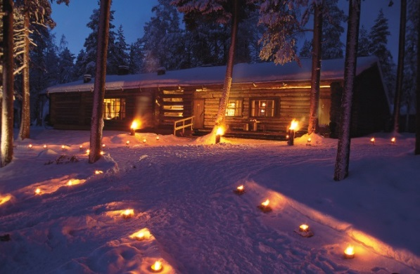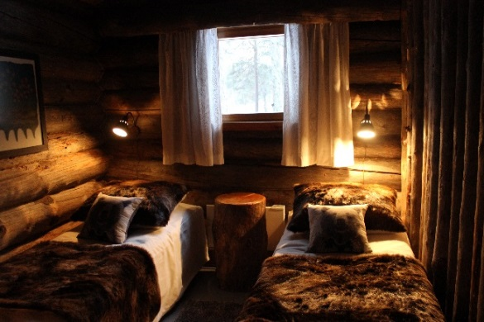

Bear’s Den/ Karhunpesä

Karhunpesä, built in 1967, is a wilderness-spirited, high-grade log house 30 kilmometers (ca. 19 miles) from the city of Rovaniemi. Its history is written by many remarkable visitors, one of whom was Urho Kekkonen, the President of the Republic of Finland 1956-1981.

Kekkonen was a regular guest in Karhunpesä during his presidency. There he hosted many important statesmen such as Lyndon B. Johnson (the President of the United States), Carl XVI Gustaf (the King of Sweden), Golda Meir (the 4th Prime Minister of Israel) and Leonid Brezhnev (the Soviet leader).

After discovering the place Kekkonen considered it to be a perfect place for his purposes. Secret negotiations between nations could be held there – far away from the bustle of the city and curious ears. Both dining and the peaceful picturesque nature were something to match the dignity of the president himself.

Kekkonen’s personality and the numerous stories of his visits color the history of Karhunpesä. Good Finnish food and Sauna vere important to the president. That’s why we in particular focus attention on dining and Sauna experience. We want our guests to enjoy the steam and the delicious food just as much as the president did!

