Sections 4/5
Introduction to Functions and Piecewise
- Select the values for the domain and range of the functions graphed below.
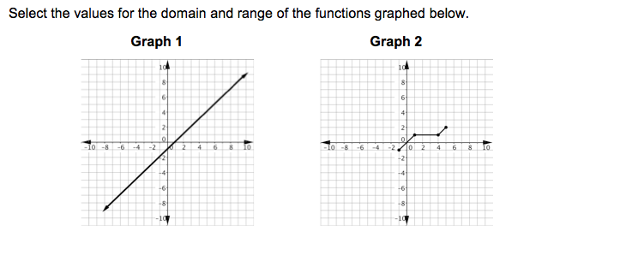

Domain of Graph 1
Range of Graph 1
Domain of Graph 2
Range of Graph 2

- Rita is spending more time at home to study and practice math. Her efforts are finally paying off. On her first assessment she scored 58 points, then she scores 63 and 68 on her next two assessments. If her scores continued to increase at the same rate, on which assessments will she be scoring above 85? Select all that apply.
- Fourth
- Fifth
- Sixth
- Seventh
- Eighth
- Ninth
- Yohanna is conditioning all summer to be fit for the next soccer season at his high school. He incorporated walking planks into his daily workout regime. Each day, he will complete 4 more walking planks than the day before. If he starts with 5 walking planks on the first day, how many walking planks will he do on the twelfth day?
- 49
- 53
- 59
- 64

- Tommy has a pet monkey. Every day, his monkey eats 4 apples in the morning. The monkey also eats two bananas for every banana that Tommy eats.
Write an equation to describe this situation where x is the number of bananas Tommy eats and y is the total number of pieces of fruit that the monkey eats.

- Luigi is an urban planner. As an independent contractor, he charges a $140 fee plus $25 per hour for each contract with the city.
Write a function to represent this scenario where y represents the total amount he charges for a project and x represents the number of hours worked on a project.
Y=
Amount earned for 10 hours of work:

- You are playing am Algebra 1 board game with your friends in Mr. Harris’s class. It is your turn. You roll the dice and move your token to the next box in the board. You are in the Arithmetic Sequence section of the game. You pick a clue card and one of your partners asks you a question. In order to stay alive in the game, you need to answer correctly. You pick the card below:
The sixth term is
22 and the
common difference
is six.
The question your partner poses to you is “what is the fiftieth term?”
- 135
- 252
- 286
- 300

- A cup is 6.4 cm tall, not including a 0.6 cm lip. Cups are stacked inside one another. You may want to draw a diagram to help you see how the height of the stack of cups increases. Select the function that represents the height of a stack of cups in terms of the number of cups in the stack.
H( c ) =
The number of cups in a 18.4 cm high stack is:

- Identify whether the graphs below are functions.
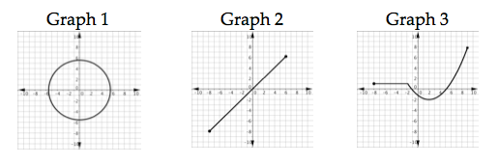
Graph 1
Graph 2
Graph 3

- One of the greatest assets of a secretary is often his/her ability on the keyboard of a computer. Mrs. Garcia has been recognized as the Most Outstanding Typist at a prestigious firm because of her outstanding typing speed. The table below displays data collected from her most recent evaluation.
Minutes | Words
1 | 70
2 | 140
3 | 210
4 | 280

Write a function to represent the total number of words, y, that Mrs. Garcia can type in x minutes.

If Mrs. Garcia maintains a constant speed consistent with the results above, how many words will she type in 49 minutes?

- A series of tile patterns is shown below. Consider the function that represents the number of white tiles in each figure.

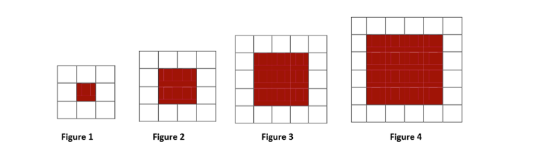
Select all statements that are true.
- W(n) = 4n + 4 represents the function
- W(n) = 4n + 8 represents the function
- Input values for the function are natural numbers
- Input values for the function are the numbers of white tiles in each figure
- The function is continuous
- Figure 6 will have 10 white tiles
- Figure 8 will have 36 white tiles

- Evaluate the function graphed below for the given value of x.
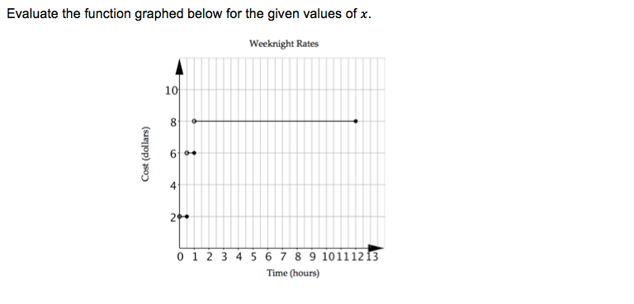
What is the value of the function when 0 < x ≤ 0.5?

What is the value of the function when x = 1?

What is the value of the function when 1 < x ≤ 12?

- Describe the piecewise function below by evaluating the function for given value of the domain.
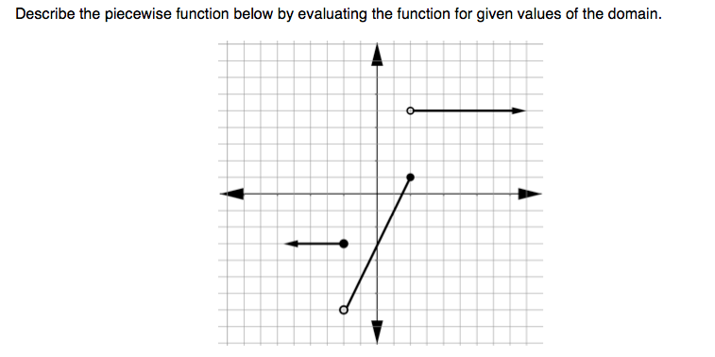
F(x) = 2x – 3 F(x) = 5 F(x) = -3

Which of the following functions corresponds to the domain x ≤ -2?

Which of the following functions corresponds to the domain -2 < x ≤ 2?

Which of the following functions corresponds to the domain x > 2?

- Jalyn plans to sell Algebra Nation t-shirts as a fundraiser for a new scholarship initiative. The wholesale t-shirt company charges Jalyn $10.00 a shirt for 75 shirts or less. If the number of t-shirts purchased is between 76 and 150 shirts, the company will lower its price to $7.50 per shirt. If Jalyn purchases 150 or more shirts, the price will decrease to $6.00 per shirt. Which of the following statements are true? Select all that apply.
- If Jalyn purchases 60 shirts, the total cost will be $600.00.
- If Jalyn purchases 75 shirts, the total cost will be $562.50.
- If Jalyn purchases 150 shirts. She will be charged $7.50 per shirt.
- At these prices, it is cheaper to buy 76 shirts than it is to buy 75 shirts
- This situation can be represented by a step function

- Use the graph below to choose the true statements. Select all that apply.
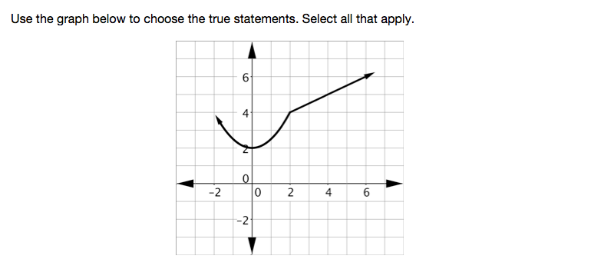
- The vertical line test confirms that the graph is a function
- The domain is x ≥ 2
- The range is y ≤ 2
- This piecewise function is made up of four intervals
- Each interval of the piecewise function contains a graph of a linear function

