Section 6
Rational and Radical Exponents
- Solve the radical equations below. (drop box)
√2x + 3 = 7

³√5x – 1 + 6 = 10

(x – 2)^{3/4} = 1

- Solve for t in the equation below.
(t^{1/3} – t^{5/3} + t^{3/2})⁰ = 2√t

- Solve for x in the radical equation below. Express your answer in ration exponent form.
2³√8x + 9 = 5
- -2
- -1
- 0
- 1

- Use the graph below to identify the square root functions.
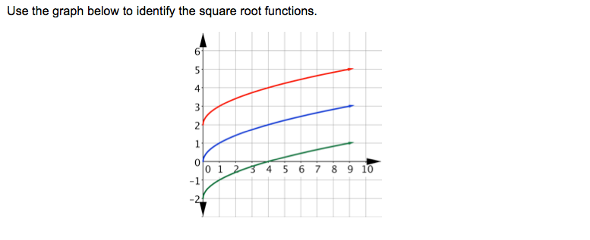
The ________ function is f(x)= √x
- Red b. Blue c. Green
The ________ function is f(x)= √x + 2
- Red b. Blue c. Green
The ________ function is f(x)= √x – 2
- Red b. Blue c. Green

- An expression is shown below.
(x^{4/3})(x^{2/3})
What is the product of the two factors?

- The time it takes for an object stopped from a certain speed can be modeled by the equation t= ½ √v, where v is the speed of an object in meters per second. If it takes 3 seconds for the object to stop, what is the speed of the object in meters per second?

- In 1980, the population of the United States was 226,545, 805. If the population has an annual growth rate of 1.68%, select all the statements below that would be true. Round your numerical answers to the nearest whole number and use the formula A = Pe^{rt} where P is the initial population in 1980 and t represents the number of years that have passed since 1980.

- In 1985, the population of the United States would be approximately 246, 397, 763
- In 1990, the population of the United States would be approximately 264, 875, 431
- The population of the United States would exceed 300 million in 2001
- The population of the United States would exceed 300 million in 1997
- The annual growth of the United States population is linear

- Which of the following functions are true for the graph below?

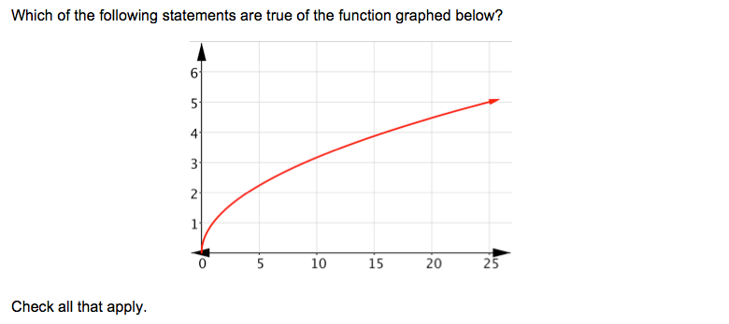
- The function graphed above is f(x)= √x
- The function graphed above is f(x)= x²
- The domain is all real numbers
- The range is all real numbers
- { x| x is a real number and x is greater than 0}
- The volume of a sphere is 950 cubic inches. Use the formula for the volume of a sphere, V= 4/3(3.14)r3, to find the radius r to the nearest tenth.

- An object is launched upward from ground level and reaches a maximum height of h feet. The initial velocity v (in feet per second) of the object is given by the function v= 8√h. Write the function in terms of h.
- h= 8v
- h= v
8
- h= v√8
- h= v²
64

