Re: Help with Head Lice

Dear Parent or Guardian:

As you well know, head lice cases are common among school-aged children. An estimated 6 to 12 million infestations occur each year in the United States, most commonly among children ages 3 to 11.¹ Regarding treatment, there is no clear evidence that home remedies such as homeopathic shampoos or mayonnaise work, and they may just end up prolonging the problem.¹ Others have depended on over-the-counter medications, but recent data shows that some head lice may be resistant to the main ingredient of these medicines. A 2016 study showed that 48 states now have lice that are genetically predisposed to resistance to commonly used treatments.⁴ Treatment failure may also be caused by incorrect use of the product, misdiagnosis of the original condition, or re-infestation.⁵

Many families will experience a head lice infestation at some point during their child’s school years. If this happens, it’s important they know that they’re not alone. Liceinators – Lice Terminating Super Heroes of South-Central Wisconsin is here to help with professional lice treatment services and products.

Our lice treatment business specializes in making our customers feel like superheroes! We provide a range of products and services to kill lice in their tracks in the comfort of your home and go above and beyond your expectations to deliver on time and with a smile. When we are done with you, you'll be faster than a speeding bullet and leap buildings in a single bound (or at least feel like you could)!

If you have any questions, please don’t hesitate to reach out to me directly at (608) 555-8883.

Sincerely,
Yeelah Knight, RN, BSN, CEN
Owner/Founder
https://www.licespecialistsofwisconsin.com

Please be sure to share this Referral Program with the parent/guardian so all benefit from discounts on lice treatment services and referral bonus.
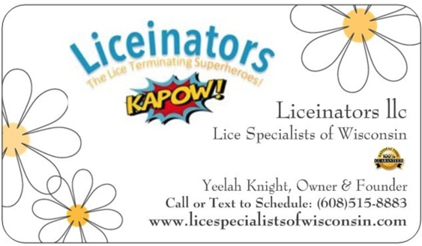

References
1. Centers for Disease Control and Prevention. Frequently asked questions (FAQs). http://www.cdc.gov/parasites/lice/head/gen_info/faqs.html. Accessed November 3, 2016.
2. Centers for Disease Control and Prevention. Epidemiology & risk factors. http://www.cdc.gov/parasites/lice/head/epi.html. Accessed November 3, 2016.
3. Meinking TL, Mertz-Rivera K, Villar ME, Bell M. Assessment of the safety and efficacy of three concentrations of topical ivermectin lotion as a treatment for head lice infestation. Int J Dermatol. 2013;52(1):106-112.
4. Gellatly KJ, Krim S, Palenchar DJ, et al. Expansion of the knockdown resistance frequency map for human head lice (phthiraptera: pediculidae) in the United States using quantitative sequencing. J Med Entomol. 2016:1-7.
5. Burkhart CG. Relationship of treatment-resistant head lice to the safety and efficacy of pediculicides. Mayo Clin Proc. 2004;79(5):661-666.

