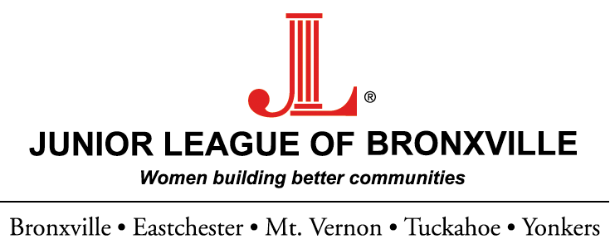

THE POSITIVE POWER and CARA KEALY
SCHOLARSHIP AWARDS

Sponsored by, The Sustaining Members of the Junior League of Bronxville

APPLICATION

To enter, you must be:
- A female, college-bound high school senior
- A resident of Bronxville, Eastchester, Tuckahoe, Yonkers or Mount Vernon

Name:______________________________________________________________________________________________

Address:____________________________________________________________________________________________

________________________________________________________________________________________________

Date of Birth:________________________________________________________________________________________

School and grade:____________________________________________________________________________________

Home Phone:________________________________________________________________________________________

e-mail address (please print this clearly!) ________________________________________________________________

Your signature:______________________________________________________________________________________

Signature of parent or guardian:________________________________________________________________________

Attach to this sheet:
- A typed essay of no less than 500-word describing the positive contributions you have made to your community, school, or nation through a volunteer commitment, a program you have initiated to improve the lives of others or an effort you’ve joined to tackle difficult problems and make our world a better place to live.

- A Resume listing part time jobs, summer employment, extra curricular activities and volunteer positions.

- Two Letters of Reference: One from an individual in school – a teacher, advisor or administrator. Another letter from a Community/Service Partner.

- A copy of academic transcript.

The application must be received by April 26, 2017

***The application and all supporting documents must be emailed, in their entirety, to jlbscholarships@gmail.com

PLEASE NOTE: Hard copy applications will not be accepted and only the winning applicants will be contacted.

Contestants must be legal residents of the United States. Subject to federal, state and local laws and regulations. Void where prohibited. The prize is not transferable. The prize may constitute taxable income to the winner. Income and other taxes are the responsibility of the winners. Entrants agree to release and hold harmless Sponsor from any liability or claim arising out of their participation or their acceptance of the prize.

