Author Bio

S.E. Zbasnik is the author of the Dwarves in Space series – think Tolkien and Hitchhiker’s merged in a horrific transporter accident – as well as a bunch of other fantasy novels. You can find her on twitter as well as facebook, and hopefully not standing right behind you.

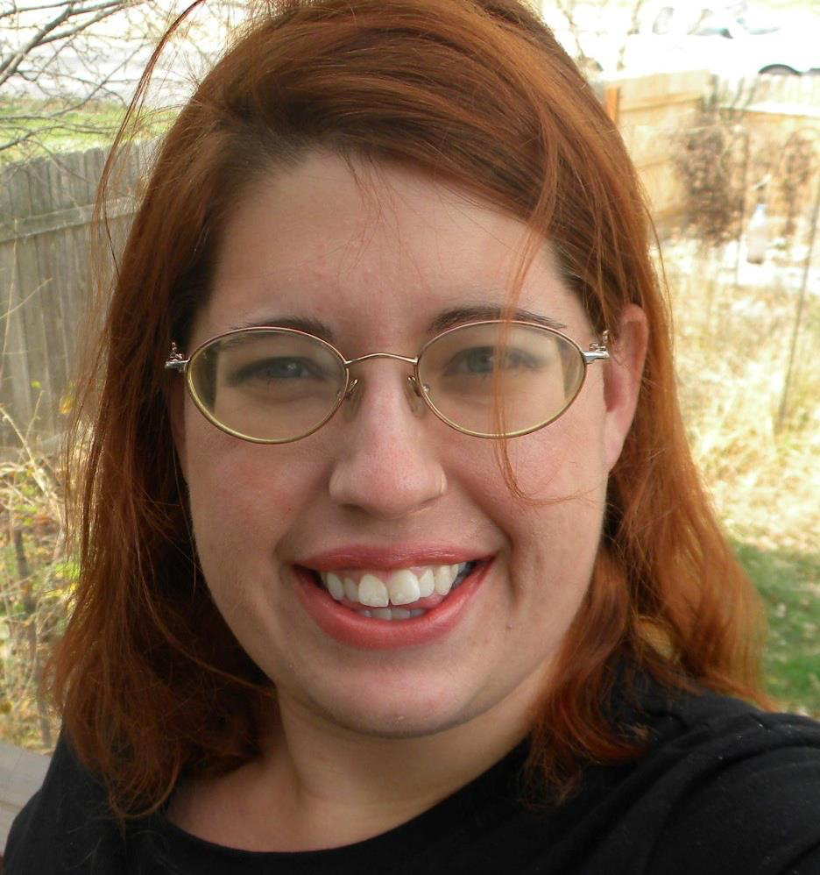
Author Photo

Longer Bio

S. E. Zbasnik has a degree in genetics, which means there may or may not be a horde of monkeoctopi doing her bidding to take over the world. Bringing that scientific approach to the fantasy world is her game, trying to put some common sense into magic and magic into common sense.

She currently lives with her husband and beloved dog, who dress up like Sherlock Holmes and solve mysteries in their spare time. She spends nearly of all her time in Nebraska but that's because it is impossible to leave without finding the lamppost. She lives in a house that has at least four walls and there are some other souls wandering forlornly calling to their lost lives within.

She loves and hates writing as she both loves and hates herself.

She's a huge video game nerd especially for Dragon Age, Mass Effect, and Bioshock as well as Doctor Who and makes fan art in her down time.

She's a neutral good assassin, so it's best to not get on her bad side.

Contact:

Email: szbasnik@gmail.com

Website - Dwarves in Space: http://www.dwarvesinspace.com/

Website - The King’s Blood: http://blablover5.wix.com/thekingsblood

Facebook: https://www.facebook.com/sezbasnik

Twitter: http://www.twitter.com/introvertedwife

Articles:

What's the Big Deal With Love Triangles?

I Hate Strong Female Characters

Diversity in YA Fantasy

The Chosen One is a Recipe for Disaster

The Problem of the Super-Serious Male Protagonist

Visualizing Your Characters

Nerdy But Flirty - Ongoing contribution

Interviews:

The Modest Verge

Don't Read My Book!

In The Chair - About Me

In The Chair - With Orn & Variel

Author Spotlight no. 405

Book Spotlight - Dwarves in Space

Morgen Bailey

Author's Interviews

Podcast “Tell Me Another” - Episode 15

