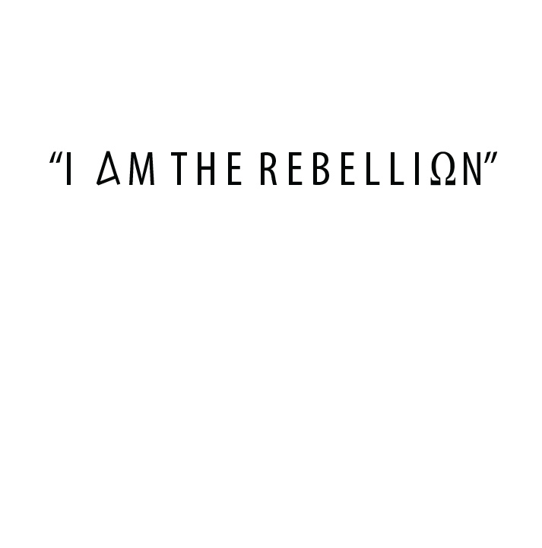

REGISTRATION LIST
NAME (MALES) | AGE | NAME (FEMALES) | AGE

Conference Date: April 17-19, 2014
Conference Cost: $49 /$10 Deposit due March 15th
REGISTER EARLY - SPACE IS LIMITED – DON’T DELAY!
Reckless will begin Thursday, April 17th at 8pm and ends Saturday, April 19th at 12pm. Registration will be open at 6:30pm on the 17th, however doors will not open until 7:30pm. Reckless is held at 310 Parker St. Vacaville, CA 95688. You can send your completed registration form to the address above along with your $10 deposit for each attending individual. The remainder can be paid on the night of the conference, however, if you are a walk in your spot can not be guaranteed. If you would like to pay using a credit card, feel free to visit us on recklessconference.eventbrite.com where we have made that option available for you. If you need another registration packet, resources are made available for you at fuelthisfire.com.
(PLEASE PRINT CLEARLY)
Name: _______________________________________ Telephone: ______________________
Address: ______________________________________________________________________
City: _______________________________________ State: __________ Zip: _______________
Church: _______________________________________________________________________
Youth Pastor’s Name (If not previously stated): _______________________________________
Number of people attending: _________________ x $10 deposit = Total deposit due _________
Number of people attending: _________________ x $39 remainder = Total ________________
*Due at Registration
I am enclosing $______________ registration fee. Registration is non-refundable. Remainder is due on April 17th at Registration.
*If children are attending, payment and registration can be made for them on Thursday at the Registration Table.
Comments:________________________________________________________________________________________________________________________________________________________________________________________________________________________________
Conference Hotel: Hampton Inn, 800 Mason Street, Vacaville California, 95688,
TEL: 1-707-469-6200 / FAX: 1-707-469-6300

Health Record & Consent Form (*All members of your group must have this form signed and completed. If under the age of 18, this form MUST be signed by a legal guardian)
Name ________________________________________________________________________
Health Problems _______________________________________________________________
Emergency Phone (____) ______________________
Drug Allergies _______________________________
Polio Vaccination: Yes / No
Last Tetanus Shot (Date) ______________________
Activity Restrictions _____________________________________________________________
______________________________________________________________________________
Regular Medication _____________________________________________________________
Insurance Company _____________________________________________________________
Policy Number _________________________________________________________________
IN CASE OF EMERGENCY, I hereby give permission to the physician selected by the Conference Director to hospitalize, secure proper treatment for and to order injection, anesthesia or surgery for my child, as named on the consent form.
I/ We do hereby release Harvest Church agents, employees, and volunteer assistants from any liability whatsoever arising out of any injury, damage or loss which may be sustained by the aforementioned camper during the involvement with the Reckless Conference.
Publicity Release: I hereby grant permission for Radical Reality to photograph / video my child during camp activities and to use the photographs in Radical Reality audio-visual and printed materials without compensation or approval rights.

Signature _________________________________Date ________________________________
(Guardian’s signature if under 18)

GROUP REGISTRATION INSTRUCTIONS
Please follow these instructions to ensure a smooth registration
- Registration Forms. Every group is required to complete a registration form. If the individual is under 18 years if age, please make sure the permission slip is filled out and signed by the parent or guardian. Anyone under 18 without a signed permission slip will not be allowed to stay.
- Send your “group” list and Registration form to church office A.S.A.P! Your group list is important information. It lets us know whom you are bringing and whether they are male or female. We have provided the group list form that we ask you to use. This will help us know exactly how many are attending. You may mail your Medical Release forms to us at any time or bring them to registration at Reckless.

- It is very important that we have your list on time. If we receive them late, you may lose your spot!

- Finances. The cost is $49 with a nonrefundable deposit of $10(included in the $49) due by March 15th

- Youth Pastors and their wives or adult leaders pay the same rate as students. The children of youth pastors or adult leaders pay the following: ages 0-5, no charge; ages 5-11, half price. * Child care will be provided.
YOUR DEPOSIT SHOULD INCLUDE $10.00 PER PERSON THAT WILL BE COMING TO RECKLESS. CHECKS CAN BE MADE OUT TO “HARVEST CHURCH”.
- Special Needs. If you are bringing special needs/disabled students that need a special diet, have inability to walk to and from the auditorium, or other medical needs, please contact our office so arrangements can be made.

- Dress Code/ Safety. We ask for modest attire at Reckless so please encourage your students in this area. Any students dressed inappropriately: spaghetti straps, short shorts, tops that reveal the stomach, overly sagging pants, etc. will be asked to change. HARVEST CHURCH allows the use of skateboards, scooters, and roller blades in designated areas. Helmets must be worn at all times while participating in these activities. Students who participate in these activities do so at their own risk.

- Registering at Reckless Conference. Registration will begin at 6:30pm on Thursday April 17th. During this time, you will need to turn in a Medical Release form for each individual in your group, a Registration form if you have not yet mailed it in, as well as pay the balance due. We look forward to seeing you at Reckless! Please feel free to call our office if we can help you in any way, or answer any questions you might have.

Fuel the Fire
(707) 689-8765
310 Parker St. Vacaville, CA. 95688
E-MAIL: fuelthefire@gmail.com
Web: fuelthisfire.com
FB: Reckless Conference

