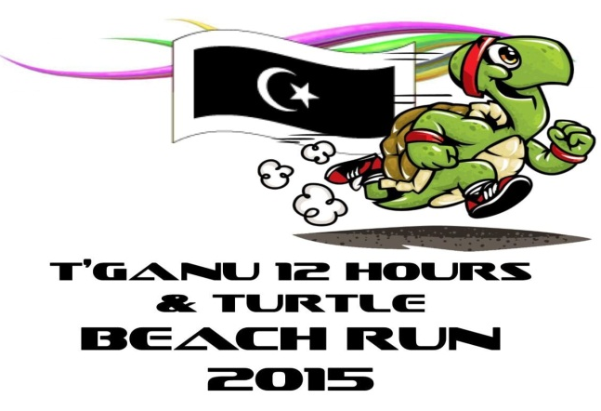

Personal Details
Full Name:
NRIC : |  | Email: |  |  |  |  | Phone:
Current address:
City: |  | State: |  |  |  | ZIP Code:

Category
Male Open - 10KM Women Open - 10KM
Male Vateran - 10KM Female Vateran - 10KM
Male junior - 8Km Female Junior - 8KM
(please choose one of the category above)
Category: |  |  |  | T-shirt Size:

Emergency Contact
Name:
Address:
City | State: |  |  |  | ZIP Code: |  | Phone:
Relationship:

Admin Details
For further information please contact ( sms/whatsapp only) |  |  | Zulkifli Ismail |  |  |  | 019 919 1902
 |  |  | Wajiha Wahab |  |  |  | 019-763 1434
 |  |  | Nazreen Sharudin |  |  |  | 017-984 1343

TURTLE BEACH RUN 2015
6TH JUNE 2015

