WHAT IS THE NEED?

Quotes:
“We have to shift our emphasis from economic efficiency and materialism towards a sustainable quality of life and to healing of our society, of our people and our ecological systems.”
- Janet Holmes à Court

“The way we see the world shapes the way we treat it.”
- Dr David Suzuki

OUR RESPONSE
In response to the growing need for environmental education we have developed a range of educational programmes that are tailored to meet the needs of your school.

Our programmes are run by qualified staff with the assistance of volunteers and are presented in an atmosphere of creative inquiry, to engage students of all learning styles.

ABOUT US
The Rockingham Regional Environment Centre (Naragebup) was opened in 2002 as the first purpose built environment centre in Western Australia. We are a not-for-profit organisation that was built by the community, for the community.

The centre was established as an education and resource facility for the community, to enable a greater understanding of environmental issues and sustainable lifestyle choices.

As well as educational programmes we also manage nature reserves around the Rockingham area and are involved in animal rehabilitation, including a programme forthe critically endangered Loggerhead Turtle.

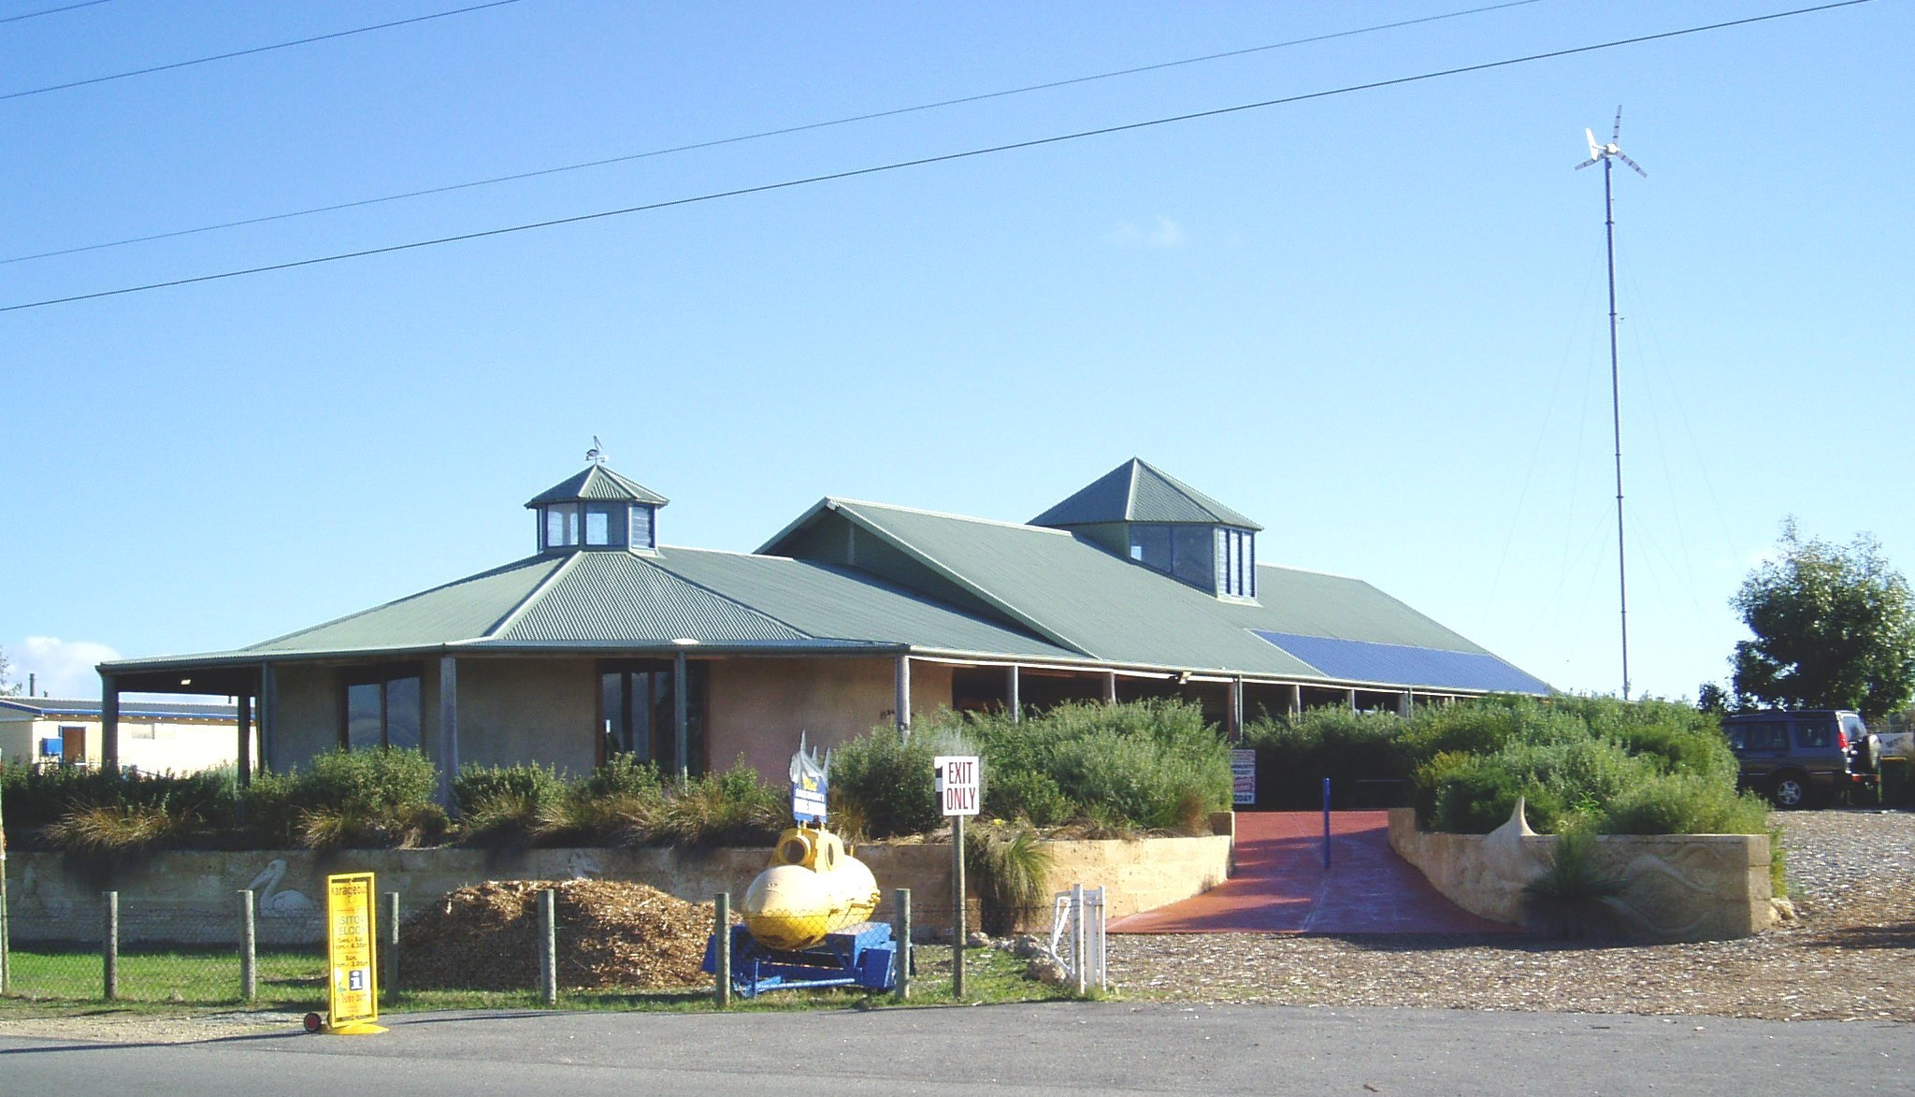

OUR METHOD
Our Education Programme takes a hands on approach to learning which both engages and challenges students. A model of experiential and discovery-based learning allows students to develop their own awareness of environmental and community issues and themes. Lessons are developed in a way that will give the students the ability to implement the themes from each lesson in their own lives, in the classroom or around their homes.

We at all times encourage students to ask questions and draw their own opinions from the information that they are given.

Lesson plans are based on both the National and WA curriculums. They have been written by primary, junior-high and high school teachers

Lessons are presented in a manner that is meaningful and relevant to the age group and learning style of the students. Activities can also be customised to meet any specific requirements that your group may have.

2011 Lesson Plans

LOCAL HISTORY AND CULTURE
This lesson is designed for students to discover both the natural and human history/culture of the local area. This includes both Aboriginal history and history since European settlement.

Students are taken on an exploratory walk around Lake Richmond, the deepest natural fresh water lake in Western Australia and home to two critically endangered species. The lake is also one of only a few Thrombolite sites in the world. Students will learn about how the lake developed over thousands of years and the more recent changes that have taken place to the lake as a result of urban development. The class is also introduced to the lakes variety of flora and fauna.

Students are then taken on a tour of the centre’s native bush tucker trail to learn about Nyoongar seasons and plant use, before enjoying a bush tucker snack.

Local History and Culture – Examples of Australian National Curriculum Outcomes and Rockingham Environment Centre Activities

Science
Curriculum Outcome | Activity Summary
Understand that the environment changes over time | Compare and contrast photos taken of the area around Lake Richmond 20 years ago and photos taken recently.  Participate in the ‘web of life’ game to identify elements of human habitation that are causing change to the environment of Lake Richmond.
Demonstrate that these changes are observable | Use media tools (still or video camera) to identify and analyse human development around Lake Richmond.

History / Society and Environment
Curriculum Outcome | Activity Summary
Understand that people and events interact over time | Use a creative problem solving grid to analyse and explore how Nyoongar people might have used the resources of the lake and nearby land.
Understands that people need to manage their resources efficiently and be aware that change has consequences | Participate in a group discussion: What next? What can we do to stop detrimental change? What resources do we need and how can we manage them?  Make a list of strategies that would help conservation work in the area.

Literacy
Curriculum Outcome | Activity Summary
Develop vocabulary.  Use oral language to describe to represent ideas and record findings | List the environmental and community features of Lake Richmond and the native bush tucker trail.
Use oral and written language to communicate understandings | Create a display board for the centre, about the environmental and community features of Lake Richmond and the native bush tucker trail.

Math
Curriculum Outcome | Activity Summary
Create a time line | Create a time line poster for thrombolites in Lake Richmond and Nyoongar groups in the Rockingham area.
Classify species into groups and graph results | Identify the life forms and populations supported by the lake and surrounds. Graph the results to identify most common species. Compare and contrast prevalence of species in other areas.

Examples of School Based Follow-up
Science - Write journal entries / do a school conservation project based around Lake Richmond.
History / S&E – Use the Lake Richmond and Nyoongar timeline in Indigenous studies.
Literacy –Have a school competition for most effective poster promoting Lake Richmond – winning poster displayed at the environment centre.
Math – Research the populations of endangered species in WA, graph the results to identify the most endangered species in WA.

2011 Lesson Plan

SUSTAINABILITY
Students are introduced to the Environment Centre and the materials that went into its construction. This includes an activities to explore heat resistant design and energy efficient technology.

The class is also are also introduced to methods that the centre uses to generate its own renewable energy, and rainwater capture that allows the centre to operate with minimal impact upon the environment.
Students are then taken on a tour of the organic permaculture garden, chicken coop and worm farms, and are given examples of how these simple ideas can be used in their own home to reduce household waste, energy use and the need for chemicals in the garden.

Sustainability – Examples of Australian National Curriculum Outcomes and Rockingham Environment Centre Activities

Science
Curriculum Outcome | Activity Summary
Identify factors that affect plant growth | Participate in organic gardening activities to identify plant growth factors: adding compost, worm and chicken casting to soil; watering plants with brown water from centre; and companion planting a vegetable patch.  Participate in discussion and interactive quiz about the effects of organic gardening.
Accept the role of science in developing systems of energy transfer | Construct a solar cooker and create a flow chart showing systems of energy transfer.

History / Society and Environment
Curriculum Outcome | Activity Summary
Understand that people need to manage their resources efficiently and are aware that change has consequences | Discuss and evaluate what happens to the environment when people do not manage their resources efficiently.  Create an information poster for environment centre visitors, using recycled art materials.
Understand to what extent people can fulfil their needs while managing resources for sustainable ecology | Construct a worm farm and create a flow chart showing the system of sustainable ecology.

Literacy
Curriculum Outcome | Activity Summary
Use a procedure genre record | Create a procedural document about the making of compost / a worm farm.
Understand that some things need different vocabulary to explain them | Create a sustainability word collage using new sustainability word vocabulary learned and recorded during the lesson.

Math
Curriculum Outcome | Activity Summary
Use of ratios and percentages | Participate in making of compost, using correct ratios and percentages of carbon and nitrogen materials.
Use of flow charts | Create a flow chart detailing one of the sustainability systems of the environmental centre.
Sort and classify familiar objects and explain the basis for these classifications. | Sort and classify recycled materials and explain the basis for these classifications.
Copy, continue and create patterns with objects and drawings | Create a patterned basket / rug / piece of jewellery using recycled fabric and plastic.

Examples of School Based Follow-up
Science – Hatch one of the eggs from the environment centre chicken coop and do a school presentation about the life cycle of a chicken.
History / S&E – Research products available for use in an organic garden, discuss the benefits and drawbacks of each product, propose a sustainability plan for your school based on the concepts learned at the centre.
Literacy – Write a compost ‘recipe’ or publish a procedure for making compost for inclusion to a school magazine or the environment centre newsletter.
Math – Make a school worm farm and calculate the rate of worm reproduction / waste input and output.

2011 Lesson Plan

HABITATS
Students take part in an introductory discussion about what makes a habitat and why they are important to our local environment. The class is also encouraged to think about ways that they can help to preserve and even create habitats in their local area and even their own garden.

Students are then taken on a tour of the centre to explore the flora and fauna of the native bush boardwalk. They will next visit the butterfly house and see the entire lifecycle of Monarch Butterflies.

The tour will also include a close encounter with reptiles and marine animals including snakes, lizards, the critically endangered Loggerhead turtle and the centre’s new artificial rock pool marine life.

Students will also have the opportunity and dip for macro-invertebrates in the centre community built wetland ecosystem.

Habitats – Examples of Australian National Curriculum Outcomes and Rockingham Environment Centre Activities

Science
Curriculum Outcome | Activity Summary
Explain ideas about features and behaviour of invertebrates from prior observation | Identify and analyse features of macro-invertebrates by dipping in the centre pond and exploring features using magnifying glasses, microscopes and classification charts.
Use senses to observe and identify small animals in their habitat  Understand techniques for recording information from field work | Observe and record field note data from marked and measured areas on the nature trail, using binoculars, magnifying glasses, rulers and measuring tapes.

History / Society and Environment
Curriculum Outcome | Activity Summary
Understand how the present environment is the result of actions in a previous times | Explore the nature trail, as well as maps and photos of the local area, to identify and analyse the effects of human populations on wetlands and coastal bush land.
Develop strategies to use knowledge of how the present environment is the result of actions in a previous time to conserve our environment | Use a creative problem solving grid to explore and evaluate problem scenarios concerning human populations encroaching on animal and plant habitats.

Literacy
Curriculum Outcome | Activity Summary
Use oral language to inquire and clarify understanding | Prepare a set of questions about animal habitats that will be explored during the lesson.
Use oral and written language to communicate understandings | Develop detailed field notes about the features and habitats of local mammals and reptiles.  Create a short, humorous and informative skit about one of the macro invertebrates found in the centre pond.

Math
Curriculum Outcome | Activity Summary
Measure an area that will become part of a grid | Mark out a measured grid on the nature trail.
Tally and record data | Tally and record the number of species found within a grid marking.  Extrapolate information to determine species density within a given area on the nature trail.

Examples of School Based Follow-up
Science – Use field notes from lesson to write a science report about a particular species.
History / S&E – Write a letter to local government about how the class would like to see natural resources managed.
Literacy – Create poetry /prose with the topic ‘small animals’.
Math – Tally and record the number of species found within a grid marking in a developed area (e.g. the school), compare and contrast this data with results from the environmental centre’s nature trail.

Comments about us
“Great displays, feeding the turtles was great.” – Teacher, Kerry Street Community School
“The guides were extremely knowledgeable. I liked the inclusion of activities involving the students on the walks.” – Teacher, Mundijong Primary School

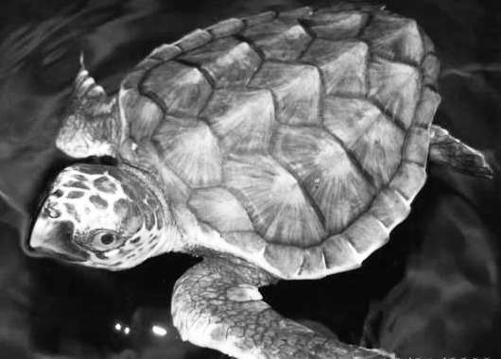
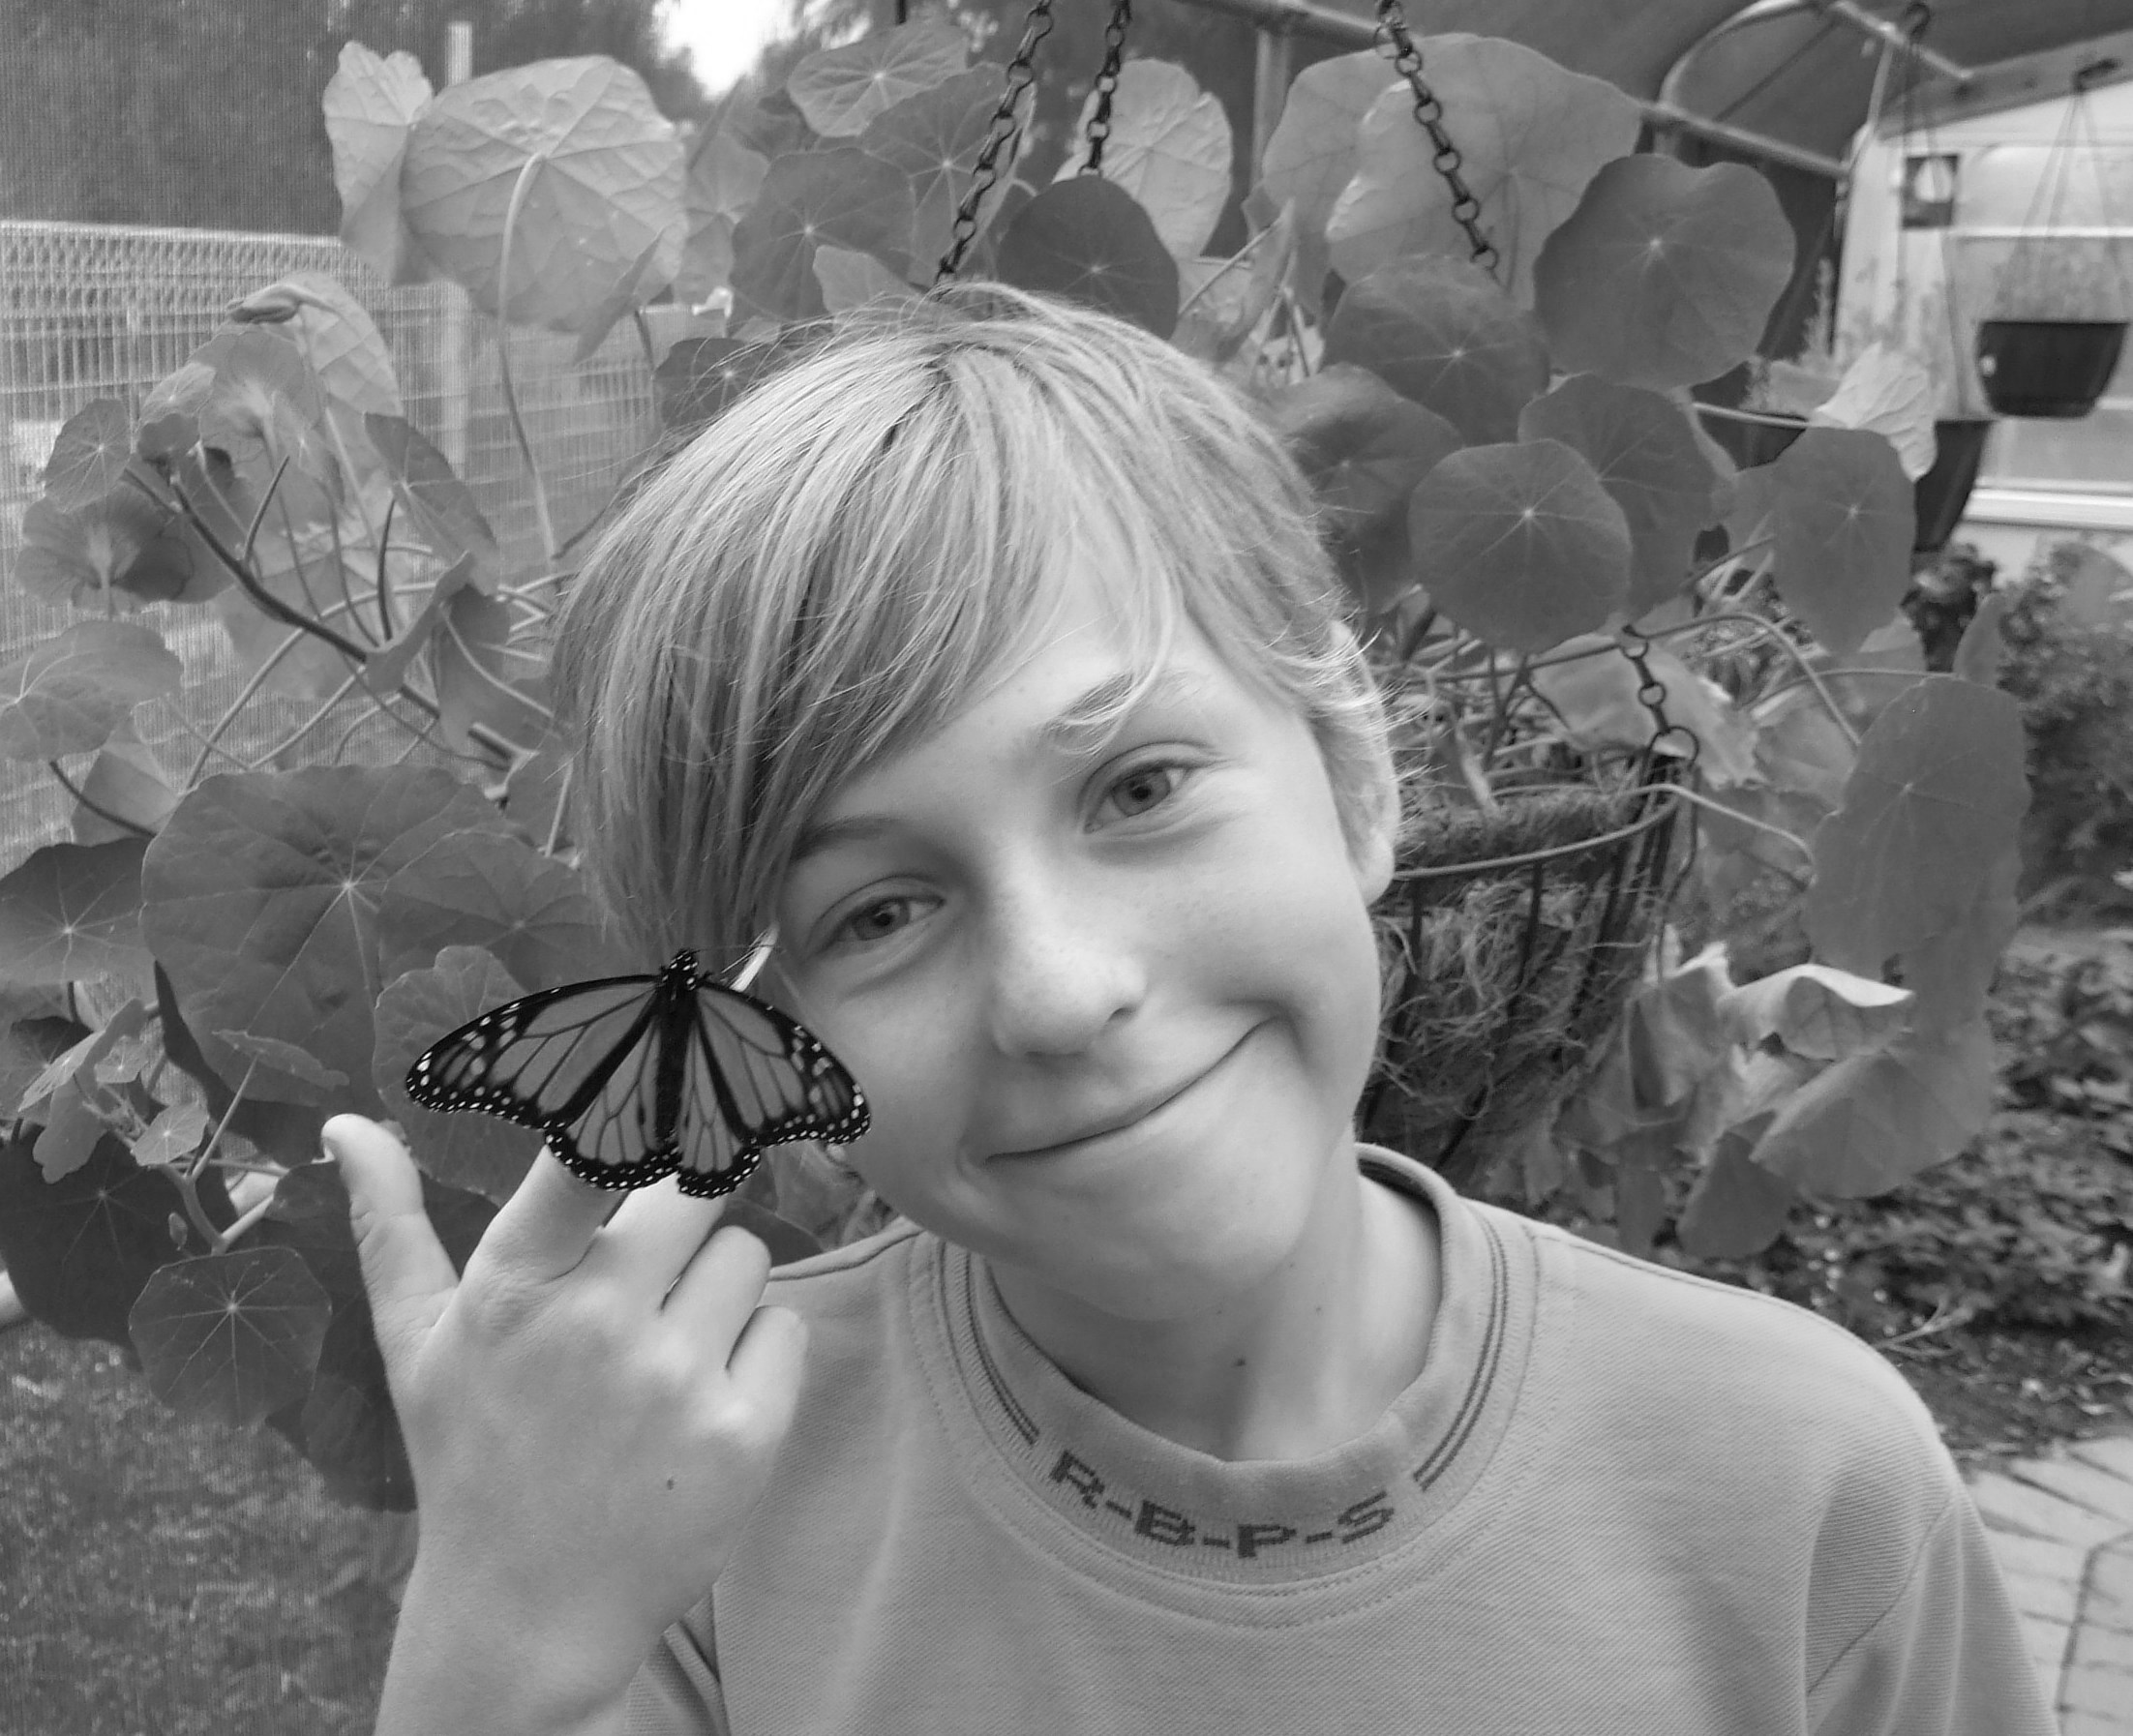
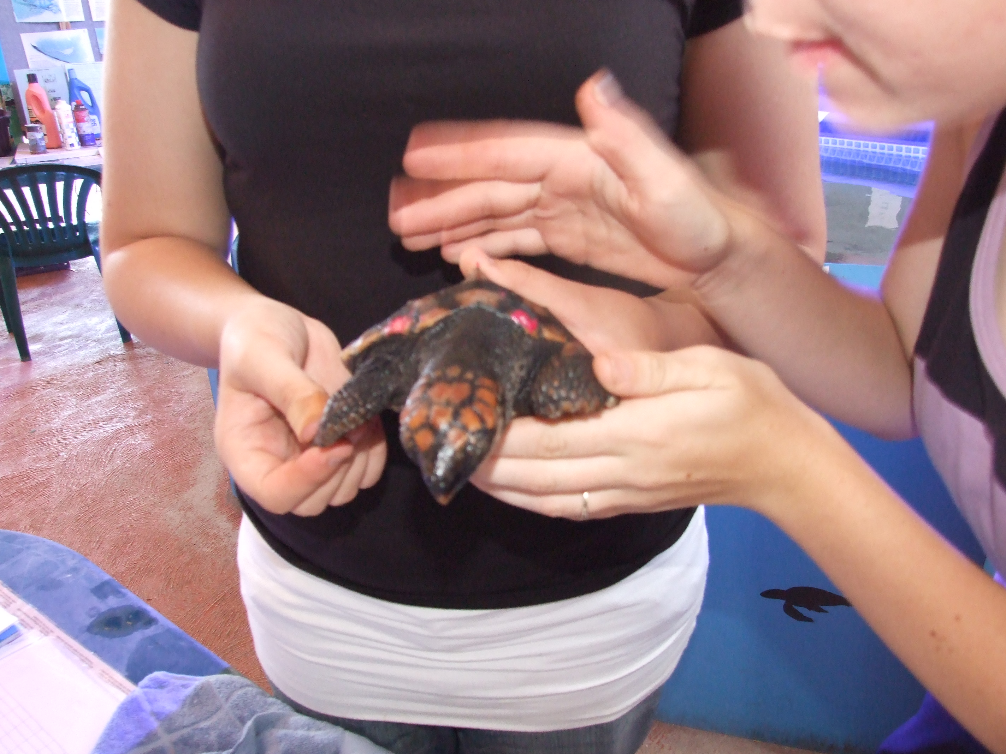
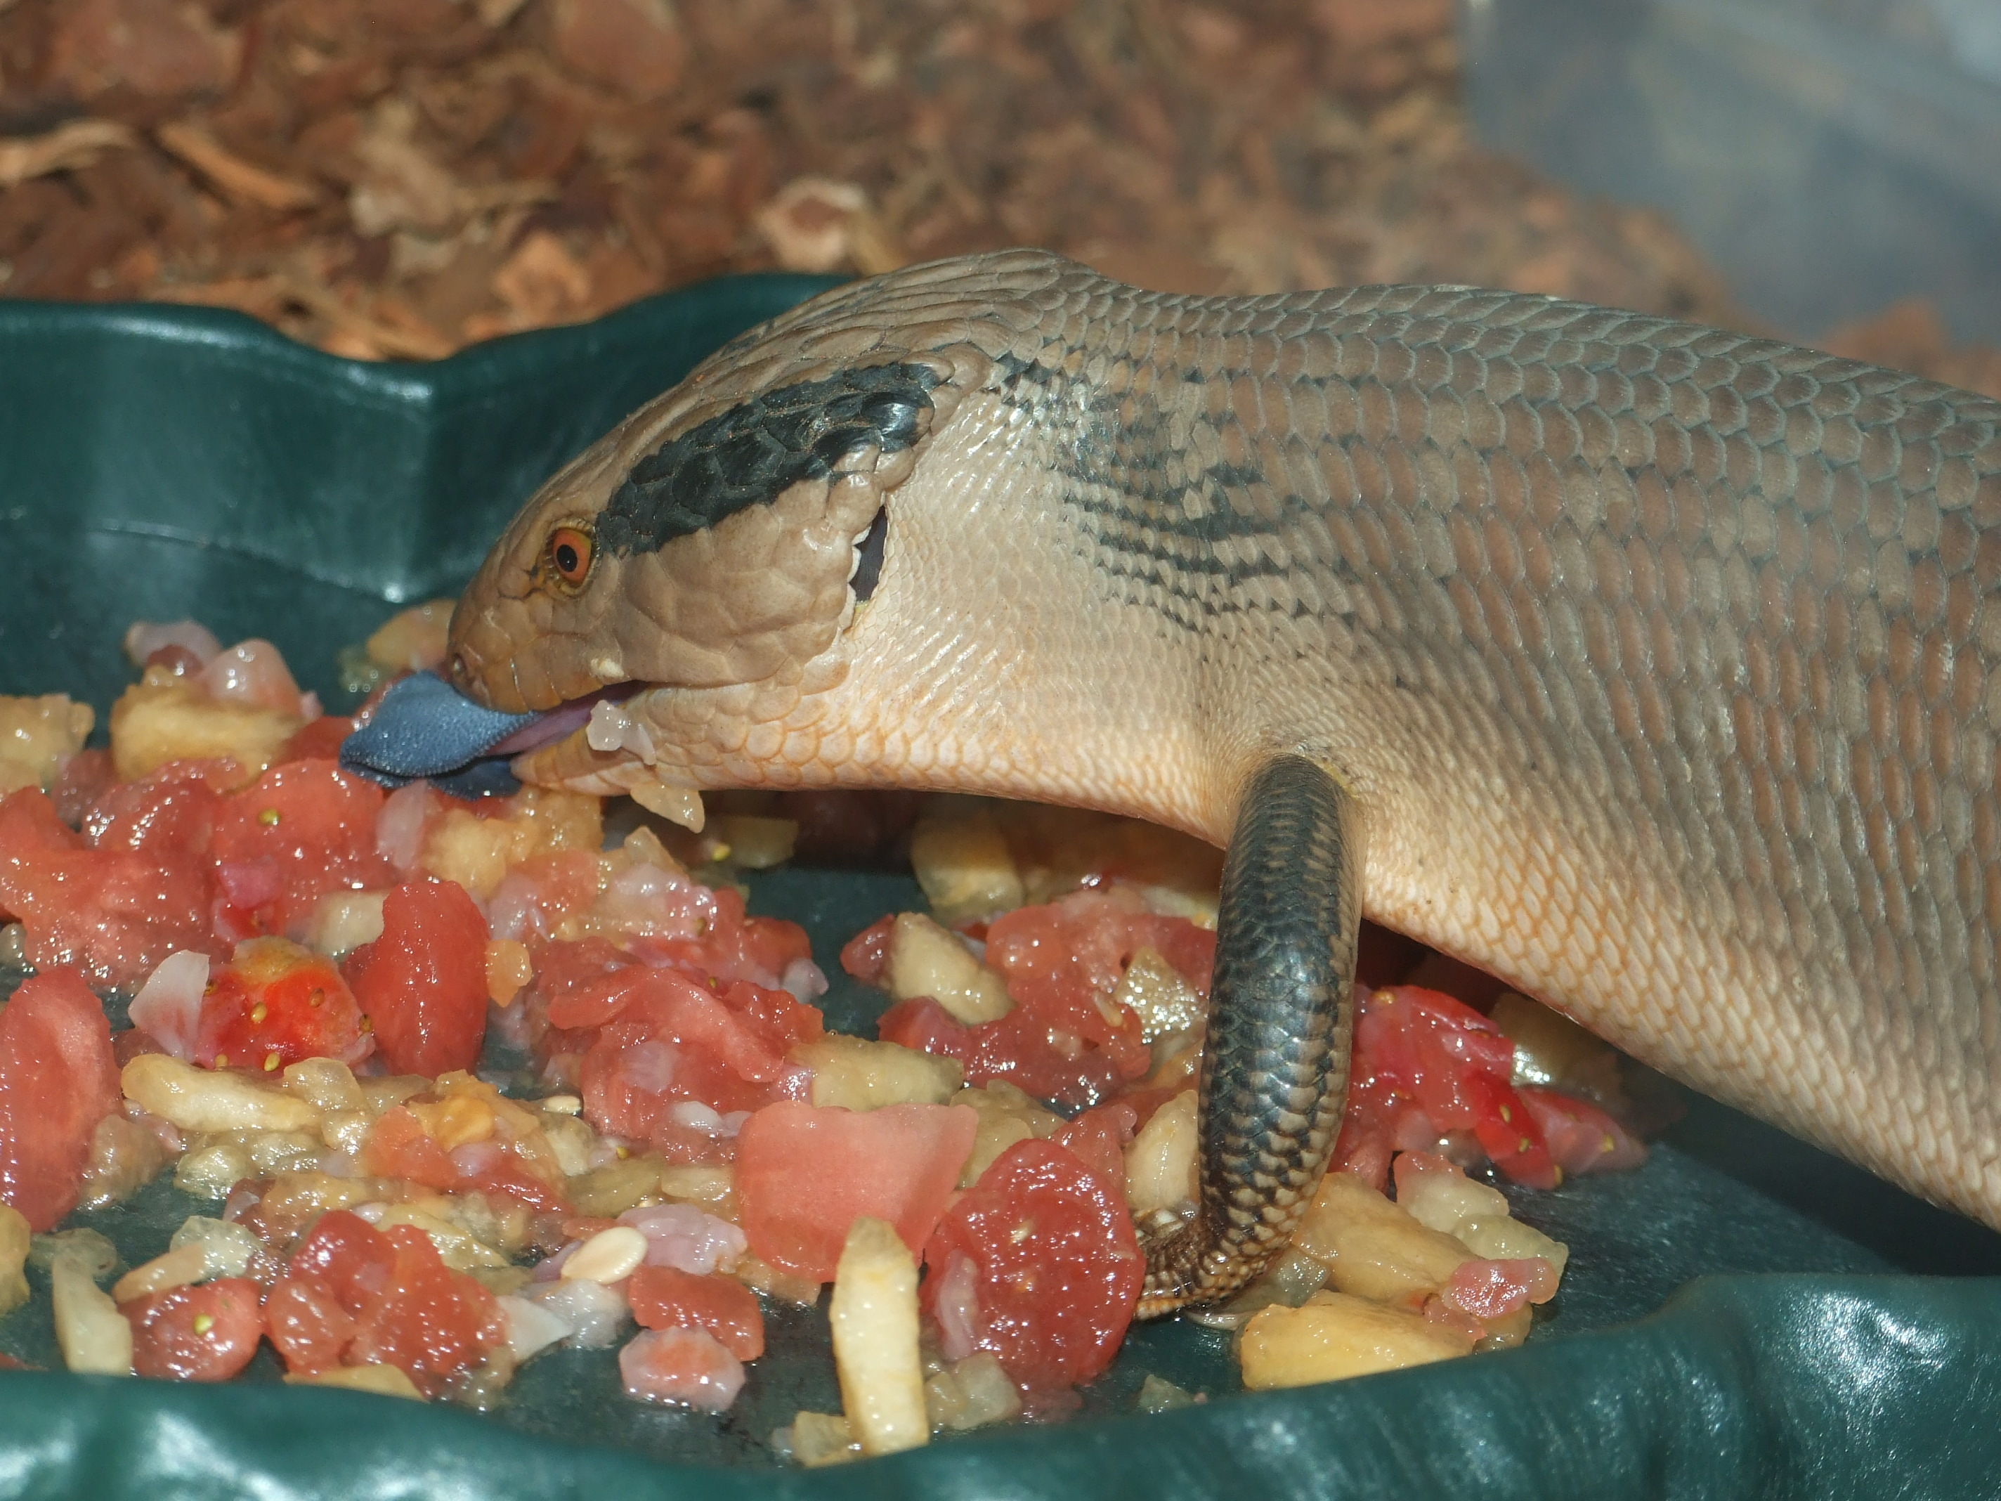
“It was a wonderful variety of experiences. Thank you, our students thought it was wonderful!!” – Teacher, Southern Cross DHS

“What I have learnt during my time at the centre has made me consider making a career from helping sick and injured animals.” – Student, Seton Catholic College

“I learnt a lot from my trip and would love to go there again.” – Student, Settlers Primary School
“Clear delivery of information, very informative.” - Teacher, Warnbro Community High School

