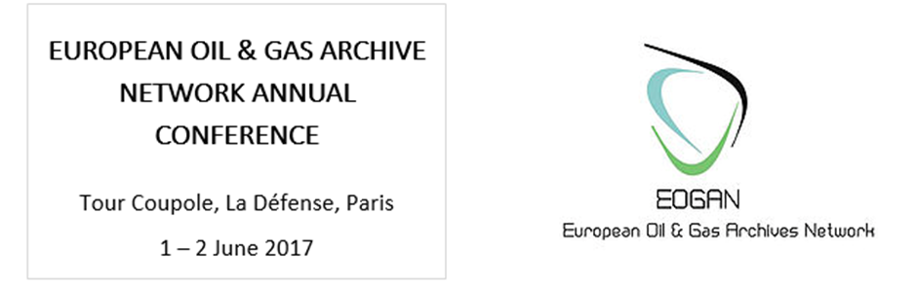

Thursday 01 June

09:30 – 10.00 Registrations open – coffee
10:00 – 10:15 Welcome: Total representative
10.15 – 10.30 Welcome: Siobhan Convery, Convenor, EOGAN

10.30 – 12.00 SESSION 1: Energy Transitions – Lessons from History
 | CHAIR:
1. | Professor Brian Black  Penn State University | ‘Leaping the Gap: Tracing Changing Conceptions  of Energy in World History’
2. | Professor Yves Bouvier  Paris-Sorbonne University  & Dr Leonard Laborie  National Center for Scientific Research,  UMR Sirice (Paris) | ‘Lessons Learnt from Writing History  with Energy Transition’
3. | Marten Boon  Norwegian University of  Science and Technology | ‘Royal Dutch Shell and the  Marketisation of Oil (1974-1990)’

12.00 – 13.00 Lunch and exhibition of material from Total’s corporate archives

13.00 – 15.00 SESSION 2: Economic and Social Transitions in Energy
 | CHAIR:
4. | Dr. John V. Bowlus  Center for Energy and  Sustainable Development,  Kadir Has University, Istanbul |  | A Farewell to King Coal: Global Power  and the Transition to Oil, 1901-17  (Paper by Dr. Volkan Ş. Ediger  & Dr. John V. Bowlus)
5. | Dr Emmanuelle Gallo  École Nationale Supérieure  d’Architecture de Bretagne |  | ‘Sources and Methodology for Studying  Energy Consumption in some Parisian  Public Buildings (19th - 20th Centuries)’
6. | Trude Meland  Norwegian Petroleum Museum | ‘Kristiansund:  A small city facing a major industry’
7. | Joe Chapman  ‘Capturing the Energy’,  University of Aberdeen | ‘Are reports of North Sea oil’s death  greatly exaggerated? Lessons from history’

15.00 – 15.30 Coffee

15.30 – 17.00 SESSION 3: Documenting Transition: the Role of Archives
 | CHAIR:
8. | Ine Fintland & Torkel Thime  Norwegian Oil and Gas Archive,  Regional State Archives, Stavanger | ‘The Value of Archives in Times of Transition’
9. | Dr Terry Brotherstone  & Andrew MacGregor  University of Aberdeen | ‘From Creator to Archivist to User – How the  Oral Record Contributes to Energy History:  examples from the experience of the  Lives in the Oil Industry Project’
10. | Eivind Skarung  Norwegian Oil and Gas Archive,  Regional State Archives, Stavanger | ‘Decommissioning: challenges and opportunities  for archival institutions’

17.15 – 18.30 Reception: drinks and canapés – free evening

Friday 02 June

09.00 – 09.30 Coffee
09.30 – 10.30 SESSION 4 – Keynote and Q&A
 | CHAIR:
11. | Alain Beltran  Director of Research, CNRS | ‘The constitution of the history  of energy in France’

10.30 – 12.00 SESSION 5: Energy History in France and the French-speaking world
 | CHAIR:
12. | Dr Marta Musso  European University Institute | ‘Oil for development: French-Algerian and  Italian-Algerian negotiations in the aftermath  of the independence war (1962-1971)’
13. | Radouan Mounecif  University of Paris 8 | ‘Petroleum engineers and technicians in colonial  and postcolonial Algeria: a contribution to social  history of the French oil industry (1944-1971)’
14. | Dr Benoit Doessant  Paris-Sorbonne University / Total | ‘Maritime Transport of Hydrocarbons:  the French oil companies between economic  imperatives and obligations of flag (1918-1998)’

12.00 – 13.00 Lunch and discussion with Dr Roberto Cantoni about his new book

13.00 – 14.30 SESSION 6: Capturing Transition: Photography and Visual Culture
 | CHAIR:
15. | Fabrizio Trisoglio  Fondazione AEM | ‘The Cathedrals of Energy: tradition and  innovation in AEM Historical Archives’
16. | Rudmer Canjels  Shell | Filming Royal Dutch Shell: Prospecting for  Science, Technology and Progress
17. | Barbara Bergaglio  Fondazione Camera - Centro Italiano  per la Fotografia, Torino | The case of the reuse of Eni’s  photographic archives

14.30 – 15.00 Coffee

15.00 – 16.30 SESSION 7: Technological Innovations in Energy
 | CHAIR:
18. | Dr Roberto Cantoni  Sciences-Po CERI, Paris | ‘Second Galicia? Poland’s fossil narratives  in the longue durée’
19. | Kristin Øye Gjerde  Norwegian Petroleum Museum | ‘The subsea-technology development  on the Norwegian continental shelf’
20. | Finn Harald Sandberg  Norwegian Petroleum Museum | New Energy – same technology  (Hydro - Petro - Ventus)

16.30 – 17.00 Members meeting & AGM

Please note: it is possible that the speakers, and the order of papers in each session, might change

