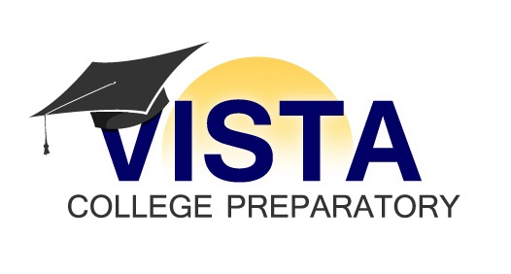

Finance & Development Committee Meeting
Thursday, May 1, 2014
4:30 – 5:30 PM
Location: United Way, 1515 E. Osborn
Call-In # - (213) 493-0800, Participant Access Code: 511965#

Agendas are available at least 24 hours prior to each meeting at 812 S. 6th Ave., Phoenix, Arizona 85003 Monday through Friday between the hours of 9 am and 5 pm. One or more Board members may attend telephonically. Board members attending telephonically will be announced at the meeting.

Agenda Items

- Current Financial Status

- Development & Fundraising Update

