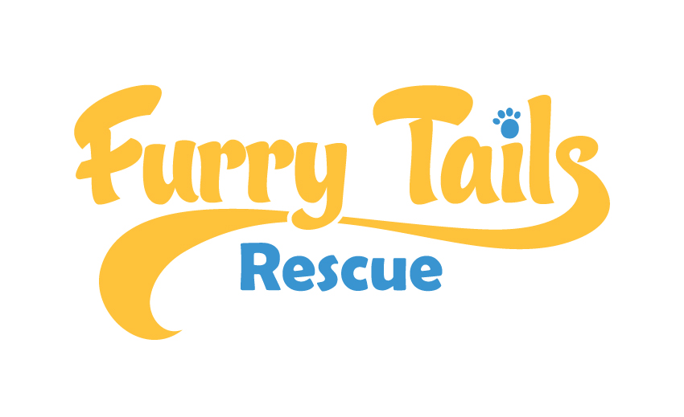
DOG: _________________ TAG: __________________

FOSTER CONTRACT

This agreement is made and hereby entered into on this ________ day of ___________________ by and between FurryTails Rescue, hereafter referred to as FTR, and _______________________________, hereafter referred to as Foster for the care of rescued dogs and cats awaiting adoption, hereinafter referred to as Foster Dog.

Both parties agree to the following terms of foster care:

Foster agrees to provide housing and care for the dog known as___________________________________ a (color) ___________________male/female; Breed: _________________________

1) Foster understands and agrees that the foster dog is currently named____________________ and as it is necessary for record keeping, appointments, public information, etc. to refer to the foster dog by one name Foster agrees to refer to him or her as such and by no other name either publicly or privately.

2) Foster agrees to keep this dog as an indoor companion and to keep this dog in a fenced yard or on a leash at all times when outside. Foster agrees not to leave this dog unattended outside either tied up or in a fenced yard when no one is home.

3) Foster agrees to provide this dog with proper food, water and loving attention. Foster understands that any food receipts for reimbursement must be submitted no later than two weeks after this foster dog is adopted. To be eligible for reimbursement food must be the same brand originally provided by Furrytails Rescue expressly agrees in writing otherwise.

4) Foster agrees to either bring this dog to veterinary appointments, adoption day events, spay or neuter appointments or to allow FurryTails Rescue to make alternate transportation arrangements for these appointments and events to ensure his/her well being and find him/her a forever home. Foster understands that all puppies will be spayed or neutered prior to adoption as long as they are 8 weeks old or older.

5) Foster agrees to allow people FTR has approved to meet the dog at their home or at another location nearby. Foster agrees to facilitate these meetings and answer questions by prospective adopters. Foster agrees to return phone call or email messages from FTR within 24 hours.

All items on the Foster Addendum are included under the terms of this contract.

6) Foster understands that FTR retains legal control of this dog and Foster is not authorized to make any legal or medical decisions on his/her behalf. This includes agreeing to administer any medications to the foster dog as directed by FTR and/or their veterinarians. If Foster does not wish to administer any medications as directed they must contact FTR immediately to allow replacement of the foster dog. FTR retains the right, in its discretion, for any reason, to retain physical possession of the animal at any time Foster agrees to release the foster dog to FTR upon written demand.

RELEASE OF LIABILITY

- We have read and fully understand the FTR Foster Home Agreement __________ (Initial). There have been no other representations or promises other than those included in this Foster Home Agreement. _________ (Initial).

- We understand that all rescue volunteer work done with FTR is at my/our own risk. __________ (Initial).

- We, ________________________ have read, understand, and agree to abide by the conditions of the FTR Foster Home Agreement and Guidelines.

- We understand that all work done with FTR is at my/our own risk and fully, irrevocably and unconditionally release and agree to hold harmless Furrytails Rescue and its individual members from any and all known or unknown, anticipated or unanticipated, suspected or unsuspected and/or fixed, conditional or contingent actions causes of actions, charges, suits, debts, demands, claims, contracts, covenants, liens, rights, liabilities, losses, royalties, costs, expenses (including, without limitation, attorney's fees) or damages, including but not limited to any medical costs, damages to property, persons or other pets, of every kind, nature and description, at law or in equity, in connection with or arising from while I am caring for the agreed rescue companion animal.

Name (please print): ____________________________________________________
Address: _______________________________________________________________
City: _______________________________ State: _________ Zip: ________________
Phone: Cell:_______________________
Home_____________________ Work:________________ Email:__________________________________________________________________
Signature: _________________________________________Date:_________________

Your Foster Home contract must be notified as soon as possible of any changes in the status of either the animal in your care or the foster home environment you have indicated above.

FTR Representative:

__________________________________________________________ Date: ___________________________

If you are unable to send electronically please forward to a FurryTails Rescue contact: info@furrytailsrescue.org

FurryTails Rescue President:
Jennicka Andersson: (310) 849 – 0504

