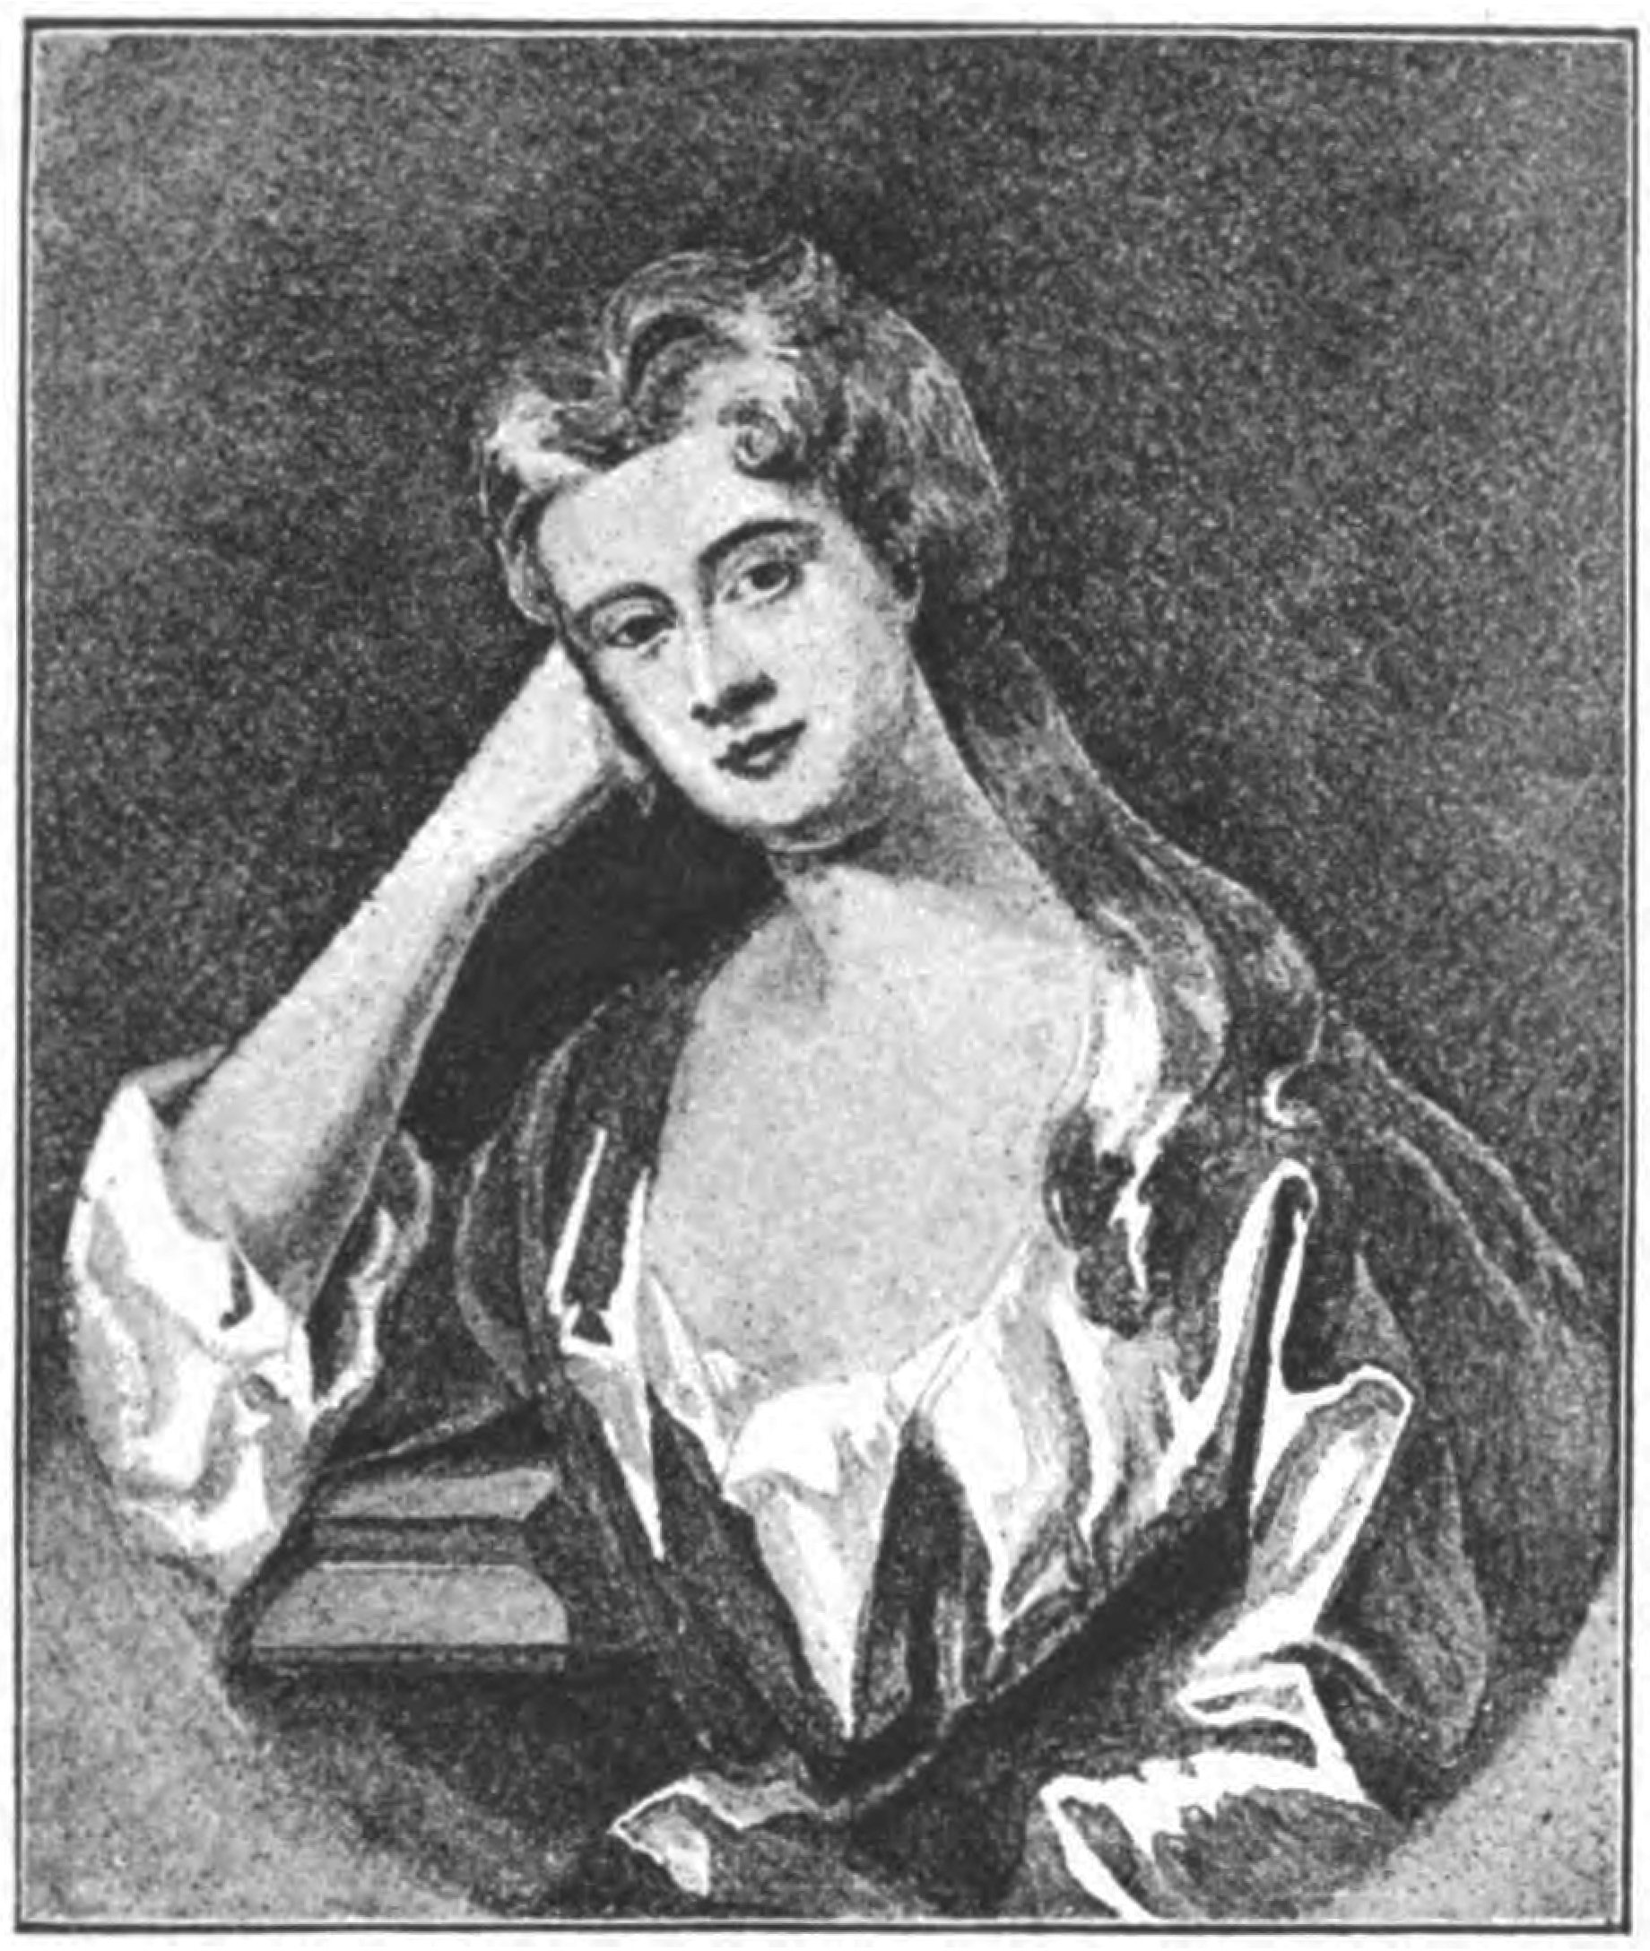
This portrait belongs to Mrs. Welby Parry, having formed part of the collection of the late Mr. Hartley of Bucklebury. It is said to be by Sir Godfrey Kneller, and its artistic merit quite bears out the supposition. It is of a woman in the prime of her beauty and grace ; the pose is very elegant, and the colouring charming ; in it she still wears the fashionable love-lock of the day. All three have much individuality and many points of resemblance. Hair of a warm golden shade, a slender neck and sloping shoulders, almond­ shaped eyes with well-formed level eyebrows,. are characteristics of them all. In fact, what is so often not the case, the representations of beauty which artists have handed down to us fully bear out in this case the praises of contemporary writers. Among these, the now not much read poet Parnell sings of the dismay of the "jeunesse doree" of the time when this fascinating lady left London for the country in the summer :
From towns fair Arabella flies;
The beaux, unpowered, grieve
The rivers play before her eyes,
The breezes softly breathing rise,
The spring begins to live.

Her lovers swore they must expire,
Yet quickly find their ease.
For as she goes, their flames retire:
Love thrives before a nearer fire ,·
Esteem, by distant rays.

Yet soon the Fair one will retur1t
When summer quits the p a£1l ;
Ye rivers, pour the weeping ur1z,
Ye breezes, sadly sighing, mour1t,
Ye lovers burn again
… and so on through several stanzas.
But in spite of the admiration of the world of fashion, which she no doubt enjoyed in her lifetime, and in spite even of Parnell's verses, it is possible that the thought of her beauty would by this time have passed away into the land where all things are forgotten, had it not been that she was the inspiring theme of perhaps • the most successful of all Pope's poetical works, The Rape of the Lock, in which the absurdities of the mock-heroic and the graceful imagery of poetic fancy are blended with the unrivalled skill of genius. The incident which suggested its composition was an indiscretion of which Lord Petre, a young man of twenty, had been guilty, when on a certain occasion he, unbeknown to the fa1r lady, cut off and stole a lock of her hair. She was very angry, and a serious quarrel\ took place between the two families. Whereupon Pope's friend, John Cary11 of Lady Holt, in Sussex, proposed to him that he should write some­ thing slight and amusing on the

subject, in hopes that good natured raillery might appease the ill-feeling that had been excited. The poem was in every way suited for its purpose ;
unfortunately, however, Pope, as it appears, was not personally acquainted with Mistress Arabella; he published it without asking her leave, and, moreover, appended to it a motto, which was taken by her friends to imply that she had asked him to compose the poem. Instead of mending matters, therefore, he only by his want of tact drew another quarrel upon himself. I hear, he writes to Carlyle, some little c
time after the publication, the celebrated lady herself is offended, &, what is stranger, not at herself, but me. Is not that’s enough to make a writer never be tender of another's character or fame? In consequence, he. brought out another edition, suppressed the objectionable motto, and prefixed a propitiatory letter of dedication to Arabella. In this he assures her that the incidents of the poem are all as fabulous as the vision at the beginning, except the loss of your hair, which I always mention with reverence ; . . . the character of Belinda as it is now managed resembles you in nothing but beaut, he goes on. It will be in vain to deny that I have some regard for this piece since I dedicate it to you. . . . If it had as many graces as there are in your Person or in your Mind; yet I could never hope it should pass through the world so uncensored as you have done. But let to fortune be what it may, mine is happy enough to have given me this occasion of assuri11g you that I am, The lady seems to have been pacified, and perhaps even accorded Pope her friend Shipwell, for on the occasion of her marriage he wrote her an almost affectionate letter. He says,
It may be expected, perhaps, that one who has the title of poet, should say something more polite on this occasion, but I am, really, more a well-wisher than a celebrator of your beauty. Besides, you are now a married woman, & in a way to be a great many better things than a fine lady, such as an excellent wife, a faithful friend, a tender parent, & at last, as the consequence of them all, a saint in heaven.
Pope was at one time a great deal at Mapledurham, which is not more than seven or eight miles from Ufton Court. It is possible, therefore, that he may have come to visit the lady he so much admired, in her married home ; there is, however, no actual record of his having done so.
Comparing Pope's account of Arabella's beauty with the existing portraits, it is strange that, as she is represented in all three pictures with fair auburn hair.
These two in sable ringlets taught to break Once gave new beaut-us to the snowy neck ; The sister lock now is uncouth, alone, and in its fellow's fate foresees unto it’s own.
That he should have made such a mistake seems to confirm Mr. Courthope's opinion, expressed in his recent edition of Pope's works, that the poet was not acquainted with the lady when he first sang the praises of her beauty.
At her marriage, in 1715. her husband settled on her the messuage commonly called Ufton Court, now it his ow1t occupation, & all that farm of Ufton town as Poole la1eds & church grounds. Also the farm called Ashpoles, then it the occupation
of john Berrington, the bailiff (there is a plot still so called not far from the church). Also the farms called Snowsewick & Penuiswick. & other lands in Buscot, & the messuage & farm called Great Balhampton. in the parish of Steeple Lang­ ford. co. Wilts. Also Perkins' farm in Hanging Langford­ in all of the value of £6oo yearly.
There is a tradition that it was for Arabella Fermor that Ufton Court was very much refashioned and enlarged, Certainly one half of the frontage (as shown in the illustration, chap. viii.) was, prior to further alterations made in 1838, of the style prevalent at the time of her marriage. Parts of the interior, also, were modernized; the hall and dining-room, while retaining their Elizabethan ceilings, were entirely re­ paneled, and the style would fix this alteration also too early in the eighteenth century.
Arabella bore to her husband one daughter, named also Arabella, who died in childhood in the year 1723, and five sons. Her second son, Henry, died in 1724, also young. Her husband died in 1736, leaving his wife for her present support £52 . His landed property he left to Sir Henry Englefield of White Knights, William Wollascott of Woolhampton, John Hyde of Hyde End, and Mr. John Herrington the bailiff, in trust for his eldest son, and to his younger sons he left £100 apiece, to place them forth apprentices to some trade, profession, or employ11unt. Arabella only survived her husband one year.
Another Francis was Squire of Ufton, but the race was now coming to an end he died at the age of thirty-four, unmarried. The year before his death, 1749, Ufton Court was let for a term of three years, at a rent of £89 4s. 6d., to Lord Kingston, with furniture now remaining except china, linen & plate. This Lord Kingston's name is to be found about the same time in a list, still preserved, of the members of a club which met every fortnight during the summer months, between the years 1727 and 1815, at the Hind's Head Inn at Aldermaston, for playing at bowls and dinner. It included nearly all the gentry and a good many of the clergy in the district. Francis Perkins, the son of Arabella, belonged to it, as did also his younger brothers. It seems to have been a most friendly and pleasant institution, and that the Ufton family attended it is a proof that by this time religious animosity no longer caused enragement among neighbours.
James and Charles, brothers of Francis, succeeded one after the other to the property. It was in their lifetime that the family fortune suffered serious diminution. James Perkins sold the Buscot estate, and later on the Wiltshire property. Great Balhampton, Langford, and Wylie were by Charles Perkins' desire sold after his death to pay his debts. As no explanation is given, one may suppose that either money had been swallowed up in the speculations that were rife at the time, or that these quiet country squires had too rashly followed the extravagant fashions of the day of their richer neighbours. Charles bequeathed his property to his youngest brother, John, and to his children ; failing them, it was to go to his cousin Jones, daughter of !tis late Aunt Wyborne, and in default to Sir Henry Englefield, of White Knights, and then in default to my 1zeighbour, Christopher Griffith, of Padworth.
John Perkins, the youngest brother, succeeded to the property in 1760. He married, but had no children, and was the last of his name of Ufton. He died in I 769. In his will he said : Having survived Mary, my late wife, I make provision for her two daughters. He described them as Elizabeth, now residing in the house with me, & Mary, now being at a boarding school at Newbury, and he left them, when they shall respectively attain the age of :!1, £1,000 apiece. To his housekeeper, Mary Wilson, he left £20, and the rest of his personal estate he left to Henry Deane, of Reading, who had been his man of business, and to Francis Prior, of Padworth. He concluded: I desire to be interred with as little ceremony & expertise as decency will permit, regard being had to what I caused to be done on the decease of my late dear wife, but wait instead of 12 poor men & women to attended on that occasion.
Henry Deane, the legatee, was the successor of John Herrington in the office of agent to the property. Francis Prior was a Roman Catholic gentleman, a neighbour and very intimate friend of the family. He held a lease for life from the squires of Ufton of the house belonging to the Perkins estate in Padworth called Pam Hall-an exceeding good dwelling house, brick & tiled, with yard & garden, as it is described in a note on the rents of the Ufton estate dated I 784. It is now pulled down.
This Francis Prior died in 1788, and was buried at Ufton. There is a remarkable testimony to the esteem in which he was held in an entry in the Padworth Register, which is as follows:
On Thursday, December 4, 1788, about 4 o'clock in the morning, Mr. F. Prior of Padworth departed this life. He was a man immensely beloved by all that knew him,• & this esteem was raised in them from the goodness of his heart & h1s steady adhere to his religious principles, which he showed by all upright co11duct of life & conversation. Th1s small tribute
his memory is left upon record to show how much he was esteemed by the rector of this parish & his family.
This from a near neighbour who must have known him well, and who could not have altogether agreed with the religious principles he alludes to, is a touching testimony to the real worth of the man.
His name is mentioned again in connection with that of his friend and landlord, John Perkins. It is at the death-bed of the latter, during a conversation related by Father Madew, the then resident priest at Ufton Court. He, Madew, was evidently aware that at his patron’s. Death the house and property were to pass away to comparative strangers, and, anx1ous for the interests of the little congregation of the faithful to which he ministered, he writes down what occurred :
I, Edward Madew, then being in the room with John Perkins, Esq..., asked ye said John Perkins if he had made a disposition of his church stuff,• that, in case he had not, I hoped he would leave it for ye benefit of the congregation & in trust to Mr. Prior or to Mr. Edward Madew. To whom he answered, I think it my best way, I do give it for Ideal purpose, & repeated over again, I think my best way. Mary Wilson being then present, I told her to bear witness of what Mr. Perkins said.
And thereupon follows the declaration of Mrs. Wilson, the housekeeper
The columns above I declare to be literally true, as witness my name, Mary Wilson.
It has been seen that the prohibitory laws against Roman Catholics had in practice been gradually relaxed. Yet as late as Pope's time they were still debarred from entering the army or navy ; they could not be barristers, or magistrates, or sheriffs, or members of Parliament. Truly, as he exclaims, ambition is a vice that "is timely mortified in us poor Papists I In his case the usual fines still levied from them had been excused, an exemption being made in his favour on account of his literary merits. In a letter in which he thanks the Earl of Halifax for this mark of favour, he says :
It is indeed a high strain of generosity in you to think of making me easy •all my life, only because I have been so happy as lo divert you . some hours; but if I may have leave to add, it is because you think me no enemy to my native country, there will appear a better reason.
In 1746, according to the Annual Register, orders had been given to the clerks of the peace throughout the country to send in a list of the Roman Catholics in their districts and the landed property they were possessed of, and a like direction was given in 1767 by the bishops to their clergy, in consequence of an order from the House of Lords, that it might be seen whether they increase in prosperity or no. It was not till February, 1794 only two years before the death of the last Mr. Perkins of Ufton Court that the rule by wild Roman Catholics were charged a double rate to the land tax was cancelled, to the great satisfaction of the liberal minded of all persuasions. No doubt the infliction of such penalties for the sake of religion seems nowadays most unreasonable bigotry and tyranny ; yet it must be understood that such repressive legislation was far more political than religious.
Men were still living in 1750 who could remember the sacrifice made by the nation in freeing themselves from the Romanising rule of James II ; and since then no long time had ever passed without some rising in Scotland or some conspiracy at home in favour of the return of the Stuarts. One William Perkins, a Roman Catholic gentleman of Warwickshire-not, however, immediately related to the Ufton family-suffered death in the reign of William and Mary for having secretly collected arms and followers to join and assist an invasion from abroad, and died declaring that he thought it no sin to fight for his lawful Sovereign. If we admire his heroism and loyalty, we must allow that no Government can continue to exist unless it takes means to suppress such as conspire for its overthrow. As late as I 745, when the Scotch army under the young Pre­ tender pushed on as far south as Derby, inviting all who .wished for the return of the old faith to join his standard, the Roman Catholics scattered about the country were naturally looked upon with suspicion, as a source of danger to the State. After that, on three separate occasions, it is believed that Prince Charles Edward paid visits to England, and went among his friends and adherents with a view of discovering whether a rising could be arranged with any chance of success. . On the first occasion (I 750) he spent a week in London, and it was then that, according to his own journal, he was formally received into the English Reformed Church, in hopes of thereby propitiating the nation at large. The second occasion was in 1752, when an attempt was actually planned to place him on the throne. Alexander Murray, a brother of Lord Elibank, was to march on St. James's Palace, and Charles was to proclaim himself. On his third visit during the following year (1754) he travelled about the country, and was at Nottingham when word was brought him that there was danger of his being discovered, and he accordingly returned to the Continent. It must have been then, if tradition says truly, that he visited Ufton Court. According to a letter, already referred to, written by Mr. Congreve, of Aldermaston, in I8J8, a Mr. Byles, a very old apothecary who had died at Aldermaston thirty-three years before, told him (Mr. Congreve) that the Pretender
Prince Charles Edward had once been at Ufton Court, not, as he explained, in '45, but a few years afterwards. This fact was also affirmed by the late Sir Paul Hunter, of Mortimer, who had heard it from his grand- father. I give the story for what it is worth, with the authorities from which I have obtained it. There is nothing improbable in it, though no recollection of the incident has survived in the neighbourhood. The Prince while travelling about the country would naturally stay at the houses of such Roman Catholic gentlemen as he thought might be favour- able to his cause, and that Ufton Court contained hiding places and secret ways of escape in case of surprise might also be in its favour as a temporary halting-place.
It is said on the authority of Hume the historian that the Prince was once more in England on the occasion of George III's coronation; but long before that time the cause of the Stuarts had been felt to be hopeless, and Englishmen at last settled down as one nation under one Government, and persecution and repressive legislation gradually ceased.
Mention has been made of a resident priest at Ufton.
The first who is known of in that capacity is a Father Price, who was at Ufton about the year 1755 Probably before that time Roman Catholics only enjoyed the services of travelling priests, or missionaries, as they called themselves, who never stayed long in any one place, but passed from house to house.
Father Madew, the next priest whose name has been found, says of himself that he came to Ufton Court, though not apparently for the first time, September 18 1761 that he spent on road & carriage of my goods £1 7s. 6d.
He was in the habit of keeping notes, which were at the same time a diary, account book, and church register, of which some loose leaves are preserved at Woolhampton College. Dr. Conway, the principal, has kindly allowed me to copy from them.
About his personal affairs he records that in May, 1762, he made a journey to Bath, evidently to attend some funeral, that his journey cost £2 1 1s., that he gave three gentlemen who assisted at a charge of £3 For which amount and a further sum of £5 ss. he notes having given a receipt to Mr. Perkins of Ufton Court.
On another occasion he says:
I leave in two purses in ye table drawer & y other in ye desk, fifty two pounds ten shillings
Signed, Ed. Madew.
The expenses are multifarious-some for the little chapel, no doubt, and some for himself-all mixed up together. Here is a specimen :
Feb. 4, 1762.- Paid to Mr. Bram for candles &breads 1/-
Jan. 27, 1763.-Paid to Mr. Ingram for candles &books 4/-
Mar. 24.-Paid to Mr. Ingram for books & snuff 6/-
Jan 22, 1764.-Canldles, credit, to Mr. Ingram- 3/-
Mr. Ingram must have been the predecessor of the miscellaneous village shopkeeper of the present day. But besides such things he records in a regular register the deaths of seven of the Perkins family, beginning with Francis Perkins' grandfather died February 7th, 1694, mentioning the death of Arabella and her husband, and of their four sons.
Curiously, he takes no notice of the two children who died in I 723 and 1724. He notes only the deaths of the heads of the family.
Then he records the baptisms, some of them children of Ufton parents, but many from the neighbouring villages. He gives a whole list of the congregation at Ufton in the year
I 749, to the number of 98, including Mrs. Prior and her son, Mrs. Berrington and maid, and many names still familiar in Ufton, and finally mentions that confirmations were held at one time at Mr. Doughty's, at Beenham, and on two other occasions at Ufton Court, by Bishop Chaloner. This ecclesiastic, whose title was Bishop of Debra, was Vicar postolic of the London district. He was the author of a book of memoirs of the missionary priests. He is buried in the parish churchyard of Milton, in Berkshire.
A last entry concerning Madew is written by his successor:
On Sunday, May 131", 1782, died, age 79, the Rev. F. Edward Madew, O.S.F., a jubiliarian, many years missiona1y at Ufton Court, where he died. He had likewise been missionary in Warwickshire, at Mapledurham, Oxon, & at Beenham & Ufton Berks.
Signed, G. A. Baynham, P.S.F.

The term "jubiliarian " has been explained to signify that he had been fifty years a priest. The F. prefixed to his name no doubt stands for Father and O.S.F. for Order of St. Francis.
It will be noticed that he survived the last of his patrons at Ufton for many years. Not only was the church stuff left for the use of the congregation, but also a priest was maintained in the house even after the property was sold. G. A. Baynham, who signed the above, lived on alone in the deserted Court till his death on March 29,I 803.
An old woman, only lately dead, used to relate how she well remembered running up from the village as a child one cold, bleak spring morning to see his funeral procession pass along the avenue, on the way to the church yard which receives all who agree or disagree in this life when at last they rest from their labours and are at peace.
Ufton Court and the estate immediately surrounding it passed to the grandson of Katherine Wyborne, Mr. John Jones, of Llanarth; but it was then a desolate, neglected, and ruinous place, and was never lived in by its new owners.
At last, in 1802, it was sold to Mr. Congreve, the owner of Aldermaston, and while in his possession the Court fell more and more into ruin. A great part of the oak panelling was stripped from the walls, some of it having been used in Aldermaston Church, and a great deal of timber was cut down on the estate, and when it was again resold in 1837 the house was described in the agents advertisement as unfit for a gentle­ man's residence.
Fortunately it fell into kind hands. Mr. Benyon de Beauvoir, of Englefield, who was the purchaser, in order to make use of it as tenements for his labourers, put it into a thorough state of repair, and under the care of Mr. Benyon, his successor, the present owner, it bids fair to last yet for many long years to come-a specimen, not of a nobleman's castle or a rich man's palace, but of the home of an English country gentleman of the olden time

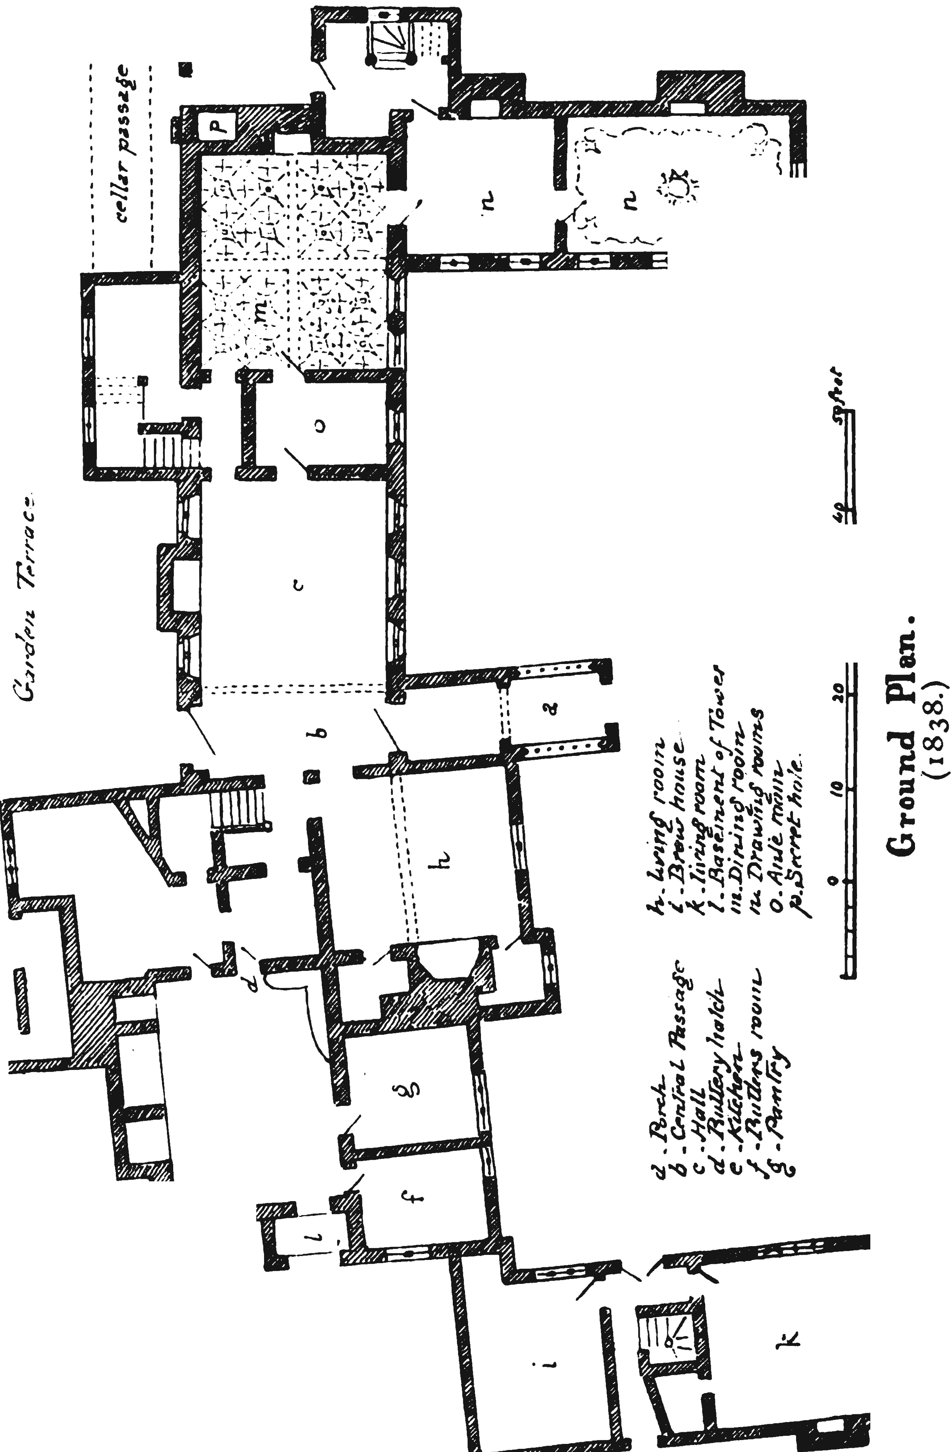

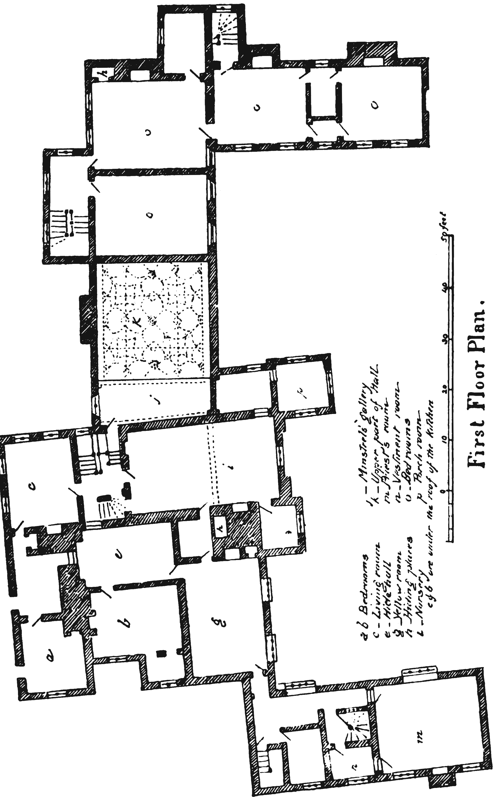

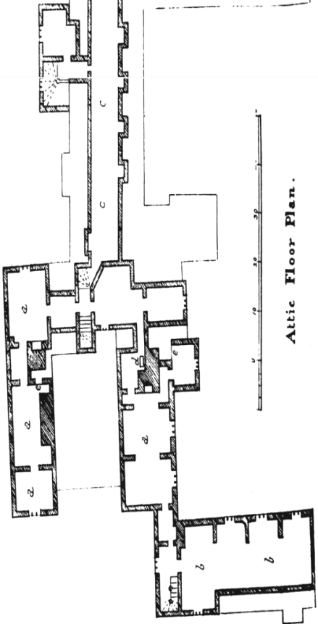
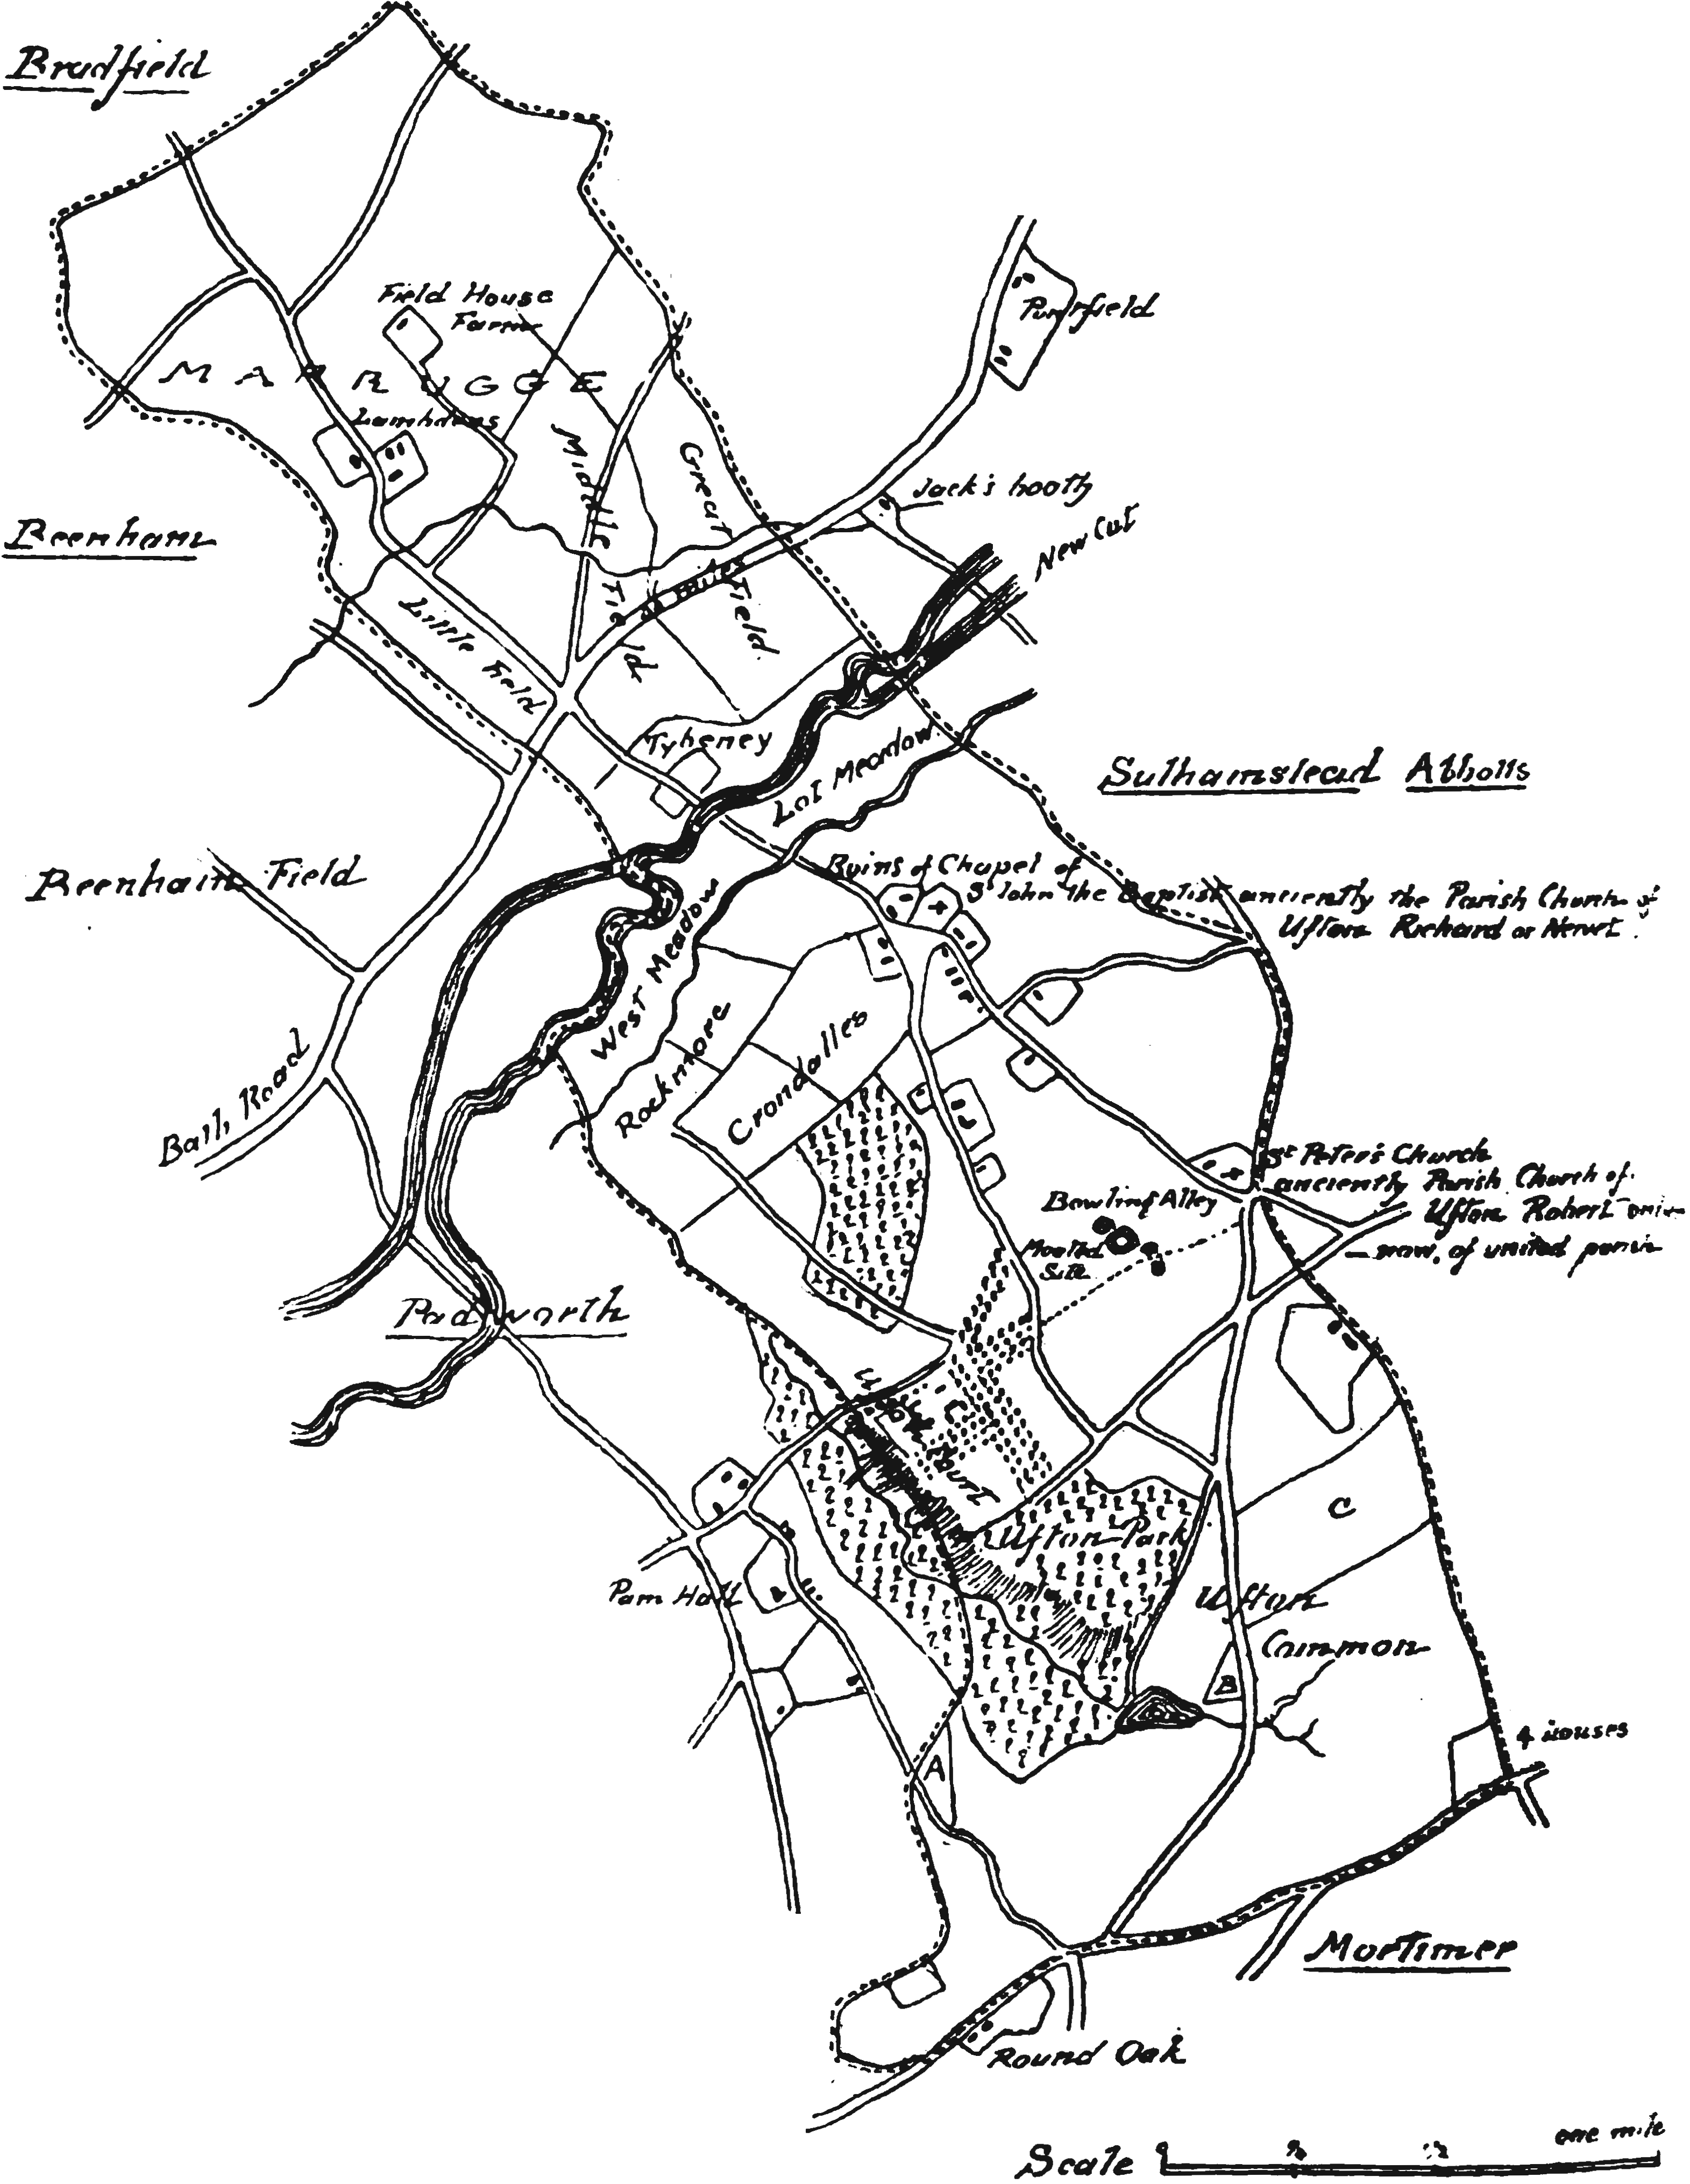

REGARDING RAPE OF THE LOCK BASED ON ARABELLA FERMORE (PERKINS)
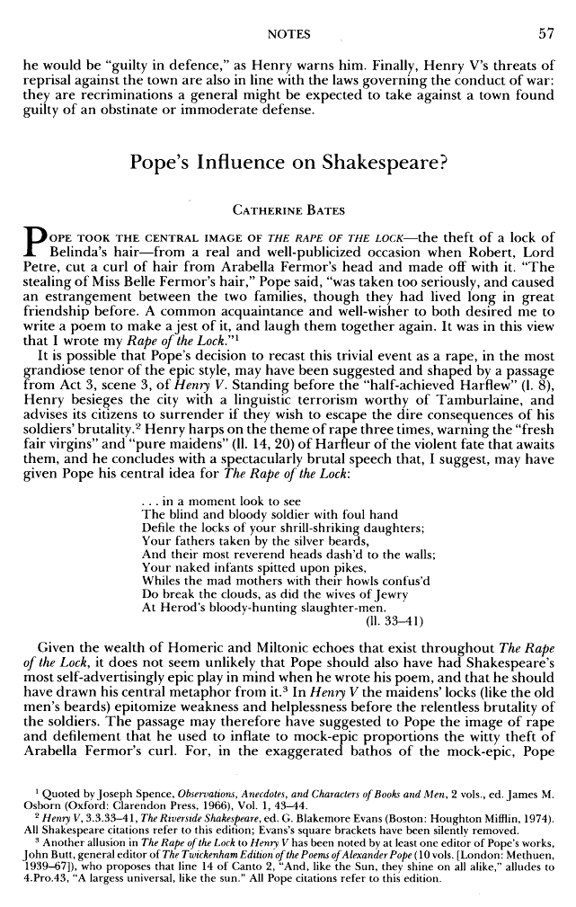
At the beginning of "The Rape of the Lock," Pope identifies the work as a “heroi-comical poem.” Today, the poem–and others like it–is referred to as a mock-epic and sometimes as a mock-heroic. Such a work parodies the serious, elevated style of the classical epic poem–such as The Iliad or The Odyssey, by Homer–to poke fun at human follies. Thus, a mock-epic is a type of satire; it treats petty humans or insignificant occurrences as if they were extraordinary or heroic, like the great heroes and events of Homer's two great epics. In writing "The Rape of the Lock," Pope imitated the characteristics of Homer's epics, as well as later epics such as The Aeneid (Vergil), The Divine Comedy(Dante), and Paradise Lost (Milton). Many of these characteristics are listed below, under "Epic Conventions."
Setting
The action takes place in London and its environs in the early 1700's on a single day. The story begins at noon (Canto I) at the London residence of Belinda as she carefully prepares herself for a gala social gathering. The scene then shifts (Canto II) to a boat carrying Belinda up the Thames. To onlookers she is as magnificent as Queen Cleopatra was when she traveled in her barge. The rest of the story (Cantos III-V) takes place where Belinda debarks–Hampton Court Palace, a former residence of King Henry VIII on the outskirts of London–except for a brief scene in Canto IV that takes place in the cave of the Queen of Spleen.
Characters
Belinda Beautiful young lady with wondrous hair, two locks of which hang gracefully in curls.
The Baron Young admirer of Belinda who plots to cut off one of her locks.
Ariel Belinda's guardian sylph (supernatural creature).
Clarissa Young lady who gives the Baron scissors.
Umbriel Sprite who enters the cave of the Queen of Spleen to seek help for Belinda.
Queen of Spleen Underworld goddess who gives Umbriel gifts for Belinda.
Thalestris Friend of Belinda. Thalestris urges Sir Plume to defend Belinda's honor.
Sir Plume Beau of Thalestris. He scolds the Baron.
Sylphs, Fairies, Genies, Demons, Phantoms and Other Supernatural Creatures

Source: A Real-Life Incident
Pope based The Rape of the Lock on an actual incident in which a British nobleman, Lord Petre, cut off a Lock of hair dangling tantalizingly from the head of the beautiful Arabella Fermor. Petre’s daring theft of the lock set off a battle royal between the Petre and Fermor families. John Caryll–a friend of Pope and of the warring families–persuaded the great writer to pen a literary work satirizing the absurdity and silliness of the dispute. The result was one of the greatest satirical poems in all of literature. In writing the poem, Pope also drew upon ancient classical sources–notably Homer’s great epics, The Iliad and The Odyssey–as models to imitate in style and tone. He also consulted the texts of medieval and Renaissance epics.
Plot Summary
Pope opens with a statement announcing the topic of his poem: A gentleman–a lord, in fact–has committed a terrible outrage against a gentlewoman, causing her to reject him. What was this offense? Why did it incite such anger in the lady?
The woman in question is named Belinda. She is sleeping late one day in her London home when a sylph–a dainty spirit that inhabits the air–warns her that “I saw, alas! some dread Event impend.” The sylph, named Ariel, does not know what this event is or where or how it will manifest itself. But he does tell Belinda to be on guard against the machinations of men.
.Belinda rises and prepares herself for a social gathering, sitting before a mirror and prettying herself with “puffs and powders” and scenting herself with “all Arabia.” Afterward, she travels up the Thames River to the site of the social festivities, Hampton Court, the great palace on the north bank of the river that in earlier times was home to King Henry VIII. As she sits in the boat, “Fair Nymphs, and well-drest Youths around her shone, / But ev'ry Eye was fix'd on her alone.” In other words, she was beautiful beyond measure. She smiled at everyone equally, and her eyes–bright suns–radiated goodwill. Especially endearing to anyone who looked upon her were her wondrous tresses:

This Nymph, to the Destruction of Mankind,
Nourish'd two Locks which graceful hung behind
In equal Curls, and well conspir'd to deck
With shining Ringlets the smooth Iv'ry Neck.

Among Belinda’s admirers is a young baron at Hampton Court awaiting her arrival. He has resolved to snip off a lock of her hair as the trophy of trophies. Before dawn, before even the sun god Phoebus Apollo arose, the Baron had been planning the theft of a lock of Belinda's hair. To win the favor of the gods, he had lighted an altar fire and, lying face down before it, prayed for success.
After Belinda arrives at Hampton Court with her company of friends, the partygoers play Ombre, a popular card game in which only 40 of the 52 cards are dealt--the eights, nines, and tens are held back. It appears that the Baron will win the game after his knave of diamonds captures her queen of hearts. However, Belinda yet has hope, even after the Baron plays an ace of hearts:

The King unseen
Lurk'd in her Hand, and mourn'd his captive Queen.
He springs to Vengeance with an eager Pace,
And falls like Thunder on the prostrate Ace
The Nymph exulting fills with Shouts the Sky;
The Walls, the Woods, and long Canals reply.

Belinda wins! Coffee is served, the vapors of which go to the Baron’s brain and embolden him to carry out his assault on Belinda’s hair. Clarissa, a lady who fancies the Baron, withdraws scissors from a case and arms him with the weapon. When he closes in behind Belinda, she bends over her coffee, exposing a magnificent lock. But a thousand sprites come to her aid, using their wings to blow hair over the lock. They also tug at one of her diamond earrings to alert her to the danger. Three times they warn her and three times she looks around. But all is for naught. The Baron opens wide his weapon, closes it around the lock, and cuts. The rape of her lock enrages Belinda:

Then flash'd the living Lightnings from her Eyes,
And Screams of Horror rend th' affrighted Skies.
Not louder Shrieks to pitying Heav'n are cast,
When Husbands, or when Lapdogs breathe their last,
Or when rich China Vessels, fal'n from high,
In glitt'ring Dust and painted Fragments lie!

A gnome named Umbriel descends to the Underworld on Belinda’s behalf and obtains a bag of sighs and a vial of tears from the Queen of Spleen. With these magical gifts, he means to comfort poor Belinda. First, he empties the bag on her. A gentleman named Sir Plume--prompted by his belle, Thalestris, a friend of Belinda--then roundly scolds the Baron for his grave offense. But the Baron is unrepentant. Umbriel then empties the vial on Belinda. Grief overcomes her as her eyes half-drown in tears and her head droops upon her bosom. She says:

For ever curs'd be this detested Day,
Which snatch'd my best, my fav'rite Curl away!
Happy! ah ten times happy had I been,
If Hampton-Court these Eyes had never seen!

Clarissa tries to mollify Belinda in a long speech, but fails. A bit of a melee ensues when Belinda attempts to retrieve her lost lock “Fans clap, Silks russle, and tough Whalebones crack.” Belinda proves a fierce combatant. She attacks the Baron “with more than usual Lightning in her Eyes” and throws a handful of snuff from Sir Plume's box up his nose. But, alas, when the battle ends, the lock is nowhere to be found.
However, the poem ends on a happy note for Belinda, Pope says, because the trimmed lock of her golden hair has risen to the heavens, there to become a shining star.
Theme
The central theme of The Rape of the Lock is the fuss that high society makes over trifling matters, such as breaches of decorum. In the poem, a feud of epic proportions erupts after the Baron steals a Lock of Belinda’s hair. In the real-life incident on which Pope based his poem, the Petre and the Fermor families had a falling-out after Lord Petre snipped off one of Arabella Fermor’s locks. Other themes that Pope develops in the poem include human vanity and the importance of being able to laugh at life’s little reversals. The latter motif is a kind of “moral to the story.” Clarissa touches upon both of these themes when addressing tearful Belinda, shorn of her lock:
But since, alas! frail Beauty must decay,
Curl'd or uncurl'd, since Locks will turn to grey;
Since painted, or not painted, all shall fade,
And she who scorns a Man, must die a Maid,
What then remains but well our Pow'r to use,
And keep good Humour still whate'er we lose?

Climax
The climax of The Rape of the Lock occurs when the Baron snips away one of Belinda's locks.

ENTRIES CONCERNING THE PERKINS FAMILY EXTRACTED FROM THE DICOT REGISTER AT SALISBURY, AND FROM THE UFTON PARISH REGISTER.

FROM THE DIOCESAN REGISTER.

Elusa the wife of Edmund Perkins was buried the xii th of September, 1615
Francis Perkins, Esquire, was buried the xxvi th of January following.

FROM THE UFTON REGISTER.

Mrs. Margaret Perkins was buried March 5th, 1642.
Winifred Perkins, of Beenham, was buried June 3n1, 1652.
Jane Perkins, of Beenham, was buried Sept. 2, 1652.
Ann Perkins, of Beenham, was buried July 17 , 1654.
Francis Perkins, Jun', eldest son of Francis Perkins, Esq.', was buried Oct. 9th, 166o.
Francis Perkins, , Esq.', was buried Sept. 29th, 1661.
George Perkins, Gent, of Beenham, was buried May th, r662.
John Perkins, of Beenham, Gent, was buried April 21st', 1665.
Elizabeth Perkins was buried May 3rd, 1677.
Ann Perkins, Gene, was buried May 28th, 1678.
John, the son of Richard & Ann Perkins, of Beenham, Gent, was buried March 31•t, 168o.
Eleanor, the daughter of Francis Perkins, Esq.', was buried April 28, 1681.
Elizabeth, the daughter of Richard Perkins, of Beenham, Gent, was buried under ye window, February 9th 1681.
Frances, the wife of James Hyde, Gent, & mother of Francis Perkins, Esq.', died 26th, was buried March 29th, 1686.
Katherine, the wife of Francis Perkins, Esq.', was buried June 6th, 1690. Mrs. Mary Perkins, daughter of Francis Perkins, Esq.', was buried March 22°d, 16
Mr. Frances Perkins, daughter of Francis Perkins, Esq.', was buried June 25, 1692
Mr. Dorothy Perkins, daughter of Francis Perkins, Esq.', was buried Jan. 21, 1692.
Francis Perkins, Esq.', died Feb. 21, was buried Feb. 27, 1694.
Richard Perkins, of Beenham, Gent, was buried July 23, 1700.
Francis Perkins, of Beenham, Gent, was buried March 25, 17 .
Ann Perkins, wife to Richard Perkins, of Beenham, was buried May 9. 1701.
Arabella, daughter of Francis Perkins, Esq.', was buried May 22, 1723.
Henry, 2d son of Fm Perkins, Esq.', was buried March 23, 1724, in the 7th year of his age.
Francis Perkins, Esq. was buried April 9th, 1736.
Mrs. Arabella Perkins was buried March 9th, 1737
Francis Perkins, Esq., was buried April ye 16, 1750.
James Perkins, Esq., was buried January 5th, 1756.
Charles Perkins, Esq., was buried June r, 1762.
Mrs. Mary Perkins was buried August 13th 1768.
John Perkins, Esq., was buried November 7, 1769.
ENTRIES IN BEENHAM PARISH REGISTER CONCERNING PERKINS FAMILY.

John Perkins, Churchwarden, 1658. Mr. Perkins was buried 1676.
Catherine, daur of Francis Perkins, Esq., and Anne, his wife, was born 1695.

WRITTEN ON THE FLY LEAF OF BEENHAM REGISTER-BOOK IS THE Following about 165o
Memoranda.
There is one Acre that Lyeth in Ufton field next to an Acre of Thomas Aldridge on the west side. It is Mr. Perkins land, which whole piece is 5 Acres ; the Meadow Bank is plowed up which did separate Padworth Tyth Acre from the other four. It concerns, that which Padworth claims for an Acre to the farm is more than a fifth part.
Measure it.

EXTRACT FROM REGISTER WRITTEN BY F. MADEW, PRIEST AT UFTON COURT.
Francis Perkins Grandfather Died Feb i, 1674.
Francis Perkins, his son, died April 5th, 1736.
Mrs. Perkins, alias Arrabella Fenner, died Feb 19th 1737
Francis Perkins, their son, died April, 1750.
James Perkins, Br, died December ye 25, 1755.
Charles Perkins died May the 21, 1762.
John Perkins, ye last of ye Family, died October ye 30, 1769.

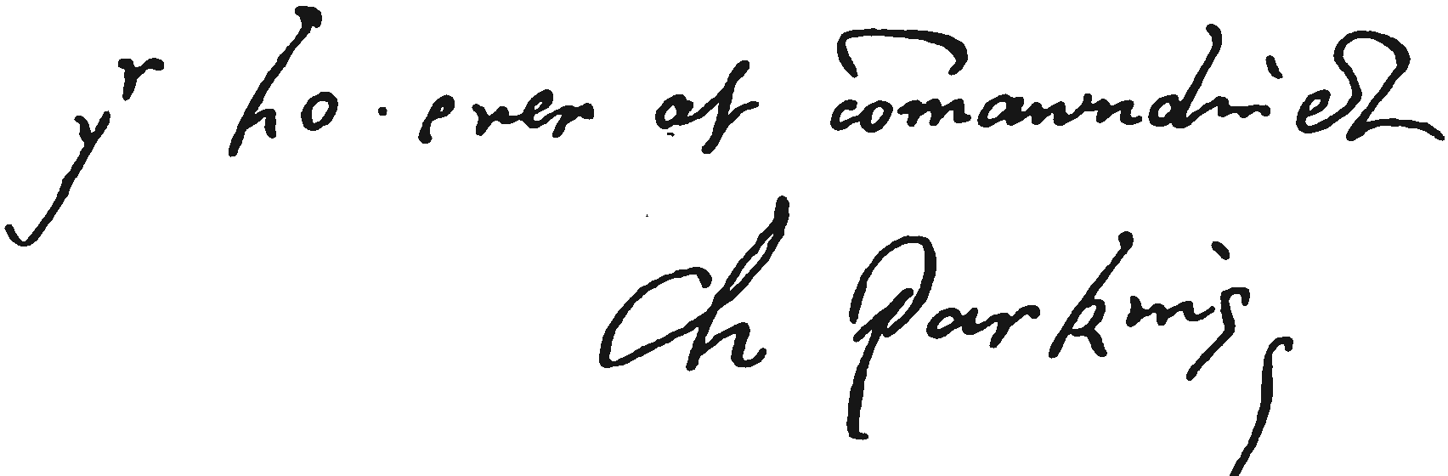

A Roll. OF THE PIONEERS OF NEW ENGLAND OF THE NAME OF PERKINS.

"The great emigration led by Winthrop included among its numbers a considerable proportion of gentry recognised as such prior to their departure from their early homes.
The remainder were men of respectable position yeomen, tradesmen, and mechanics, but most evidently not of the lowest class, for in those days colonists must have required a large sum of money to equip a vessel, or even to pay for a passage on so long a voyage, also to provide themselves with means of subsistence when arrived at their destination. A large majority of them, as witnessed by the early county records of New England, could read and write; they were capable of self government, and were prompt to devise satisfactory solutions for the problems presented by their new life."
Among these men of pluck and decision there were at least twenty bearing the name of Perkins, who settled in New England before the eighteenth century began, all of whom are believed to have been of English birth, not having been identified as belonging to any family already found in the colonies. They were probably adventurers from England ; but once arrived in the New World they made it their home, became heads of families, and no doubt performed their part in establishing the struggling colonies, which in after years were destined to become a great nation.
Their names are here arranged in chronological order ; that is, in the order in which they are mentioned in the colonial and other authentic records.
It is quite unlikely that this is the order of their arrival in New England.
Of only two among them is it known when they arrived there ; the others may have been in the colonies for
months, or even years, before making a permanent home ; for until they had done this it is hardly probable that their names would be found on record.
The names of the twenty emigrants, the places where they settled, and the first year in which their respective names appear on New England records, are as follow:

1631. John Perkins, of Ipswich, Massachusetts.
1632. William Perkins, of Topsfield, Massachusetts.
1633. William Perkins, of Roxbury, Massachusetts.
1637. Isaac Perkins, of Ipswich, Massachusetts.
1639. Abraham Perkins, of Hampton, New Hampshire.
1639· Isaac Perkins, of Hampton, New Hampshire.
165o. Edward Perkins, of New Haven, Connecticut
1662. William Perkins, of Dover, New Hampshire.
1665. Thomas Perkins, of Dover, New Hampshire.
1666. Luke Perkins, of Charlestown, Massachusetts.
1671· Jonathan Perkins, of Norwalk, Connecticut.
1674· Jacob Perkins, of Edgartown Massachusetts.
1675· Edmund Perkins, of Boston, Massachusetts.
1677. James Perkins, of Exeter, New Hampshire.
1678. Eleazer Perkins, of Hampton, New Hampshire.
1682. Daniel Perkins, of Norwich, Connecticut.
1684. Benjamin Perkins, of Newbury, Massachusetts.
1686. William Perkins, of Easthampton, Long Island,
1688. John Perkins, of New Haven, Connecticut.
1698. Joseph Perkins, of Norwich, Connecticut.

I. John Perkins, of Ipswich, Massachusetts.
He was the pioneer of the name in New England, and settled in Ipswich, in the colony of Massachusetts Bay, where he spent the remainder of his life.
Winthrop, in his Journal, mentions his arriving at Nantasket, February 5,

163o, on the ship Lyon. He says: …

"The ship Lyon, Mr. William Peirce master, arrived at Nantasket She brought Mr. Williams (a godly minister), with his wife, Mr. Throgmorton, -- Perkins, -- Ong, and others, with their wives and children, about twenty passengers, and about two hundred tons of goods. She set sail from Bristol December 1. Deputy-Governor Dudley, in a letter to Lady Bridget, Countess of Lincoln, shows what was the state of feeling at home towards the Puritans of New England at the time of the departure of the Lyon, and also records some incidents of the ship voyage, and what transpired on its arrival. He writes as follows:

"On the 5th of February arrived here Mr. Peirce with the ship Lyon, of Bristowe, with supplies of victuals from England, who had set forth from Bristowe the rest of December before. He had a stormy passage hither, and

lost one of his sailors not far from our shore, who in a tempest having helped to take in the spritsail, lost his hold as he was coming down, and fell into the sea, where, after long swimming, he was drowned, to the great dolor of those in the ship, who beheld so lamentable a spectacle without being able to minister help to him, the sea was so high, and the ship drove so fast before the wind, though her sails were taken down. By this ship we understood of the fight of three of our ship and two English men-of-war coming out of the Straits, with fourteen Dunkirkers, upon the coast of England, as they returned from us in the end of the last summer. By this ship we understood the death of many of those who went from us the last year to Old England, as likewise of the mortality there. Also, to increase the heap of our sorrows, we received advertisement by Winthrop enumerates the passengers who arrived with their wives and children in the L7tm as twenty seven,” but Dudley expressly states they numbered twenty seven." It is improbable that the names of all the twenty·six will ever be known ; but, having followed up the clues to the four

families mentioned in the text the following incomplete list has been made up and it is believed to be correct.
Mr. Roger Williams.
Mrs. Mary Williams, wife of above.
Mr. John Throgmorton:
John Perkins.
Judith Perkins, wife of above.
John, Thomas,
Elizabeth, Mary and Jacob Perkins, children of John and Judith.
Frances Onge, wife of above.
Simon, aged 6, and Jacob Onge, children of and Frances Onge. Thus accounting for fourteen out of the twenty-six.
It is unnecessary to mention any particulars concerning the Reverend Roger Williams, the founder of Rhode Island they may be easily obtained elsewhere

.

letters from our friends in England, and by the reports of those who came hither in this ship to abide with us (who were about twenty-six), that they who went discontentedly from us the last year, out of their evil affections towards us, have raised many false and scandalous reports against us, affirming us to be Brownists in religion and ill-affected to our State at home, and that these vile reports have won credit with some who formerly wished us well.
"Upon the 22nd of February we held a general day of Thanksgiving throughout the whole Colony for the safe arrival of the ship which came last with our provisions.

" The wheat we received by this last ship stands us in thirteen or fourteen shillings a strike [bushel], and the pease about eleven shillings a strike, besides the adventure, which is worth three or four shillings a strike; which is a higher price than I ever tasted bread of before.

"And everyone having warning to prepare for the ship departure tomorrow, I am now, this 28th day of March, 1630, sealing my letter."

John Perkins, according to a family tradition, partly confirmed by known facts, was born in 1590, His family at the time of his emigration consisted of his wife, Judith, and five children
John, aged sixteen
Thomas, fourteen
Elizabeth, twelve
Mary, ten
Jacob, six.

He arrived in America at a comparatively early date in its history. Only 138 years had passed since its discovery by Columbus, uS since Ponce de Leon had explored the coasts of Florida, and 107 since the Italian Verrazano entered what is now known as New York Bay.

The planting of the first permanent settlement at jamestown, in the
colony of Virginia, was effected in r6o7, and it was two years later when Hudson sailed up the river that now bears his name. It was in 1615 that the Dutch established a trading post of a storehouse and fort, and four
huts where New York City now is ; and it was five years later that the Pilgrim Fathers sailed from England in the Mayflower; and a year had not elapsed since John Winthrop and his followers began the settlement of Boston.
On the 18th of May, John Perkins took the oath of freeman, which admitted him to all the civil rights of the colony. He resided in Boston during 1631, and his youngest child, Lydia, was born there, and baptized on June 3 in the latter year. April J, 1632. "It was ordered" by the General Court, "that no person whosoever shall shoote at fowle vpon Pullen Poynte or Noddles Ueland ; but that the said places shall be reserved for John Perkins to take fowle with nets."

November 7, 1632. He and three others were appointed by the Court to set down the bounds betwixte Dorchester and Rocksbury." In 1633 he removed with his family to the new settlement then being founded by the younger Winthrop and twelve others. In 1634. t6JS1 1636, and 1639 he was granted land in Ipswich, aggregating 171 acres ; and in 1637 he sold 40 acres to Thomas Howlett.

In February, 1636, he was one of the seven men chosen to order town business for the three months following, and in the same year was Deputy to the General Court.

June 21, 1637· He and his son John signed a petition to the Governor and Council of Massachusetts, asking that John Winthrop, junior, be permitted to remain with the Ipswich colony; which document is still extant, and in the possession of the Essex Institute, Salem, Massachusetts.

In 1645 he was appraiser of the estate of Sarah Dillingham, and the inventory then taken (which is still extant) also bears his signature. In 1648, and again in 1652, he was on the Grand Jury. In March, 165o, ''being above the age of sixty, he was freed from ordinary training by the Court."

On March 28th, 1654, "being at this time sick and weake in body," he made his will, and died a few months later.

He was a typical representative man : and his inventory shows how small were the values and how limited the range of the possessions then necessary to everyday life in his station. His house and bam were valued at £4o, and his 8 acres of land about the house at£12. Other lands, comprising 52 acres,

were put down at £77. He had cows, horses, pigs, and sheep, in all 33 animals, valued at £93· His bed and furniture were put down at £4; his cash on hand at £6; his utensils, farm and kitchen, at £7; and his wearing apparel at £5· In all, there was a total of £250, or $1,250.

The children of John and Judith Perkins were:
John, born 1614; married, 1635, Elizabeth
was a yeoman, inn­keeper, and quartermaster
lived in Ipswich, Massachusetts, where he also died, December 14, 1686.
His wife died September 27, 1684. Their children were:

John, born 1636, died 1659.
Abraham, born 164o, died April 27, 1722.
Jacob, born 1646, died November 26, 1719.
Luke, born 1649, died after 1694. Isaac, born •6so, died 1726.
Nathaniel, born 1652, died after 1703.
Samuel, born 165s. died • 700. Thomas, born 16-, died after 1683. Sarah, (Mary Perkins, who married Thomas Wells, January 10, 1669,
Thomas, born 1616; married Phebe Gould in 1640;

John was a farmer, deacon, selectman, tithing-man, and committee-man; died May 7, 1686.

This It is from Isaac that both Dr. George A. Perkins and Mr. D. Walter Perkins are descended ; the line of descent of the former being :

Jacob (born November 9, 1678; died March 28, 1754).
Francis (born May 5, 1732; died June 12, 1812).
David (born September 24. 1770; died April 22, 1859).
George A. Perkins, born October 15, 1813; resides in Salem, Massachusetts.

And the line of descent of the latter :

Abraham (born September 15, 1671 ; died after August, 1750).
James (born 1705 ; died September 27, 1789. at Lyme, Connecticut).
Isaac (born June 14. 1749; died in 1776).

David Lord (born July 4, 1776; died February t5, 1852, at Utica, New York). David (born January 8, 1816; died June 20, 1877).
David Walter, born October 23, 1851; resides at Utica

Elizabeth, born 1618; married William Sargent as early as 1642; lived in Ipswich, Newbury, Hampton, and in Amesbury, Massachusetts, where she and

her husband permanently settled. She died in 17oo, at the age of eighty­ two. They had five children.
Mary, married, in June, 1636, Thomas Bradbury; settled in Salisbury, Massachusetts, where she died in 17oo, at the age of eighty. He died March 16, 1695. They had eleven children.
Jacob, married, first, Elizabeth --, about 1648; and second, after 1685, Damaris Robinson, widow; was a farmer, also sergeant of a military company ; lived in Ipswich, where he also died, January 27, 1699·17oo. His wife Elizabeth died February 12, 1685, and his wife Damaris in 1716. By his first wife he bad nine children, but none by his second.
Lydia, born in Boston in x63:z, and also baptized there June 3rd of that year; married Henry Bennet in 1651, lived in Ipswich, and died there about 1672. After her death Henry Bennet married Mary (Smith) Burr, widow; he died after October 3, 1707. She had five children, possibly one or two more.
II. Reverend William Perkins, of Topsfield, Massachusetts.
He was the son of William Perkins, merchant tailor, of London, and Katherine his wife, and grandson of George and Katherine Perkins, of Abbots Salford, in Warwickshire.
His grandfather was a yeoman of a class who were the owners of land of a stated considerable yearly value, and had various privileges.
His father's will-that of William Perkins, of the City of London, Merchant Taylor, of the parish of St. Dunstan in the West-supplies what few particulars are known concerning the family of his grandfather, George Perkins.
One of the latter's daughters married-- Fosbrooke, of Bridgenorth, in Shropshire, and the testator bequeaths to her daughter Katherine, his niece, is. Another married -- Charlett, and Beatrice Charlett, probably her daughter, is given £so by the testator, who styles her his "cousin." A third married -- Parker, and each of her two daughters, Dorothy and Alice, is given a bequest of £s.
Nothing has been learned concerning George Perkins' son Thomas or his other two daughters.

The children of George and Katherine Perkins were :
    - Elizabeth, baptized in 156-. (:z) Beatrice, baptized in 156-.
    - Joane, baptized May 14, 1571.
    - Anne, baptized February :28, 1573.
    - Thomas, baptized February 14, 1576.
    - William, baptized January 1, 1579. died 1657.
    - Francis, baptized April 23, 1583

His father, William Perkins, son of George and Katherine Perkins, of Abbots Salford, in Warwickshire, was baptized there January 1, IS79, and settled in London, where he was a merchant tailor.
This William Perkins, of London, married three wives. The first was Katherine--, whom he married May 22, r6o3; she died September 25, 1625. The second was Mary, daughter of Mr. George Purchas, of Thaxsted, in Essex, whom he married March 30, 1619; she died October 29, 1639, having been married twenty years and seven months.
His third wife was Jane, widow of -- Filmer, who then had two un­ married daughters. She survived him; and January 2o, 1671, his son William, who was then residing in Topsfield, Essex County, in the colony of Massachusetts Bay, in New England, drew three bills of exchange upon his mother, "Mrs. Jane Perkins, widow, dwelling at the Three Cocks, upon Ludgate Hill, near to the west end of St. Paul's Church, in
London." William Perkins, of London, was possessed of considerable property, and gave £so to Harvard College, in Boston. He made his will April 1S, r6s7, and died not long after, for the instrument was proved at the London Registry, November 1oth following, by the widow and his son Edward, the executors. In his will (which is recorded in volume" Ruthen," page 45O) he directs that he shall be buried in the Parish Church of All Saints, in Thread Street, "where I learnt so much of Jesus' Church, by the ministry of that his faithful servant, Master Richard Stocke."
To his wife he bequeaths £too and the furniture of his chamber in his dwelling-house; also £20 per annum out of his rents in Bell Yard, to be added to his wife's jointure of £so per annum, during the time of said lease.
If his wife deceased before the expiration of the Bell Yard lease, then her annuity of £5o per annum for two years was to go to her daughters, Elizabeth and Anne Filmer.
The widow's annuity of £5o, her jointure of £5o, and the £1o per annum from the Bell Yard rents, make altogether £14o, which would be equivalent to about £1,ooo a year, present value, so that he must have been a considerably wealthy man for his time.
To his son William he bequeaths £7o per annum out of his Bell Yard rents ; also £1oo more among his seven children, whose legacies were to be paid at their ages of fourteen and fifteen, probably one-half at each age.
To his daughter Rebecca, who had married Master Martin Cousins, he bequeaths £12 per annum out of his Bell Yard rents, also £1oo; besides £2o, to each of her five children; and to her husband he gives £33 6s. 5d.
Two of his daughters married, respectively, Mr. William Carrington and Mr., Thomas Mead, whom he appoints overseers of his will, and to each of whom
he gives.£5. To his daughter, Mrs. Mead, he wills £so; to her six children £to each;
and to her daughter Mary to more.
To his daughter, Mrs. Carrington, he bequeaths .£1oo; to each of her three children £2o; and to her daughter Mary £to more.
To his son Edward he bequeaths £to per annum out of his Bell Yard rents, and appoints him one of the executors of his will. Edward was unmarried probably, and may have been a clergyman, as he is styled "Master Edward Perkins."
He also bequeaths as follows : To Master Ashton, £1o.
"To Ellen Gomersall, widow, late wife to a minister in Thornecombe, in Devonshire, 100 marks."
The residue of his estate was to be equally divided among all his said children. The legacies were to be raised out of his lands and rents in Rathbury and Kilkiddy, in Ireland.
His children, no doubt, had received their portions before ; and, in addition to the legacies mentioned, the residue of his property, stock-in-trade, etc., was probably of considerable value. The fact of his having property in Ireland need not suggest that he was of Irish origin. In 16so Cromwell subdued Ireland ; and land there, no doubt, was to be bought very cheap, and many Englishmen became owners of Irish land.
Since his other children are not mentioned in his will it is probable that they died young and left no families.
The date of the death of his widow, Mrs. Jane Perkins, has not yet been ascertained, but it was after 167 I.
The children of William and Katherine Perkins were:
(1) Rebecca, born May 24, I6os; married Master Martin Cousins. (2) William, born August 2s, I6o7; emigrated to New England;
afterwards of Topsfield, Mass.
(3) John, born January-, 16o8; probably died young.
(4) Toby, born March -, 1609; probably died young.
(5) Sarah, born on Low Sunday, April I9, 1612.
(6) Harrington, born March 30, 1615; probably died pre 1619.
The children of William and Mary (Purchas) Perkins were:
(7) Harrington, born January 22, I6I9; probably died young.

(8) Edward, born January I8, 1622; was in London in I657·
(9) Samuel, born June I3, I624; probably died young. Elizabeth, born May IS, I629.
William Perkins sailed for New England in the William and Francis, Mr. Thomas, master, leaving London March 9, I632, and arriving at Boston June s, following.
In March, I633, with the illustrious John Winthrop, junior, and twelve others, he began the settlement of Ipswich ; was admitted freeman September 3, I634, and removed to Roxbury, where he married Elizabeth Wootton,
August 30, 1636. October 10, I638, he was one of the surveyors appointed to survey and run the southerly line of the patent. October 7, 164I, because of his father's gift of £so to Harvard College, he was granted 400 acres of land by the General Court. In I642 he removed to Weymouth, and while there was leader of the military band; was also a lieutenant in 1642, and captain in I644. in which year he represented the town in the General Court.
He was one of the Ancient and Honorable Artillery Company, and was chosen commissioner "to end small controversies in Weymouth." From 1650 to I655 he was preaching to the inhabitants of Gloucester; in I6sr he gave his testimony in regard to a lost will of Walter Tibbet, of Gloucester, upon which the Court allowed a copy to be proved.
From Gloucester he went to Topsfield; and after preaching a few years, spent the remainder of his life in the calm pursuits of husbandry.
He was probably one of the most accomplished men among the first settlers of Topsfield ; a scholar and a man of business ; a clergyman ; a soldier and a legislator; and, during the latter part of his life, a farmer.
In each of these relations, so unlike, and, according to
present notions, so incompatible, he bore himself, so far as we can learn, with ability and discretion.
He often revisited his native country; was there in February, I64o; in October, I646; in the spring of 1667; in April, I67o, and during the winter of 1673-4.
January 20, 167 I, he mortgaged to Thomas Clark, "late of Plimouth, but now of Boston, merchant," all his house and seven acres of land in Topsfield, on the northerly side of which stood a grist mill, etc., "provided always that if the just and true sum of twenty pounds in lawful money of England be well and truly played at one entire payment unto the said Thomas Clarke or his assigns in the city of London within six weeks space after the arrival of the good ship called the Blessing of Boston above said, whereof is Master William Greenough, in the river of Thames, according to the true intent and meaning of three bills of exchange

charged by the above named Wm. Perkins upon his mother, Mrs. Jane Perkins, widow, dwelling at the Three Cocks upon Ludgate Hill, near to the West End of
St. Paul's Church in London, which three bills doe beare date with these presents that then this deed is void and of none effect, and every clause therein mentioned." (This
mortgage was satisfied by Clark February 21, I676.)
He died at Topsfield May 21, 1682, leaving a widow and nine children surviving. The date of his widow's death has not yet been ascertained.
The children of Rev. William and Katherine (Wootton) Perkins were:
I. William, born October I2, I639; died December 23, 1639.
2. William, born in Roxbury, February 26, 164o-1 ; married Elizabeth,
daughter of Daniel Clarke, of Topsfield, October 24, 1669; died October 30,
1695• aged 54·
3· Elizabeth, born in Weymouth, June I8, I643; married John Ramsdell,
of Lynn, May 31, 1671.
4· Tobijah, born in Weymouth, October 20, I646; married Sarah Denison,
November 4. 168o; died in Topsfield, April 30, 1723, aged 77·
5· Katherine, born in Weymouth, October 29, 1648; married John Baker,
of Ipswich, May I31 1667.
6. Mary, born in Gloucester, February q, I65I; married Oliver Purchas,
September 17, 1672. His first wife, Sarah, had died October 21, 1671.
7 John, born in Topsfield, April 2, 1655; married Anna Hutchinson,
August 29, 1695 ; settled in Lynnfield and died there January 12, 1712, aged
57 His widow died in 1717·
8. Sarah, born in Topsfield, March 2, r656-7 ; married John, son of
Governor Simon Bradstreet, June 11, I677.
9· Timothy, born in Topsfield, August I1, 1658; married Edna Hazen, of
Rowley, August 2, 1686.
10. Rebecca, born in Topsfield, May 4, 1662; married Thomas, son of
Captain Fiske, of Wenham, November 3, 1678; and died before 1719.
William Perkins, of Roxbury, Massachusetts.
In 1633 he was sergeant of a military company. September 3, 1634, " Srieant Perkins is chosen ensigne to the company at Rocksbury, & Mr. Pinchon is desired to give him possession thereof."
March 3, r6JS·J6. "Ensigne Perkins is discharged of his office of ensigne." American writers, authorities on the early settlers of New England, do not mention the fact that there were two men of the same name residing in Roxbury at about the same time (1634-43). But there must have been; for it is highly improbable that one, a college-bred, accomplished man, and who was afterwards a minister, could have been the drinking,

dissipated man the records prove the other to have been ; and it is in support of the theory that there were two, that the following extracts from the records of the General Court are given :
October 1, 1633. "It is ordered that Srieant Perkins shall carry 40 turfes to the fort, as a punish for drunkenness by him committed"
April s, 1636. "Ordered, that Willm. Perkins shall (for drunkenness & other misdemeanors by him committed) stand at the next General Courte one hour in public view, with a white sheet of pap on his breast having a great D made vpon it, & shall attend the pleasure of the Court till he be
dismissed."
In the inventory of the estate of Joseph Weld, "late of Roxbury," taken February u, 1646, the name of "Wm. Perkins" is mentioned; while the Weymouth records prove the other William Perkins was residing there at that date.
No other facts concerning him have been ascertained.
Isaac Perkins, of Ipswich, Massachusetts.
He is believed to have been a younger brother of John Perkins, senior, of the same place, and seems to have followed the latter there within a few years after he had settled, and likewise became an inhabitant of the town. He must have settled there some time before 1637, for in that year the town granted him a parcel of land
He died within a year or two, and the town granted land to his widow, Alice. In 1639 it is recorded that :
"Alice Perkins, widow of Isaac Perkins, is possessed of a parcel of land granted to the said Isaac, lying in Brook Street."
Alice Perkins soon afterwards sold her land, but continued to reside in the town, and is referred to in the will of Joseph Morse, of Ipswich; in which document (dated April 24, 1646) the testator bequeaths to his wife "about six acres bought of
Widow Perkins," which indicates she was yet a resident, and known to her neighbours as "Widow Perkins."
The Boston family traces its descent back to an Edmund Perkins, who with his wife had settled in Boston some time before 1675. One family tradition says that he was a son of "Alice Perkins, a widow, and was brought up by John Perkins, of Ipswich"; and another associates him in his early youth with Richard Saltonstall, who was also a resident of the same place from 1635 until 1649.
While no documentary evidence has been discovered that absolutely proves Edmund to have been the son of Isaac Perkins, of Ipswich, authentic records and family traditions clearly indicate, and almost prove, that such was the fact.

Assuming this theory to be true, a tradition in the Boston family supplies the names of the children of Alice Perkins, widow; and also assuming that she was the widow of Isaac Perkins, of Ipswich, the family record is here given:
The children of Isaac and Alice Perkins were :
1. Alice, born about 163-.
2. Ralph, born about 163-.
3· Edmund, born about 1638; married, before 1675, Susannah, widow of John Howlett, and daughter of Francis and Mary Hudson. He died in 1693
Abraham Perkins, of Hampton, New Hampshire.
He was one of the first settlers of the town, and was there as early as 1638, and was admitted freeman May 13, 1640, at Boston.
He was a man of good education, an excellent penman, and much employed in town business.
Since he and Isaac Perkins (his brother?), also of Hampton, are found in the colony so soon after John Perkins had become an inhabitant of Ipswich, it is probable they were relatives and followed him to New England upon receiving a favourable report of the country. They certainly settled in a town very near to Ipswich, and, although nothing has been discovered that shows any intimacy or communication between them, the frequency of the Scriptural names Abraham, Isaac, Jacob, and Luke, in both families, warrants the conclusion that a relationship existed.
Two children of Abraham Perkins-viz., Humphrey (born 164z), and James (born 1644)-died young; but the names were again given to two other children-viz., James(born 1647), and Humphrey(born 1661)-which proves an evident intention on the part of the parents to perpetuate the names in the family. From the Visitation of Worcestershire, 1569, it appears that a member of the Madresfield branch James Perkins had a son Humphrey, who married into Shropshire, and had a son Humphrey, junior. The appearance of these identical names in the Hampton family certainly suggests some sort of a family connection or relationship with this earlier Shropshire family; but as a fact it has not yet been established The following is taken from the records of the General Court :

1661.
"In answer to the petition of Abraham Perkins, the Court judgeth it meet to grant the petitioner's request-i.e., so far as to review his case in the same Court, in case the magistrates of that country are willing thereto, as in his petition is alleged."

The phrase " of that country " evidently refers to England ; and it is possible that the papers in this case may be found among the records of one of the English Courts.

Abraham Perkins is supposed to have been born about 16u; he died in 1683. His will is dated August 22, and was proved September 18 following.
His wife was Mary--, who was born about 1618. She died May 29, 1706.

His old family Bible is still extant, and from it and the town books the family record is compiled.
The children of Abraham and Mary Perkins were :
1. Mary, baptized December 15, 1639; married Giles Fifield, June 7, 1652, and removed to Charlestown, Massachusetts.
2. Abraham, born September 2, and baptized December 1s, 1639; married Elizabeth, daughter of Thomas Sleeper, August 27, 1668; killed by the Indians June 13, 1677.
3· Humphrey, born January 22, 1642; died before 1661.
4· James, born April 11, 1644; died before 1647.
5· Timothy, born July , 1646; died young.
6. James, born October 5, 1647; married, first, Mary--, about I674; married, second, Leah, daughter of Moses Cox, December I31 I68I. He died before December 9, 173I, upon which date his will was proved. His widow, Leah, died February 19, 1749, aged eighty-eight.
7· Jonathan, born May 26 I65o; married Sarah--, December 20, 1682, at Exeter; died January 20 I689. His widow married, in 169o, Josiah Sanborn; she died at Hampton, September 1, 1748, aged eighty-five.
8. David, born April 28 (or February 2), 1653; living in 1683.
9· Abigail, born April 2, 1655; married John Foulsham, of Exeter, November 10, 1675·
10. Timothy, born June 29, 1657; died January 27, 1659·6o.
11. Sarah, born July 7 (or 26), 1659; was living in 1683.
12. Humphrey, born May 16 (or 17), 1661; married Martha Moulton; died January 7, 1712, aged fifty-one.
I3· Luke, born 166-; was living in 1683.
14. Isaac Perkins, of Hampton, New Hampshire.
He is believed to have been a brother of Abraham Perkins, of Hampton, and is supposed to have been born about 1612-13.
He settled in Hampton about 1638, and was among the first grantees when the plantation was laid out, and resided in that part of the town called Seabrook.
May I5, 1642, he took the freeman's oath at Boston.

His wife was named Susannah, but her parentage is unknown.
He died November 13, 1685; but the date of his wife's death has not been ascertained.
The children of Isaac and Susannah Perkins were :
1. Lydia, born 163-; married Eliakim Wardhall, October 17, 1659·
2. Isaac, baptized December 8, 1639; drowned September to, 1661.
3· Jacob, baptized May 24, I64o; married, December 30, 1669, Mary Philbrick.
4· Rebecca, born 164-; married John Hussie, September 21, 1659. S· Daniel, born 164-; died August 1, I662.
6. Caleb, born 164-; married Bethia Philbrick, April 24, 1677.
7· Benjamin, born February 17, I6so; died November 23, 167o.
8. Susan, born August 2 I, I 652 ; married, first, Isaac Buzwell, of Salisbury,
May 12, 1673; anq, second, William Fuller, junior, of Hampton, June 22,168o.
9· Hannah, born April 24, 1656; married James Philbrick, December 1,
1674; died May 23, 1739, aged eighty-three.
10. Mary, born July 23, 1658; married Isaac Chase, of Hampton.
n. Ebenezer, born December 9, 1659; married Mary--, about 1690. u. Joseph, born April 9, 1661; married Martha--, about 1687. Edward Perkins, of New Haven, Connecticut. He and his three sons were still living as late as r685, but very little relating to him is known.
He married Elizabeth Butcher, March 20, r6so. The children of Edward and Elizabeth Perkins were :
1. John, born August 18, r651.
2. Mehitable, born September 21, 1652.
3· Jonathan, born November u, 1653·
4· David, born October 3, 1656; and perhaps others.
VIII. William Perkins, of Dover, New Hampshire. He is said to have been born in the West of England in 1616; was in
Dover as early as 1662; took the oath of freeman, June 21, 1669; and died in New market in 1732, at the very great age of 1 16. Hardly anything is known of him or his family; but he is probably the "William Perkinson " who had a grant of land in Dover in 1694. The names of the members of his family are not known.
Thomas Perkins, of Dover, New Hampshire.
He is said to have been born in r6:z8; was in Dover in 1665; and took the oath of fidelity in r669. April25, 1693, he gave land to his son Nathaniel. Nothing more relating to him or his family is known Luke Perkins, of Charlestown, Massachusetts.

Very little is known concerning him; he was in Charlestown in 1666. His wife's name was Hannah.
The children of Luke and Hannah Perkins were :
I. Henry, baptized January 13, r667.
2 John, baptized January 13, 1667; died before June 19, 167o.
3· Luke, baptized January 13, r667; died before March 24, 1667.
4· Luke, baptized March 24, 1667.
5· Elizabeth, baptized March 21, 1669.
6. John, baptized June 19, r67o.

1· Abraham, baptized July 28, 1672.
8. Hannah, baptized December 14, 1673.
9· Mary, baptized April 9, 1676.
Jonathan Perkins,of Norwalk, Connecticut.
Nothing is known of him except that he was in Norwalk from 1671 to 1677.
Jacob Perkins, of Edgartown, Massachusetts. He appears to have been a settler there from 1674 to 1685; nothing
further has been learnt concerning him.
Edmund Perkins, of Boston, Massachusetts.
He was established at Boston as a master ship wright some time
previous to 1675, when he, Susannah, his wife and Andrew Neale petition the court "to confirm their sale of the house and land but the Court sees no cause to grant their request." His wife, Susannah, was the daughter of Francis Hudson and Mary his wife, who was born in England in 162o. She had one daughter by her first husband.
There is strong probability that he was the son of Isaac and Alice Perkins of Ipswich ; but no proof of such relationship has yet been found.
The children of Edmund and Susannah Perkins were :
1. Edmund, born May 8, 1678; died September 14, 1682, aged four years.
2. John, born October 14. 168o.
3· Edmund, born September 6, 1683; married, first, Mary Farris,
1709; and second, Esther Frothingham, March 8, 1722; died 1762
4- Jane, born February 25, 1687.
James Perkins, of Exeter, New Hampshire.
He was in Exeter as early as 1677. No other facts concerning him are known.
Eleazar Perkins, of Hampton, New Hampshire.
He was a settler in Hampton in 1678. Nothing else is known
Daniel Perkins, of Norwich, Connecticut.

According to Miss'Caulkins's "History of Norwich," the first of the family· mentioned in the town records, is Daniel Perkins, who in 1682 married Dolinda, daughter of Thomas Bliss, of Norwich. After his marriage he is lost sight of. Nothing else is known about him.
Benjamin Perkins, of Newbury, Massachusetts.
All that is known of him or his family is that he had a son Daniel, who was born in Newbury, December t8, 1684
William Perkins, of Easthampton, Long Island, New York.
He and his wife, Mary, were living at Easthampton in
1686. On November 19 of that year Governor Dongan, of New York, issued a warrant for the arrest of the minister of Easthampton, because of his
having preached "a seditious libel"; and because some of his parishioners upheld him, warrants were issued for the arrest of several of them, and
among them was William Perkins ; and the warrants directed that they " bee likewise taken into custody to answer the same, the same day."
John Perkins, of New Haven, Connecticut. a John Perkins in New Ha\·en in 1688. Possibly he was a son of Edward of that town; the latter had a son John, who was born August 18, 1651. Nothing further concerning him has been ascertained.
Joseph Perkins, of Norwich, Connecticut.
Miss Caulkins, in her "History of Norwich," says: "The death of a Mr. PnteiNs, or Joseph Perkins is recorded in 1698." His antecedents are unknown: He must not be confounded with Deacon Joseph, the son of Sergeant Jacob, and grandson of John, senior, of Ipswich, Massachusetts, who settled in Norwich in 1695, where, five years later, he married Martha Morgan. Deacon Joseph Perkins died at Norwich, September 6, 1726.
Besides the above twenty emigrants, there is still another who is found in Dover so early (1703) that he may have been there before the eighteenth century began, which would entitle him to a place in the foregoing list.
His name is Samuel Perkins, and his wife's name is Mary ; except the names of their children nothing is known concerning them. The children of Samuel and Mary Perkins were :
1. Hannah, born December 9, 1703.
2. Francis, born February II, 1705.
3· Joseph, born August 25, 1714.
4· Abigail, born April 30, 17 17.
5. Samuel, born February 13, 17 2 3·
Besides the above emigrants to New England, there were others of the name who sailed for Virginia. The names of
several such have been dis­ covered, and we herewith append them :

Edward Perkins, of Virginia. - He was the fourth son of John Perkins, gentleman, of London, who died there in 1665,
He sailed for Virginia in 1627, and seems to have died young and unmarried. Nothing has been ascertained concerning him after his arrival in Virginia.
James Perkyns. - He sailed from London, January 2, I634, in the Bonavmlure, for Virginia.
Robert Perkins. - In 1635, Robert Perkins, aged twenty-five, sailed from London for Virginia.
Martin Perkins. - In 1635, Martin Perkins, aged eighteen, sailed from London for America. These entries can be found in Botten's "Lists of Emigrants."

Further Interest
Mary was born on September 3, 1615 in Hillmorton, Warwickshire, England. Mary died December 20, 1700, in Ipswich, Essex County, Massachusetts. She married Thomas Bradbury in 1636. Thomas was the son of Wymond Bradley and Elizabeth Whitgift. The Bradbury family goes back to Louis IV of France.
Children of Mary Perkins and Thomas Bradbury:

Wymond Bradbury
Judith Bradbury
Thomas Bradbury
Mary Bradbury
Jane Bradbury
Jacob Bradbury
William Bradbury
Elizabeth Bradbury married John Busse
John Bradbury
Ann Bradbury
Jabez Bradbury.
MARY AND THE SALEM WITCH TRIALS:
On May 26, 1692, Mary [Perkins] Bradbury was named as a tormentor of Mary Walcott, Mercy Lewis, and Ann Putnam, Jr. She was arrested by Constable William Baker when she was 70 years of age. Her husband, Captain Thomas Bradbury, was disliked by Suzanna Martin for his suspected tampering with her father's will.
On August 9, 1692, Mary's accusers depositions were taken. Suzanna Martin, enemy of her husband, was already hanged on July 19, 1692.
Mary was supposedly seen signing the Devil's book. Other enemies were John Carr and his niece Anne Putnam, Jr. John Carr desired to marry Mary Bradbury's daughter. Mary did not agree to his wants, since she thought her to be too young to marry. Later on, John Carr died in 1689. Mary Walcott and Ann Putnam, Jr. told the court that Uncle John appeared to them in a sheet as a spectre and told them that Mary Bradbury had killed him. John's brother William, on the other hand, felt that John Carr had died of natural causes.
On Saturday, September 10, 1692, Mary [Perkins] Bradbury was sentenced to hang. Most of the testimony against Mary came from the Endicotts and the Carrs. The Carrs were the brothers of Mrs. Ann Putnam, Sr.
Samuel Endecott testified that butter he bought from Mary Bradbury turned rancid and full of maggots. They also said that she turned herself into a boar and charged Zerubabal, George, and Richard Carr's horses. James Carr was said to have been "behagged" when he was courting the same woman as one of Mary Bradley's sons. The flesh of the boar/swine was forbidden by Levitical law. Moses only warned about any "unclean" animals. The unclean mammals were those with cloven feet. Swines were thought to induce cutaneous disorders in hot climates. It was thought that leprosy was related to the eating of pork. Heathen nations like Palestine ate pork.
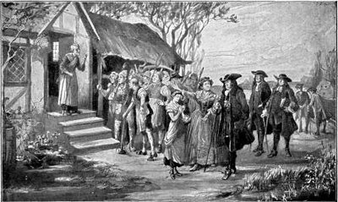
A herd of swine (Matthew 8:32) allowed the devil to enter their herd. The wild boar makes its home in the woods (Psalms 80:13), which the English felt that pagan inhabitants in nature.
After Mary's sentence a group of her supporters broke Mary Bradley out of jail. One of her accusers, Samuel Endicott, was said to have left home around the same time as she broke out of jail. He never returned. Seven years later he was still not found and was declared legally dead.
By Saturday, January 14, 1693 (four months later), Mary Bradbury was still in hiding, fearing that if she came back she would be charged for Samuel Endicotis murder.
On Friday, May 12, 1693, Mary Bradbury rejoined her family and lived another seven years, until her death in 1700. By 1693, most prisoners were set free and the "Witch Hunt" was over.
Incictment & Trial
In the notorious witch trials of 1692, Mary Bradbury was indicted for (among other charges):
"Certaine Detestable arts called Witchcraft & Sorceries Wickedly Mallitiously and felloniously hath used practiced and Exercised At and in the Township of Andivor in the County of Essex aforesaid in upon & against one Timothy Swann of Andivor In the County aforesaid Husbandman -- by which said Wicked Acts the said Timothy Swann upon the 26th day of July Aforesaid and divers other days & times both before and after was and is Tortured Afflicted Consumed Pined Wasted and Tormented..."
Witnesses testified that she assumed animal forms; her most unusual metamorphosis was said to have been that of a blue boar.
Another allegation was that she cast spells upon Shipwell
Over a hundred of her neighbors and townspeople testified on her behalf, but to no avail and she was found guilty of practicing magic and sentenced to be executed.
Through the ongoing efforts of her friends, her execution was delayed. After the witch frenzy had passed, she was released. By some accounts she was allowed to escape. Others claim she bribed her jailer.

Another account claims that her husband bribed the jailer and took her away to Maine in a horse and cart. They returned to Massachusetts after the witch hysteria had died down.
Mary Bradbury died of natural causes in her own bed in 1700.
In 1711, the governor and council of Massachusetts authorized payment of £578.12s to the claimants representing twenty-three persons condemned at Salem, and the heirs of Mary Bradbury received £20. A petition to reverse the attainder of twenty-two of the thirty-one citizens convicted and condemned as a result of the trials was passed by the Massachusetts General Court in 1711, and in 1957 The Commonwealth of Massachusetts reversed the stigma placed on all those not covered by earlier orders.

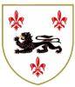
Thomas PERKINS (PARKYNS) and Ellen TOMPKINS
And

Guardians of Henry VI (r. 1422-1461, 1470-1471) until he came of age.

Thomas PERKINS (PARKYNS) Born: 1358 in Hillmorton, Warwickshire, England, United Kingdom
Ellen TOMPKINS b: 1400 in Nappend, Herefordshire, England

Thomas and Ellen married: ABT 1428 in Hillmorton, Warwick, England, United Kingdom

Thomas and Ellen had seven children

- William PERKINS b: 1430 in Warwick, England, United Kingdom
- John PARKYNS b: ABT 1445 in Madresfield, Worcestershire, England
- Thomas PARKYNS b: ABT 1441 in Madresfield, Nottinghamshire, England,
- James PARKYNS b: ABT 1442 in Madresfield, Worcestershire, England
- Richard PARKYNS b: ABT 1443 in Madresfield, Worcestershire, England
- Lawrence PARKYNS b: ABT 1443 in Madresfield, Worcestershire, England,
- Humphrey PARKYNS b: ABT 1446 in Madresfield, Worcestershire, England

William PERKINS and Joanna READ
William PERKINS was born 1430 in Warwick, England, United Kingdom
William PERKINS died AFT 1495
Joanna READ was born 1434 in Hillmorton, Warwick, England, United Kingdom

William and Joanna had four Children
- John PERKINS b: 1456 in Hillmorton, Warwick, England
- William PERKINS b: 1460 in Morton, Warwick, England
- Thomas PERKINS b: 1458 in Hillmorton, Warwick, England
- Richard PARKYNS b: ABT 1470 in Hillmorton, Warwickshire

He was the first of this ancient family to have arrived in Berkshire, where he became lord of the manor of Ufton Robert. From 1411, he is named in the diocesan registry as patron of that living and is styled variously Lord of Ufton, Donzell and True Patron. He lived at the old moated site in the parish. The family were not associated with Ufton Court, the manor house of Ufton Pole, until 1567 when it was purchased by the widow of William’s great great grandson.
William was attached to the service of Prince Humphrey, Duke of Gloucester, as bailiff or agent. It was probably in that capacity that he was concerned in an agreement by which one William Leyre confirmed the Lord Shipwell of Child’s Manor in East Barsham, Norfolk, to Humphrey, Duke of Gloucester, Eleanor his wife and William Perkins Esq. For immediately afterwards, in another deed, he released his right therein to the Duke. He sealed this deed with the arms, or, a fesse dancetty between eight billets ermines. This is the first time in which the armorial bearings of the family appear. They differ from the later shield in the number of the billets, which were afterwards increased to ten. Humphrey, Duke of Gloucester, was the brother of King Henry V, and uncle and guardian to the young Henry VI during his minority. The "good Duke Humphrey," as he was called, whose disgrace and tragic death suggested to Shakespeare the lament which he puts into the mouth of Henry: "For in the shades of death I shall find joy, in life but double death, now Gloucester's dead".
William Perkins is said in the Heralds’ Visitation pedigree to have been living in the year 1419, that is, during the French wars. On 29th May that year, soon after Rouen had capitulated to the English, a meeting took place at Menlau between the French Queen, accompanied by the Duke of Burgundy, and Henry V. It was to arrange conditions of peace, the most important of which was to be the marriage of the King with the French Princess Katherine of Valois. King Henry was, on that occasion, accompanied by his brother, the Duke of Gloucester, and from the special mention of the date in connection with William Perkins, it may have been that he also was present in attendance on his patron.
In 1426 and the two succeeding years, William’s name appears in the accounts of the Corporation of Readingas follows: "For payment at games given before the Mayor at William Perkins', 6s. 8d. For ale given at the same, 2d. To the minstrels of the Duke of Gloucester at the Mayor's breakfast at Perkins', 20d." Whether the Mayor came out to Ufton or whether William Perkins entertained him in Reading is not clear. The Mayor had to pay for his own ale and the music and the games provided for the entertainment.
William married a lady whose Christian name was Margaret and, conjointly with her in 1424, he was party to an agreement with John Colney and Elizabeth his wife. The manor and advowson of Ufton Robert and a moiety of lands in Borwardescote were settled on the same William and Margaret and, in case of William's death, then on Margaret and her heirs male, subject to the yearly payment of eight marks of silver to Elizabeth Colney. It is certain that the manor and advowson of Ufton Robert had been already, for some years past, the property of William Perkins. This deed may, therefore, perhaps be considered as of the nature of a marriage settlement on his wife. From the fact that Elizabeth Colney had a charge on the Ufton Estate, it seems probable that she was in some way a relation of William Perkins - perhaps his own or his wife's sister. John Colney was the owner of a manor in the neighbouring parish of Padworth, called Hussey's Manor, and his name appears, with that of William Perkins, in a list of gentry of the county of Berkshire, returned in 1434 by Robert Neville, Bishop of Salisbury.
In 1427 and during several succeeding years, William Perkins served as Escheator for the counties of Berkshire and Oxfordshire. The most important event, however, in which he took part - at least, as regards the history of Berkshire - was the ecclesiastical union of the two parishes of Ufton Robert and Ufton Richard (or Nervet). In 1435, an agreement to this effect was sanctioned by the Lord Bishop of Salisbury and signed respectively by William Perkins and the Prior of the Knights of St. John of Jerusalem, who with his brethren had owned the advowson of the smaller living. This they now resigned and William Perkins and his successors henceforth, for several generations, held the patronage of the united living of Ufton as it now is.
In 1444, William signed his name as a witness to a deed of grant, made by King Henry VI, to the Provost and College of Eton, of lands in New and Old Windsor and in Clewer. In 1447, he is mentioned in the Court Rolls of the Manor of Bray as still holding the office of bailiff to the Duke of Gloucester. The manors of Bray and Cookham had been granted to the Duke by his father, Henry V.
William must have died not very long after this date, it is thought in 1449. For, two years later, his son, Thomas, presented to the living of Ufton as true patron. Around the same time, his wife gave birth to a son, who they called Humphrey after his father's old patron.

Richard PARKYNS was born ABT 1470 in Hillmorton, Warwickshire, England
Richard PERKINS and Anne TWYNBORRO
Anne TWYNBORRO was born bet 1460 - 1500 in Woodmenton, Herefordshire
Anne was the daughter of Walter TWYNBORROWE and Mrs. Walter TWYNBORROWE
Richard marries Anne TWYNBORRO

Richard and Ann have at least two children

Thomas Parkyns b 1530 in Marston Jabbett married Hanna (parents of William 1558)
Richard PARKYNS b: 1541 in Mandresfield, Worcestershire, England, United Kingdom

Richard Parkyns Birth 1541 in , Worcestershire, , England
Richard Parkyns Died 3 Jul 1603 in Bunny Park, Nottinghamshire, , England
Richard Parkins Parkyns and Elizabeth Beresford
Elizabeth Beresford Birth 1550 in Fenny Bently, Derbyshire County, England
Elizabeth Beresford died 8 Apr 1608 in Bunny Park, Nottinghamshire County, England
The Roman road from Silchester to Dorchester-on-Thames once ran through Ufton Nervet and there are several sections of the sub-Roman 'Grim's Ditch' still surviving in the parish. This was built to protect Silchester from the unpredictable Saxons settling in the Thames Valley. One of these men was called Offa. He was not the famous King of Mercia, but he did give his name to the area: 'Offa's Town'.
It would be much better if this parish were called merely Ufton, for the parish church of St. Peter is not the church of Ufton Nervet at all, but that of Ufton Robert, a separate manor. Iis unclear where the name came from, presumably an early owner. His manor house stood within the moat just west of the church. The place came into the hands of the Perkins family around 1411, and it was here, a hundred years later, that Sir Humphrey Forster of Aldermaston House broke in with ten armed men, intent on murdering the owner, Richard Perkins. He was saved only by the pitiful pleading of his wife! Ufton Nervet, or Ufton Richard as the manor was also known, was at Ufton Green. It had its own church (of St. John the Baptist), the ruined walls of which can still be seen today. The place was named after Richard Neyrnut or 'Black Night, later corrupted to Nervet. He owned the manor in the 13th century and presumably had a somewhat unsavory reputation. By 1435, the church was in the hands of the Knights Hospitallers from Greenham, who agreed with William Perkins that the two parishes should combine. This was probably due a considerable decline in the local population which had been decimated by the Black Death a hundred years earlier. St. John's became a mere chapel and, by the 18th century, seems to have been converted into two cottages. these were mostly pulled down in 1883.
The beautiful Elizabethan Ufton Court was originally a minor manor, possibly split off from Ufton Robert in the late 14th century, and called Ufton Pole. Some of the present house still dates from the 15th century, including the crossway of the great hall with the original buttery and pantry doors. It was largely rebuilt by the Perkins family who moved over from Ufton Robert in 1567. The Perkins were well known Catholics who were persecuted by the local magistrates in the 16th century. They had to pay heavy fines for refusing to attend the parish church, and Ufton Court was raided at least twice by officials looking for priests in hiding. In 1586, a Sulhamstead tailor ran the family in but, although three servants were imprisoned, the expected ecclesiastic was not found. Sir Francis Knollys Junior found some of the priests' hiding places and a small fortune in gold plate in 1599 but, again, the men had gone. The priests' holes and the secret chapel up in the rafters of the court still remains today, as well as traces of an escape tunnel leading into the woods. In the 18th century, long after the persecutions had stopped, Bonnie Prince Charlie is said to have visited the Perkins' on one of his forays back into the country incognito. Many Perkins memorials decorate the church they tried so hard to stay away from. They have been badly damaged, perhaps by the Parliamentary soldiers who are known to have moved through the region around the of the two Battles of Newbury. The Perkins family are perhaps best known for instigating the Ufton Bread Dole which is distributed every year from a certain window at the Court. Lady Elizabeth Marvyn, widow of Richard Perkins, left the money for the dole in her will (1581) in thanks for finding her way home after getting lost in some woods. A later Lady of the Manor was Arabella Fermor who married Francis Perkins in the early 18th century. She was the original Belinda of Pope's 'Rape of the Lock'. This had been written after Lord Petre had forcibly cut a lock from the lady's hair: an incident which led to much animosity between the two families. The Perkins finally sold up in 1802. It was left in a somewhat run-down state until restored by Miss Mary Sharpe, a tenant in Victorian times who also wrote the house's history. The house is currently owned by the Benyons of Englefield House, but is leased to West Berkshire District Council.
Ufton Court is an Elizabethan manor house at Ufton Nervet in the English county of Berkshire. Today is it used by an educational charity, The Ufton Court Educational Trust. Other than historical education, the site hosts creative projects too including theatre and music courses.
Parts of the house date from the 15th century. In 1567 it was modified by Richard Perkins and his family who were Catholic. The house is notable for its priest holes where Recusant Catholics could hide priests and vestments and could hear mass in the house.
The history of Ufton Court can be tracked back to the Domesday Book, where it is referred to as 'Offetone', with land for five ploughs, forty acres of meadow and wood for one hog. The house was originally a small medieval manor called Ufton Pole and was one of the minor manors belonging to Lord Lovell. Parts of this building remain, including the great hall crossway with the original pantry and buttery doors. Lovell was made a Viscount by Edward IV and then was in Richard III’s inner circle. A well-known doggerel of the time refers to Lovell in less than complimentary terms;
The cat, the rat and Lovell the dog, Rule all England under the hog.
The writer of this, Collingwood, was hanged, drawn and quartered for his efforts. Lovell fell from grace after the battle of Bosworth and the death of Richard III. Lovell was accused of high treason by Henry VII and Ufton Pole was confiscated by the crown. Twenty three years later Henry VIII gave Ufton Pole to Sir Richard Weston, one of his pages.
In 1568 Pole Manor was bought by Lady Marvyn, the widow of Richard Perkins of Ufton Robert Manor at Ufton Green. She enlarged the house significantly, completing it in 1576, and moved her family from Ufton Robert to Ufton Court, as it then became known. Some of the decorative beams in the house today are thought to have come from Ufton Robert. Lady Marvyn began a tradition that is continued to the present day. In thanks to the villagers who rescued her when she got lost in the extensive local woods, she left money in her will for an annual dole to be handed out to the villagers every Maundy Thursday. It is said there is a curse on the landlord who breaks the tradition, whether this is true or not, no landlord has risked it and Sir William Benyon, the current landlord, can be found on Maundy Thursday handing out bread and sheets to the parishioners of Ufton Nervet. Lady Marvyn left the house to her nephew, Francis Perkins, it then remained in the Perkins family until 1769.
The Perkins were persecuted in the 16th century for being Catholics. They were obliged to pay fines for non-attendance at church, and, at least twice, Ufton Court was raided by local magistrates looking for hidden priests. In 1599, Sir Francis Knollys discovered both priest holes and much gold plate there, but the priests were not in residence. There is still a secret chapel in the roof of the court and traces of a tunnel for escape into the surrounding woods. In the 18th century, Bonnie Prince Charlie is supposed to have visited the family there.
In 1715, Francis Perkins married Arabella Fermor, the daughter of Henry Fermor of Tusmore in Oxfordshire and a well-known society figure. Painters and poets celebrated her charms and her beauty. In the early 18th century, she was the belle of London society. Despite the world's admiration she enjoyed at the time, it is unlikely that she would have been remembered had she not inspired Alexander Pope in his most successful work, 'The Rape of the Lock'. The poem was inspired by a London scandal when Lord Petre, a young man of twenty, cut off and stole a lock of her hair without her knowledge. Arabella was extremely angry and a fierce quarrel broke out between the families. John Caryll, Pope's friend, suggested Pope write some amusing lines concerning the event in order to settle this ill-feeling.
The poem he produced was ideal, but not being personally acquainted with the lady, Pope published his work again without permission asking her leave. He appended a motto which implied she had asked for its composition. Pope therefore only made them worse and found himself obliged to publish again. He replaced the motto with a dedicatory letter assuring Arabella that subject matter was "as fabulous as the vision at the beginning, except the loss of your hair, which I always mention with reverence; . . . the character of Belinda as it is now managed resembles you in nothing but beauty....It will be vain to deny that I have some regard for this piece since I dedicate it to you....If it had as many graces as there are in your Person or in your Mind; yet I could never hope it should pass through the world half so uncensored as you have done." Miss Fermor was apparently pacified and, the two may even become friends.
Though it is unlikely they were aware of the fact, Francis Perkins and Arabella were 9th cousins. Pope wrote her an affectionate letter on the occasion of their marriage: "It may be expected, perhaps, that one who has the title of poet should say something more polite on this occasion, but I am, really, more a well-wisher to your felicity than a celebrator of your beauty. Besides, you are now a married woman, & in a way to be a great many better things than a fine lady, such as an excellent wife, a faithful friend, a tender parent, & at last, as the consequence of them all, a saint in heaven."
It is traditionally said that Ufton Court was enlarged and refashioned for Arabella. Half of the facade, prior to the 1838 alterations, was certainly of the style popular when they married. Some of the interior was modernized at this time too. The dining room and the hall, retained their Elizabethan ceilings, but were entirely repaneled. Arabella and Francis had six children who all died childless and the house fell into neglect and virtual abandonment.
It was advertised for sale in 1837 as ‘unfit for a gentleman's residence.’ It was finally bought by Mr. Benyon de Beauvoir of the neighbouring estate of Englefield, who repaired the house and turned it into tenements for his labourers.
Various tenants lived in the house over the next 100 years. The most notable were Mary Sharp, whose detailed history of the house provides us with much valuable information, and Mr. and Mrs. Harry Benyon. During this time the house was restored into a gentleman's residence again and there are pictures of the gardens resplendent with herbaceous borders and roses.

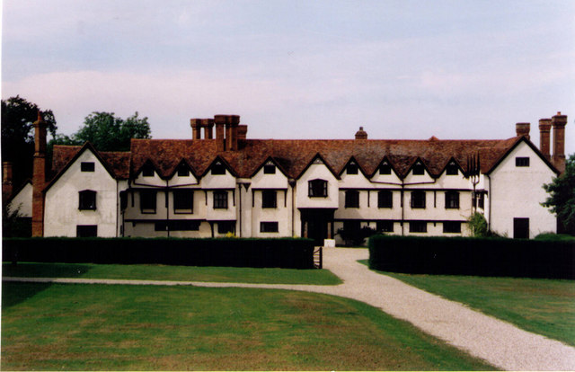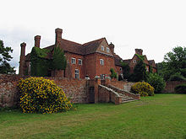

The Perkins were devout at this time, demonstrated by the below individual who was son of Thomas (brother to Richard previous individual) and Hanna Perkins,
For interest only William Perkins

William Perkins (1558 – 1602) was a clergyman and Cambridge theologian who was one of the foremost leaders of the Puritan movement in the Church of England.
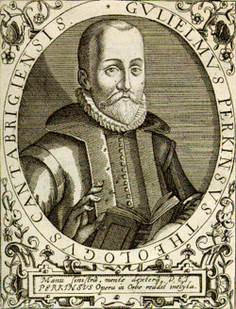
Perkins was born to Thomas and Anna Perkins at Marston Jabbett in the parish Bulkington, Warwickshire, England in 1558, the year in which the Protestant Elizabeth I succeeded her Catholic sister Mary as Queen of England. Perkins lived his entire life under Elizabeth I, dying one year before the Virgin Queen's own death in 1603. Perkins' relationship with Elizabeth was ambiguous: on the one hand, she was Good Queen Bess, the monarch under whom England finally and firmly became a Protestant nation; on the other hand, Perkins and the other members of the Puritan movement were frustrated that the Elizabethan settlement had not gone far enough and pushed for further Reformation.
Little is known of Perkins' childhood. His family was of some means, since in June 1577, at age 19, Perkins was enrolled as a pensioner of Christ's College, Cambridge. He would receive his BA in 1581 and his MA in 1584. Perkins' early adulthood is often portrayed as being one of rampant immorality, although it is unclear how much of this portrait is influenced by the later slander of his enemies, on the one hand, and the general Puritan tendency to exaggerate their youthful depravity in order to make their subsequent conversion more dramatic, on the other hand. At any rate, there is the possibility that Perkins fathered a child out of wedlock during this period, and also some suggestions that he dabbled in astrology at this time.
William showed promise with his academic abilities, but while at Christ’s College, Cambridge, he showed a talent for drunkenness that was quite notorious.
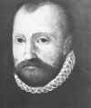
A former drunk who also dabbled in the occult, became by God’s grace, the most influential Puritan Theologian and Pastor in England. His work at Cambridge and at St. Andrews church influenced two generations of Puritans and his legacy set the tone for Puritanism in America from the Pilgrims at Plymouth to Jonathon Edwards and the Great Awakening.
According to an unverifiable story, Perkins was convicted of the error of his ways after he heard a Cambridge mother say to her child, "Hold your tongue, or I will give you to drunken Perkins yonder." Whether or not the story is true, it is clear that Perkins had a religious awakening sometime between 1581 and 1584.
Perkins thus began a lifelong association with the "moderate-puritan" wing of the Church of England, which, according to historian Peter Lake, held views similar to those of the continental Calvinist theologians Theodore Beza, Girolamo Zanchi, and Zacharias Ursinus. Perkins' circle at Cambridge included Laurence Chaderton and Richard Greenham.
Following his ordination, Perkins preached his first sermons to the prisoners of the Cambridge jail. On one celebrated occasion, Perkins encountered a young man who was going to be executed for his crimes and who feared he was shortly going to be in hell: Perkins convinced the man that, through Christ, God could forgive his sins, and the formerly distraught youth faced his execution with manly composure as a result.
In 1584, after receiving his MA, Perkins was elected as a fellow of Christ's College, a post which he would hold until 1594. In 1585, he became rector of St. Andrew's Church in Cambridge, a post he would hold until his death.
As a "moderate Puritan", Perkins was firmly opposed to non-conformists and other separatists who refused to conform to the Church of England. On the other hand, he also opposed the Elizabethan regime's program of imposing uniformity on the church. For example, when Archbishop of Canterbury John Whitgift imprisoned Francis Johnson for Johnson's support of a presbyterian form of church polity, Perkins loudly defended Johnson.
On January 13, 1587, Perkins preached a sermon denouncing the practice of kneeling to receive Communion, and was ultimately called before the Vice-Chancellor as a result.
During the final set of trials against Puritan ministers in 1590-91, Perkins confirmed that he had discussed the Book of Discipline with Puritan ministers, but claimed that he could not remember whom he had talked to.
Perkins married Timothye Cradocke of Grantchester on 2 July 1595. (He had previously resigned his fellowship at Christ's College, since only unmarried men could be fellows.) Eventually, the couple would have seven children, three stillborn.
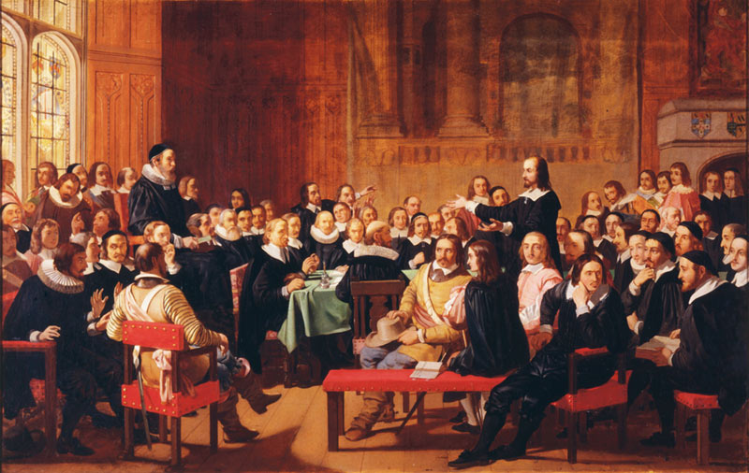Perkins was a proponent of "double predestination" and was a major player in introducing the thought of Theodore Beza to England. He was responsible for the publication in English of Beza's famous chart about double predestination.
Perkins first gained international renown as a polemicist with the publication of A Reformed Catholike in 1597, in which he argued that Protestants were the real catholic Christians.
Perkins' views on double predestination made him a major target of Jacobus Arminius, the Dutch Reformed clergyman who opposed the doctrine of predestination.
In his lifetime, Perkins attained enormous popularity, with sales of his works eventually surpassing even Calvin's. His works were translated into Dutch, German, and Latin, and to a lesser extent into French, Czech, and Welsh.
From his position at Cambridge, Perkins was able to influence a whole generation of English churchmen. His pupils include:
- William Ames, Puritan who eventually left England to become professor of theology at Franeker
- John Robinson, the founder of congregationalism in Leiden and pastor of the group which went on to found the Plymouth Colony
- Thomas Goodwin
- Paul Baynes
- Samuel Ward, master of Sidney Sussex College, Cambridge
- Phineas Fletcher, a poet
- Thomas Draxe
- Thomas Taylor
- James Ussher, Archbishop of Armagh
- James Montagu, master of Sidney Sussex and later bishop of Winchester
In 1602, Perkins suffered from the stone. After several weeks of suffering, he died on October 22, 1602, at age 44. (Perkins died of kidney stone complications in 1602, one year before Queen Elizabeth’s death; he lived his whole life during her reign )

James Montagu preached his funeral sermon, taking as his text Joshua 1.2, ‘Moses my servant is dead’. He was buried in St. Andrew's, the church which he had pastored for eighteen years.

Impact:
Though Perkins taught God’s sovereign election and reprobation, he was a passionate soul winner amongst the prisoners in the jail (who were often mere moments away from the hangman’s noose) as well as with the cultured and refined scholars of Cambridge. Calvinism was no cold, formal formula for Perkins; it led to a burning compassion for the downtrodden and lost.
His writings totaled over 2500 pages and enjoyed 8 printings by 1635, with translations into half a dozen languages including Latin, French, Dutch and Spanish. His writings focused on the Apostle’ Creed, Lord’s Prayer, Galatians, the Sermon on the Mount and Hebrews 11. In his lifetime the sales of his books in England exceeded those of Calvin, Beza, and Bullinger combined.
He was such a gifted preacher that even though his church consisted of scholars, students, townsfolk and people from the surrounding countryside, his sermons were understandable and satisfying to all. He aimed to join strong doctrinal preaching with practical godly living so that “his preaching was a comment on the text and his practice was a comment on his preaching.”
A “moderate Puritan’, Perkins worked to purify the Church of England from within rather than separating from the Church.
Not just a scholar, preacher and evangelist, Perkins was much sought after for his skills in counseling.
Perkins was responsible for introducing the theology of Theodore Beza into England and taught Beza’s Double Predestination.
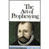
Perkins’ students included: William Ames, author of The Marrow of Theology, the theology book most often used in America in the 17th and early 18th centuries; John Robinson, who would go on to separate from the Church of England, move to Leiden, and then to the new world as the pastor on the Mayflower; Thomas Goodwin; James Ussher- famous for his Chronology of the World; Richard Sibbes and John Cotton.
“Nearly one hundred Cambridge men who grew up in Perkins’ shadow led early migrations to New England, including William Brewster of Plymouth, Thomas Hooker of Connecticut, John Winthrop of Massachusetts Bay, and Roger Williams of Rhode Island. Richard Mather was converted while reading Perkins and Jonathon Edwards was fond of reading Perkins more than a century later. Samuel Morison remarked that ‘your typical Plymouth Colony library comprised a large and a small Bible, Ainsworth’s translation of the Psalms, and the works of William Perkins, a favorite theologia

Tmeline
1577 Perkins entered Christ’s College, Cambridge. He was a student of Mathematics but also dabbled in the occult and black magic
1581 received his BA and his MA in 1584. At some point in those years Perkins heard a mother of a small child refer to him as a drunk; this convicted him and was instrumental in his coming to Christ.
After his conversion he was mentored by Laurence Chaderton. They met with a few others and studied Calvinist theology and became Puritans.
Soon after his conversion he started preaching in the Cambridge jail. One account has Perkins leading a convict to Christ on the scaffold where he was executed immediately after trusting in Christ. Crowds began gathering at the jail to hear Perkins preach grace to those undergoing the disciplines of the law.
1584 he became a faculty member of Christ’s College, where he was a teaching fellow until 1595, and started preaching at St. Andrews Church, Cambridge, where he preached until his death in 1602 at the age of only 44 years. In those 18 years he influenced two generations of Puritan students who went on to pastor, teach, and write.
1590-91 Perkins was the Dean of Christ’s College and he catechized students on Thursdays and counseled on Sunday afternoons.
1595 Perkins marries a young widow, Timothye Cradocke. They would have seven children though three died in infancy.

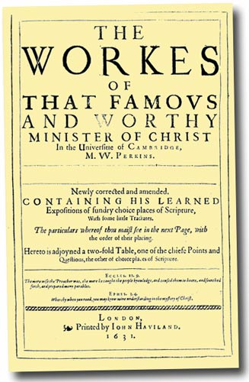
Publications by William
- Libellus de Memoria, Verissimaque Bene Recordandi Scientia (1584)
- Antidicsonus Cuiusdam Cantabrigiensis (1584)
- Foure Great Lyers, Striuing Who Shall Win the Siluer Whetstone: Also, A Resolution to the Count (1585)
- A Treatise Tending Vnto a Declaration Whether a Man be in the Estate of Damnation or in the Estate of Grace: And If he be in the First, How he may in Time Come out of it: if in the second, how he maie discerne it, and perseuere in the same to the end. The points that are handled are set downe in the page following (1590)
- Armilla aurea, id est, Miranda series causarum et salutis & damnationis iuxta verbum Dei: Eius synopsin continet annexa tabula (1590)
- A golden chaine, or the description of theologie: containing the order of the causes of saluation and damnation, according to Gods woord. A view of the order wherof, is to be seene in the table annexed (1591)
- The foundation of Christian religion : gathered into sixe principles. And it is to bee learned of ignorant people, that they may be fit to hear sermons with profit, and to receiue the Lords Supper with comfort (1591)
- Prophetica, sive, De sacra et vnica ratione concionandi tractatus (1592)
- A case of conscience : the greatest that euer was; how a man may know whether he be the child of God or no. Resolued by the word of God. Whereunto is added a briefe discourse, taken out of Hier. Zanchius (1592)
- An exposition of the Lords prayer : in the way of catechising seruing for ignorant people (1592)
- Two treatises·: I. Of the nature and practice of repentance. II. Of the combat of the flesh and spirit (1593)
- An exposition of the Lords prayer : in the way of catechisme (1593)
- A direction for the government of the tongue according to Gods word (1593)
- An exposition of the Symbole or Creed of the Apostles : according to the tenour of the Scriptures, and the consent of orthodoxe Fathers of the Church (1595)
- A salve for a sicke man, or, A treatise containing the nature, differences, and kindes of death : as also the right manner of dying well. And it may serue for spirituall instruction to 1. Mariners when they goe to sea. 2. Souldiers when they goe to battell. 3. Women when they trauell of child (1595)
- A declaration of the true manner of knowing Christ crucified (1596)
- A reformed Catholike, or, A declaration shewing how neere we may come to the present Church of Rome in sundrie points of religion, and wherein we must for euer depart from them : with an advertisement to all fauourers of the Romane religion, shewing that the said religion is against the Catholike principles and grounds of the catechisme (1597)
- De praedestinationis modo et ordine : et de amplitudine gratiae diuinae Christiana & perspicua disceptatio (1598)
- Specimen digesti, sive Harmoniæ bibliorum Veteris et Novi Testamneti (1598)
- A warning against the idolatrie of the last times : And an instruction touching religious, or diuine worship (1601)
- The true gaine : more in worth then all the goods in the world (1601)
- How to liue, and that well: in all estates and times, specially when helps and comforts faile (1601)

Posthumously:
- The works of that famous and worthie minister of Christ, in the Universitie of Cambridge, M.W. Perkins : gathered into one volume, and newly corrected according to his owne copies. With distinct chapters, and contents of euery book, and a generall table of the whole (1603)
- The reformation of couetousnesse: Written vpon the 6. chapter of Mathew, from the 19. verse to the ende of the said chapter (1603)
- A commentarie or exposition, vpon the fiue first chapters of the Epistle to the Galatians: penned by the godly, learned, and iudiciall diuine(1604)
- Lectures vpon the three first chapters of the Reuelation: preached in Cambridge anno Dom. 1595 (1604)
- Gvilielmi Perkinsi Problema de Romanæ fidei ementito Catholicismo. : Estq´; Antidotum contra Thesaurum Catholicum Iodoci Coccij. Et [propaidoia] iuventutis in lectione omnium patrum (1604)
- The first part of The cases of conscience : Wherein specially, three maine questions concerning man, simply considered in himselfe, are propounded and resolued, according to the word of God (1604)
- Satans sophistrie ansuuered by our Sauiour Christ: and in diuers sermons further manifested (1604)
- Hepieíkeia: or, a treatise of Christian equitie and moderation (1604)
- M. Perkins, his Exhortation to repentance, out of Zephaniah: preached in 2. sermons in Sturbridge Faire. Together with two treatises of the duties and dignity of the ministry: delivered publiquely in the Vniuersitie of Cambridge. With a preface prefixed touching the publishing of all such workes of his as are to be expected: with a catalogue of all the particulars [sic] of them, diligently perused and published, by a preacher of the word (1605)
- Works newly corrected according to his own copies (1605)
- Of the calling of the ministries two treatises, describing the duties and dignities of that calling (1605)
- The combat between Christ and the duel displayed, or A commentary upon the temptations of Christ (1606)
- A godly and learned exposition vpon the whole epistle of Ivde... (1606)
- A Christian and [plain]e treatise of the manner and order of predestination : and of the largeness of Gods grace (1606)
- The arte of prophesying, or, A treatise concerning the sacred and only true manner and method of preaching (1607)
- A cloud of faithful witnesses, leading to the heavenly Canaan, or, A commentary vpon the 11 chapter to the Hebrews (1607)
- A treatise of mans imaginations : Sewing his natural evil thoughts: His want of good thoughts: The way to reformed them (1607)
- A discourse of the damned art of witchcraft: so farre forth as it is revealed in the Scriptures and manifest by true experience ... (1608)
- The whole treatise of the cases of conscience : distinguished into three books (1608)
- Christian economy: or, A short survey of the right manner of erecting and ordering a family : according to the scriptures (1609)
- A grain of muster-seed: or, the least measure of grace that is or can be effectual to salvation (1611)
- A resolution to the countryman proving it utterly unlawful to buy or use our yearly prognostications (1618)
- Deaths knell: or, The sick mans passing-bell : summoning all sick consciences to pr[e]pare themselves for the coming of the great day of doom, lest mercies gate be shut against them: fit for all those that desire to arrive at the heavenly Jerusalem. Whereunto are added prayers fit for householders. The ninth edition. (1628)
- The works of William Perkins, ed. Ian Breward (1970)

Aden Perkins Birth 22 Jul 1582 in Bunny Park, Nottinghamshire, , England
Aden Perkins Death 1633 in , Nottinghamshire, , England
Aden PERKINS and Mary Unknown

Mary was born 1582 in , Nottinghamshire, , England
Mary died 1633 in Placé, Mayenne, Pays de la Loire, France
Marriage to Mary in 1613 at, Nottinghamshire, England
Aden and Mary had six children

Mary Perkins 1612 – 1662
Nicholas Perkins 1614 – 1664
William Perkins 1625 –
George Perkins 1631 –
Thomas Perkins 1633 –
Elizabeth Perkins 1643 – 1693
Aden lived for a while as a young man in Virginia USA, he appears as a member of the ‘Virginia Colony in 1607 it is believed that he returned to England with the sickly Lord De la War, in March, 1611
Prior to the year 1607, a period of one hundred and fifteen years from the discovery of San Salvador by Columbus, several attempts were made to effect settlements in various parts of North America, including Roanoke; but none had proved successful. In the Month of May of 1607, a colony from England, consisting of one hundred and five persons, arrived in Virginia; and on a beautiful peninsula in James river, began a settlement, which they called Jamestown. This was the first permanent settlement effected by Europeans in the United States.
This place was called Jamestown, in honor of James I of England, who, in 1606, claiming the country lying between the 34th and 45th degrees of north latitude—from the mouth of Cape Fear river, one hundred and fifty miles northeast from Charleston, South Carolina, to Halifax, the capital of Nova Scotia—that was divided it into two nearly equal parts, and granted it to two companies, called the London and Plymouth Companies. The southern part, called South Virginia, he conveyed to the London Company; and the northern part, called North Virginia, to the Plymouth Company.
The first settlement of Virginia was commenced under the auspices of the London Company. The expedition was commanded by Captain Christopher Newport; but the government of the colony was framed in England, before it even sailed. It was to consist of a council of seven persons, with a president, to be elected by the council from their number. Who composed it was unknown at the time the expedition sailed, their names being carefully concealed in a box, which was to be opened after their arrival.
The original intention of the colony was to form a settlement at Roanoke; but, being driven by a violent storm north of that place, they discovered the entrance of Chesapeake Bay (Maryland), the capes of which they named Charles and Henry. Entering this, they at length reached a convenient spot upon which to commence a settlement. The code of laws, hitherto cautiously concealed, was now promulgated; and, at the same time, the council appointed by the company in England was made known. It consisted of Bartholomew Gosnold, John Smith, Edward Wingfield, Christopher Newport, John Radcliffe, John Martin, and George Kendall. Mr. Wingfield was chosen president.
Among the most enterprising and useful members of this colony, and one of its magistrates, was Captain John Smith, whose devotion to the interests of the colony was as signal and unremitting, as his life had been replete with danger arid suffering. But for his spirit of patriotism and self-denial, it is certain that its existence would have been short lived. Before the arrival of the colony, his colleagues in office, becoming jealous of his influence, arrested him on the absurd charge that he designed to murder the council, usurp the government, and make himself king of Virginia. He was, therefore, rigorously confined during the remainder of the voyage.
On their arrival in the country, he was liberated, but could not obtain a trial, although, in the tone of conscious integrity, he repeatedly demanded it. The infant colony was soon involved in perplexity and danger. Notwithstanding Smith had been calumniated, and his honor deeply wounded, his was not the spirit to remain idle when his services were needed. Nobly disdaining revenge, he offered his assistance, and, by his talents, experience, and undeniable zeal, furnished important aid to the infant colony. Continuing to assert his innocence, and to demand a trial, the time at length arrived when his enemies could postpone it no longer. After a fair hearing of the case, he was honorably acquitted of the charges alleged against him, and soon after took his seat in the council.
The colony, thus commenced, soon experienced a variety of calamities, incidental, perhaps, to infant settlements, but not the less painful and discouraging. Inefficiency and a want of harmony marked the proceedings of the council. Provisions were scarce, and of a poor quality. The neighboring tribes of Indians became jealous and hostile; and, more than all, sickness spread among them, and carried a large proportion of their number to an early grave, among whom was Captain Gosnold, the projector of the enterprise.
The condition of the colony, however, was, at length, somewhat improved, by the arrival of Captain Newport (who had been dispatched to England), with a supply of provisions, and an additional number of men. Captain Nelson, who had sailed with Newport, also soon after arrived, with additional emigrants and provisions. With these accessions, the colonists now amounted to two hundred men. This number was still further increased, before the end of 1608, by the arrival of seventy colonists, among whom were many persons of distinction.
Early in the year 1609, the London Company, not having realized their anticipated profit from their new establishment in America, obtained from the king a new charter, with more ample privileges. Under this charter, Thomas West, otherwise called Lord De la War, was appointed governor for life. The company under their new act of incorporation, was styled as "The Treasurer and Company of Adventurers and Planters for the First Colony in Virginia." They were now granted in absolute property what had formerly been conveyed only in trust—a territory extending from Point Comfort two hundred miles north and south, along the coast, and throughout the land from sea to sea.
Lord De la War, being appointed governor of the colony, but not being able to leave England, immediately dispatched to America nine ship and five hundred men, under command of Sir Thomas Gates, his lieutenant, and Sir George Somers, his admiral. Eight of these ship arrived in safety at Jamestown, in the month of August; but that on board of which was Sir Thomas and other officers, being wrecked on the Bermuda’s, did not arrive till May of the following year; and then in two small vessels, which meanwhile they had built.
At the time Sir Thomas and the other officers arrived, the colony had become reduced to circumstances of great depression. Captain Smith, in consequence of a severe accidental wound, had some time before returned to England; and his departure was the signal for insubordination and idleness. Moreover, the Indians refused the usual supplies of provisions; in consequence of which, famine ensued, during which the skins of the horses were devoured, the bodies of the Indians whom they had killed, and even the remains of deceased friends. Of five hundred persons, sixty only remained. At this juncture, the ship wrecked persons from Bermuda arrived. An immediate return to England was proposed; and, with that intent, they embarked. But just as they were leaving the mouth of the river, Lord De la War appeared, with supplies of men and provisions, and they were persuaded to return. By means of his judicious management, the condition of the colony soon wore a better aspect, and for several years continued to prosper.
It was unfortunate, however, that ill health obliged Lord De la War, in March, 1611, to leave the administration. He was succeeded by Sir Thomas Dale, who arrived in May. Until then, no right of property in land had been established, but the produce of labor was deposited in public stores, and shared in common. To remedy the indolence and indifference growing out of such a system, Sir Thomas assigned to each inhabitant a lot of three acres as his own, and a certain portion of time to cultivate it. The advantages of this measure were soon so apparent, that another assignment, of fifty acres, was made, and, not long after, the plan of working in a common field was abandoned.

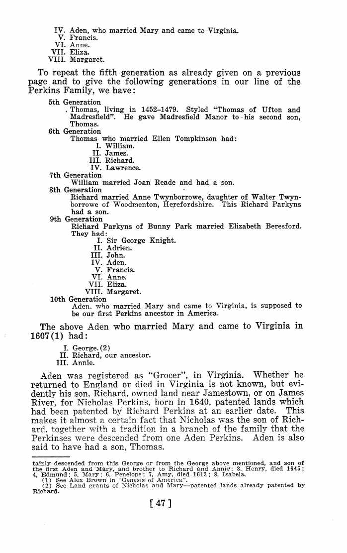
William Perkins (Parkyns) and (1) Mary Ault
(2) Mary Parker
William Perkins Birth 1625 in , Leicestershire, England
William Perkins Died 1677 in America
Mary Ault Birth 1629 in Leicestershire County, England, United Kingdom
Mary Ault died 1652
Marriage to Mary 1652

William had several children all of who thrived several became notable figures of the time including William b (Sir) 1649 died 1996 (Beheaded) a full transcript of his train is included in the pages following Thomas Perkins .
Mary Parker Birth and Death unknown but she was born in England and died in America and so I have assumed that after Ault died in their first year of marriage William and the 2nd Mary sailed to America possibly with his brother Edward shown below on the ‘Hector’
Edward was the brother of William (1625) and Thomas (1633)
Edward Perkins was the son of William and Mary Purchas (or Purchase) Perkins and was born in Essex County, England, on January 18, 1622 (1623 N. S.). Subsequently, other family researchers have placed his birth at All Hallows Parish, Bread Street, in the City of London, i.e., near to the probable location of his father’s place of business. This is, perhaps, more consistent with his subsequent settlement in New Haven because it is known that many of the original settlers had lived in or near London and many had been merchants in the city. Nevertheless, the origin of Edward Perkins remains a vexing issue. Digressing briefly, it seems safe to presume that Edward was a religious dissenter, i.e., a Puritan. Indeed, this is consistent with his origin in London or its close environs since this area was the stronghold of Parliamentarian sentiment during the English Civil War, which ranged from 1642 to 1651. Within this context, the New Haven Colony was settled by strict Puritans led by their minister, Rev. John Davenport, and a wealthy London merchant,
New Haven Settlement
Between 1638 and 1662, the New Haven Colony was an independent entity, separate and legally apart from the Connecticut Colony. Following a common pattern, New Haven was simply taken from the Quinnipiac Indians for token value by John Davenport and The Ophilus Eaton and their followers. "New Haven" was both a name connoting an English port and, more importantly, a literal signifier of what the Puritan founders hoped the American port colony would be: a purer Bible commonwealth than even the Massachusetts Bay Colony, from which the New Haven settlers had migrated.
In its one generation of independent existence, the colony at first lived up to its commitment to religious zealotry. The Puritans adopted a "plantation covenant" so pure that it bound every inhabitant to governance by literal Mosaic law. Reality intruded in short order, of course, and within a few years a civil government was reluctantly established, subject still to church dictates. Both the strength of the colony and its significance resides in the fact of its immaculate religious commitment, perhaps the most extreme of all the independent Puritan entities in the seventeenth-century New World colonies.
Its 1639 constitution mentions neither the king nor English a common law; it forbade, for example, trial by jury. "Seven pillars" of religious strength (men) were elected to head both the church and the state in the colony. The term "theocracy" probably applied nowhere more aptly in the New World than in New Haven. Only church members could vote, and the community remained true to the vision of the Reverend John Davenport, its primary founder. (Old Testament blue laws in New Haven remain justly famous, with most on local books until well into the twentieth century.) Outsiders were turned away at the colony's borders, Quakers violently. These borders originally included what is now the city of New Haven and its hinterland, the towns of North Haven, Wallingford, and Hamden; over time the colony added the towns of Guilford, Milford, and even briefly Southold, Long Island. With hostile Dutch nearby in New Amsterdam, and assorted Baptists and omnipresent Quakers seeking entry, the colony was always a tense place, driven by its sense of religious mission to both hold its ground and expand where possible.
When the monarchy was restored in England in 1660, the influential John Winthrop left Connecticut for London to secure a charter. He did that in 1662, bringing home a charter that included title to New Haven. Sporadic rebellion ensued for a year or so, but with so many enemies waiting nearby (labeled "royalists, Romans, and Stuarts" by the locals), enemies even more odious than the backsliding Connecticut Congregationalists, the New Haven Colony submitted to the inevitable. On 13 December 1664 the colony reluctantly merged its fate with (by comparison) the more liberal and less theological Connecticut Colony. John Davenport, as zealous as ever, announced that the New Haven Colony had been "miserably lost." Even though independent no more, New Haven remained an obstreperous orphan within the larger Connecticut for at least a generation.
Its heritage is largely as a symbol of the heights of devotion to which these most committed of Puritans could aspire. New Haven in its brief existence was a living, breathing Bible commonwealth that endured for a single glorious generation
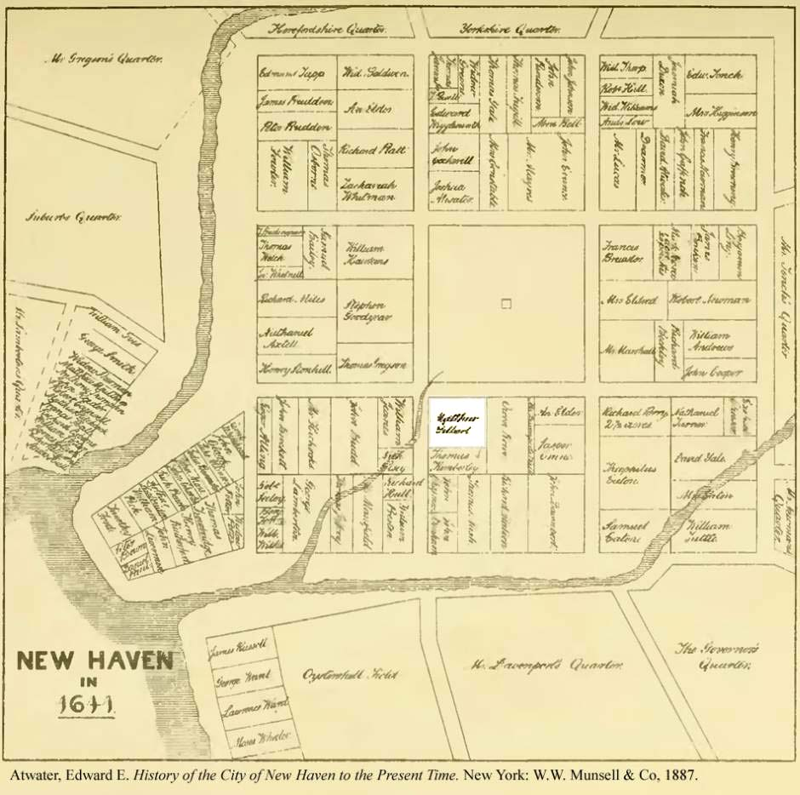

For interest only not direct line …..Thomas Perkins (Parkyns)
And
Thomas Perkins 1633 was the 5th child of Aden and Mary and brother of William and Edmund

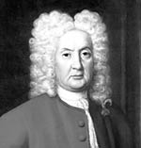
The second Baronet, Sir Thomas Parkyns, became a noted man in his day. He seems to have combined much culture and philanthropy with great devotion to the science and art of wrestling. The large and remarkable mural monument at the N.E. end of the chancel was erected by him during his lifetime. There are two compartments to this strange monument. In the left Sir Thomas is represented in a wrestling posture, and in the right compartment he appears as having been "thrown" by Time. The sculpture is said to have been the work of his chaplain, while the Latin inscription was written by Dr. Friend, Master of Winchester School, where Sir Thomas, as a boy, was educated. The inscription is in hexameter and pentameter lines
It runs thus:—
Quem modo stravisti longo in certamine, Tempus, Hic recubat Britonum clarus in orbe ; fugit Hinc primus stratus; praeter te vicerat omnes ; De te etiam victor, quando resurgit, erit. Throsby, in his additional notes to Dr. Thoroton's history, is very indignant that a monument of this character should find a place in the chancel of a church; and in this respect he has given utterance to the feelings of many other persons besides himself; but Throsby emphasizes the pugilistic character of the inscription by writing "pugil" for "fugit," and entirely disregards the Christian hope and belief expressed in the fourth line. The following may be given as an English rendering of the inscription:— Only now in lengthened fight, hast thou thrown, O Time One who here reclines, illustrious in the British ring; Hence he flees, first thrown; yet all but Thee he'd conquered; And even from Thee, when again he rises, will he bear the palm.
Sir Thomas took a pride in styling himself "Luctator," and wrote a treatise on wrestling, called "Inn Play; or Cornish Hugg Wrestler. Digested in a method which teacheth to break Holds, and throw most Falls Mathematically," dedicating the book to King George I. His wrestling ground was in the garden of what is now the "Rancliffe Arms," He added vastly to the estate by purchasing the Manors of Ruddington, Great Leake, Costock, Wysall, Thorpe, Willoughby, with parts of Keyworth, Barrow-upon-Soar, and Gotham. He also restored the Hall, enclosing the park with a wall, three miles in circumference, and built to a great extent on arches; a method that was new in England. He put a new roof on the chancel of Bunny Church, built a new Vicarage ; built and endowed the Free School at Bunny with the four almshouses adjoining; he also built the hunting tower on Bunny Hill, and planted woods ; and in public matters relating to the town and county of Nottingham always took an active part. In 1741, he died at the age of 78, having lived in the reigns of James II., William and Mary, Queen Anne, George I., and George II. He was succeeded by Sir Thomas Parkyns, third baronet, who died in 1806, and was twice married, (i) to his great niece Ann Parkyns, by whom he had Thomas Boothby Parkyns, and (2) to Jane Boultbee, by whom he had Thomas Boultbee Parkyns, the father of Mr. Mansfield Parkyns, of Woodborough. Colonel Thomas Boothby Parkyns was M.P. for Leicester in 1790 and in 1796; and as he died in 1800, before his father, he never succeeded to the baronetcy. But in 1795 for some reason or other he was made an Irish peer, with the title of Baron Rancliffe.
His son, Sir Thomas George Augustus Henry Anne Parkyns, succeeded to the peerage of Rancliffe on the death of his father in 1800, and to the baronetcy on the death of his grandfather in 1806. This second Lord Rancliffe may be remembered by some of the older members of the Thoroton Society as a prominent Whig politician, who at one time represented Nottingham in Parliament. He died in 1850, without issue, and alienated the Bunny estates from the family, bequeathing them to Mrs. Harriet Forteath. The peerage therefore became extinct and the baronetcy passed to his first cousin, Sir Thomas George Augustus Parkyns, fifth baronet, the son of Thomas Boultbee Parkyns, who at one time lived at Ruddington. He died in Italy."
To the above history of the Parkyns family, it may be well, while dealing with it to give the following additional facts.
The name Parkyns, or Perkins in its more modern form, is a derivative of Peter or Piers, and the Bunny family traces its descent from Peter Morley, alias Perkins of Shropshire, "servus" or bailiff of the estates of Hugh De Spencer (1380). The grandson of this man was John Perkyns, who held lands at Madresfield in 1393, and had a son William who became lord of Ufton Robert in 1411, and a grandson Thomas Parkyns, who having two sons, divided his estates between them; bequeathing Ufton Robert to his eldest son John, and Madresfield to the younger son Thomas. The Parkyns of Notts, are descended from this younger son Thomas Parkyns of Madresfield, in Worcestershire.
The arms of the Parkyns of Notts, were originally the same as the Ufton shield, "or, a fess dancette between "ten billets ermines," but in 1559 Richard Parkyns, of Madresfield, obtained a grant as follows:—Arms, "Argent, an eagle displayed sable, in a canton golde, a fesse dauncette, between seven billettes sable, on eche an erminey." Crest—"on a wreath argent and sable a pine apple braunche verte, the aple in his proper couller mantled gules, double argente."
Judged from an "Introduction to the Latin tongue" which Sir Thomas the wrestler wrote for his grandson and the school at Bunny, his classical scholarship cannot have been otherwise than indifferent; and the book can never have been revised by his old master of Westminster, Dr. Friend. Among the rules for syntax is given the extraordinary one that after such verbs as 'see,' 'hear,' 'think,' 'know,' 'believe,' 'wonder,' 'hope,' 'promise,' 'rejoice,' 'shew,' 'say,' or their contraries 'quod' should be used! ' I go to see ' is prosed as ' eo videre;' and 'I will wait till the master comes' as 'manebo dum magister venit'!
Another interesting member of this family deserves mention, viz., the late Mr. Mansfield Parkyns, of Woodborough, who was the second son of Thomas Boultbee Parkyns, and the younger brother of Sir Thomas George Augustus Parkyns, fifth baronet. He was educated at Woolwich and Trinity College, Cambridge. His residence at Cambridge was not continued beyond his first year as a freshman. This fact seems to have been due to his great and possibly inherited keenness for the "Britonum orbem." He was a first-rate boxer as his great-grandfather had been a first-rate wrestler. But this keenness for the art of self-defence was not found compatible with a study of mathematics; so "Alma mater" was left behind for a nine years' tour in the East. No news of Mr. Parkyns reached England during this long period of absence, but at the end of it he returned to Europe and was appointed attache to the British Embassy at Constantinople. Returning to England about 1852, he wrote his "Life in Abyssinia." His travels had embraced Abyssinia, Nubia, Sennar, Kordofan, and Egypt; and throughout these countries, at that time comparatively unknown to Europeans, he had lived with the natives, adopting their customs and dress. He married the Hon. Emma Louisa Bethell, third daughter of Richard, first Baron Westbury, who died in 1877, leaving eight daughters. He was made official assignee to the Court of Bankruptcy at Exeter and the Comptroller in London, but retired in 1884. The last years of his life were spent in great retirement at Woodborough, and to a large extent in genealogical and artistic pursuits ; the last work of his life being the carving of the beautiful oak choir stalls in Woodborough Church, which were dedicated to the memory of his wife on Christmas Eve, 1893. Cholera, dysentery, and the hardships of his nine years' travels had severely weakened his constitution, and he died January 12, 1894, after a few days' illness.

