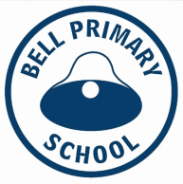
Welcome to Semester 2! Who can believe that it is already half way through July! We have exciting things ahead of us this term, most notably Writer’s Festival! We hope you all had a wonderful holiday. We are really looking forward to a great term.

Swimming
It’s here! Swimming will be starting in week 3 for those students who have elected to attend. Students will be going over to the pool in three groups throughout the morning.
The first bus will depart at 9:05 for a 9:30am – 10:15am class. The second group will depart school at 9:45am for a 10:15 – 11:00 class and the third will depart at 10:40 for an 11:00 – 11:45 class. The 3/4s will follow the 1/2s.
On the day, students need to come to school with their bathers under their uniform. They need to have a separate swimming bag with their towel, goggles and underwear that they can take to the pool. Please include a spare plastic bag for the wet towel and bathers.
They strip down to bathers at the side of the pool and then change into underwear and uniforms afterwards in the change rooms. Teachers supervise and support the students to get dressed and organise their belongings.
On the first swimming day students will be assessed and placed into the appropriate teaching group by the YMCA staff. From the second session students will swim in these groups with the same instructor for specific skill development.
Please ensure that on swimming days students have extra morning tea and a larger lunch... swimming is hard work and students are super hungry by the time we get back to school! A snack in their swimming bag is also a good idea just in case we are waiting for the buses.
Students not attending swimming will spend the time with another 1/2 class and will continue with regular class work and some water safety activities.

Dates to Remember......
- Swimming on Thursdays – 31st July, August 7th, 14th, 21st & 28th and September 4th
- First Aid Course for Kids (St Johns Ambulance) Friday 1st August
- 1st of September Hats are back!
- Writer’s Festival Week 9 (Sep 8 -12)
- Term 3 ends September 19th
Don’t forget -Swimming starts Week 3!

Please make sure your child’s belongings are all clearly named. Super important for swimming this term! It’s hard to find owners when things are not named.

Team Contact Details...
Throughout the year teachers can be

Italian Rotations

The 1/2s will be continuing with Italian rotations this term. Students are divided up into six different coloured groups and visit a different teacher each week to learn new things and get to know their 1/2 peers.

Topics this term include –
Italian Sports with Mr A
Famous Landmarks with Ms Gidley
Music with Miss S
Seasons and Weather with Mr Griffin
Months of the year with Moya
Italian greetings with Renee

The Writers Festival
It’s an exciting term coming up with the Writer’s Festival! It will be happening in week nine (September 8th – 12^{th.}) Every student in the school will produce at least one piece of published work. In the 1/2s we have been working on the different stages of writing, such as drafting, editing and publishing. We can’t wait to get into it again! If you are available to assist with typing, laminating or binding of books please see your child’s classroom teacher.

What’s happening in Maths?
We have been having a wonderful time playing the Place Value Mystery Game. It's a great way of exploring how place value works and is a favourite in 1/2LT. You can play at home too, all you need is a piece of paper.
How to Play Place Value Mystery
You need - pencil and scrap paper (or a whiteboard and markers), two or more players.
1) Decide how many place values you will work with, eg. two digit numbers, three digit numbers, etc. To set up the boards, draw columns for very digit in the number.
2) Label your columns with the value of that digit. eg, o for the ones, t for tens, h for the hundreds column.
3) One player chooses a mystery number.
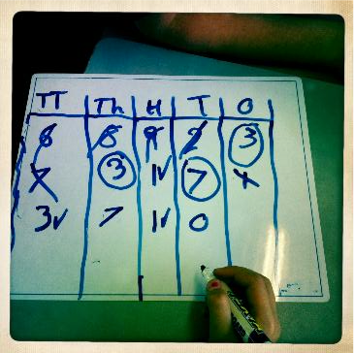
4) The other players start guessing by saying numbers, one at a time. Player one writes each number in the columns and marks each digit to give clues.
cross = wrong number circle = right number, wrong place tick = right number, right spot.
5) Keep guessing, using the clues until someone gets the right number!
Inquiry

Our areas of Inquiry (Living and Non-living Things, Force and Motion, Design and History) will continue on in Term 3. Inquiry has seen our students become self motivated learners who take risks and question their understandings. We are looking forward to even more exciting learning this term!

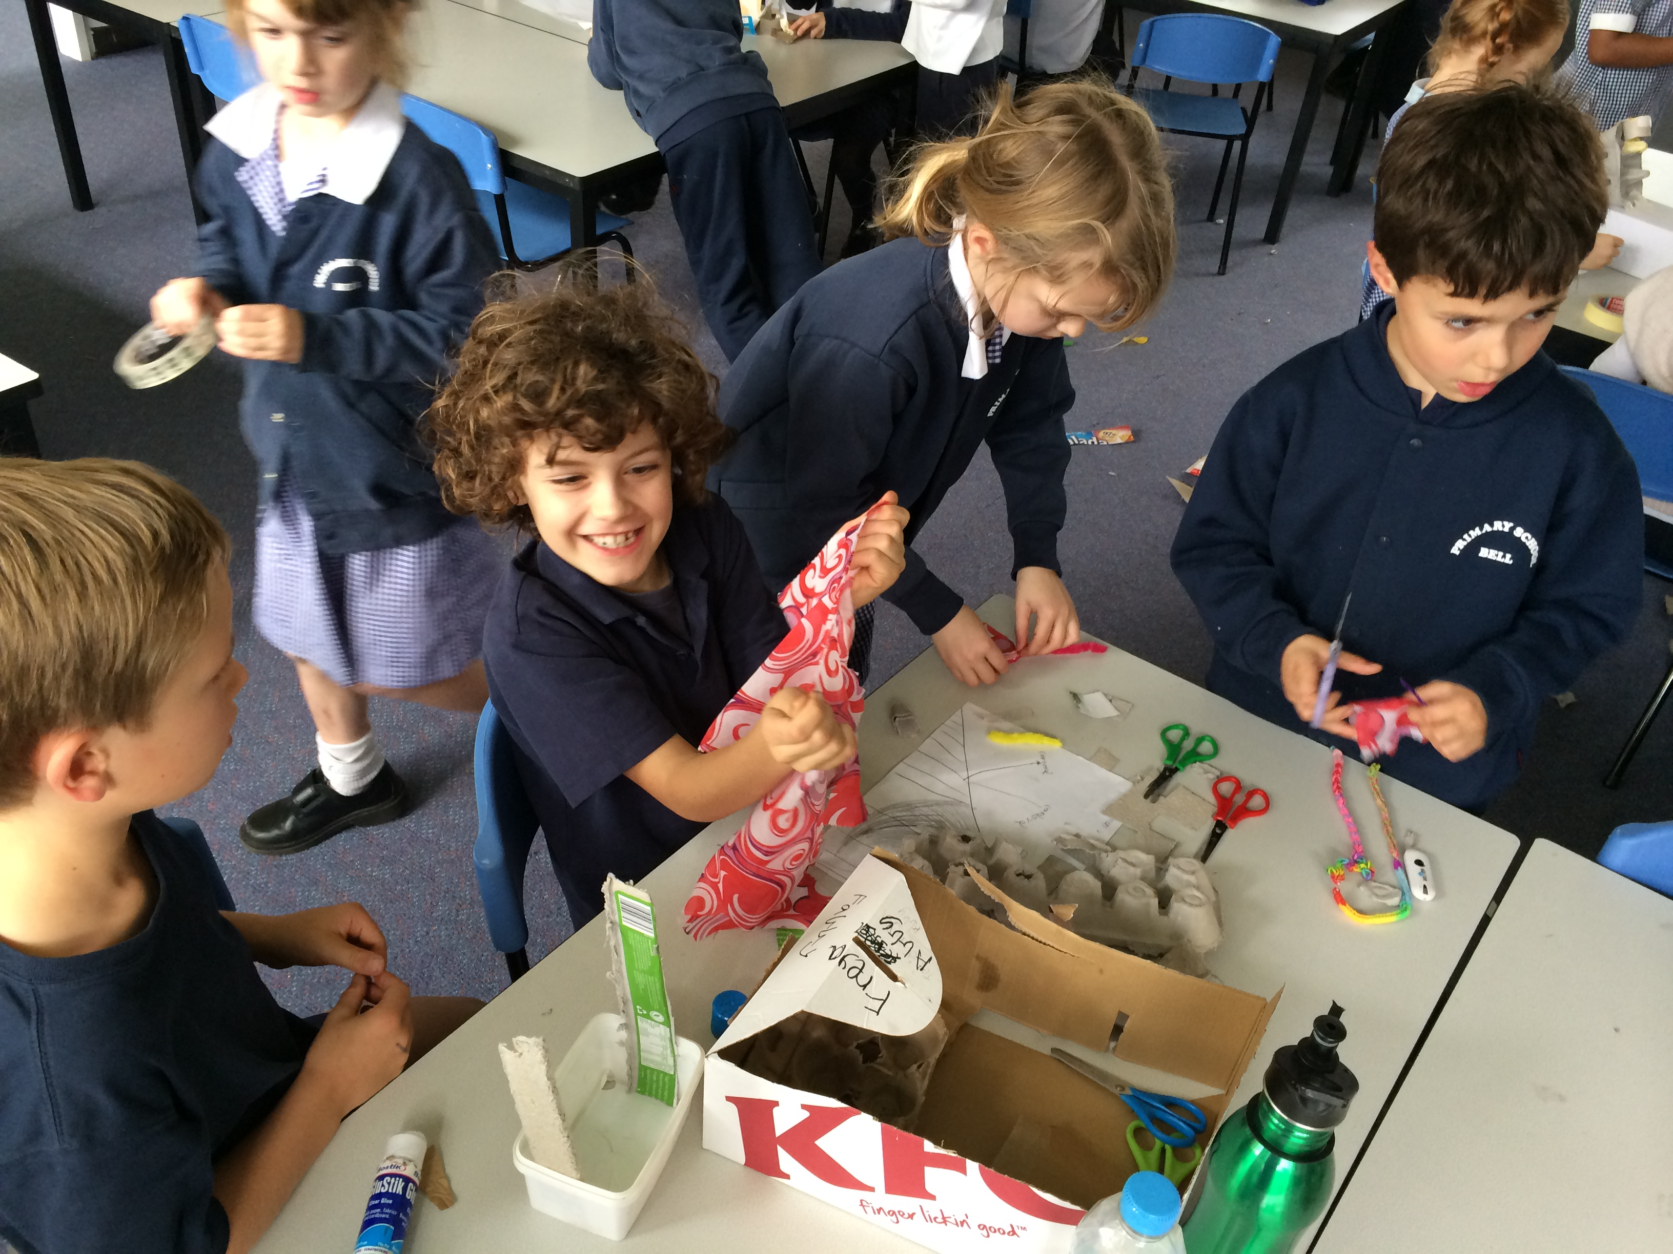

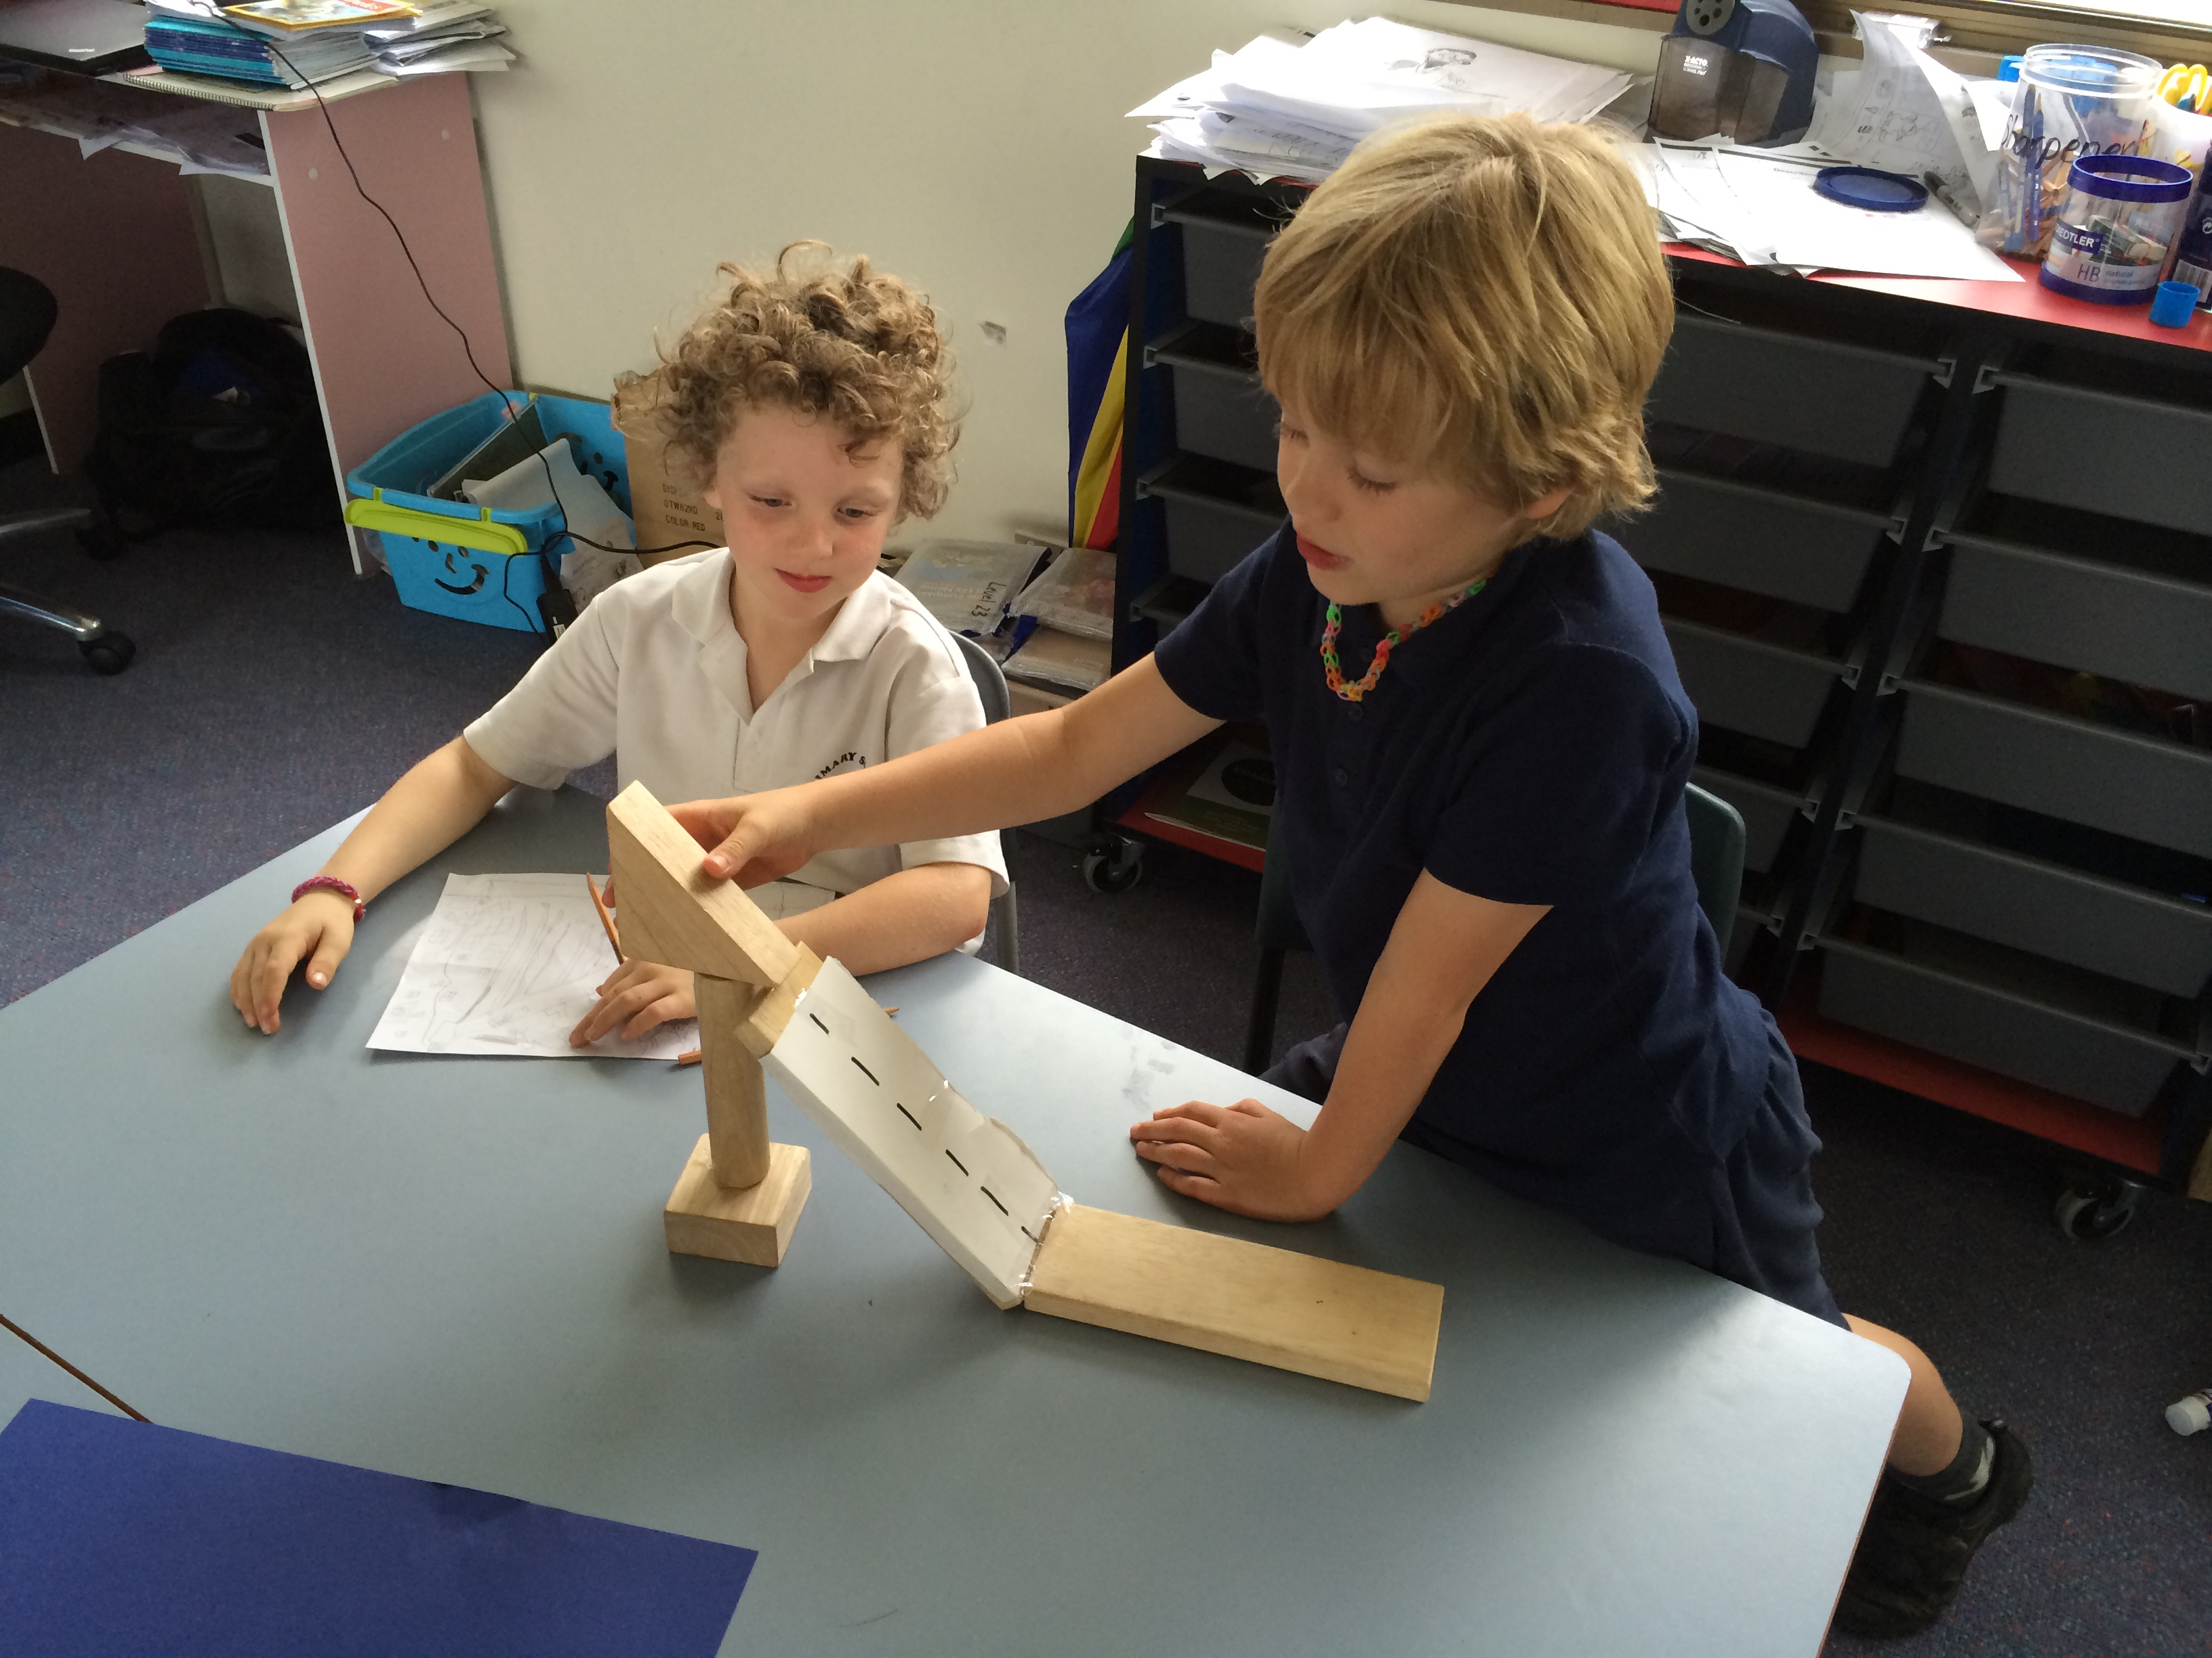

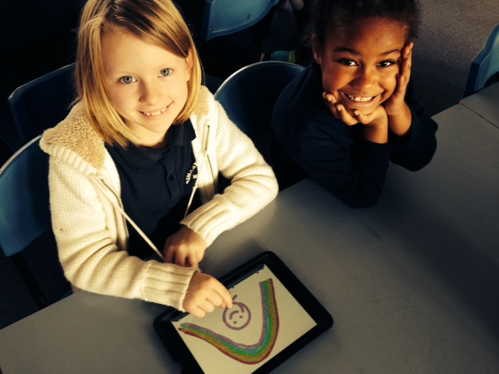

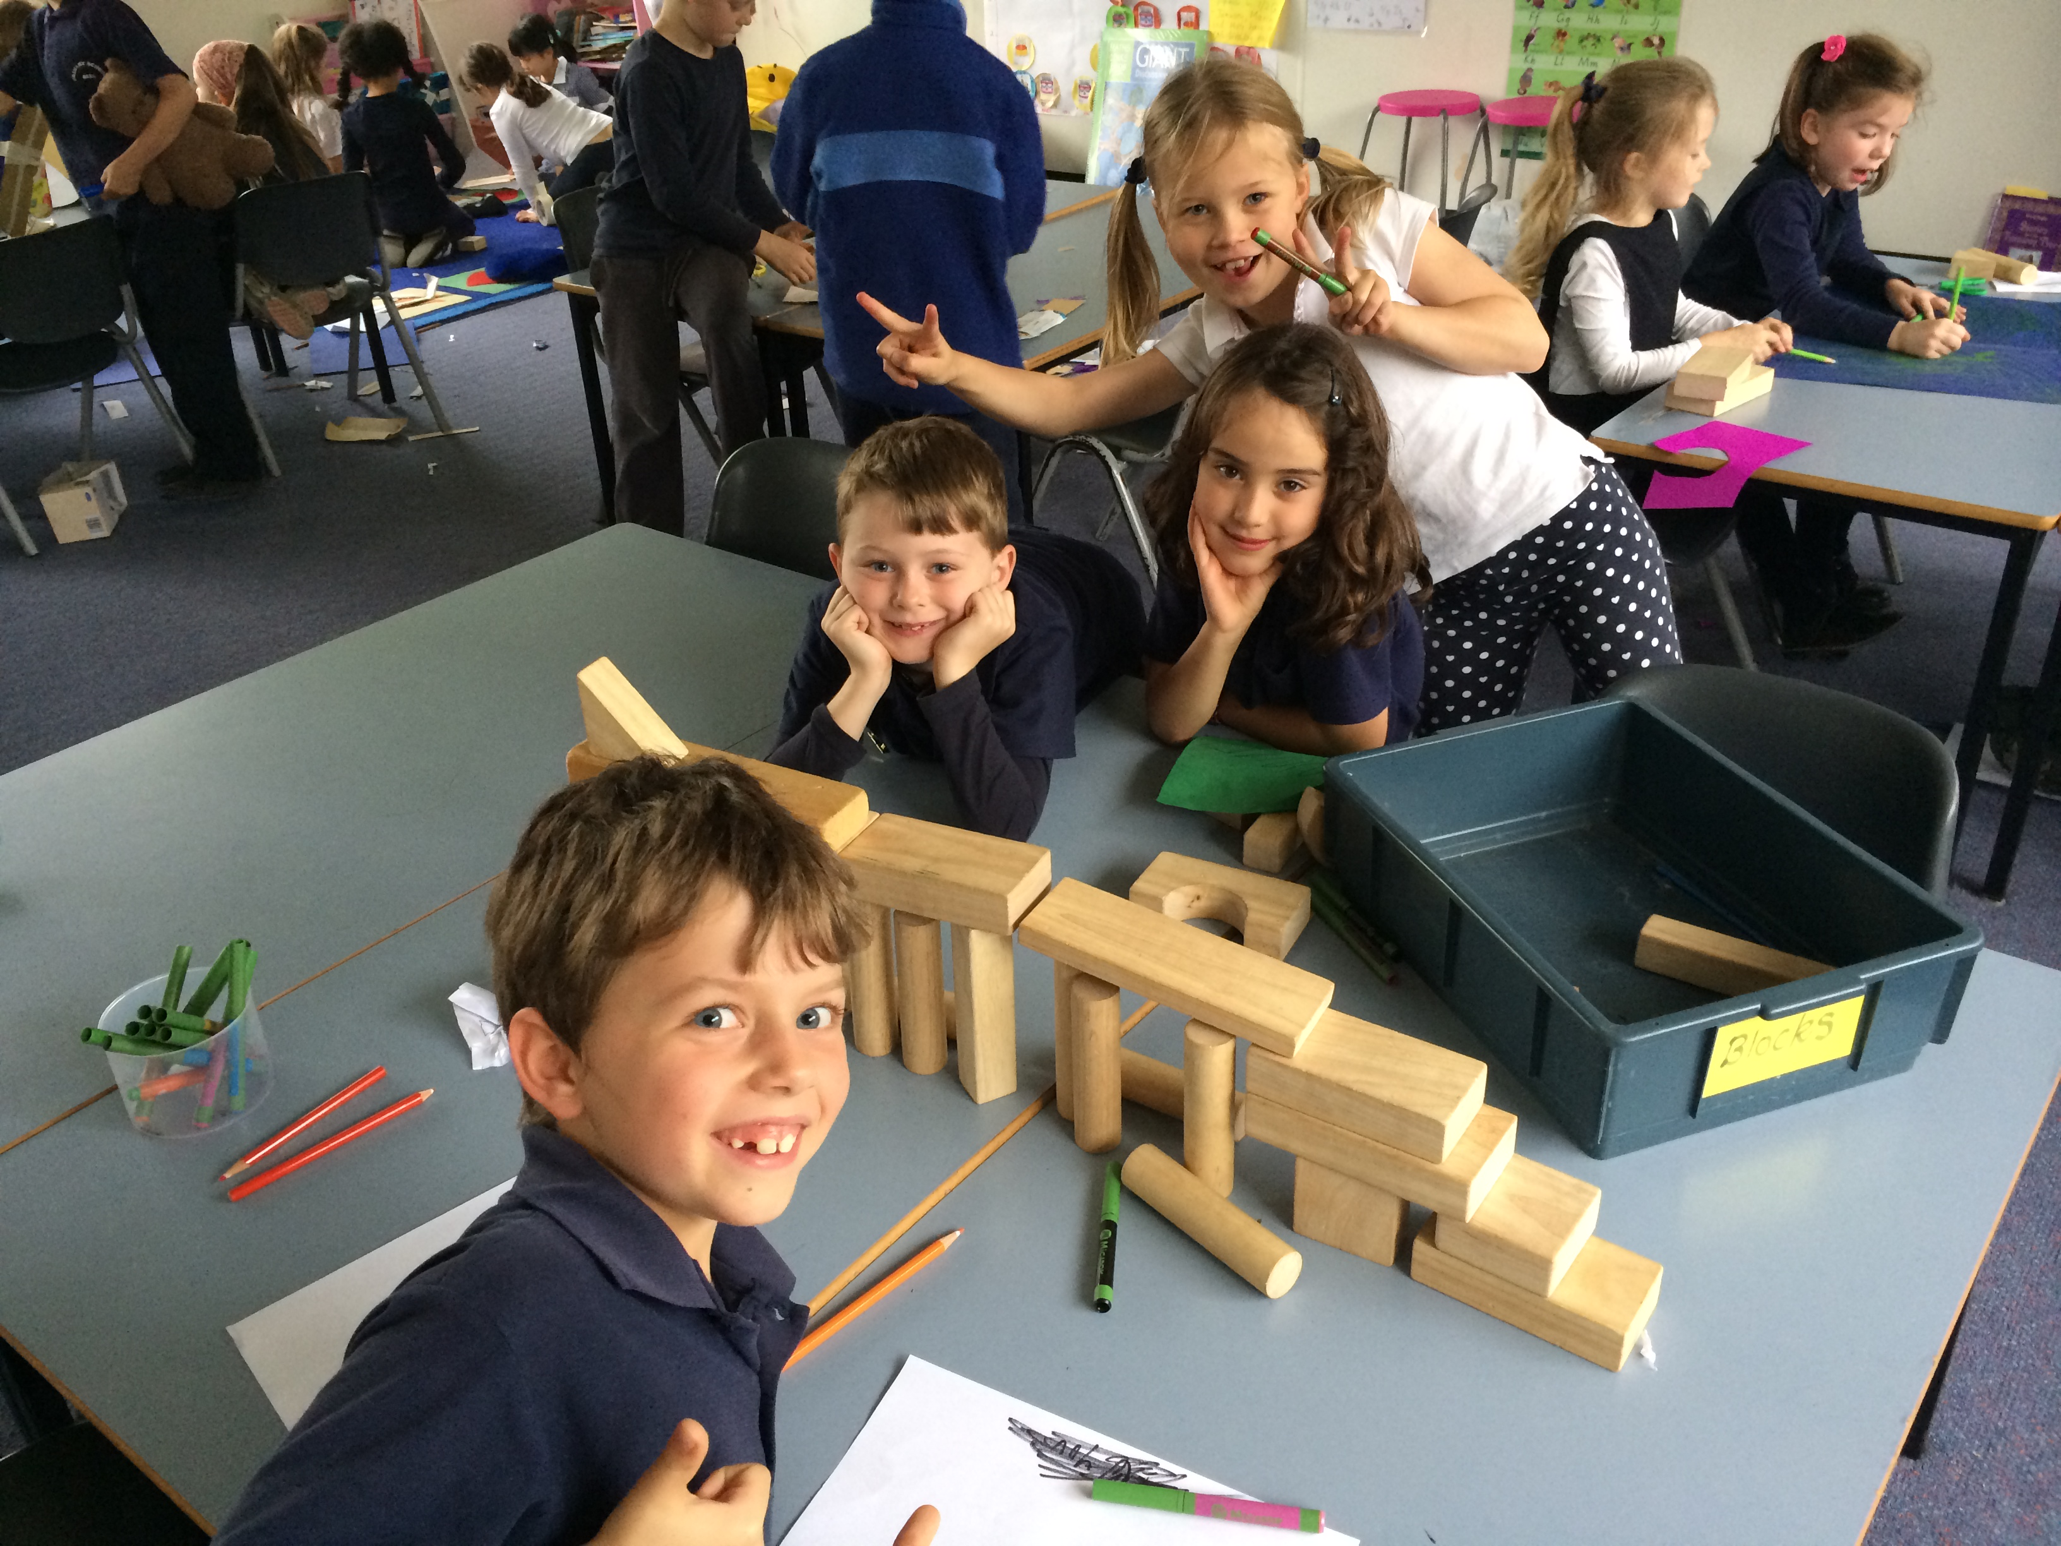

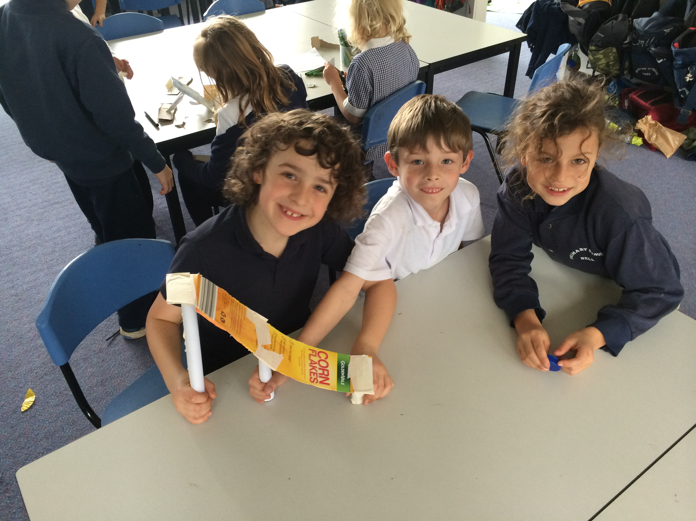

Healthy Foods Policy

If you would like to know more about our healthy foods policy, you’ll find a link here: http://www.bellps.vic.edu.au/#!policies/c14yv or through the Bell PS webpage.

FRUIT BREAK

Thanks for your help in keeping fruit break short and sweet! We’ve seen lots of carrots, bananas and apples that we can munch on with one hand while we work away. We are really making the most of our learning time!

Art

 | Music | Art | PE | Library
1/2S | Friday | Friday | Tuesday | Tuesday
1/2G | Friday | Friday | Tuesday | Monday
1/2T | Friday | Friday | Tuesday | Wednesday
1/2L | Friday | Friday | Friday | Tuesday
1/2M | Tuesday | Thursday | Friday | Wednesday
1/2A | Friday | Tuesday | Friday | Wednesday
The Year 1 and 2 students will be looking at the work of Dr. Seuss and creating artworks inspired by his famous book One Fish, Two Fish, Red Fish, Blue Fish. They will be exploring the work of Maurice Sendak and making their very own ‘Where The Wild Things Are’ hand-puppets. Lastly, the students will be exposed to the work of Roy Lichtenstein and will develop self-portraits in the style of the pop art/comic book genre.

Chelsea Kneale

Term 3 Specialists

Please note - this can change at times to help accommodate school events and planning.

Music

Grade 1&2 students will be digging deeper into the concepts of rhythm and rhyme. Drawing on their prior knowledge of rhythm and beat from last semester, grade 1&2 students will be exploring rhyme and meter through the musical genre Rap and Hip Hop. The students will then be creating their own Raps and Hip Hop backing track. These creative opportunities will link in with the artists as illustrators focus in art looking at Dr Seuss.

Andrew Williamson

iPad Program

We would like to invite you to our first iPad information session. The rollout of the iPads into P-2 classrooms will be a gradual process involving continued professional development for teachers, trials and assessment of potential applications and their educational value, and will also include information sessions for the wider school community.

Our first iPad focused Information Session for Prep - 2 parents/guardians will be held on Monday 11th August from 6:30 to 7:30pm in the Learning Centre. This session will provide a look at some of the applications we will be using in the classroom and will give you a chance to have-a-go yourself at what the P-2 students will be doing. This is a parent only session so please leave your children at home. We hope that many of the Prep -2 parents will come along and embrace the iPad program at Bell.
Please RSVP by Wednesday 6th August by going to this website: bit.ly/p-2ipads

Staff Contact Details

Please don’t hesitate to contact us on the below emails if need be. Alternatively we can be contacted at school on 9480 5622.

lythgo.moya.m@edumail.vic.gov.au
stefanovic.milica.m@edumail.vic.gov.au
atanasovski.matthew.m@edumail.vic.gov.au
gidley.sophie.e@edumail.vic.gov.au
timion.renee.m@edumail.vic.gov.au
griffin.robin.j@edumail.vic.gov.au

3.
Don’t forget to check out the 1/2 blog! http://onetwobell.global2.vic.edu.au

