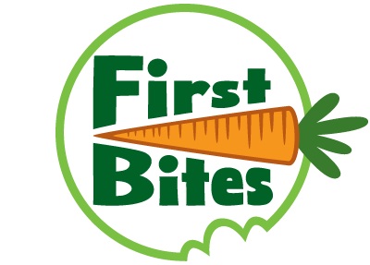
Free (& Fun) Vegetable Party at Your Early
Child Care Center
Apply for our program today!

This free program is offered with support from MOMs Organic Market and is available first come, first served.

We are offering a free, one-time class to early child care centers in the DC area. Up to ten early child care centers will be eligible for this class, which will include:
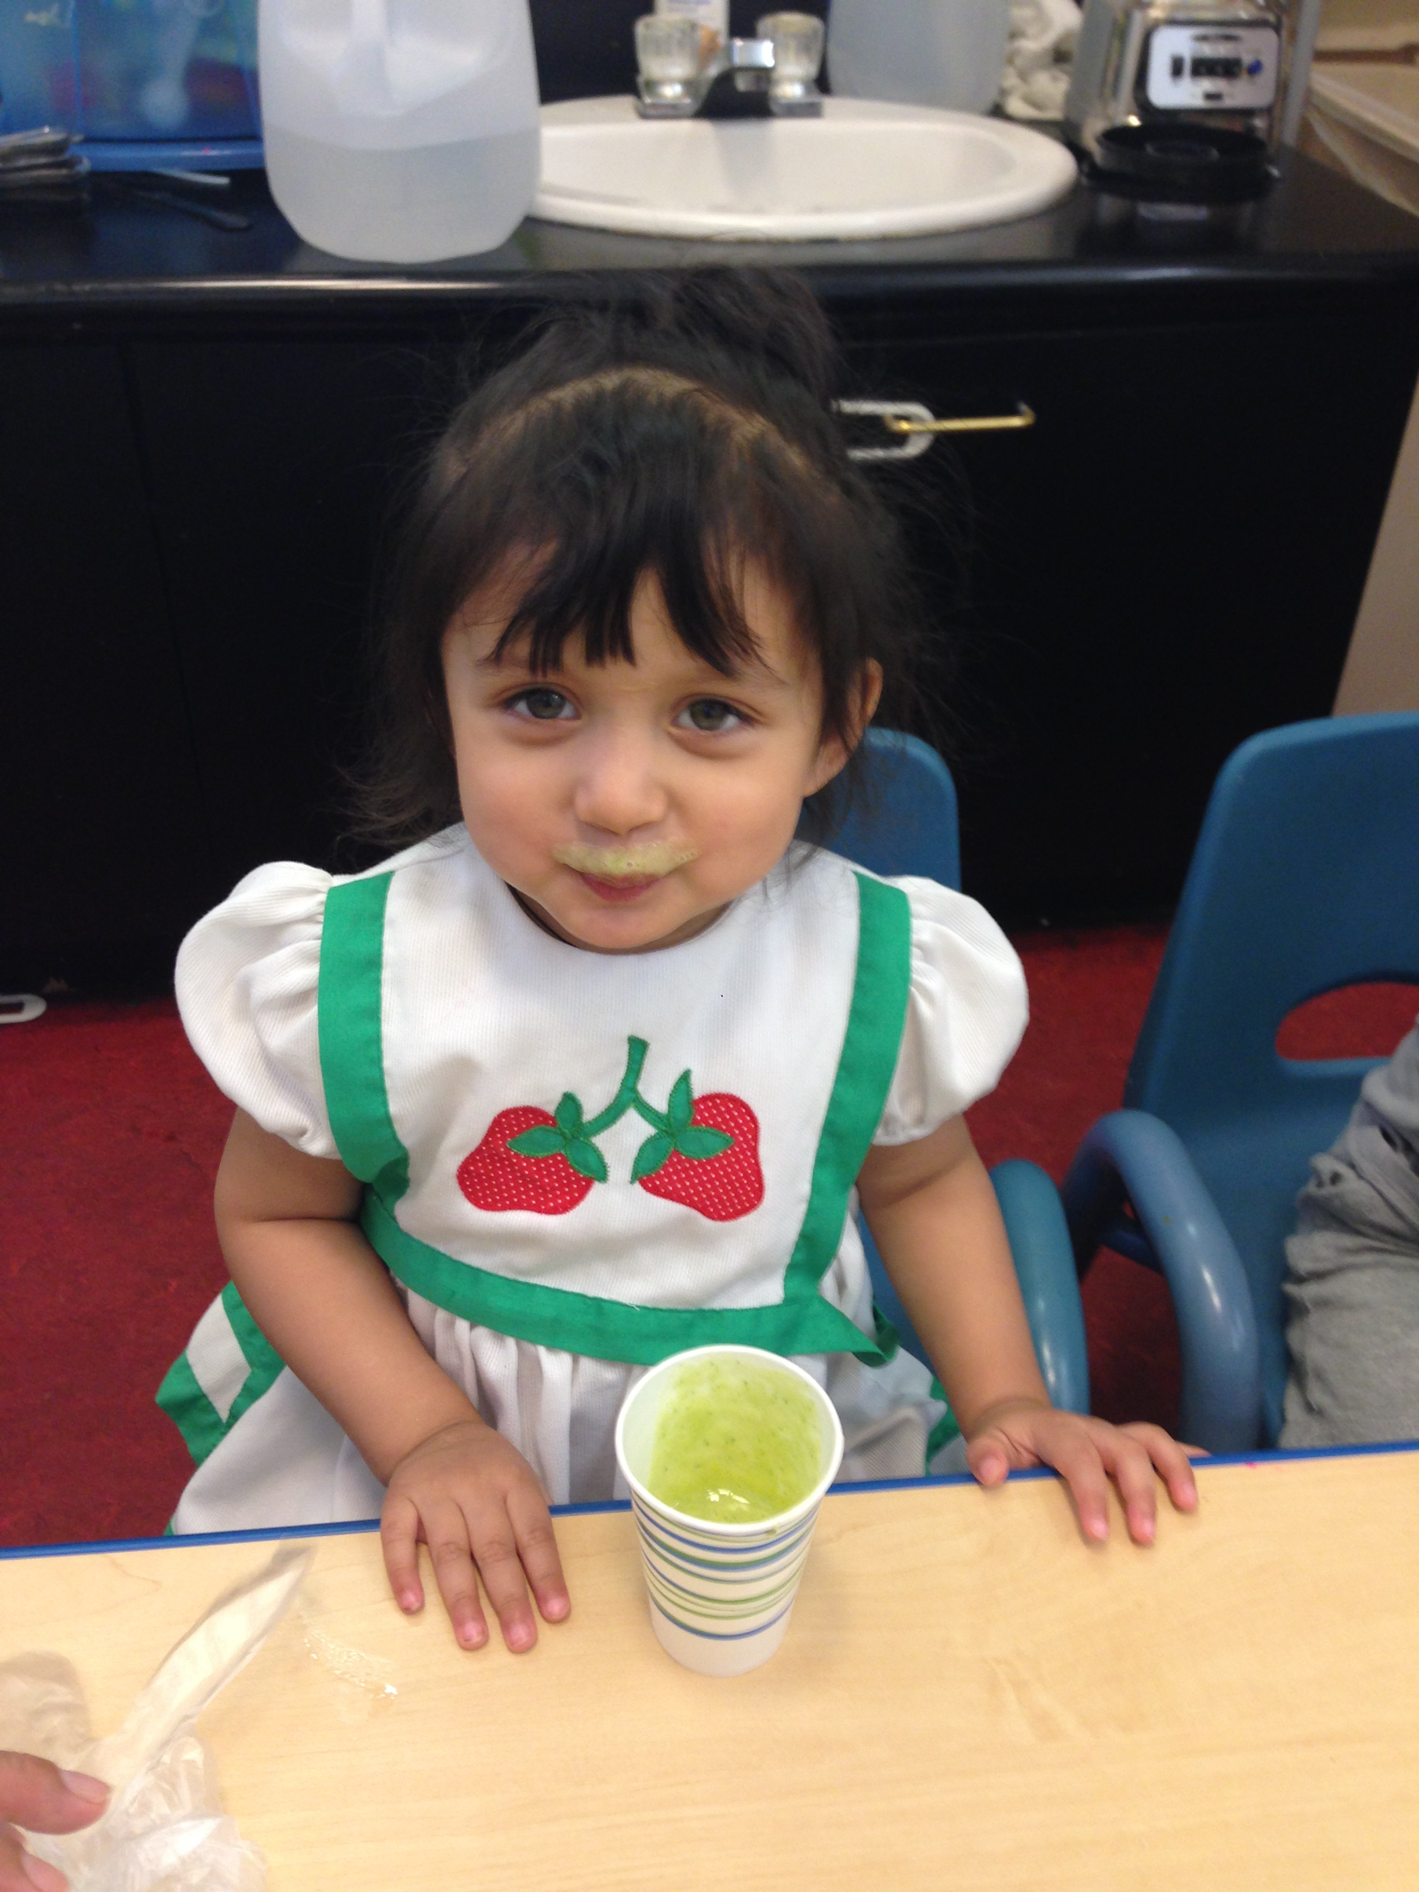
- Up to $100 in child-friendly kitchen supplies for your classroom;
- A trained First Bites educator, who will come to a classroom one morning and lead a session designed to make eating fruits and vegetables fun. The session will include a:
  - Fruit/vegetable tasting activity; and
  - Cooking activity in which children make their own fruit/vegetable snack.
- Costs associated with all produce and ingredients needed for the activities; and
- Handouts to send home to families with the recipe as well as a tip sheet for teachers on how to make it fun to eat more fruit and vegetables in the classroom.
The class will last for about 30 minutes.

We have worked with hundreds of early child care teachers, administrators, students and families in the Washington DC area to get them excited about eating fruits and vegetables. Our work has been featured on the local CBS, ABC and Fox news channels as well as Univision in Spanish.

Apply here or go to FirstBites.org. Applications will be accepted on a first-come, first serve basis and evaluated based on location.

