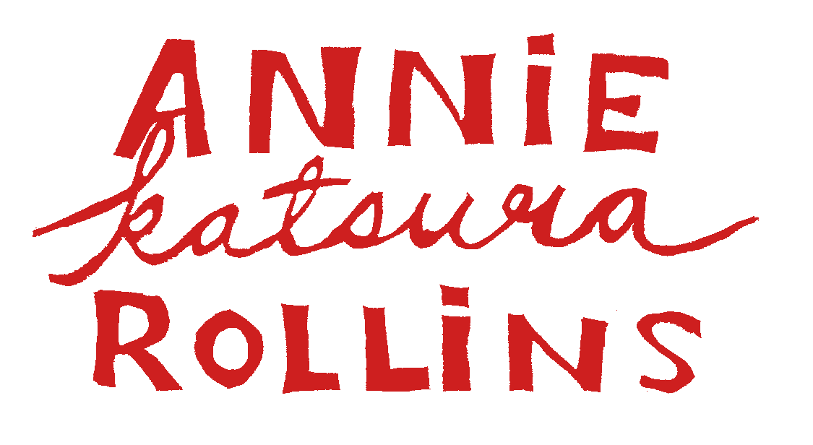
Fulbright Fellow, 2011

Chinese Shadow Puppetry Research and Practitionership
anniekrollins@gmail.com : www.anniekatsurarollins.com

EDUCATION
PhD, Interdiscplinary PhD in Chinese Shadow Puppetry and Tacit Learning Concordia University, Anticipated 2018
Graduate Fulbright Fellowship, Chinese Shadow Puppetry US State Department, 2011
MFA, Scenography University of Minnesota, 2010
BFA, Music Theatre Carnegie Mellon University, 2002
Shaanxi China Shadow Puppet Making Apprenticeship Master Wang Tianwen, 2011
Shaanxi China Shadow Puppet Performance Apprenticeship Master Wei Jinquan, 2011
Hebei China Shadow Puppet Making Apprenticeship Master Lu Fuzeng, 2011

TEACHING
Chinese Shadow Puppet Workshop Center for Puppetry Arts, Atlanta 2014
COMPAS Teacher, Global Arts and Culture Minnesota, 2008-2013
Shadow Puppet Workshop Open Eye Figure Theatre, 2012, 2013
Introduction to Puppetry St. Paul Conservatory for the Performing Arts, 2011
Chinese Shadow Play Workshops Confucius Institute, 2009-current
Theatre Design Penumbra Summer Institute, 2012
Puppetry Workshop Shanghai Theatre Academy, 2011
Experimental Shadow Puppetry Workshop Residency TsingHua Academy, Beijing 2011
Reuse Shadow Puppetry Workshops Davince Academy of Arts & Sciences, 2011
RecPlus Shadow Puppet Workshop Minneapolis Park Board, 2009
Puppetry Workshop and Build New York Mills Cultural Center, 2009
Direct Contact/Bunraku Workshop St. Mary’s University, 2009
Pupperyt Workshop New York Mills Cultural Center, 2008
Pupperyt Workshop for Teachers New York Mills Cultural Center, 2008
Puppetry Workshop Arts Center on 7, 2008

CONSULTING,COLLABORATIONS,LECTURES & PRESENTATIONS
Chinese Shadow Puppet Display Festival Casteliers, Montreal 2014
Chinese Shadow Puppetry Presentation and Demo Virginia Fine Arts Museum, 2014
Chinese Shadow Puppetry USCPFA National Conference, 2013
Chinese Shadow Puppet Lecture/Demo/Workshop In the Heart of the Beast Theatre, 2013
Puppetry Lecture Concordia University, Montreal 2013
Chinese Shadow Puppetry Collaboration Droom Theatre, Holland, 2012
Chinese Shadow Puppetry Identification Lin Liu-Hsin Puppet Theatre Museum, Taipei 2012
Chinese Shadow Puppet Acquisition Consulting Indiana Children’s Museum, 2012
Chinese Shadow Puppetry Lecture and Workshop Ballard Institute of Puppetry U CONN, 2012
Chinese Shadow Puppetry Demo and Workshop Passage to China, Chinese Heritage Foundation, 2012
Chinese Shadow Puppetry Lecture and Workshop Linden Centre, Yunnan, China, 2011
Migration of Shadows, A Poster Session on the effects of
Urbanization on Chinese shadow puppetry CHIME Asian Performance Conference, England, 2011
Chinese Shadow Puppetry Lecture
Cultural Revolution Breaking the Continuum China Culture Center, Beijing 2011
Chinese Shadow Puppetry Lecture Confucius Institute, 2009
Chinese Shadow Puppetry Lecture Midwestern Moon Festival Conference, 2008

PUBLICATIONS
www.chineseshadowpuppetry.com,
first comprehensive informational site in English Creator & contributor, current
Research Blog, www.annierollins.wordpress.com Ongoing, started 2010
The Inheritance of Shadows;
China’s loss of shadow puppet masters threatens the continuation of the form Puppetry International, 2012
Puppet Hunting in Mainland China Fulbright Newsletter, 2011
The Slow Exchange; learning to make shadow puppets in China Fulbright U.S. Student Blog, 2011
Apprenticing a Shadow Master SYA Alumni Newsletter, 2009

PUPPET NEW WORKS DIRECTION/CREATION (Selected)
There’s A Better Way To Do That, recreating the future’s past Open Eye Figure Theatre, 2014
没有什么可说(There’s Nothing to Tell), A Chinese-American Shadow Story Heart of the Beast Theatre, 2012 & 2013
The Spice of Life, Beijing Hutong Shadow Bike Tour II Beijing Hutong Tour, 2012
Dumb Show, Beijing Hutong Shadow Bike Tour Beijing City Streets, 2011
The Tailor, stop motion puppet music video Gladiola, 2011
little BIG world, a miniature puppet performance captured on live video The Soap Factory, 2010
After Sunset Shadows, a touring summer evening shadow puppet show Minneapolis Parks, 2010
New York Mills Puppet Pageant, collaborative community project New York Mills CC, 2009
After Sunset Shadows, a touring summer evening shadow puppet show Minneapolis Parks, 2009
Shadows; an original full length shadow play Experimental theatre, 2009
New York Mills Puppet Pageant, collaborative community project New York Mills CC, 2008

GRANTS & AWARDS
Fulbright Fellowship US Department of State, 2011
Cultural Community Partnership Grant Minnesota State Arts Board, 2013
Artist Grant Puffin Foundation, 2012
Next Step Grant Minnesota Regional Arts Council, 2012
Artist Initiative Grant Minnesota State Arts Board, 2011
SAGE Dance Awards Outstanding Design Nomination, 2011
Red Pockets Travel Grant U of MN China Center 2010
Hsiao Scholarship U of MN China Center 2010
Departmental Travel Grant U of MN Theatre Department, 2010
Departmental Travel Grant U of MN Theatre Design MFA Program, 2010
Cultural Community Partnership Grant Minnesota State Arts Board, 2009
Jerome Fellowship New York Mills Cultural Center, 2008
New York Mills Residency New York Mills Cultural Center, 2008
Red Pockets Travel Grant U of MN China Center, 2008
Janet M. Ryger Memorial Scholarship U of MN Theatre Department, 2008
Adelyne Roth Levine Memorial Award Carnegie Mellon University, 2002

References

Marcus Dilliard Lou Bellamy Lisa Channer
Associate Professor Artistic Director Director
University of Minnesota Penumbra Theatre Company Theatre NoviMost
612.327.0045 651.224.3180 612.308.1365
dilli008@umn.edu bellamylou@hotmail.com lisa.channer@gmail.com

