[Written by Rachel Jin from Sydney in September 2014]
This is the way I prepare my ginger water at home:
- First, I dedicate a clean, new scorer pad to scrub the ginger pieces under low running water. I use a small paring knife to trim away bad ends and clean any hard to get areas.
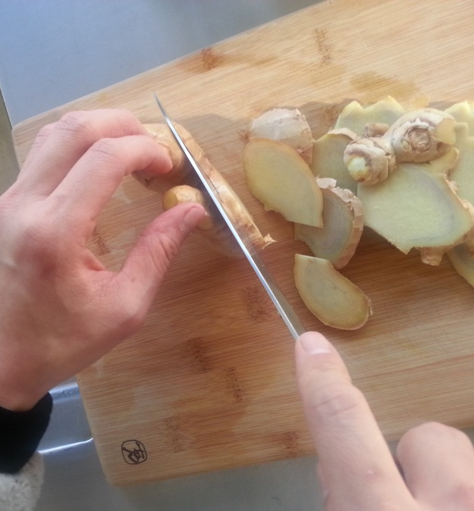
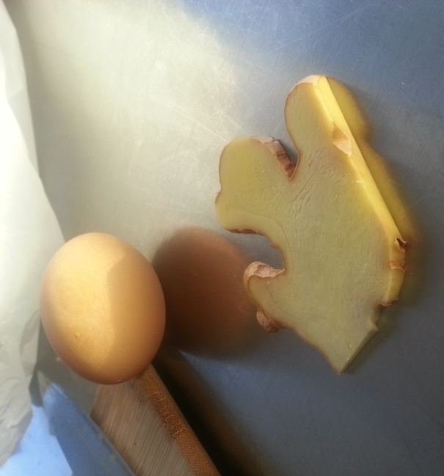
- After washing, slice ginger in large pieces, about 3mm thick. Too thin you will lose all the flavour in one boil, too thick then the boiling time will need to be adjusted.
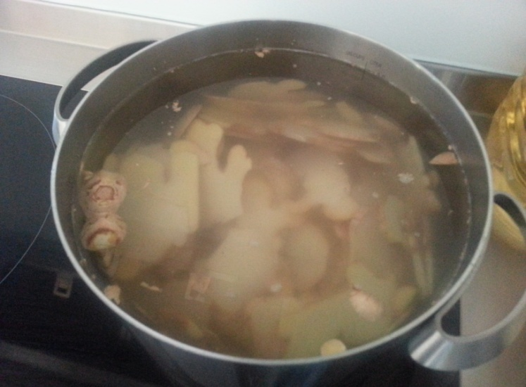
- This time I have about 800g of fresh ginger, fill about 2 litres of the sauce pan I am using. I am going to fill it with cold tap water to the “4 litres” mark (double the height of ginger in the pot).
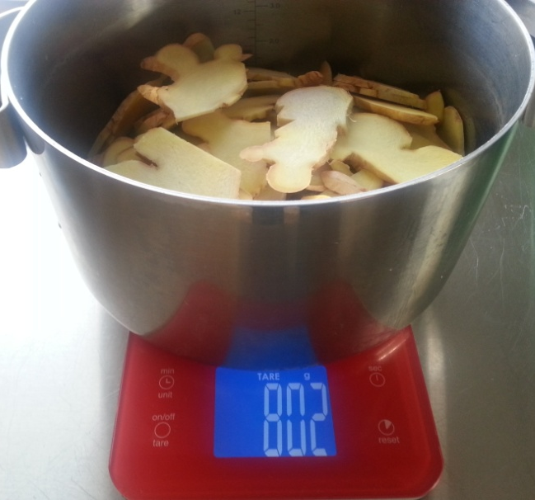
- Cover the pan and bring to the boil over high heat. Then reduce to medium-low heat to continue boiling for about 4 hours, until ginger water turns reddish colour and tastes spicy.
- Consume about 120ml-150ml each time, as many time as needed. For beginner who had been treated with antui, your first drink for the day should be this warm ginger water, followed by a warm breakfast (at least) half an hour later. Then ideally the 2nd dose of ginger water should be in the afternoon then last one before going to bed.
- Each night for your last consumption, bring the sauce pan of ginger water to the boil, ladle out required amount of your last drink for the day then turn off the heat. Keep sauce pan somewhere on your counter top, undisturbed, and away from direct sunlight.
- Next morning, bring the sauce pan filled with ginger water to the boil. Enjoy your drink. You can continue to enjoy your ginger water during the day, heating it in the microwave or take it to work in a thermo, so you can take a few sips whenever you like.
- Repeat the same routine at night as mentioned in step 1 each night. When the ginger water is down to around the 2 litre mark on your pot (or same height as the ginger in the pan) you need to top up the liquid. Just fill the pot to the “4 litres” mark and bring to the boil. Turn down the heat to medium low and continue boiling for another 2 hours. You can keep doing this until the ginger is no longer spicy, say for about a week or a bit more, depending on how much ginger you put into the pot at the beginning. I recommend that you make at least 800g to 1kg of fresh ginger at a time to get the amount of heat you need.

****************** HAPPY COOKING *********************

