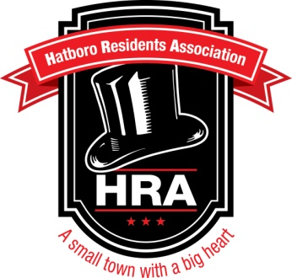
Hatboro Farmer’s Market
2014 Vendor Information
Dear Vendor,

We cordially invite your participation in the second year of the Hatboro Farmer’s Market! We are excited to offer you, our Vendors, as well as local residents (your customers!), an exciting way to spend Friday evenings in our small town.

The 2014 market will begin on Friday, May 2nd from 6:00pm to dusk, with Vendor set up beginning at 5:00pm. Market days will take place EVERY Friday, until October 24th (with no Market on July 4th). There will be a total of 25 weeks of fun!

This year, the Hatboro Residents’ Association (HRA) has planned to have live music and entertainment each week, and will feature a highlighted local restaurant with specialty foods and samples.

We are again so thankful to the Hatboro Baptist Church and LeRoy’s Flowers for letting us utilize their parking lots, and now this year the front lawn of the Church as well, which will provide for increased exposure for our Vendors!

The location of the Hatboro Farmers’ Market is:

May, June 6th and 20th, July, August, September and October:
Hatboro Baptist Church **
32 North York Road
Hatboro, PA 19040

June 13th and 27th ONLY:
LeRoy’s Flowers
16 North York Road (right next door to Church)
Hatboro, PA 19040

** PLEASE NOTE: Vendors must use the back entrance to the Church parking lot located on MONTGOMERY AVENUE. The Church daycare is located at the front of the property, with children being picked up between 4-6pm, so we cannot use the entrance on York Road during that time. This will NOT affect our customers, as the daycare closes at 6pm. This back entrance will be marked as “Vendor’s Entrance.” Thank you in advance for your cooperation in this matter. **

HRA Members and volunteers will be available on site to direct Vendors to where they need to go. After parking your vehicle(s), please check-in at the HRA table.

If you have not done so already, please ‘like’ “Hatboro Residents’ Association” on Facebook, as well as our satellite Facebook page, “Hatboro Farmer’s Market”, so that we may like you back! Also, if you have not already done so, please provide us a link to your website so that we may promote your presence at our market. We would love to feature our vendors (with pictures of your products/produce)! If you’re not on Facebook, feel free to email us pictures with description(s) and we’ll be happy to post them on our sites.

We are planning a press release for this year’s Market, with advertising on our website and Facebook page (with over 1200 followers!), Farmer’s Market websites, local cable television, local publications such as Hatboro Life Magazine and The Midweek Wire, as well as an email blast to our Hatboro resident mailing list, and listings on community calendars everywhere.

Attached is our Vendor Application for the 2014 season, which also contains our contract rules. If you are interested in participating in the Hatboro Farmer’s Market this year, please complete and return these documents with your initial payment to the HRA by April 15, 2014. Applications can be accepted by email at hatbororesidents@gmail.com or by postal mail at P.O. Box 268, Hatboro PA 19040.

Please let us know if you have any questions or concerns. You can reach the HRA via email at hatbororesidents@gmail.com, or visit our website at www.hatbororesidents.com for additional information.

If you need immediate assistance (particularly on the day of the Market if you are lost or have a last minute issue), you can contact Melinda Goodwin, HRA President, on her cell phone at (267) 648-5792. Please direct all less urgent issues to the HRA email address above.

We hope to see you at this year’s Market!

Regards,

Hatboro Residents’ Association

