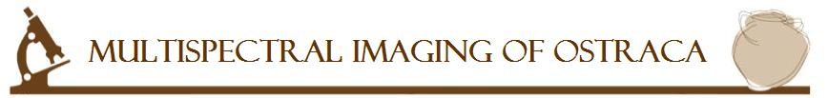

LEO (Legibility improvement of Ostraca) Group in Tel Aviv University can provide the following services:
- Image the written bellow ostraca using the multispectral imaging system in our lab.
- Perform a computerized analysis on the spectral images, in order to find the best contrasted image (under contrast and brightness transformations)

The transportation of the ostraca from its current location to the Tel-Aviv university lab, should be done by the customer.

Please fill the following form:

Customer details:
First Name: ________________ | Last Name : ________________
Company : ________________ | Address : ________________
Phone : ________________ | Email Address : ________________

Ostracon details:
Ostracon Name
Place of discovery
Year of discovery
Registration number
Current location
Current state
Total number of ostraca to image: _________

Acknowledgment
When using the images taken the following acknowledgment should be used:
"we would like to thank the LEO group from Tel-Aviv University[1]"
In the reference section please add:
[1] Legibility Enhancement of Ostraca[LEO] group from Tel-Aviv
University: S. Faigenbaum, B.Sober, M.Moinester, E. Piasetzky,
M.Cordonsky"

Please return the form to the following email: TauEpigraphyProj at gmail.com

