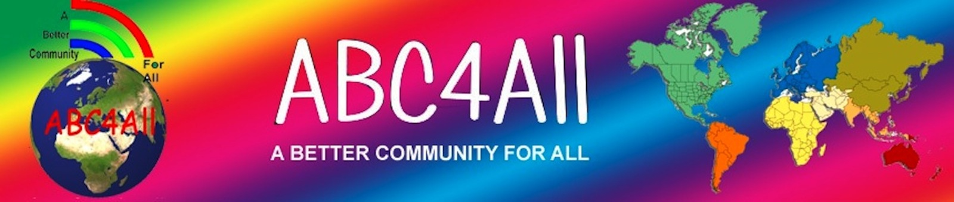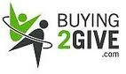

The Legacy of ABC4All / Buying2Give

Partner to provide

ABC4All WorldSolutions™

Natural Disasters Require Sustainable

Global Humanitarian Relief!

Raising funds for the aftermath of ALL Disasters including the Philippines!

FOREVER Campaign for Global Humanitarian Relief (GHR)

ABC4All ALL-DISASTER REAL RELIEF FUND

Never-Ending Self-FUNding4All!

Are you 1 in 1 Billion?

The world has what it needs to have every person on this planet afforded sustainable living. What is needed is simply a

GLOBAL COMMON SENSE SOLUTION:

If you buy anything costing $2 or more, then please donate $1.

EVERY TIME! This is The Beginning of the End of Human Suffering!

When 1 Billion people donate $1
or when 1 billion $1 (or more) donations are received,

the world will make possible sustainable solutions and

opportunities otherwise not possible.

“Making The Impossible Possible” via cooperation and collaboration!

LET’S DO IT! Are you 1 in 1 billion? No more ignoring those sick and dying from lack of potable water, inadequate food, no housing, etc.

PLEASE DONATE YOUR $1 (or more) NOW!

And do the same the next time you spend more than $2

and the next…and the next…and the next…creating

The World of A Better Community For All

