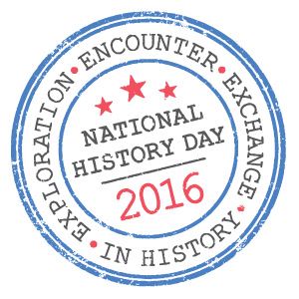
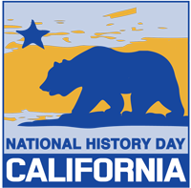
National History Day – Classroom Outline
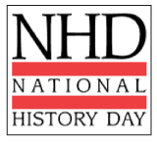
Exploration, Encounter, Exchange in History

Mondays are dedicated to NHD Lessons, Research and Construction

September 28 What is NHD? Project information and guidelines presented to students
October 9 DUE: Submit Topic Applications for Approval (Topic must be specific and connected to this year’s theme.)
October 12 HD Monday Lesson: What the heck is a Thesis?
October 13 HD Lesson: How do I Cite & Annotate for my Bibliography?
October 19 HD Monday Lesson: What came comes first, Primary or Secondary sources?
October 26 DUE: Thesis proposal and project title/subtitle (Draft) and preliminary annotated bibliography #1 (Minimum of 6 sources)
October ? Parent Workshop/ Kiwanis Bar-B-Que
November 2 HD Monday Lesson: Societal Effects; Economic, religious, political and cultural changes?
November 9 HD Monday Lesson: How to respectfully show differing perspectives?
November 30 HD Monday Lesson: What is story line? How do we storyboard?
December 7 DUE: Preliminary annotated bibliography #2 (Minimum of 15 sources)

-WINTER BREAK-

January 4 HD Monday Lesson: How do I layout what my project will look like?
January 7 Backboard Construction Day, 10:00-2:00 pm in the OGMS Quad!
January 8 DUE: Supplemental annotated bibliography #3 (Minimum of 20 sources. (Photographs/Maps/Graphs due)
January 11 HD Monday Lesson: How do I write a Process Paper?
January 18 Student interviews, project evaluations, and research check.
January 19 DUE: Written Material, Title Page, Process Paper (final draft Attach editor signature page) & Annotated Bibliography (Minimum of 20 sources – at least 10 primary)
January 19 DUE: All Projects are due in the gym. (Class time is available to make final adjustments. 6th and 7th grade students preview projects.)
January 20 School History Day (Judges screen projects for County Competition.)
January 21 School NHD Community Showcase (Student Presentations/Parent Night)
January 29 County History Day Registration
February 12 Documentaries/Papers/Websites Due
March 5 County History Day

