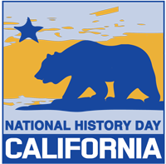
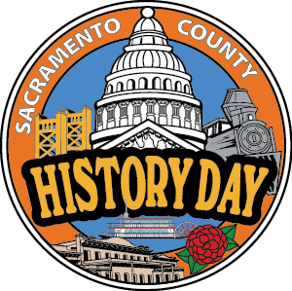
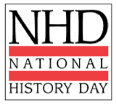
Dear Parent,
All 7th grade Social Studies classes will be participating in National History Day (NHD). We are very pleased to add National History Day to our full 7th grade curriculum. All of the state literacy standards in social studies will be met through the process of creating an NHD project. Teachers will be working closely with the Media Center Specialist and the County Historical Society to help students with research. One class each week will be devoted to NHD work. Your student may choose to create an individual or group project in the exhibit or website category. When choosing a group project please choose group members wisely. Groups may include 2 – 5 students. Group members MUST work together inside and outside of class from September through January. Students whose projects meet all requirements may choose to continue on to the Sacramento County Competition in March.

Project Deadlines
September 18 – Broad topic due, decision on group members or individual
October 2 – 10 notecards due (5 from primary sources and 5 from secondary sources)
October 23 – Rough draft of annotated bibliography due, 10 sources minimum
November 6 – Thesis statement; specific topic due
November 13 – Completed annotated bibliography due
November 18 – Rough draft of process paper due
December 16 – Projects due in class
January – School competition
March 6 – Sacramento County History Day
May 6-7 – National History Day - California
June – National History Day contest

Each of the deadlines prior to December 16th will count as a classroom grade. All assignments will be described in more detail as time approaches. All completed projects will be turned in for a classroom grade and may be entered in the school competition. Accepted projects will be judged at the school competition by county historical societies, local history professors, and members of the community.

More information about NHD can be found at www.nhdca.org. We will be hosting an NHD Parent Night Thursday, September 25th at 6:00 p.m. to give you more information and let you see some examples and resources!

------------------------------------------------------------------------------------------------------------------------------------
National History Day Introduction Letter September 2015
I understand that my child is required to participate in National History Day. I understand that if my child chooses to work with a group they may need to find time outside of school hours to work together on the project.
Group Members ________________________________________________________________
______________________________________________________________________________
Student Name __________________________________________________________________
Student Signature _______________________________________________________________
Parent Signature ________________________________________________________________

