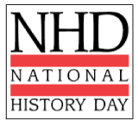
Bibliography Notes - Websites

Website URL
Name of Institution/Organization Affiliate with site. (sometimes this can be found in the copyright statements)
Date of posting/revision
Date you visited site
What did you learn from this Resource?

Website URL
Name of Institution/Organization Affiliate with site. (sometimes this can be found in the copyright statements)
Date of posting/revision
Date you visited site
What did you learn from this Resource?

Website URL
Name of Institution/Organization Affiliate with site. (sometimes this can be found in the copyright statements)
Date of posting/revision
Date you visited site
What did you learn from this Resource?

