April 2013 |  |  | Long Branch Free Public Library
Main Library  328 Broadway  732.222.3900  Mon & Tues 10-8  Wed & Thurs 10-8  Fri & Sat 10-5  Elberon Branch  168 Lincoln Ave.  732.870.1776  Mon 1-4  Tues 9-1  Wed 4-7  Fri 10-2 & 3-5  Sat 10-1  ___________________  www.longbranch.lib.org  “Celebrating 97 years of service to the people of Long Branch”  _________________  Free Tax Help  Continues Until 4/15  See our tax help calendar!  Computer Class Schedule  April 9: Parts of the Computer  April 16: Basic Internet  April 23: Email  April 30: Word | MON | TUES | WEDS | THURS | FRI | SAT
 | Technology Center  Mon-Thurs 11:00-1:30pm  Thurs 5:30-7:30pm  Fri & Sat 1:00-4:30pm  Teen Tech Time @ Main  Mon-Thurs 4:00-5:30pm | Adult Bridge @ Main Tuesdays 1-4pm  Adult Chess Club @ Main Tuesdays 5:30pm | Adult Mah Jong @ Main Wednesdays 11-1 | Adult Bridge @ Main Thursdays 6-7:30pm
 | 1 | 2 Main  Toddler Time 11am  Ages 1-2 (with adult)  Kidz Club 4pm | 3 Elberon  Story Time 4:45pm  Special Musical Program  Elberon Book Club 6pm  Skeletons at the Feast by Chris Bohjalian  Friends of the Library 7pm | 4 Main  Story Time 4pm  Mud Puddles | 5 Elberon  Toddler Time 10am  Ages 1-2 (with adult) | 6 Main  Family Fun 10-4pm  Flowers  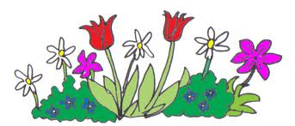
 | 8 Main  Children’s Room Book Club @ 6pm | 9 Main  Toddler Time 11am  Ages 1-2 (with adult)  Kidz Club 4pm | 10 Elberon  Story Time 4:45pm  How Does Your Garden Grow? | 11 Main  Story Time 4pm  Jump, Frog, Jump!  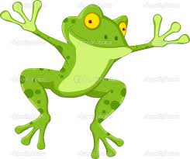 | 12 Elberon  Toddler Time 10am  Ages 1-2 (with adult) | 13 Main  Family Fun 10-4pm  Frog Prince  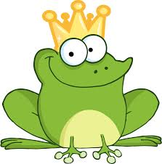
 | 15 Main  National Library Week Begins!  Communities Matter @ Your Library  Library Board Meeting  @ Elberon 7:30 pm | 16 Main  Toddler Time 11am  Ages 1-2 (with adult)  Kidz Club 4pm  Tween Book Club 5:30pm  Chitty Chitty Bang Bang  Paul G. Gaffney II @ 7pm | 17 Elberon  Story Time 4:45pm  Down Came the Rain  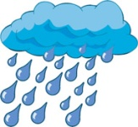 | 18 Main  Story Time 4pm  Welcome Trees!  Non-Fiction Book Club 1:30pm America’s Favorite Poem | 19 Elberon  Toddler Time 10am  Ages 1-2 (with adult) | 20 Main  Family Fun 10-4pm  Earth Day  Meet the Wolves!  11am A Visit from Howling Woods Farm  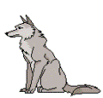
 | 22 | 23 Main  Toddler Time 11am  Ages 1-2 (with adult)  Kidz Club 4pm  Teen Book Club 5:30pm  The Great Gatsby | 24 Elberon  Story Time 4:45pm  Rhyme Time | 25 Main  Story Time 4pm  Splish Splash | 26 | 27 Main  Family Fun 10-4pm  Lots of Laughs  Family Film Day  Les Miserables @ 2pm (PG-13, 2012)
Local History Room  Hours: 11-2  Tuesdays @ Main  or by appointment. | 29 | 30 | Basic Computer Classes  For Adults: Tues. @ Main 1:30-2:30pm  Please check the calendar for dates and topics. | Adult Literacy Classes  Tues. Citizenship  Weds: ESL Intermediate  Thurs: ESL Beginner All classes 6-7:30pm | April is National Poetry Month @Your Library

