APRIL 2015 |  |  |  | Long Branch Free Public Library
Main Library  328 Broadway  732.222.3900  Mon & Tues 10-8  Wed & Thurs 10-8  Fri & Sat 10-5  Elberon Branch  168 Lincoln Ave.  732.870.1776  Mon 1-4  Tues 9-1  Wed 4-7  Fri 10-2 & 3-5  Sat 10-1  www.longbranchlib.org  “Celebrating 99 years of service to the people of Long Branch”  First sponsored in 1958, National Library Week is a national observance sponsored by the American Library Association (ALA) and libraries across the country each April. It is a time to celebrate the contributions of our nation's libraries and librarians and to promote library use and support. All types of libraries - school, public, academic and special - participate. | MON | TUES |  | WEDS | THURS | FRI | SAT
 | Technology Center  Mon-Thurs 11:00-1:00pm  Fri & Sat 2:00-4:00pm  Teen Tech Time @ Main  Mon-Thurs 4:00-5:30pm | Tablet Tuesday  Technology Center  @ 3:30pm on the last Tuesday of the month |  | Adult Mah Jong  @ Main  Wednesdays 11-1 | Adult Bridge  @ Main  Tuesdays 1-4pm  Thursdays 6-7:30pm | Computer Classes resuming!  Technology Center  Sat. 4/11 and Sat. 4/25  10:00-11:30am  Beginner Computer | 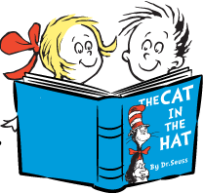
 | Tax Help Available Through April 15th! Call or visit our Website for hours. | Adult Literacy Classes  Tuesdays- Citizenship Class @5:30 |  | 1 Elberon  Story Time 4:45pm  Foolish Fun  Elberon Book Club 6:30  My Name is Mary Sutter  By Robin Oliveira | 2 Main  Story Time 4pm  Bunny Basket! | 3  LIBRARY CLOSED  Good Friday | 4 Main  Family Fun 10-4pm  Funny Bunny
 | 6 Main  Free Blood Pressure Screening by VNA from 3:00pm-4:000pm | 7 Main  Toddler Time 11am  Ages 1-2 (with adult)  Kidz Club 4pm  Teens: “Smart Mouth”’  Word Game |  | 8 Elberon  Story Time 4:45pm  Just Ducky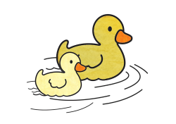 | 9 Main  Story Time 4pm  Rhyme Time  Teens: “Make Your Own Magnetic Words” | 10 Elberon  Toddler Time 10am  Ages 1-2 (with adult) | 11 Main  Family Fun 10-4pm  Poetic Poems  2pm Family Film:  Annie (PG, 2014)
 | 13 Main  National Library Week! |  | 14 Main  Toddler Time 11am  Ages 1-2 (with adult)  Kidz Club 4pm  Teens: “Apples to Apples” | 15 Elberon  Story Time 4:45pm  Time Sprinkles | 16 Main  Story Time 4pm  Chuck E. Cheese  Loves Our Library!  Non-Fiction Book Club 1:30pm  Q: The Autobiography  by Quincy Jones  Teens: Group Poem | 17 Elberon  Toddler Time 10am  Ages 1-2 (with adult)  Main  11 AM: Important Financial Papers Workshop | 18 Main  Family Fun 10-4pm  Build a Book!
 | 20 Main  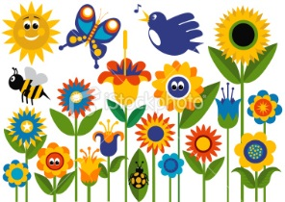 |  | 21 Main  Toddler Time 11am  Ages 1-2 (with adult)  Kidz Club 4pm  Tween Book Club 5:00pm | 22 Elberon  Story Time 4:45pm  Earth Day  Teens: Soda Tabs  Activities | 23 Main  Story Time 4pm  If You Plant a Seed…  Teens: Make A Bookmark For World Book Day! | 24 Elberon  Toddler Time 10am  Ages 1-2 (with adult) | 25 Main  Family Fun 10-4pm  Wonderful Green Earth!  2pm Family Film:  Frozen Sing-Along  (G, 2013)
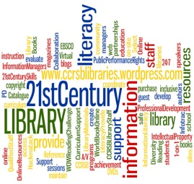 | 27 Main |  | 28 Main  Toddler Time 11am  Ages 1-2 (with adult)  Kidz Club 4pm  Tablet Tuesday @ 3:30pm  Teen Book Club 5:00pm | 29 Elberon  Story Time 4:45pm  Butterfly  Main  7pm Vinnie: Bartender to the Mob author talk & signing | 30 Main  Story Time 4pm  Frogs!  Teens: Sidewalk Chalk |  | 