APRIL 2016 |  |  | Long Branch Free Public Library www.longbranchlib.org
MONDAY | TUESDAY | WEDNESDAY |  | THURSDAY | FRIDAY | SATURDAY
Technology Center  Mon-Thurs 11:00-1:00pm  Fri & Sat 2:00-4:00pm  Teen Tech Time @ Main  Mon-Thurs 4:00-5:30pm | Tablet Tuesday  Technology Center  @ 3:30pm on the last Tuesday of the month | Adult Mah Jongg  @ Main  Wednesdays 11am-1pm |  | Adult Stretch YOGA  Thursdays 5pm  Beginners welcome! Please bring a yoga mat or large towel to class. | Elberon Branch  168 Lincoln Avenue  732.870.1776  Mon 1-4  Tues 9-1 Wed 4-7  Fri 10-2, 3-5  Sat10-1 | Main Library  328 Broadway  732.222.3900  Monday-Thursday  10am-8pm  Friday & Saturday  10am-5pm
Adult Literacy Classes 5:30pm  Mon. ESL  Tues. Citizenship | Adult Bridge  Tuesday afternoons 1-4pm, Thursday 6-7:30pm |  |  | Eat Healthy,  Be Active!  en español  Adult Program 10-11am  April 14th, 21st, 28th | 1 Elberon  Toddler Time 10am  Ages 1-2 (with adult) | 2 Main  Family Fun 10-4pm “LOL”!
4 Main  FREE Blood Pressure Screening 3-4pm  Teens: Arts & Crafts | 5 Main  Toddler Time 11am  Ages 1-2 (with adult)  Kidz Club 4pm  Teens: Volunteer Applications | 6 Elberon  Story Time 4:45pm  Silly Stories  Elberon Book Club 6:30pm  The Paris Wife by Paula McLain at MAIN/Friends meet at 7:30pm  Teens: Career Discussion |  | 7 Main  Story Time 4pm  Umbrellas  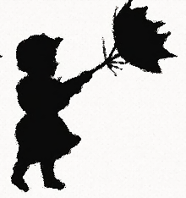  Teens: Teen Job Search | 8 Elberon  Toddler Time 10am  Ages 1-2 (with adult) | 9 Main  Family Fun 10-4pm  Grow My Garden  Family Film Day 2:00  Star Wars: The Force Awakens (PG-13, 2015)
11 Main  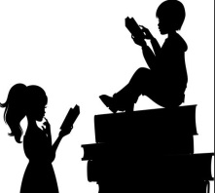  Teens: Group Reading | 12 Main  Toddler Time 11am  Ages 1-2 (with adult)  Kidz Club 4pm  Teens: Planting Flowers | 13 Elberon  Story Time 4:45pm  Ducks in the Library?  Teens: Game Night |  | 14 Main  Story Time 4pm  100 Books!  Non-Fiction Book Club  Mom & Me & Mom by Maya Angelou 1:30pm  Teens: Make Cannoli | 15 Elberon  Toddler Time 10am  Ages 1-2 (with adult) | 16 Main  Family Fun 10-4pm  Love My Librarian  Laughs at the Library with Comedian Mark Brier 2pm
18 Main  Board Meeting  Elberon 7:30pm  Teens: Learn Chess! | 19 Main  Toddler Time 11am  Ages 1-2 (with adult)  Kidz Club 4pm  Tween Book Club:  Death Note 10 | 20 Elberon  Story Time 4:45pm  100 Rain Drops  Teen Movie Night: Hunger Games, Catching Fire |  | 21 Main  Story Time 4pm  100 Frogs  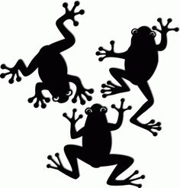  Teens: Cartoon Drawing | 22 Elberon  Toddler Time 10am  Ages 1-2 (with adult) | 23 Main  Family Fun 10-4pm  Jolly Jellies
25 Main  Teens: Guesstures and other fun games | 26 Main  Toddler Time 11am  Ages 1-2 (with adult)  Kidz Club 4pm  Teen Book Club:  Uglies, Shay’s Story | 27 Elberon  Story Time 4:45pm  Tell a Story Day  Teens: Poetry Reading  Author Talk and Signing  Howie Marlin’s Sportalk: In the Presence of Greatness 7pm |  | 28 Main  Story Time 4pm  Quack!  Teens: Nutritious Snack | 29 Elberon  Toddler Time 10am  Ages 1-2 (with adult) | 30 Main  Family Fun 10-4pm  Duck, Duck Goose  