**Run 45 – 5.3km Reynella run**

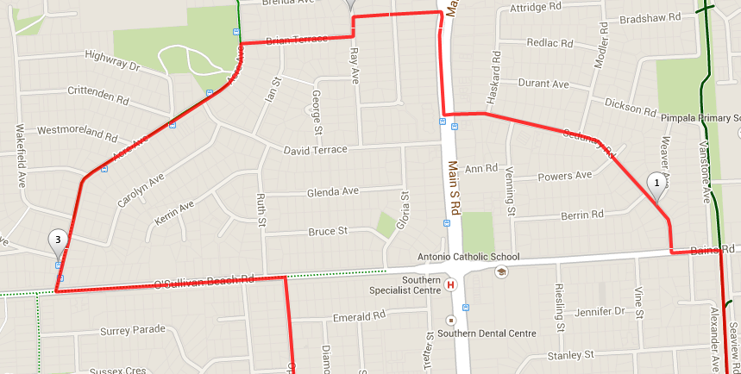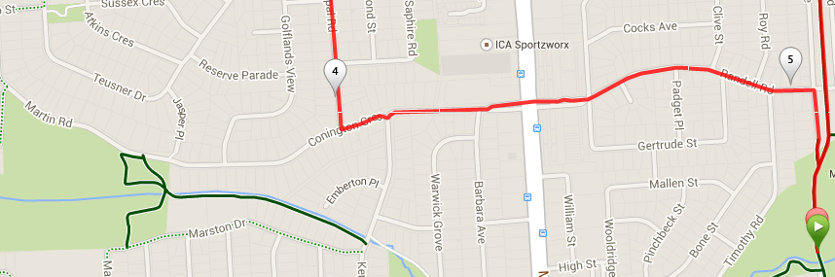

**Directions**

1. Run along the bike track to Bains road
2. Cross over and turn left un Sedunary road and turn right
3. Cross over and turn tight up the hill, after approx. 250 metres turn left into a laneway, then cross the street and take the next laneway then turn left into Ray Ave then right into Brian Terrace
4. At the T-Section turn left into Acre Ave and follow until O’Sullivan’s beach road
5. Cross over and turn right along O’Sullivan’s beach road then turn right into Opal road
6. At the T-Section turn left into Connington Ave and follow across MS road at the lights and continue
7. Just before the bridge turn right and follow back to the park.

**Run 45 – 10.5km Reynella run**

**Directions**

1. Run along the bike track to Bains road
2. Cross over and turn left until Sedunary road and turn right
3. Cross over and turn tight up the hill, after approx. 250 metres turn left into a laneway, then cross the street and take the next laneway then turn left into Ray Ave then right into Brian Terrace
4. At the T-Section turn right into Acre Ave until Sheriffs road
5. Cross over and turn left until Bimbadene road and turn right
6. At the end of this road (when it swings to the right) go straight ahead onto the expressway track and turn left, then right across the footbridge
7. Once across the footbridge turn left and right into Sugarbush road

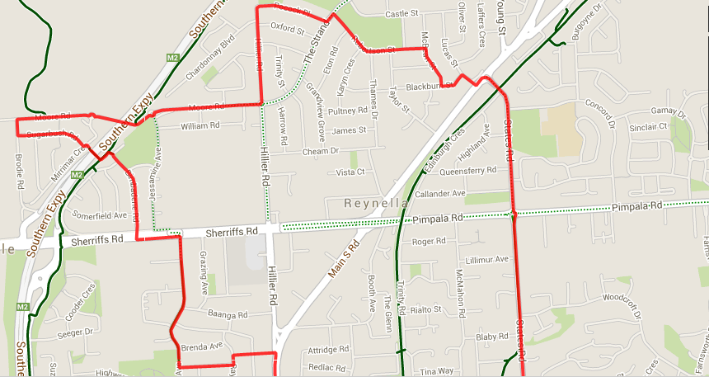 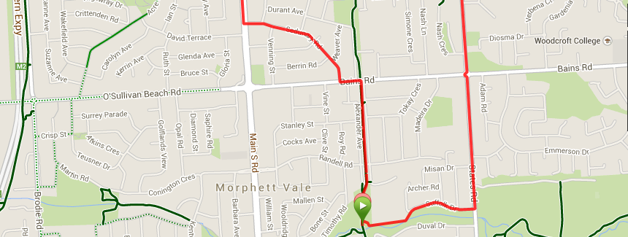

1. At the T-Section turn right, then take the next right into Moore road and follow back across the expressway and continue through the roundabout (left side road) up the hill
2. When you reach the roundabout at the top of the hill turn left into Hillier road and continue to the end, then around to the right as road becomes Pocock Place
3. At the T-section opposite the park turn left, then right into Robertson St. and follow till the end
4. Turn right into McBean St, then left again at the end into Blackburn St
5. Turn right into Lucas St which will bring you back to MS road
6. Cross over and turn left then right into States road
7. Follow States road across Pimpala and Bains roads, until you reach Suffolk Dr (Christies Creek) and turn right
8. Run along Suffolk Dr, then to the left of the school and back over the ‘mound’ to the park

**Run 45 – 21.1km Reynella run**

**Directions**

1. Run to Wheatsheaf road, turn left and follow across States road until Panatalinga road
2. Follow for approx. 3.5km across Bains and Pimpala roads until Reyenll road (Winery) and turn left
3. When you reach the bike track turn left and follow until you get to States road (first road crossing), then turn left onto States road
4. Follow States until you pass Pimpala and Bains road, then just after Christies Creek turn right into Duval Drive
5. Continue to the end and around to the left, then take the first entry onto the bike track and turn right back to the park
6. Run along the bike track to Bains road
7. Cross over and turn left until Sedunary road and turn right

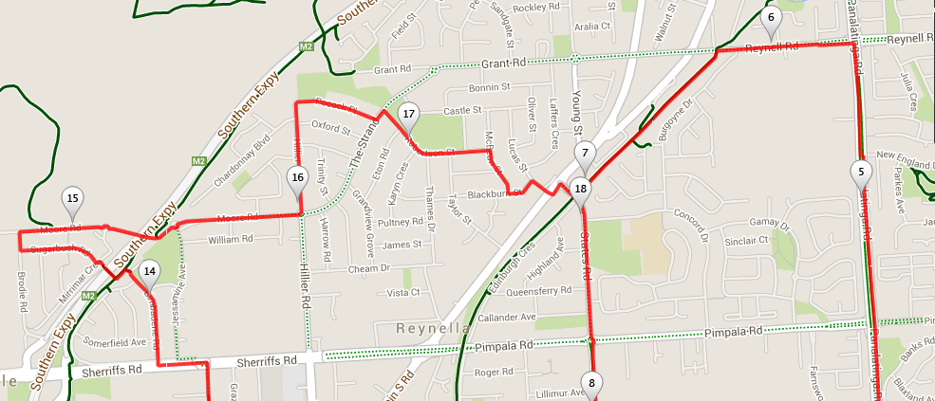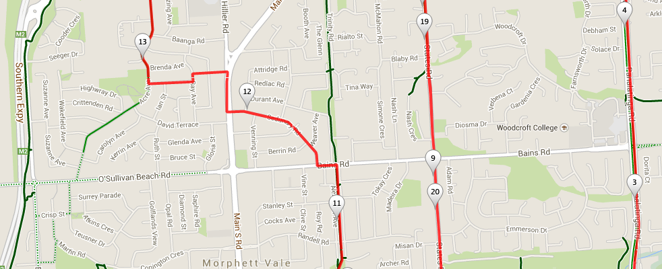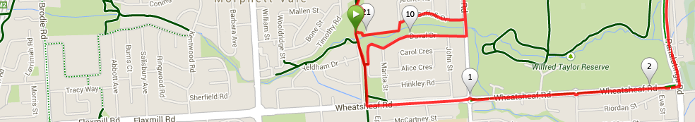

1. Cross over and turn tight up the hill, after approx. 250 metres turn left into a laneway, then cross the street and take the next laneway then turn left into Ray Ave then right into Brian Terrace
2. At the T-Section turn right into Acre Ave until Sheriffs road
3. Cross over and turn left until Bimbadene road and turn right
4. At the end of this road (when it swings to the right) go straight ahead onto the expressway track and turn left, then right across the footbridge
5. Once across the footbridge turn left and right into Sugarbush road
6. At the T-Section turn right, then take the next right into Moore road and follow back across the expressway and continue through the roundabout (left side road) up the hill
7. When you reach the roundabout at the top of the hill turn left into Hillier road and continue to the end, then around to the right as road becomes Pocock Place
8. At the T-section opposite the park turn left, then right into Robertson St. and follow till the end
9. Turn right into McBean St, then left again at the end into Blackburn St
10. Turn right into Lucas St which will bring you back to MS road
11. Cross over and turn left then right into States road
12. Follow States road across Pimpala and Bains roads, until you reach Suffolk Dr (Christies Creek) and turn right
13. Run along Suffolk Dr, then to the left of the school and back over the ‘mound’ to the park