Run 39 – 5.2km Reynell – Woodcroft loop run
c 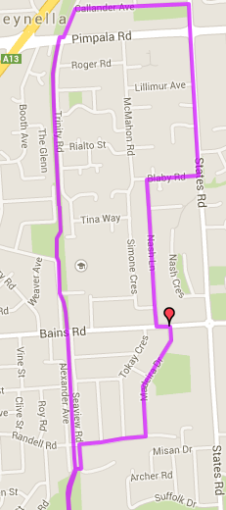
Directions:
- Follow track to Bains road and continue until Pimpala road (Hungry Jacks).
- Join the road on the right side and continue straight ahead till Callender Ave (first right)
- Turn right onto States road, crossing Pimpala road
- Turn right into Blaby road then take the first left into Nasha Lane
- When you reach Bains road, cross over and turn left then right straight away. Follow until T-Section with Randell road and turn right
- At the bridge, turn left down the road and join the track, to the park
Start & Finish

5
4
3
2
1
Start & Finish
Run 39 – 10.2km Reynell-Woodcroft loop run
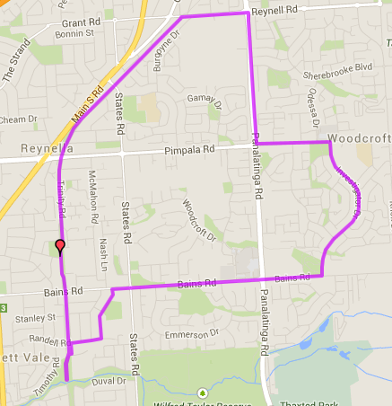
Start & Finish

Start & Finish
Start & Finish
5. Turn right onto Bains and follow across Pantalinga, until States road
- After crossing States road, turn left at the first road on the left and follow until T-Section with Randell road and turn right
- At the bridge, turn left down the road and join the track, to the park

Directions:
- Follow track to Bains road and continue across Pimpala road (Hungry Jacks).
- After Old Reynella bus interchange, turn right onto Reynell road.
- Turn right onto Panatalinga road and follow till Pimpala (Paramount Gym) then turn left
- Opposite the shopping centre turn right into Investigator Drive and follow till Bains road (T-Section)
Run 39 – 21.4km Reynell-Woodcroft loop run
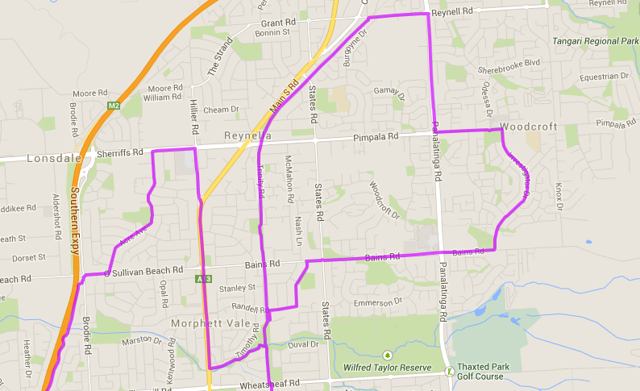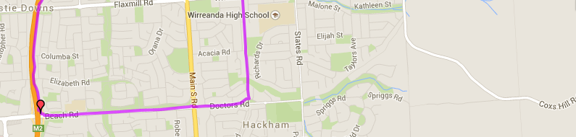
7. Turn into Emu Hotel and continue along the Christies Creek trail until you reach the park
8. Follow track to Bains road and continue across Pimpala road (Hungry Jacks).
9. After Old Reynella bus interchange, turn right onto Reynell road.
10. Turn right onto Panatalinga road and follow till Pimpala (Paramount Gym) then turn left
11. Opposite the shopping centre turn right into Investigator Drive and follow till Bains road (T-Section)
12. Turn right onto Bains and follow across Pantalinga, until States road
- After crossing States road, turn left at the first road on the left and follow until T-Section with Randell road and turn right
- At the bridge, turn left down the road and join the track, to the park

Directions:
- Follow the track towards Wheatsheaf road and continue onto until you reach Doctors road
- Turn right and follow across MS road, continuing along Beach road until you get to the expressway track and turn right
- Follow expressway track until just before O’Sullivan’s Beach road, take exit track then turn right onto O’Sullivans Beach road
- Turn left into Acre Ave and follow till the end – T-Section at Sherriffs road
- Turn right and then turn right again into Hillier road, at the traffic lights near Southgate shopping centre
- Continue onto South road until you reach Emu Hotel (on the left near petrol stations)
Start

Start & Finish

