MV Run # 44 - 5.5km Southern Expressway & Christies Creek run
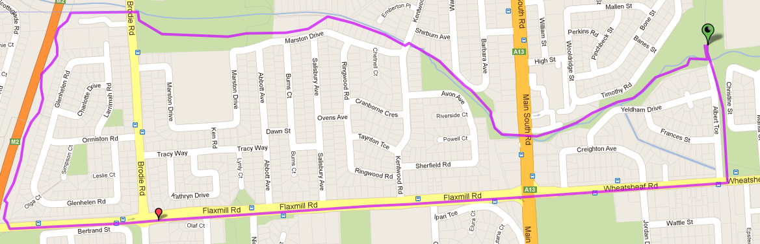
6
5
4
3
2
Start & Finish
1
Directions

- Follow track till Wheatsheaf Road & turn right  - Cross at lights and continue up hill to expressway & turn right onto expressway track  - Follow expressway track till bottom of hill (Christies creek track) and turn right to Brodie Rd | - Cross over at Brodie Rd and take track into park, staying on the right of the lagoon – continue past toilet block until you reach the houses then follow track behind the houses and continue along Christies Creek trail  - After road crossings (continue following track either side of roads along creek) cross park and then take tunnel under MS Road | - Continue through hotel carpark and continue along track, back to the park

MV Run # 44 - 10.8km Southern Expressway run
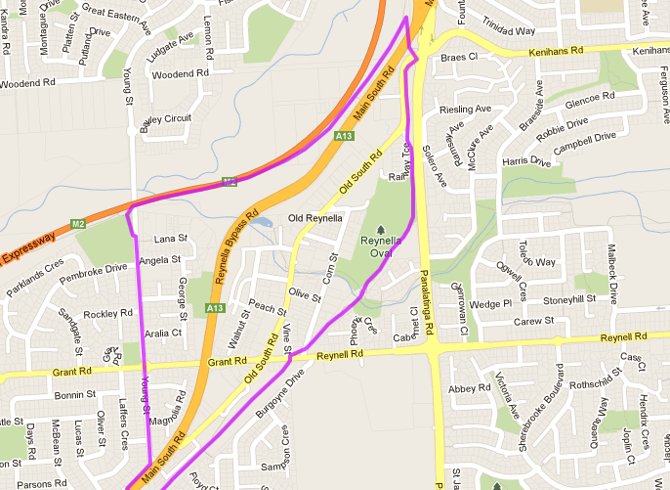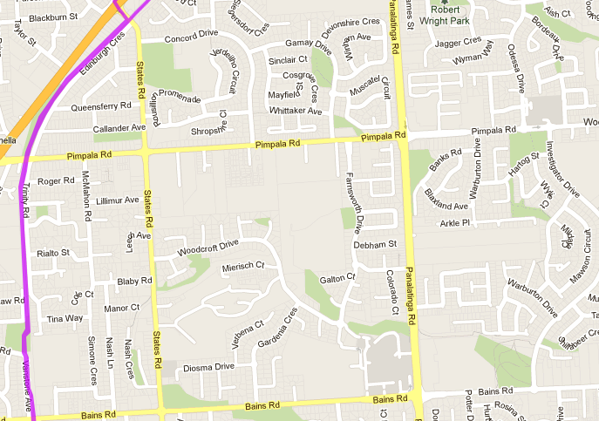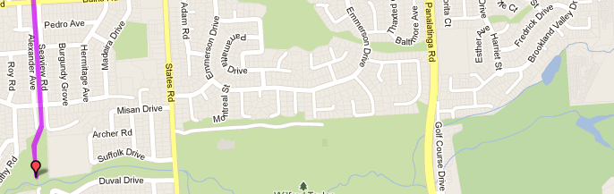
Directions
- Follow track towards Bains Road and continue across Pimpala (Hungry Jacks) until States Road and turn LEFT until MS Road
- Cross MS Road and turn right, then left into Young Street and continue until roundabout – Go straight ahead
- Continue down Young St until expressway entry track on left, just before bridge over expressway
- Take entry track then turn right onto the expressway track and follow until Panatalinga road exit (just before construction works) – take exit to right and follow till traffic lights
- At top of exit track, cross road Old Main road (to the right) and follow a few hundred metres down to the Coast to vines trail
- Join Coast to Vines track to the left and continue to follow track back to the park
6
5
4
3
2
1
Start & Finish
MV Run # 44 – 22.3km Southern Expressway run
4
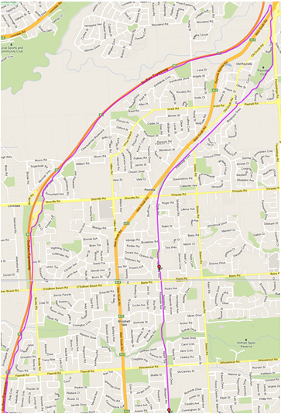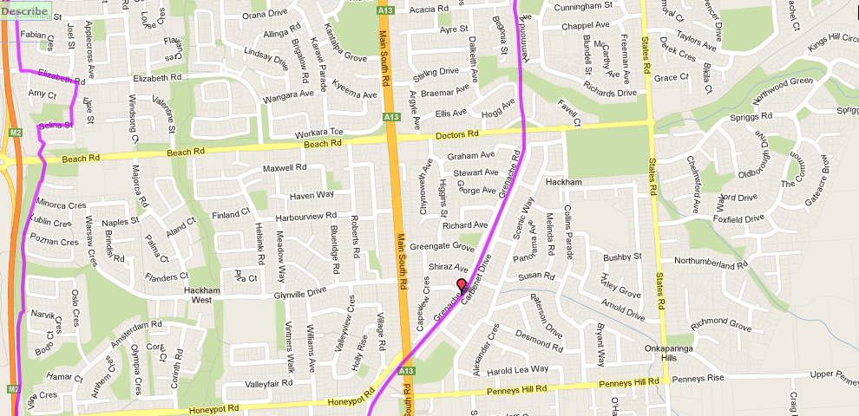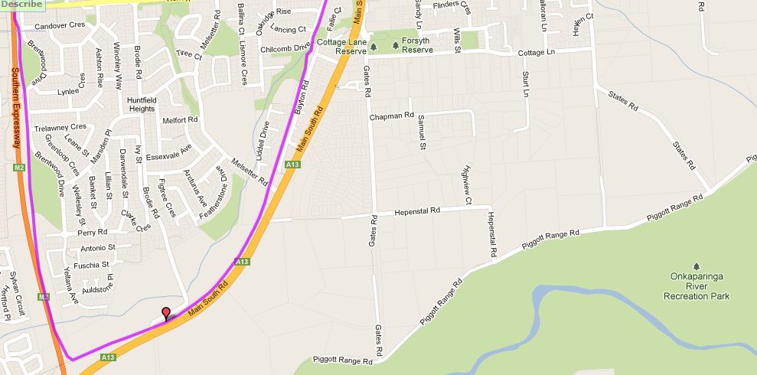
2
1
3
5
6
Directions
- Follow the track towards Wheatsheaf Road – continue along track across Wheatsheaf, Doctor’s and Main South roads
- Continue until you reach the track tunnel under the end section of the expressway – TURN RIGHT onto the expressway track
- Follow expressway track all the way until Panatalinga Road exist
NOTE:
  - The track changes between Honeypot road and Flaxmil road – Simply follow the signs and arrows indicating the adjusted track
  - Small track changes are also in place near Sheriffs road – follow markers and arrows

- At Panatalinga road exit (just before construction works) – take exit to right and follow till traffic lights
- At top of exit track, cross road Old Main road (to the right) and follow a few hundred metres down to the Coast to vines trail
- Join Coast to Vines track to the left and continue to follow track back to the park
Start & Finish

