**Run A17 - 5.3km Port Noarlunga & Christies Beach run**

Take a left and right at Gulfview Road, continuing along Fletcher Dr until you reach Heather St.

Turn left until the Esplanade (coast)

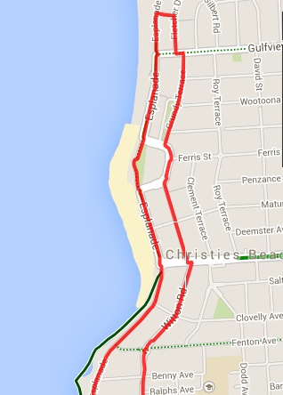 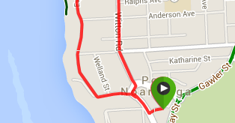

Continue past the jetty, along Saltfleet until Clarke St, and follow back to the carpark.

Turn left onto the Esplanade. Follow the footpath along the track to Christies Beach then on the road, over Witton bluff (the Esplanade) till Port Noarlunga.

Continue behind the caravan park and just after, take the road to the right (Grundy Terrace), continuing in the same direction that you’ve been running

From carpark run out to Saltfleet St and turn right, continuing until Port Noarlunga Hotel and turn right into Gawler St then left again at the T-Section onto Witton road

At Beach road, cross over and go to the left and then right, continuing along Grundy Tce until the T-section near Christies Beach Caravan Park

**Run A17 - 10.7km Port Noarlunga & O’Sullivan’s Beach run**

**Directions:**

1. Cross through the carpark to Gawler St, then continue to follow Murray road up the hill until Dyson
2. Follow the footpath to the left and continue along Dyson, passing Goldsmith, Beach and Gulfview roads
3. Just after the petrol station, join the side road to the left of Dyson road and continue down the hill
4. Cross the footbrifdge and go on, straight ahead up Morrow Road, until the top, then turn left into Baden Tce
5. At the end of Baden Terrace, continue through the carpark and follow the track down the hill to the coast
6. Continue along this track until the boat ramp, then approx 200 metres up the hill turn right onto the bike track
7. Follow the biketrack until the SA water gates then contiue along the track to Christies Beach on over Witton bluff (the Esplanade) till Port Noarlunga
8. Continue past the Jetty, along Saltfleet until Clarke St, and follow back to the carpark.

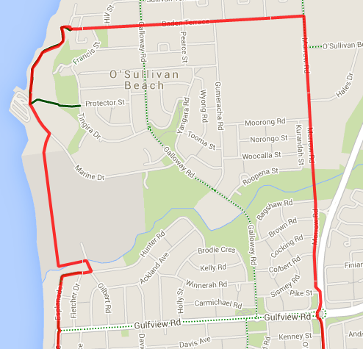 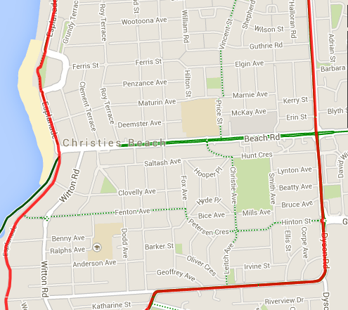 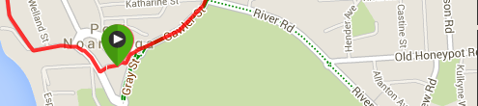

**Run A17 - 20.7km Seaford, Port Noarlunga and O'Sullivan's beach run**

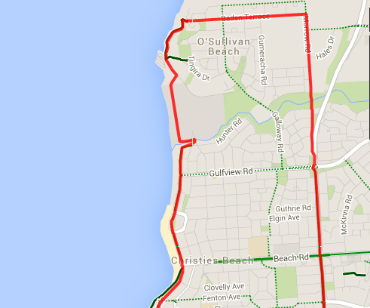 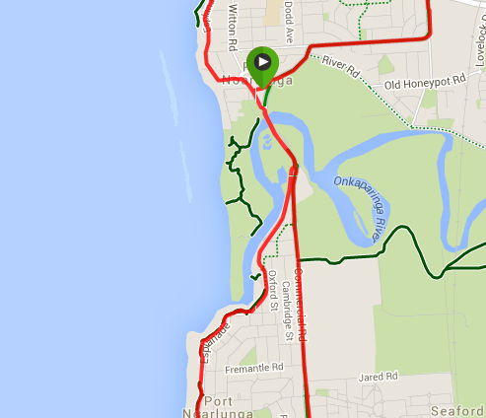 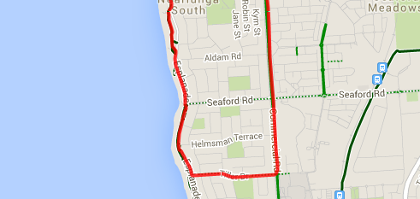

**Directions:**

1. From Beck’s Bakehouse carpark follow access road out to Saltfleet St and turn left
2. Cross Saltfleet bridge and continue through the roundabout along Commercial road
3. Cross Seaford road, and continue along Commercial road
4. Just after the McDonalds resturant turn right into Tiller Drive, and follow until the Esplanade bike trac
5. Turn right onto the coastal bike track and continue along this track, staying on the coast and river until you get back to Saltfleet bridge and return to the carpark the same way that you started

**JOIN WITH 10K RUNNERS**

1. Cross through the carpark to Gawler St, then continue to follow Murray road up the hill until Dyson
2. Follow the footpath to the left and continue along Dyson, passing Goldsmith, Beach and Gulfview roads
3. Just after the petrol station, join the side road to the left of Dyson road and continue down the hill
4. Cross the footbrifdge and go on, straight ahead up Morrow Road, until the top, then turn left into Baden Tce
5. At the end of Baden Terrace, continue through the carpark and follow the track down the hill to the coast
6. Continue along this track until the boat ramp, then approx 200 metres up the hill turn right onto the bike track
7. Follow the biketrack until the SA water gates then contiue along the track to Christies Beach on over Witton bluff (the Esplanade) till Port Noarlunga
8. Continue past the Jetty, along Saltfleet until Clarke St, and follow back to the carpark.