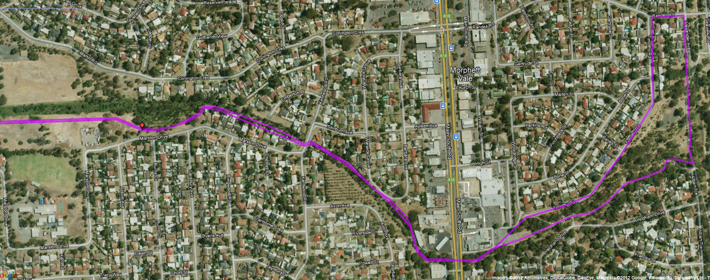
Follow the trail along the left side of the lagoons – at the end (Brodie Rd), go 50 mtrs to the right then cross the road and follow the trail under the freeway
10km – Straight ahead at the bench seat – down the hill to the tunnel
10km return – up the hill to the left of the trail to the top then right and right again (back to the park)
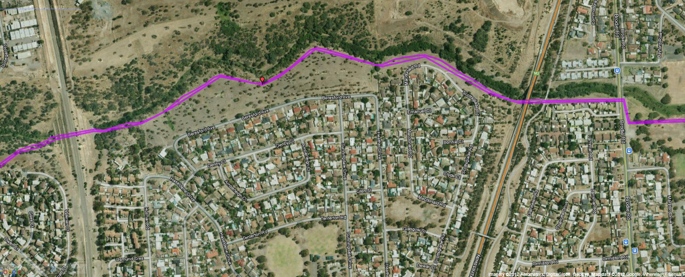
Cross Dyson Road at the bridge and go 200 mtrs then turn left at the pathway and across the foot bridge
5km turn around point
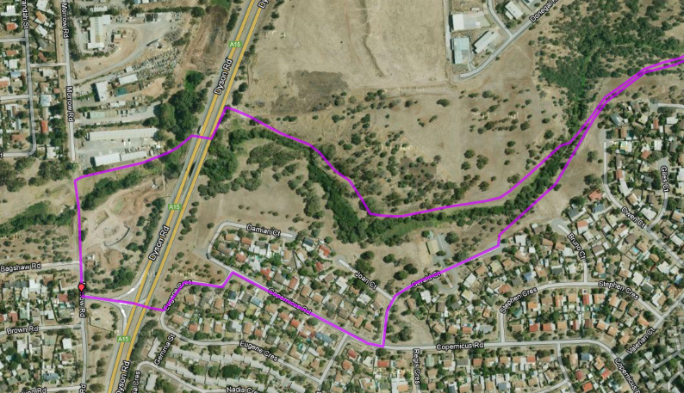
Go to the left of the houses at the end of this street and follow the track back to the outbound trail

Run 2 – 17.2km Christies Creek Trail run
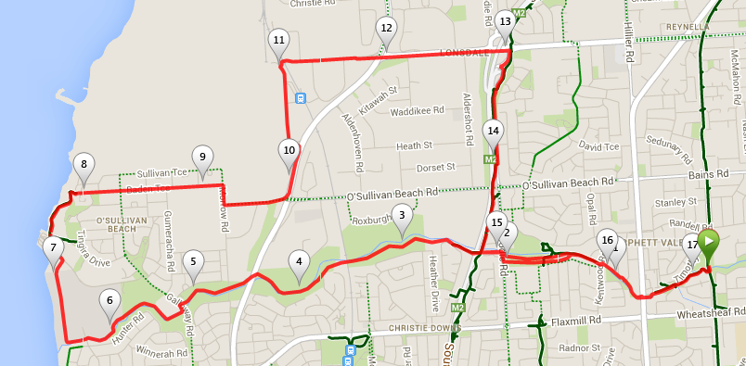
Directions:
- From the park follow the Christies creek trail – passing (under) Main South Road until the wetlands
- Once at Brodie Road turn right then left before crossing over the creek and continue along the creek trail
- After another km or so when the track swings to the left (near a bench seat), take the rough track to the right/straight ahead and pass through the tunnel under the railway line. On the other side continue to follow the trail
- After crossing the creek and reaching Dyson road, cross over and re-join the trail near the bridge and continue on until O’Sullivan’s beach school
- At the school cross the road then turn down the hill) near the entrance of the school) then right and continue to follow the fence line and trail – this will lead you to the SA water plant entry
- Continue straight ahead and follow the bike track as it goes along the coast line towards O’Sullivan’s Beach. When you reach the road above the marina, turn left and pass by the marina office and go straight ahead onto the gravel trail
- Follow the track as it goes around the coast, then up the hill to Baden Tce and go straight ahead
- At the end of Baden Tce turn right, then take the next left into O’Sullivan’s beach road. At the Dyson road traffic lights turn left until the next road on the left – turn left and follow this road till the end - railway footbridge
- Cross the footbridge and continue along Sherriffs road until you pass the expressway, then turn right and follow the expressway track until you get to the bottom of the hill where the expressway passes over the Christies Creek trail again – Turn left and re-join the Creek trail through the wetlands and back to the park

