SRG 5.3km Rocky Creek Hut Christmas 'Away' run
Continue to follow track and markers, continuing to the right when you meet another dirt road just after the 3km mark
At approx. 2.5km, turn hard right through the forest
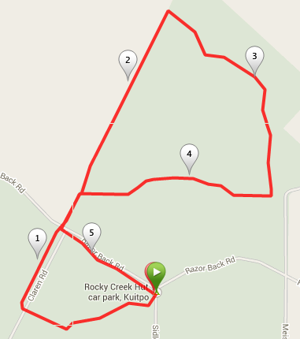
Follow Red & white trail markers & arrow signs
Once you cross Razorback road again turn left immediately and follow track along fence line back to the car park
At a T-Section turn right and continue along this main track until you reach the fenceline and turn LEFT, back towards Razorback road
Follow track between fence line and forest straight ahead after crossing road.
Start from Rocky Creek Hut carpark and follow Heysen trail markers to the right until you reach Razorback road

SRG 10.2km Rocky Creek Hut Christmas 'Away' run
7. Follow road to the left and then left again
6. Follow Heysen trail signs until road and continue along trail to the left
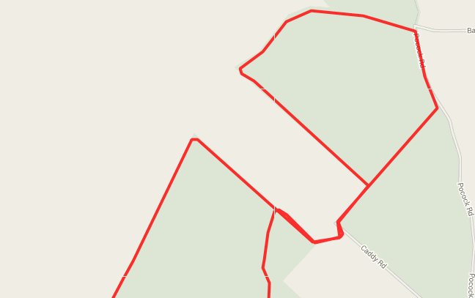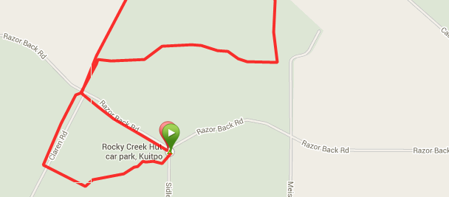
10. Continue along this track until T-section
1. Start from Rocky Creek Hut carpark and follow Heysen trail markers to the right until you reach Razorback road
2. Follow track between fence line and forest straight ahead after crossing road.
12. Once you cross Razorback road again turn left immediately and follow track along fence line back to the car park
11. At a T-Section turn right and continue along this main track until you reach the fenceline and turn LEFT, back towards Razorback road
9. After crossing fence stiles again start along the track followed earlier (opposite way) then turn left after approx. 250 metres
8. Follow road till T-section then turn left and cross wetlands again
5. Use raised foot bridge to cross wetlands area then go to the right until you reach the next fence stile and cross over
Follow Red & white trail markers & arrow signs and Heysen Trail signs
4. At the end of this track at the fence cross over fence using stile and cross over open section
3. At the end of the forest section turn right and continue between fence line and forest

