**SRG Trail Run – 9.5km**

Towards end, turn left back to the cars when you reach main track

*Onkaparinga River National Park*

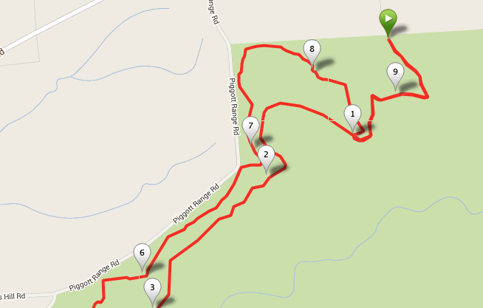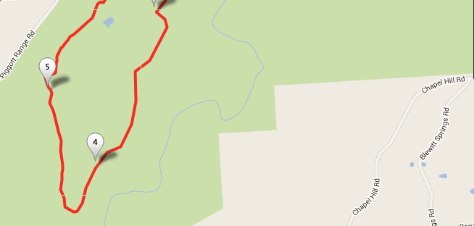

*Nature Trail*

***Sundews Ridge Hike***

***Echidna Trail***

Near gate - Turn right at sign board then left onto Nature Trail

Left turn onto Echidna Trail

Follow Nature Trail

Continue straight up track first then when joining track towards end, turn right towards Bakers Gully Track

Cross over road and continue along single track

Turn left towards Lookout. Just before lookout, turn right down Sundews Ridge track