SRG Run # 6 – 10.1km Pimpala loop
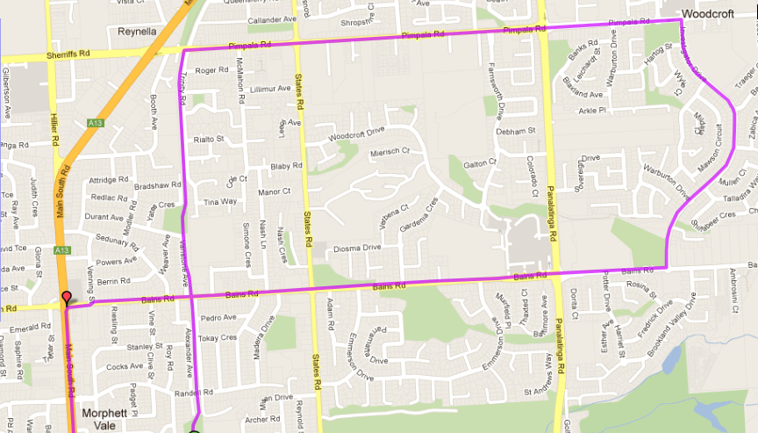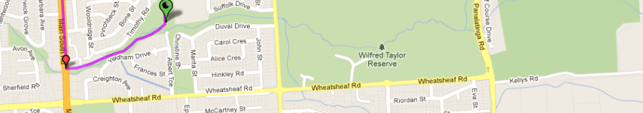

Directions:
- From the park head up the Bike track, Cross Bains road and continue to Pimpala Rd (Hungry Jacks/Junk Food Corner)
- Turn right and follow Pimpala across States Road and to Panatalinga Rd (Paramount Gym). Cross Panatalinga and continue along Pimpala till you go through a roundabout near the shopping centre on left (Park area on Right)
- Turn right at the roundabout (opposite Shopping centre car park) into Investigator Drive. Follow road all the way to the end (Roundabout T-Section with Bains Road)
- Turn right into Bains road. Cross Panatalinga (Woodcroft Shopping centre), States Road (Corner shops) and run till Main South Road lights
- Turn left and go downhill till Emu hotel
- Turn left into the Emu hotel carpark and follow the track back to the path.
SRG # 6 – 5.0km Pimpala loop
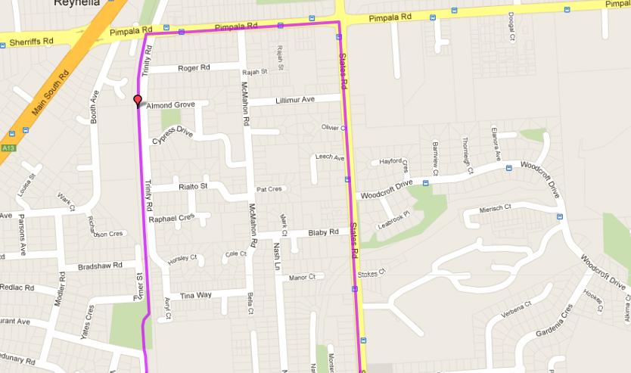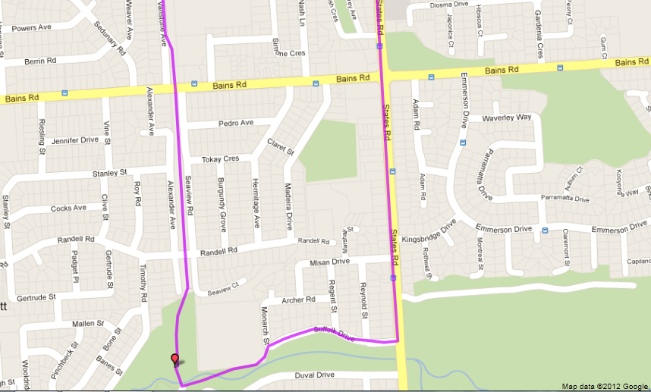

Directions:
- From the park head up the Bike track, Cross Bains road and continue to Pimpala Rd (Hungry Jacks/Junk Food Corner)
- Turn right and follow Pimpala until States Road (Roundabout with shops on left and park on right)
- Follow States Rd across Bains Rd until Christies Creek (opposite Sports fields)
- Turn right into Suffolk Drive until the school then take tunnel to Park and finish

Run # 6 – 20.0km Pimpala loop
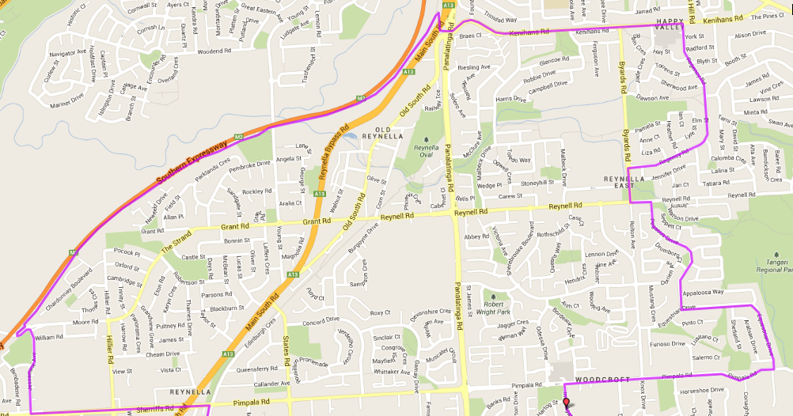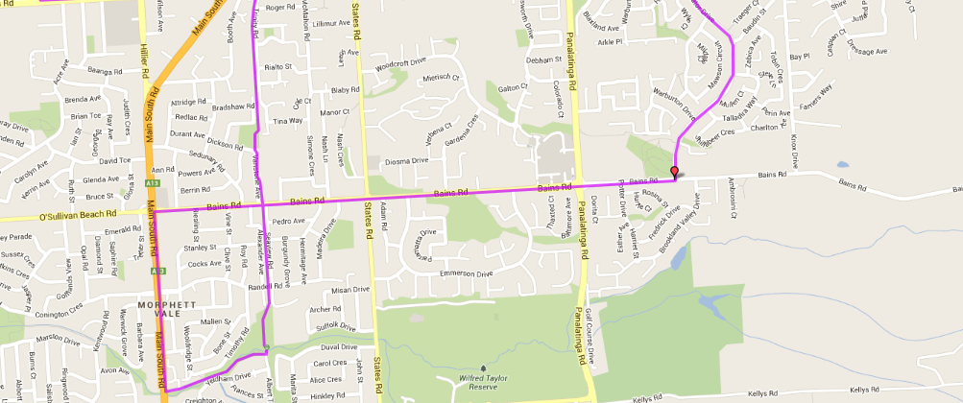
3. Turn left towards Moor Rd bridge (over expressway) then take entry ramp onto expressway track and turn right (towards Panatalinga Rd)
4. Follow track until you reach Panatalinga Rd expressway entry then take exit up to traffic lights and cross over towards Bus interchange car park
5. Follow Kenihans Rd till shops and McDonalds and turn right into Regency Rd. Follow until T-Section with Byards Rd
6. LEFT into Byards then left into Reynell Rd THEN first right into Pegasus Dr (Wake Glen Up).
7. At the end T-Section turn left into Equestrian Dr and follow till Pimpala Road
8. Turn right into Pimpala and follow till Investigator Dr (opposite shopping centre) and turn left. Follow road all the way to the end (Roundabout T-Section with Bains Road)
9. Turn right into Bains road. Cross Panatalinga (Woodcroft Shopping centre), States Road (Corner shops) and run till Main South Road lights
10. Turn left and go downhill till Emu hotel
11. Turn left into the Emu hotel carpark and follow the track back to the path.

Directions:
- From the park head up the Bike track, Cross Bains road and continue to Pimpala Rd (Hungry Jacks/Junk Food Corner)
- Turn left and cross traffic lights. Follow Sheriffs Rd till just after Radio transmitter aerial/tower and turn right into Jessamine Ave. Follow Jessamine til roundabout near expressway

