Run 20 - Christies Creek & O'Sullivan's 5.2km run
Directions
- Follow Christies Creek trail towards Emu hotel. Just before Main South rd, take track to left and through tunnel.
- Follow track until park and cross to the road. Just past the left side footbridge, take gravel pathway on the left and continue to follow creek
- Cross road and continue along creek trail until lagoons. Stay on left hand trail until you reach Brodie Road and turn right
- Pass shops and continue up road until roundabout. Turn right into O’Sullivans Beach Rd
- Follow O’Sullivan’s beach road until MS Road. Cross road and continue up Bains Rd till bike track
- Turn right into bike track and follow back to park
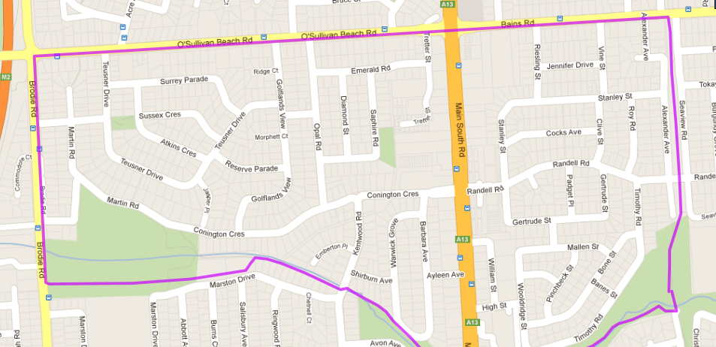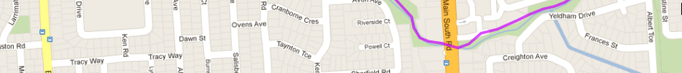
1
6
5
4
3
2

Run 20 - 10.0km Christies Creek & Morphett Vale loop
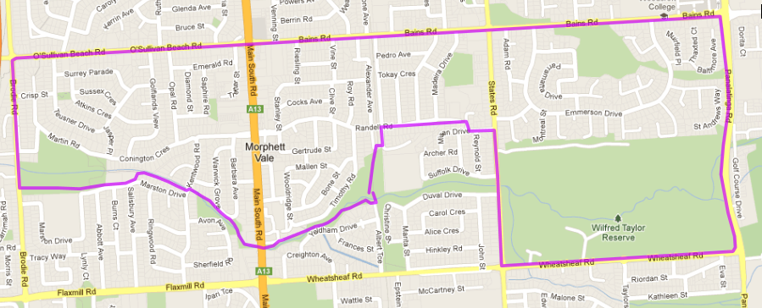
11
10
9
8
4
5
6
7
- Follow Wheatsheaf Rd until States Rd roundabout and turn right
- Cross over Christies Creek (Past Duval & Suffolk Dr) until Misan Drive & turn left and then right into Marshall St
- Turn left into Road (across verge) and follow (Randell Rd) back to the Bike Track
- Turn left and follow back to park
- Pass shops and continue up road until roundabout. Turn right into O’Sullivans Beach Rd
- Follow O’Sullivan’s beach road until MS Road. Cross road and continue up Bains Rd till bike track
- Continue along Bains Rd, crossing States until Panatalinga (Woodcroft shops) & turn right
- Continue until Wheatsheaf road and turn right
3
Directions
- Follow Christies Creek trail towards Emu hotel. Just before Main South rd, take track to left and through tunnel.
- Follow track until park and cross to the road. Just past the left side footbridge, take gravel pathway on the left and continue to follow creek
- Cross road and continue along creek trail until lagoons. Stay on left hand trail until you reach Brodie Road and turn right

2
1
3
2
1

Run 20 – 19.6km Christies Creek & Morphett Vale loop
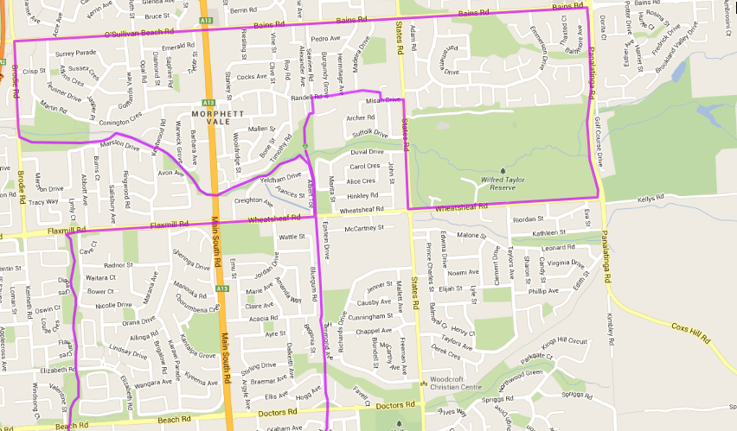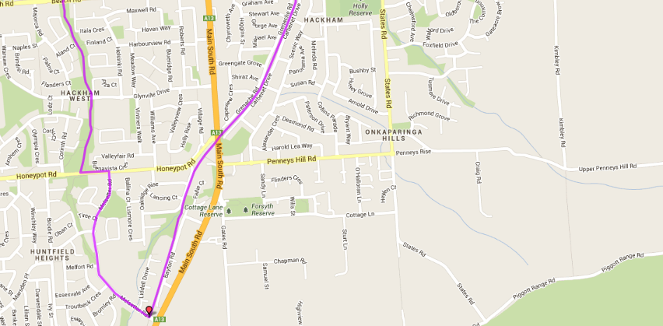
- Continue along Bains Rd, crossing States until Panatalinga (Woodcroft shops) & turn right
- Continue until Wheatsheaf road and turn right
- Follow Wheatsheaf Rd until States Rd roundabout and turn right
- Cross over Christies Creek (Past Duval & Suffolk Dr) until Misan Drive & turn left and then right into Marshall St
- Turn left into Road (across verge) and follow (Randell Rd) back to the Bike Track
- Turn left and follow back to park
- Follow track until park and cross to the road. Just past the left side footbridge, take gravel pathway on the left and continue to follow creek
- Cross road and continue along creek trail until lagoons. Stay on left hand trail until you reach Brodie Road and turn right
- Pass shops and continue up road until roundabout. Turn right into O’Sullivans Beach Rd
- Follow O’Sullivan’s beach road until MS Road. Cross road and continue up Bains Rd till bike track

Directions
- Follow track to Wheatsheaf road and continue on, crossing Doctors Road and Main South Road (Near Honeypot Rd)
- At next Road crossing (Near Irish Hotel) turn right into Melsetter road and continue until T-Section with Honeypot road
- Cross road and turn left onto Honeypot then at the bottom of the hill turn right onto the bike track through the park
- Follow bike track across Glynville Drive (IGA), Beach Road, under Elizabeth Rd until Flaxmill Rd (path goes through tunnel)
- Turn right and follow Flaxmill to Main South road and continue on to bike track – turn left and return to park
- Just before bridge at park turn left past the car park and follow Christies Creek trail towards Emu hotel. Just before Main South rd, take track to left and through tunnel.

