Run 27 - 5.1km Emmerson Run

**4**

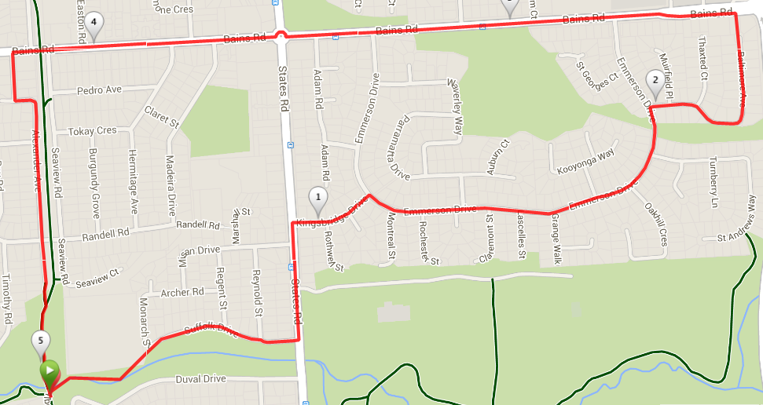

**6**

**5**

**3**

**2**

**1**

**Directions**

1. From the park, cross over the mound hill pass the school and follow Suffolk road until States rd.
2. Cross over and turn left until you reach Kingsbridge and turn right, then right again into Emmerson Drive
3. After 1km turn right into Baltimore Ave and follow until Bains Road (T-Section)
4. Turn left and follow Bains until Bike track at top of hill
5. PASS THE BIKE TRACK then take the next left into Alexander Ave
6. Follow Alexander Ave as it swings to the left then to the right and continue on this road until you reach the park

Run 27 – 10.3km Emmerson Run

**Directions**

1. From the park, cross over the mound hill pass the school and follow Suffolk road until States rd.
2. Cross over and turn left until you reach Kingsbridge and turn right, then right again into Emmerson Drive
3. After 1km turn right into Baltimore Ave and follow until Bains Road (T-Section)
4. Turn right then left onto Panatalinga Road, and cross at the lights
5. Near the petrol station take the footpath/track to the left until you reach the creek – TURN LEFT ALONG THE CREEK until you reach the roundabout behind Woodcroft shops
6. Continue through the roundabout onto Woodcroft Drive, and continue until the end (T-Section at States Road)
7. Turn right along States road till Pimpala Road roundabout and turn right again

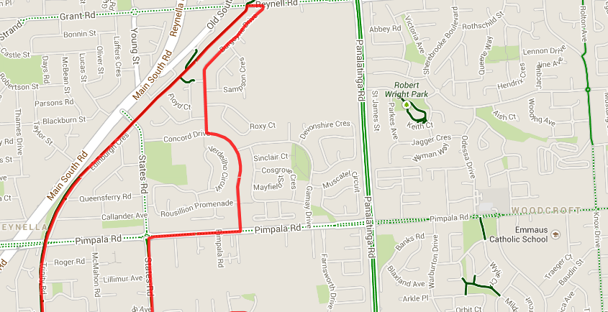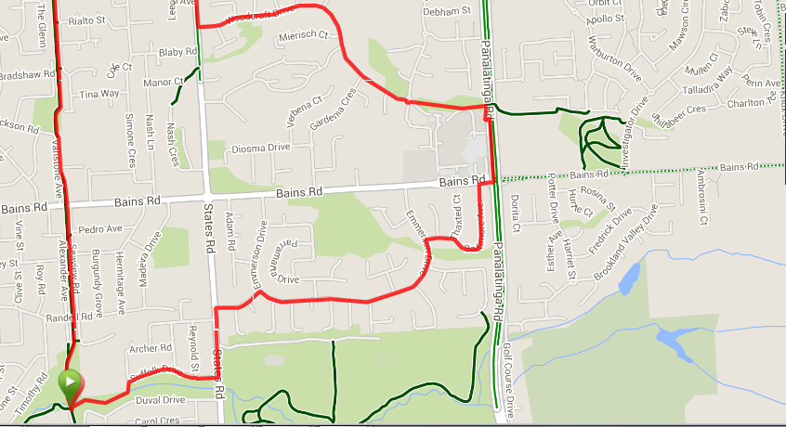

**9**

**8**

**7**

**6**

**5**

**4**

**3**

**2**

**1**

1. Take the first left into Concord Drive then the 2nd right into Burgoyne drive until the end (Reynell road)
2. Turn left then left again onto the bike track, and follow the track back to the park

Run 27 – 20.5km Emmerson Run

**Directions**

1. Follow bike track towards Wheatsheaf road and continue across Wheatsheaf & Doctors, till you reach Main South road
2. Turn left into Main South road and cross at Traffic lights, continuing on the Service road into Gates road
3. Turn left near the petrol station into Cottage lane and follow to the end (States road)
4. Follow States across Penney Hills road, then at the bottom of the hill turn right into Foxfield Dr
5. When you reach the roundabout, turn left into Spriggs road and return to States road and TURN RIGHT
6. Pass Doctors road then turn left into Richards Drive and continue until you again reach States road. Turn left
7. At Wheatsheaf road roundabout turn left and follow Wheatsheaf till the park and follow back to the bike track and turn right back to the park

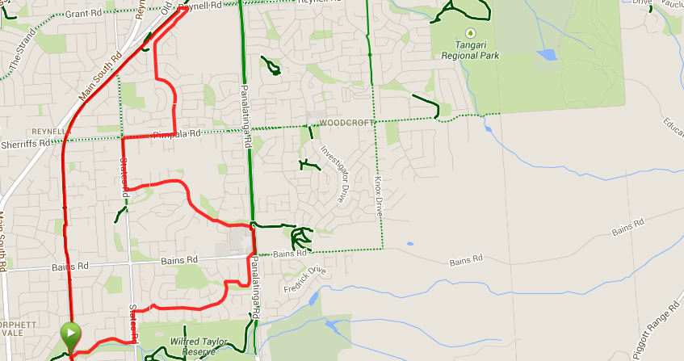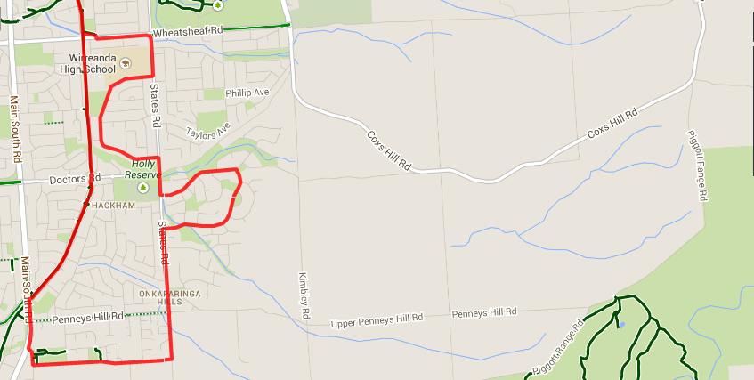

1. Near the petrol station take the footpath/track to the left until you reach the creek – TURN LEFT ALONG THE CREEK until you reach the roundabout behind Woodcroft shops
2. Continue through the roundabout onto Woodcroft Drive, and continue until the end (T-Section at States Road)
3. Turn right along States road till Pimpala Road roundabout and turn right again
4. Take the first left into Concord Drive then the 2nd right into Burgoyne drive until the end (Reynell road)
5. Turn left then left again onto the bike track, and follow the track back to the park
6. From the park, cross over the mound hill pass the school and follow Suffolk road until States rd
7. Cross over and turn left until you reach Kingsbridge and turn right, then right again into Emmerson Drive
8. After 1km turn right into Baltimore Ave and follow until Bains Road (T-Section)
9. Turn right then left onto Panatalinga Road, and cross at the lights