**Run 50 – 5.1km Morphett Vale Loop run**

**5**

**Directions**

1. Follow the track towards Bains road then go to the right onto Seaview Road until Randell Road and turn right
2. Take the 2nd left into Hermitage Ave and run to the end.
3. Cross Bains Road then turn right and Left into Nash Lane
4. Run to the end then turn right into Blaby Road and left at the end into States road
5. Continue through the Pimpala Road roundabout then take the next left into Callender Ave
6. At the end turn left into Edinburgh Cres until Pimpala road
7. Continue ahead on the bike track and follow back to the park

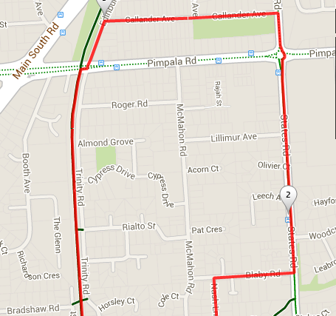 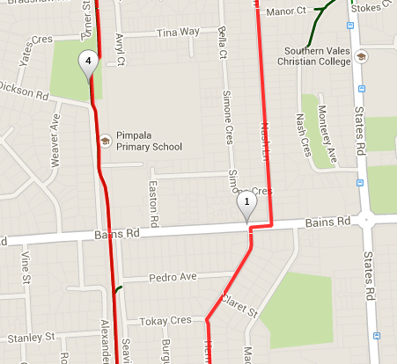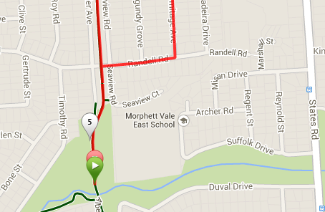

**4**

**6**

**3**

**2**

**1**

**Run 50 – 10.2km Morphett Vale Loop run**

**6**

**Directions**

1. Follow the track towards Bains road then go to the right onto Seaview Road until Randell Road and turn right
2. Take the 2nd left into Hermitage Ave and run to the end.
3. Cross Bains Road then turn right and Left into Nash Lane
4. Run to the end then turn right into Blaby Road and left at the end into States road
5. Continue through the Pimpala Road roundabout until the end of States road (Intersection with MS Road)
6. Cross MS Road and turn Left, then right into Lucas St (top side of Petrol station)
7. Take the first left into Blackburn St and follow till the end
8. At the T-Section turn left then right into Humble St then left again to into Thames Drive
9. Continue to the end, then turn right into Cheam Drive
10. At the T-Section turn left into Hillier Road and follow this across Sheriffs road (Southgate shopping centre)
11. Before Hillier road joins MS Road turn right into Baanga Road and follow till the end

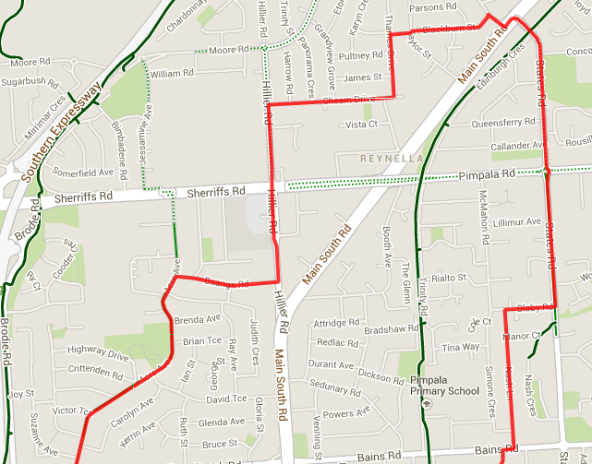 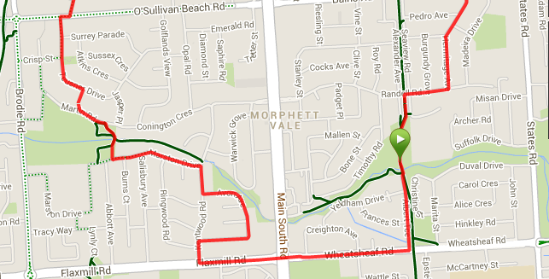

**19**

**17**

**15**

**13**

**12**

**10**

**8**

**2**

**4**

**1**

1. Turn left into Acre Ave until you reach O’Sullivan’s Beach road
2. Cross O’Sullivans Beach road then turn right and left into Teusner Drive
3. After this road swings to the left, take a laneway between hours to the right, Joining Martin road (Opposite Wetlands)
4. Continue briefly on Martin road before turning right onto the wetlands track, crossing the footbridge till you reach the toilet block – Continue straight ahead till you reach Marston Drive
5. Turn left into Marston Drive and run till the end then turn right into Kentwood Rd
6. Turn left into Avon Ave and continue till it loops back to Kentwood road
7. Turn left into Kentwood, then left again into Flaxmill road
8. Continue across MS Road and along Wheatsheaf road till Albert Ave. Turn left and follow back to the park.

**Run 50 – 20.4km Morphett Vale Loop run**

**Directions**

1. From the park, cross over the hill, and to Suffolk road until States road, and turn right
2. Turn left into Wheatsheaf and continue till Panatalinga then turn right until the track through to Doctors Road
3. Follow track to Doctors road then turn left onto States road and continue till Cottage lane
4. Turn right and follow Cottage lane till the end then turn right, and continue across Penney Hills Road until the bike track – Follow the track back to the park
5. Continue past the park towards Bains road then go to the right onto Seaview Road until Randell Road and turn right
6. Take the 2nd left into Hermitage Ave and run to the end. Cross Bains Road then turn right and Left into Nash Lane
7. Run to the end then right into Blaby Rd and left at the end into States road until the end
8. Cross MS Road and turn Left, then right into Lucas St (top side of Petrol station) and take first left into Blackburn St and follow till the end
9. At the T-Section turn left then right into Humble St then left again to into Thames Drive

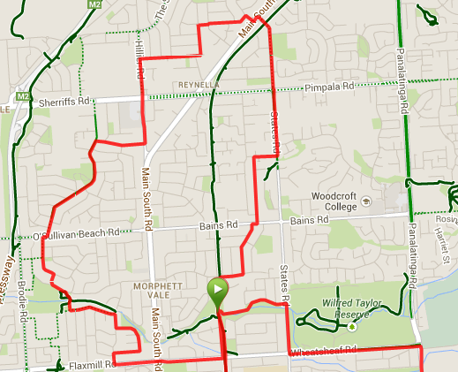 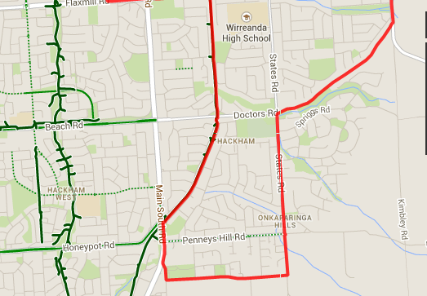

1. Turn left into Marston Drive and run till the end then turn right into Kentwood Rd
2. Turn left into Avon Ave and continue till it loops back to Kentwood road
3. Turn left into Kentwood, then left again into Flaxmill road
4. Continue across MS Road and along Wheatsheaf road till Albert Ave. Turn left and follow back to the park.
5. Turn left into Acre Ave until you reach O’Sullivan’s Beach road
6. Cross O’Sullivans Beach road then turn right and left into Teusner Drive
7. After this road swings to the left, take a laneway between hours to the right, Joining Martin road (Opposite Wetlands)
8. Continue briefly on Martin road before turning right onto the wetlands track, crossing the footbridge till you reach the toilet block – Continue straight ahead till you reach Marston Drive
9. Before Hillier road joins MS Road turn right into Baanga Road and follow till the end
10. Continue to the end, then turn right into Cheam Drive
11. At the T-Section turn left into Hillier Road and follow this across Sherriffs road (Southgate shopping centre)