Run 18 - 5.8km Morphett Vale Expressway Loop
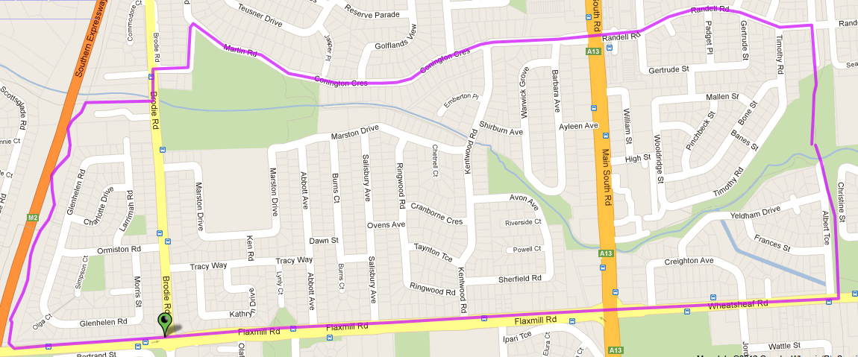
7
6
5
4
3
2
1
Directions

- Follow track till Wheatsheaf Road & turn right  - Cross at lights and continue up hill to expressway & turn right onto track (for shorter 5.1km route, turn right at Ambulance station roundabout – Brodie Rd) | - Follow expressway track till bottom of hill (Christies creek track) and turn right to Brodie Rd (shorter route re-joins)  - Left at Brodie Rd then first right into Bayford Rise – follow around corner till T-Section | - Turn right onto Martin Rd (turns into Connington Cres) and continue until MS Road (near coffee shop)  - Continue straight ahead onto Randell Rd and follow till Bridge over track  - Turn right and follow back to park

Run 18 - 10.9km Track & Expressway run
Directions
- Follow track across Wheatsheaf Road and onto Beach Rd & turn right
- Cross at lights and continue until expressway & turn right onto track (for shorter 10.3km route, turn right at just after pedestrian lights and continue onto Brodie Rd)
- Follow expressway track past Flaxmill & O’Sullivan’s beach Rds until Sherriffs Rd – Turn right
- Follow Sherriffs Rd till Hillier Rd (Southgate Shopping Centre) and turn right
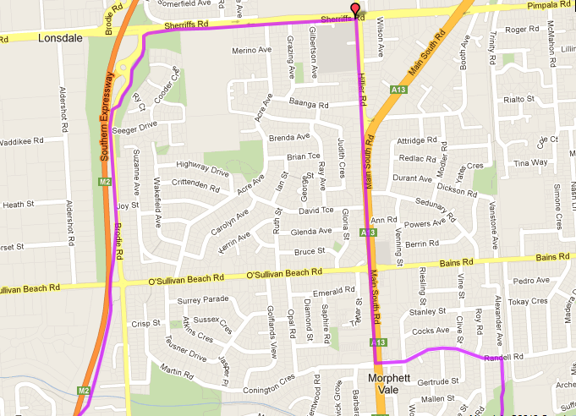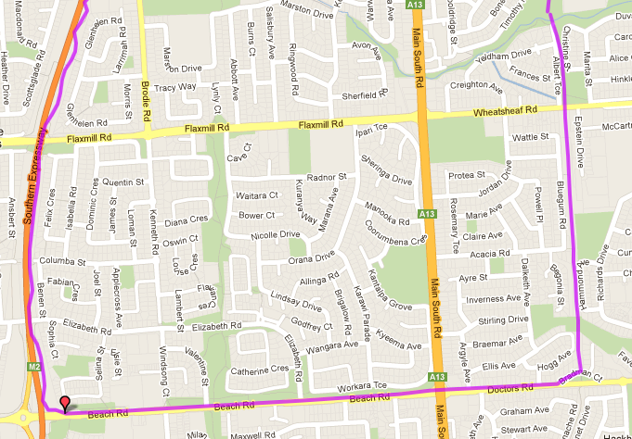
7
5
6
4
3
1
5. Follow Hillier Rd & MS Rd till lights near coffee shop and turn left onto Randell Rd
6. Continue straight ahead onto Randell Rd and follow till Bridge over track
7. Turn right and follow back to park
2
Run 18 – 20.7km Track & Expressway
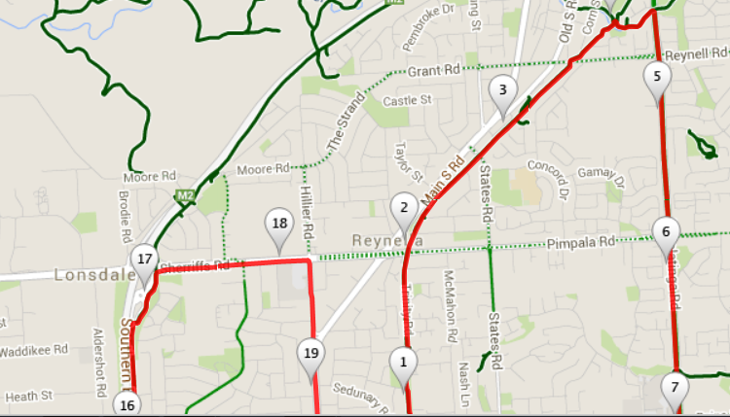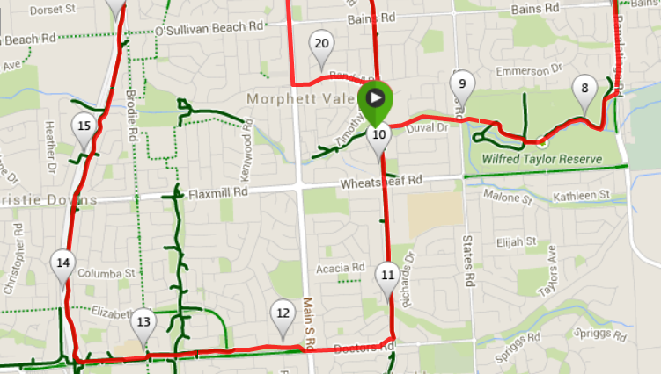
- Follow expressway track past Flaxmill & O’Sullivan’s beach Rds until Sherriffs Rd – Turn right
- Follow Sherriffs Rd till Hillier Rd (Southgate Shopping Centre) and turn right
- Follow Hillier Rd & MS Rd till lights near coffee shop and turn left onto Randell Rd
- Continue straight ahead onto Randell Rd and follow till Bridge over track
- Turn right and follow back to park
Wheatsheaf road, take the track into and across Wilfred Taylor reserve
- Continue across States road on the track near Suffolk Drive and then go to the left of the school and up the stairs to the park (Start of 10k run)
- Follow track across Wheatsheaf Road and onto Beach Rd & turn right
- Cross at lights and continue until expressway & turn right onto track (for shorter 10.3km route, turn right at just after pedestrian lights and continue onto Brodie Rd)
Directions
- Follow track towards Bains road, continuing past Pimpala, States and Reynel road
- Just after crossing the creek before Reynella overall turn right and follow track to Panatalinga Road
- Follow Panatalinga till you pass Bains road (Woodcroft shops) then when you rach the bus stop, half way top

