Run 21 – 5.4km Panatalinga Run
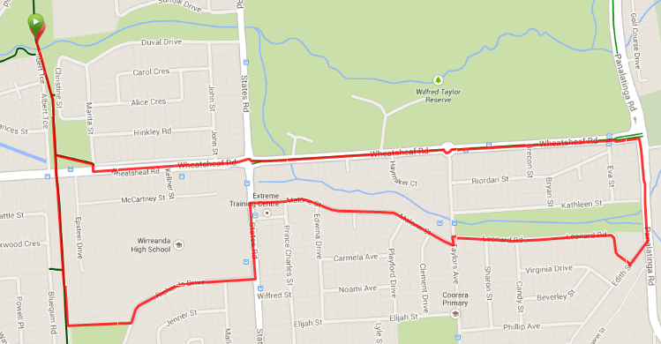
4
5
6
3
2
1
- Turn right into Panatalinga. Cross over the creek section then turn right into Edith St then right again into Leonard Road and follow along beside the creek.
- At T-Section turn left then right straight away into Malone St and follow to the end (States Rd)
- Turn left into States road then the first right, after the oval into Richards Drive
- Just after the school and houses turn right off Richards Drive and follow the track across the park area to the bike track
- Turn right onto the track and follow back to the park
Directions
- Run South to Wheatsheaf road and turn left, crossing States road until you reach Panatalinga Road
Start & Finish
3

Run 21 – 12.8km Panatalinga & Piggott Range Road Run
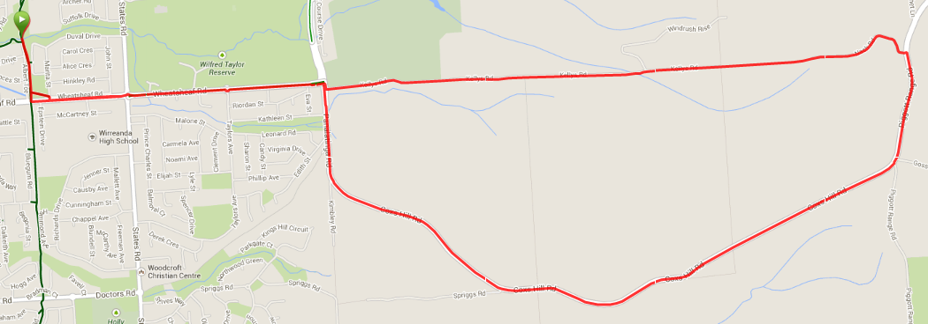
Start & Finish
Directions
- Run South to Wheatsheaf road and turn left, crossing States road until you reach Panatalinga Road
- Turn right into Panatalinga then LEFT into Kelly Road
- Continue along Kelly road till the end, then continue through the trail gate and follow the track up the hill until you reach the house and road – continue until you reach Piggott Range road
- Turn right onto Piggott Range Road, then continue to the right down Coxs Hill road

**STAY TO THE RIGHT OF THE ROAD AND DON’T GROUP UP TOO MUCH FOR SAFETY AS THERE IS NO FOOTPATH AND LIMITED ROAD VERGE**

- Continue onto Panatalinga at the bottom of the hill then turn left into Wheatsheaf road
- Follow Wheatsheaf across States road until you reach the bike track
- Turn right onto the track and follow back to the park

Run 21 – 22.5km Flaxmill, Panatalinga & Piggott Range Road Run
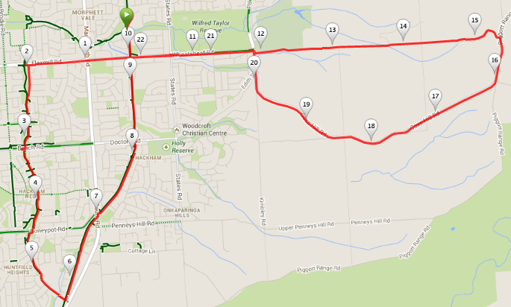
Start & Finish
Directions
- Run South to Wheatsheaf road and turn right, crossing Main South road until you reach Nicolle Dr and turn left
3. Turn right onto Melsetter road and follow until the bike track, just short of MS road and the Irish Pub – Turn left onto the bike track.
4. Follow the bike track across MS road, Doctors Rad and Wheatsheaf road until you get back to the park (joining the 10k runners)
5. Do a U turn and follow the track back to Wheatsheaf road and turn left, crossing States road until you reach Panatalinga Road
- Turn right into Panatalinga then LEFT into Kelly Road
- Continue along Kelly road till the end, then continue through the trail gate and follow the track up the hill until you reach the house and road – continue until you reach Piggott Range road
- Turn right onto Piggott Range Road, then continue to the right down Coxs Hill road
**STAY TO THE RIGHT OF THE ROAD AND DON’T GROUP UP TOO MUCH FOR SAFETY AS THERE IS NO FOOTPATH AND LIMITED ROAD VERGE**
- Continue onto Panatalinga at the bottom of the hill then turn left into Wheatsheaf road
- Follow Wheatsheaf across States road until you reach the bike track
- Turn right onto the track and follow back to the park
- When Nicolle Dr swings to the left, take the right hand track onto the bike track and continue to follow this track under Elizabeth Road, across Beach road and Honeypot road until you reach the road at Huntfield Heights School

