Run A12 - 6.2km McLaren Flat 'Away' run
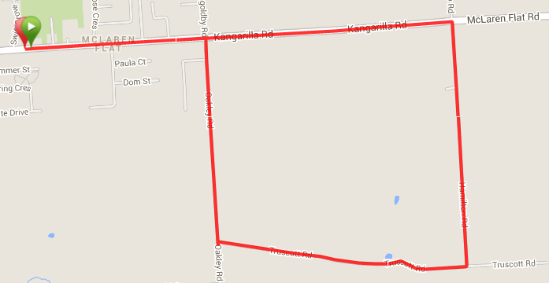
4
3
1
2
Directions
- From the Football ground entry follow Kangarilla road towards Kangarilla until just before you leave the main town area and turn right into Oakley Road
- After approx. 1km turn left into Truscott Road
- Follow Truscott Road for about 1.2km before turning left into Hamilton Road
- Run along Hamilton road until McLaren Flat (Kangarilla) Road, then turn left and follow back to the start point
Start & Finish

Run A12 – 11.6km McLaren Flat 'Away' run
Start & Finish
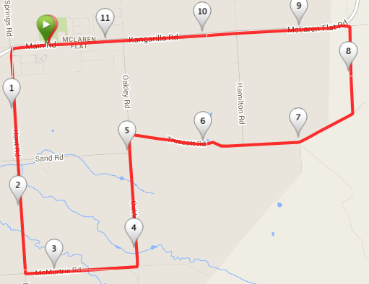
6
5
4
3
2
1
Directions
- From the Football ground entry follow Kangarilla road towards McLaren Vale (Opposite direct to 6.2km route) for a few hundred metres and turn left into Hunt Road
- Follow this road for approx. 2.5km, across Sand road until McMurtrie road and turn left
- Follow McMurtrie for just over 1km then turn left into Oakley Road
- After approx. 1.5km turn right into Truscott Road
- Follow Truscott Road past Hamilton Road until the road swings to the left and becomes Elliot Road (this road is gravel and more of a track in sections – do not follow the sealed road to the right onto Thomas Hill or Edwards roads)
- Continue along Elliot road until it meets McLaren Flat (Kangarilla) Road, then turn left and follow back to the start point

Run A12 – 21.1km McLaren Flat ‘Away’ Run
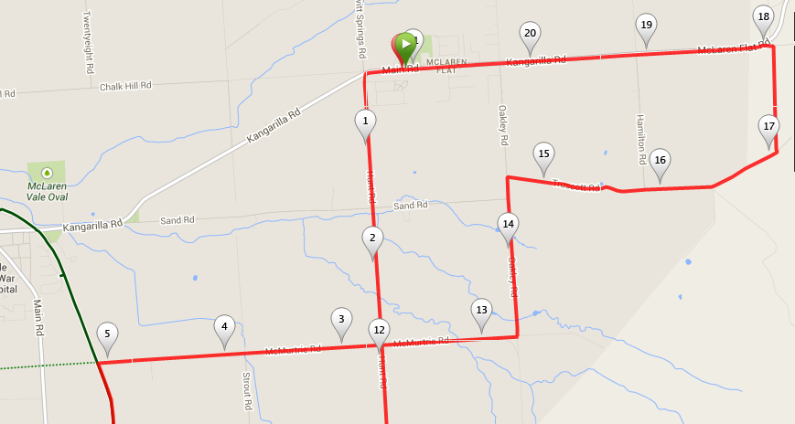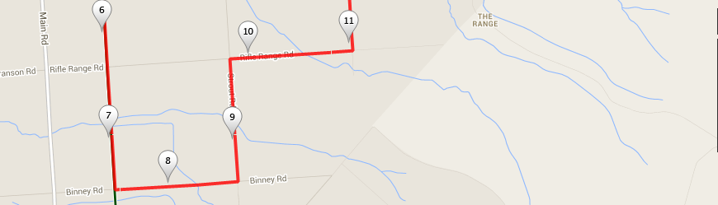
5
6
7
8
9
4
3
2
1
Directions
- From the Football ground entry follow Kangarilla road towards McLaren Vale (Opposite direct to 6.2km route) for a few hundred metres and turn left into Hunt Road
- Follow this road for approx. 2.5km, across Sand road until McMurtrie road and turn RIGHT
- Follow McMurtrie for just over 2km until you reach the bike track and turn left
- Follow the bike track across Rifle Range Road, until Binney Road and turn left
- Take the next left turn into Stout Road until you reach Rifle Range road and turn right
- Take the next left turn into Hunt road and follow for just over 1km then turn right into McMurtrie road for about 1.2km before turning left again into Oakley Road
- Follow Oakley for approx. 1.5km past Sand road then turn right into Truscott Road
- Follow Truscott Road past Hamilton Road until the road swings to the left and becomes Elliot Road (this road is gravel and more of a track in sections – do not follow the sealed road to the right onto Thomas Hill or Edwards roads)
- Continue along Elliot road until it meets McLaren Flat (Kangarilla) Road, then turn left and follow back to the start point
5
Start & Finish
2

