Run 5 – 5.3km Morphett Vale Run
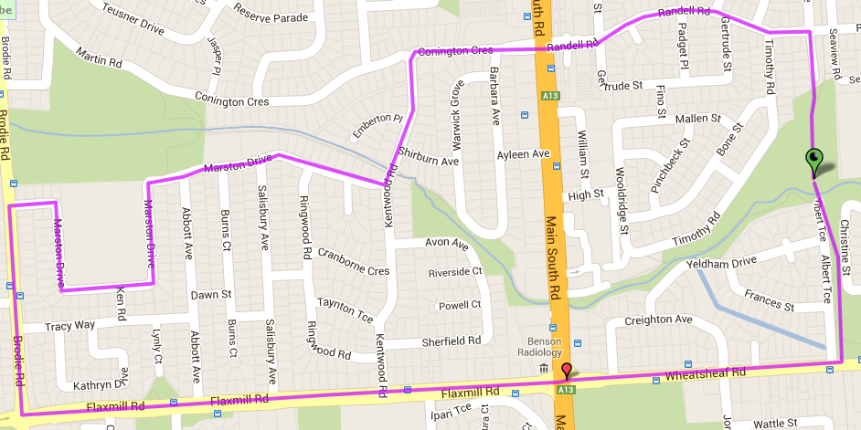
6
5
4
3
2
1
4. Turn left and then left into Flaxmill road (at roundabout and Ambulance station)
5. Follow Flaxmill road down the hill and across MS road until the bike track (Albert Tce)
6. Turn left and follow track back to the park

Directions
- Follow the track towards Bains Road and continue up the side road to Connington Rd
- Left into Connington Road and follow across MS Road until Kentwood road and turn left
- Turn right into Marston Drive and follow the road, continuing in a ‘U’ shape around the school until you reach Brodie road
Start & Finish
8
3
Run 5 - 10.2km Morphett Vale Run
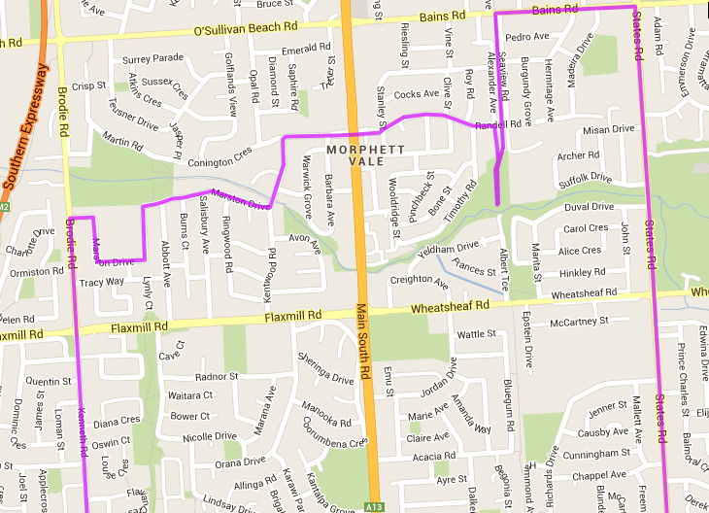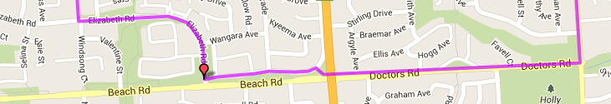
Start & Finish
8
7
6
5
4
3
2
1
Directions
- Follow the track towards Bains Road and continue up the side road to Connington Rd
- Left into Connington Road and follow across MS Road until Kentwood road and turn left
- Turn right into Marston Drive and follow the road, continuing in a ‘U’ shape around the school until you reach Brodie road
- Turn left and follow Brodie road across Flaxmil until Elizabeth road (Nature strip)
- Turn left and follow Elizabeth road until Beach road and turn left onto footpath/bike track
- follow Brach road until MS Road then cross over and continue on Doctors road until T-Section roundabout at States Road
- Turn left into States road and follow across Wheatsheaf road till Bains Road
- Turn left up the hill until bike track (at crest of hill) then turn left and follow track back to the park
Run 5 - 20.2km Morphett Vale run
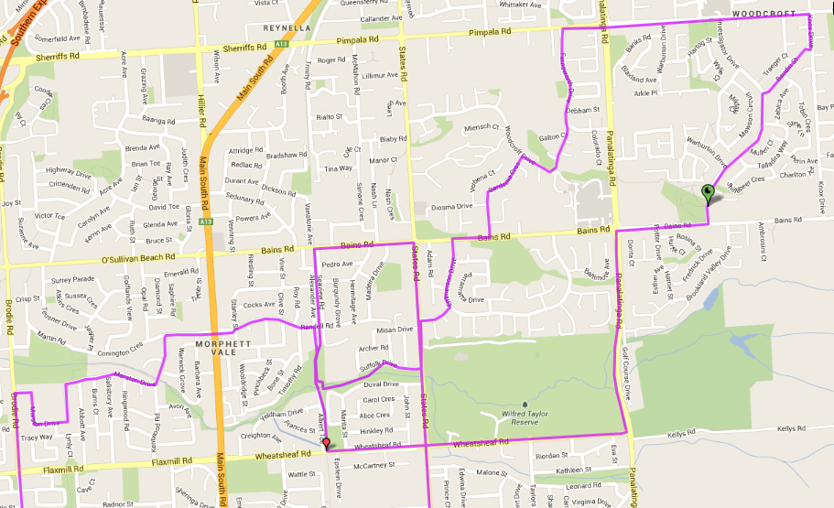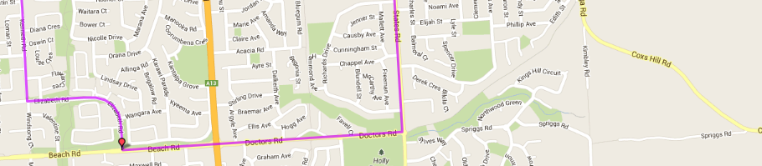
Directions
- Take the track towards School and follow Suffolk Dr to States road
- Turn left into States road then first right into Knightsbridge dr then Left into Emmerson drive
- Turn right into Bains Road then take the first left into Gardenia Cres and follow till the end
- Turn right into Woodcroft drive then left at the roundabout into Farnsworth Drive
- At T-Section turn right into Pimpala road and follow across lights until Knox Drive (roundabout)
- Take 2nd right into Baudin St and follow until T-Section with Investigator Drive, then turn left and go to the end
- Turn right into Bains Road until Panatalinga road lights the cross over and turn left until Wheatsheaf road
- Turn right into Wheatsheaf road and follow across States road until bike track
- Turn right onto bike track and follow back to park (starting point)
- Follow the track towards Bains Road and continue up the side road to Connington Rd
- Left into Connington Road and follow across MS Road until Kentwood road and turn left
- Turn right into Marston Drive and follow the road, continuing in a ‘U’ shape around the school until you reach Brodie road
- Turn left and follow Brodie road across Flaxmil until Elizabeth road (Nature strip)
- Turn left and follow Elizabeth road until Beach road and turn left onto footpath/bike track
- Follow Brach road until MS Road then cross over and continue on Doctors road until T-Section roundabout at States Road
- Turn left into States road and follow across Wheatsheaf road till Bains Road
- Turn left up the hill until bike track (at crest of hill) then turn left and follow track back to the park
Start & Finish

