SRG # 43 – 5.0km MV run
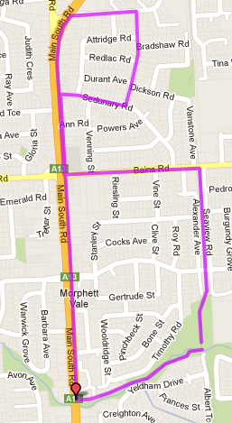
5
4
3
2
1
Directions:
- Follow the track to Bains Road and turn left down to MS Road
- Turn right into MS Road and cross Ana and Sedunary Roads then turn right into Booth Ave
- Turn right into Modler Road and at the end turn right again into Sedunary until you reach MS road (again)
- Turn left into Main South Road and follow down the hill across O’Sullivan’s beach road until the Emu Hotel (near Petrol Stations)
- At the second driveway into Emu hotel (just before the bridge and Vets) turn left onto the Christies Creek trail and follow back to the park
Start & Finish

SRG # 43 – 9.9km O’Sullivans Run
4
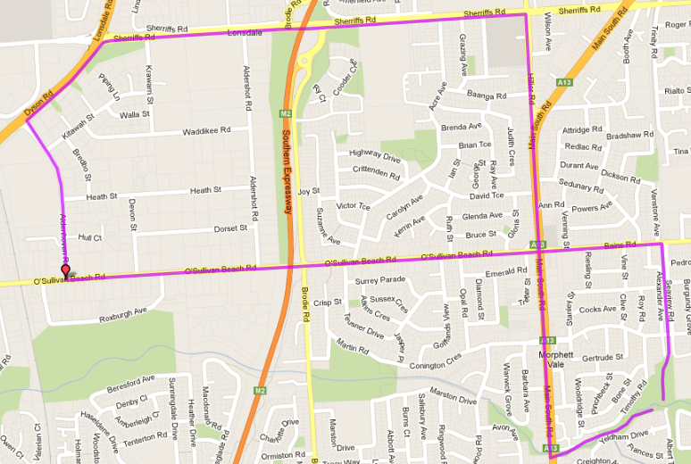
6
5
3
2
- Follow the track to Bains Road and turn left.
- Cross at lights and continue along O’Sullivans Beach Road – across Freeway bridge until Aldenhoven Road and turn right
- At the end (Dyson Road) turn right
- At Sherriffs Rd, turn right again and continue until shopping centre then turn right into Hillier road
- Follow Hillier road down the hill and continue along Main South Road across O’Sullivan’s beach road until opposite the Emu Hotel (Petrol Stations)
- Cross MS Road (or go under) onto the Christies Creek trail and follow back to the park
1
Start & Finish

SRG # 43 – 20.1km O’Sullivans Run
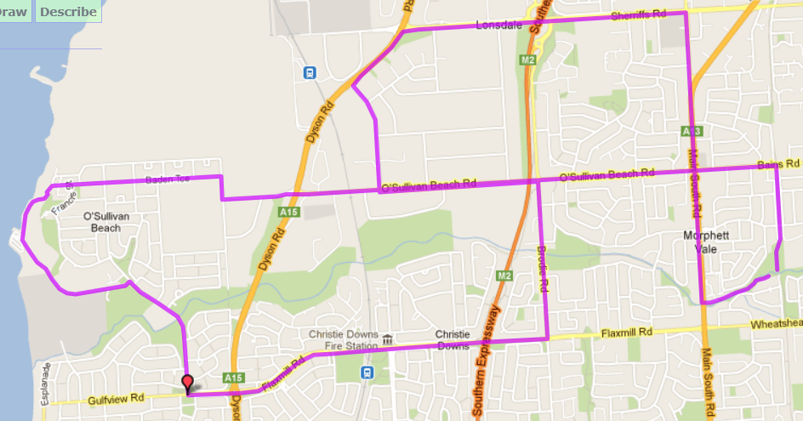
Directions:
- Follow the track to Bains Road and turn left. Follow till Dyson Road
- Continue across Dyson Road until T-Section at Morrow Road. Turn right into Morrow Road then first left into Baden Tce
- At the end of Baden Tce (carpark) continue onto pathway down into the bay and follow path to Marina.
- Continue up the hill (Marine Drive) and turn right at the end onto Galloway Road until Gulfview road (IGA)
- Turn left onto Gulfview and continue across roundabout onto Flaxmill Road. Continue across expressway until roundabout at Brodie Road (near Ambulance station)
- Turn left into Brodie Road until O’Sullivan’s Beach Road and turn left across the bridge (again!). Follow until Aldenhoven Road and turn right
- At the end (Dyson Road) turn right then right again into Sherriffs Roadand continue until shopping centre and turn right into Hillier road
- Follow Hillier road down the hill and continue along Main South Road across O’Sullivan’s beach road until opposite the Emu Hotel (Petrol Stations) and cross MS Road (or go under) onto the Christies Creek trail and follow back to the park
Start & Finish

Start & Finish
Start & Finish
Start & Finish

