[**SRG Run # 17 - 5.1km Morphett Vale Loop**](http://www.stepwhere.com/maps/route/MV-Run-17-5-1km-Morphett-Vale-Loop)

**1**

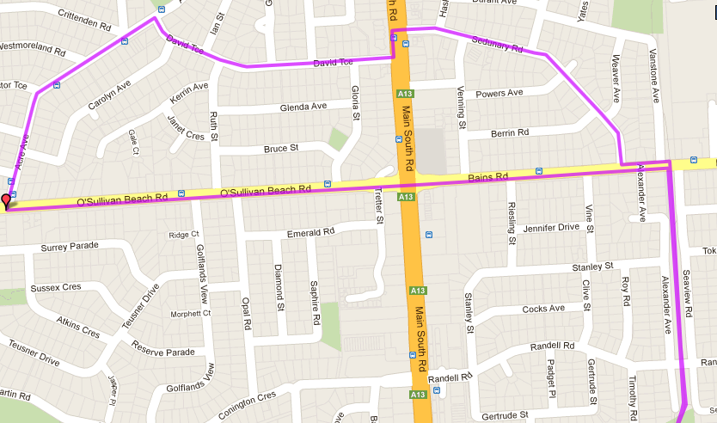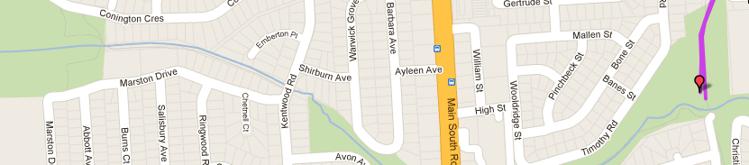

**6**

**5**

**4**

**3**

**2**

**Directions**

1. Follow track to Bains Rd. Cross road and turn left
2. Turn right into Sedunary Rd and follow till Main South Rd. Cross road
3. Turn left at MS Road then right into David Tce and follow till end
4. Turn left into Acre Ave and follow till O’Sullivans Beach road – cross road
5. Turn left and follow across MS rd and up hill to the bike track
6. Turn right onto the track and follow back to the park

[**SRG Run # 17 - 10.7km Track & Freeway**](http://www.stepwhere.com/maps/route/MV-Run-17-10-7km-Track-Freeway)

**2**

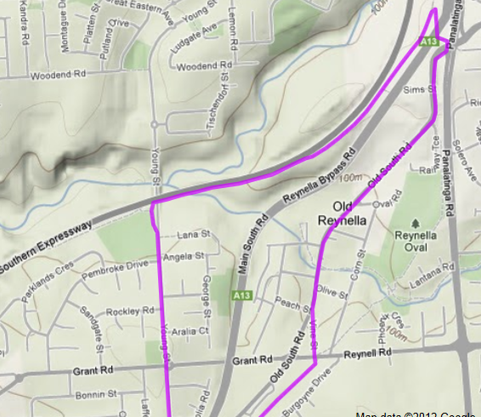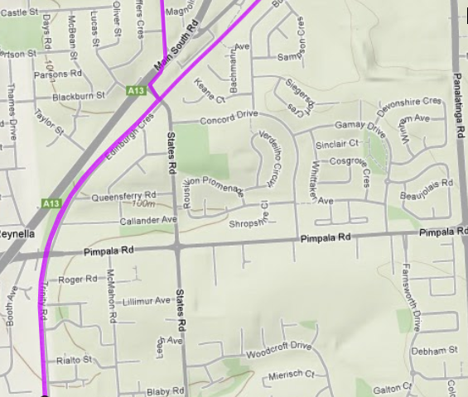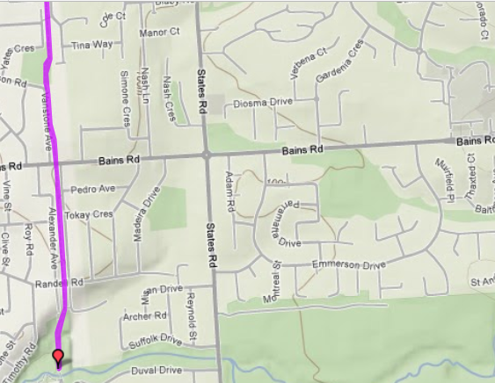

**4**

**5**

**6**

**1**

**3**

**Directions**

1. Follow track towards Bains Rd. Remaining on track, continue until the intersection of MS Rd & Panatalinga Rd (Traffic Lights near Expressway entry)
2. Cross at lights and follow path onto Expressway track – turn left and follow track
3. Take Young St Exit off track. Turn right off exit track onto Young Street up hill to Roundabout
4. Continue through roundabout until Main South Rd.
5. Cross Main South Rd then turn right and left into States Rd (Cheese cake shop)
6. Turn right onto bike track and follow all the way back to the park

[**SRG Run # 17 – 19.8km Track & Freeway**](http://www.stepwhere.com/maps/route/MV-Run-17-10-7km-Track-Freeway)

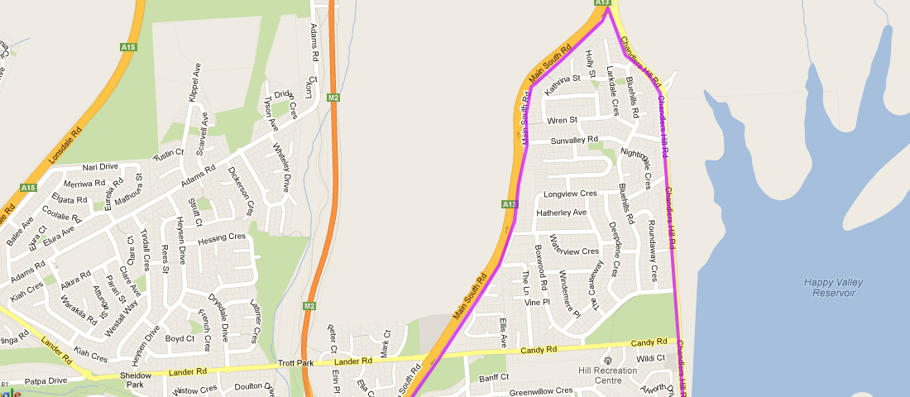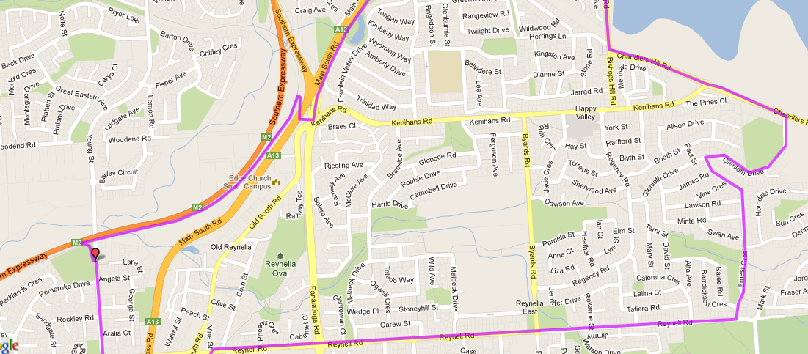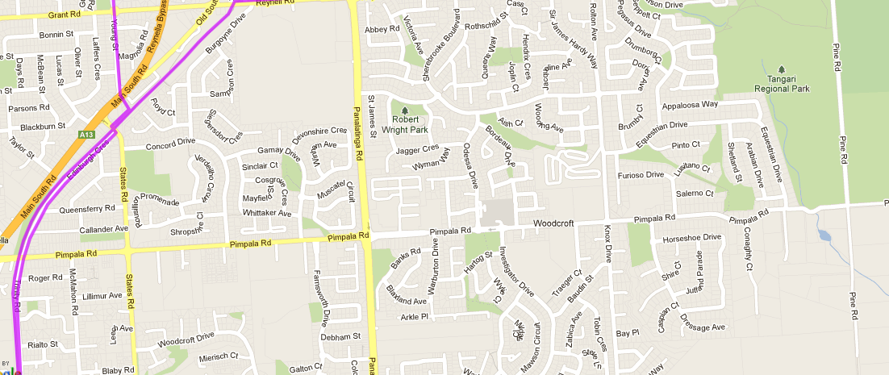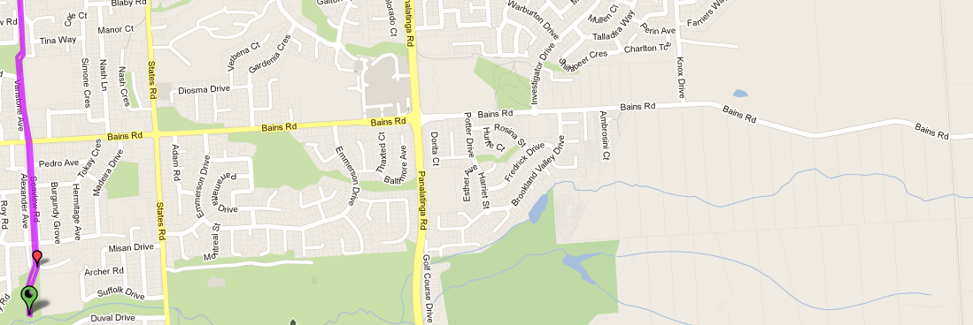

1. Turn left onto Chandlers Hill – continue along Chandlers Hill, through the roundabout until it turns to the right, following the Happy Valley Reservoir fence line
2. Continue along Chandlers Hill road till it meets Main South Road (Coastlands Church) the turn left
3. Follow Main South Road past the O’Halloran Hill shops, across Candy Road (Opposite Lander Rd) until you reach the intersection of MS Rd & Panatalinga Rd (Traffic Lights near Expressway entry)

***##BE CAREFUL OF TRAFFIC AS YOU RUN BETWEEN CANDY ROAD AND THE PANATALINGA RD LIGHTS##***

1. Cross at lights and follow path onto Expressway track – turn left and follow track until Young St exit (at the bottom of the hill)
2. Take Young St Exit off track. Turn right out of exit track onto Young Street up hill to Roundabout
3. Continue through roundabout until Main South Rd.
4. Cross Main South Rd then turn right and left into States Rd (near Cheese cake shop)
5. Turn right onto bike track and follow all the way back to the park

**Directions**

1. Follow track towards Bains Rd. Remaining on track, continue until Reynell Road (after Bus Interchange) and turn right
2. Follow Reynell road across States, Pnatalinga and Byards Road till Ernest Cres (Opposite Tangari park) and turn left
3. At the end T-Section turn right into Glenloth Drive and run till the end (Chandlers Hill Road)