**Run 12 – 5.0km Vale loop Run**

Directions:

1. Follow the track to Bains Road and turn right
2. Cross States Road and turn right into Adam Road, immediately after shops)
3. Turn left into Baulkham St then right into Emmerson Drive
4. Take the 6th right into Lascelles St and go to the end, then continue on the path to the (?? dirt) road and turn left

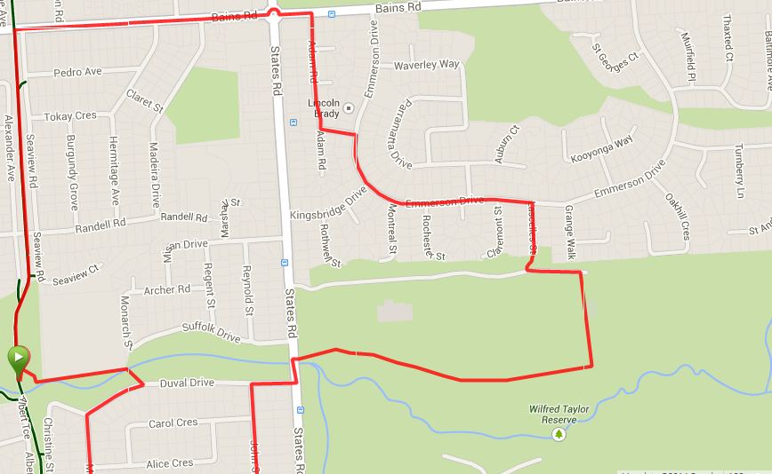 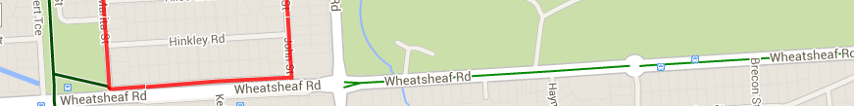

**9**

**8**

**7**

**6**

**5**

**4**

**3**

**2**

**1**

**Start & Finish**

1. Follow into car park and continue out the other side into Wilfred Taylor reserve and turn right onto the track, back to States Road
2. Cross States road and turn left, then right into Duval Drive
3. Take the first left into John Street and at the end turn right onto Service road (alongside Wheatsheaf road)
4. At the end, near park turn right into Marita Street and follow to the end and continue to the right until the footbridge
5. Take the footbridge to the left then left again and follow the track back to the park

**4**

**3**

**Run 12 – 10.7km Vale Loop Run**

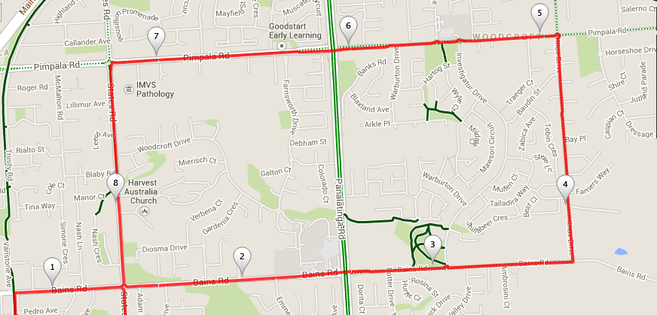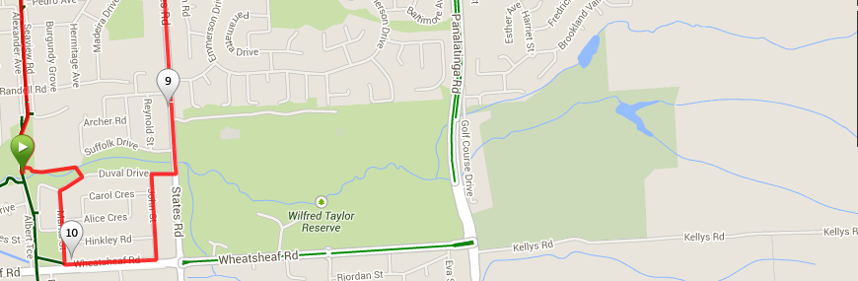

**8**

**6**

**7**

**5**

**Directions**

1. Follow the track to Bains Road and turn right
2. Cross States Road and continue past Woodcroft shopping centre and Panatalinga road till Knox Drive
3. Turn left into Knox and follow till Pimpala Road (the next main road) and turn left
4. Cross Pimpala till States road (small shops on right) and turn left
5. Pass Sporting clubs on left then at Christies Creek, turn right into Duval Drive
6. Take the first left into John Street and at the end turn right onto Service road (alongside Wheatsheaf road)
7. At the end, near park turn right into Marita Street and follow to the end and continue to the right until the footbridge
8. Take the footbridge to the left then left again and follow the track back to the park

**4**

**3**

**2**

**1**

**Start & Finish**

**Run 12 – 20.4km Vale Loop Run**

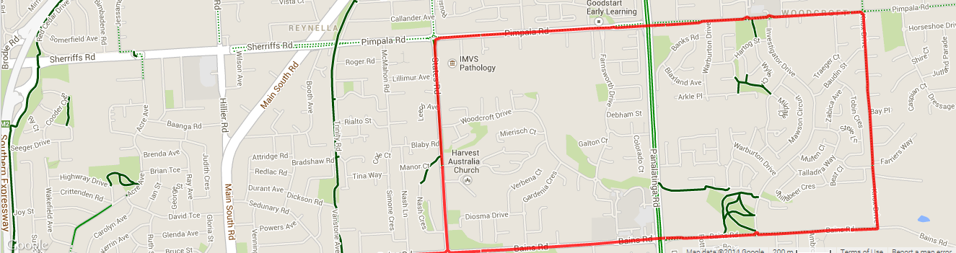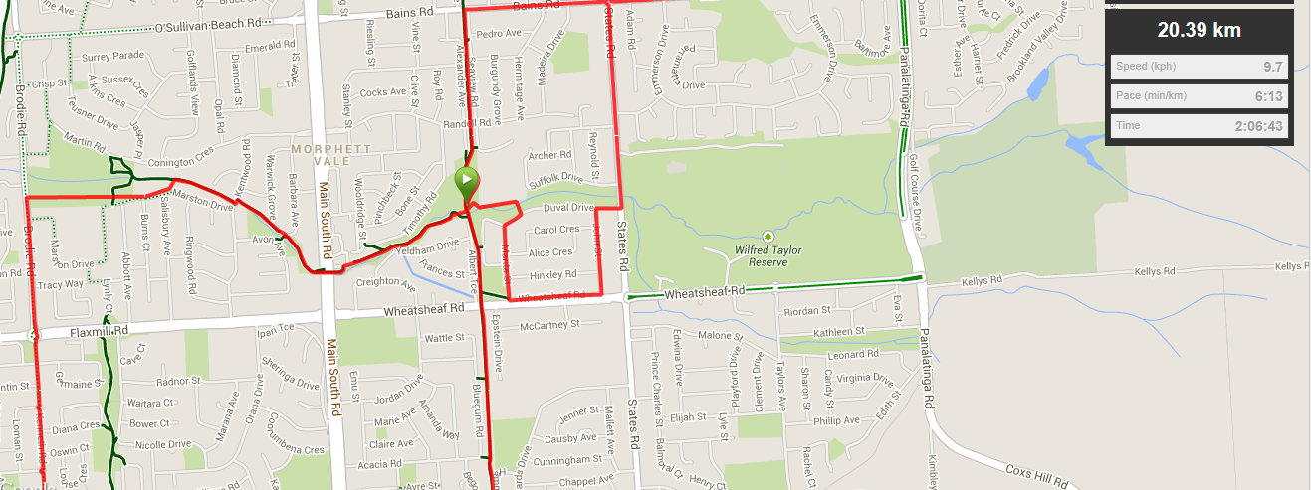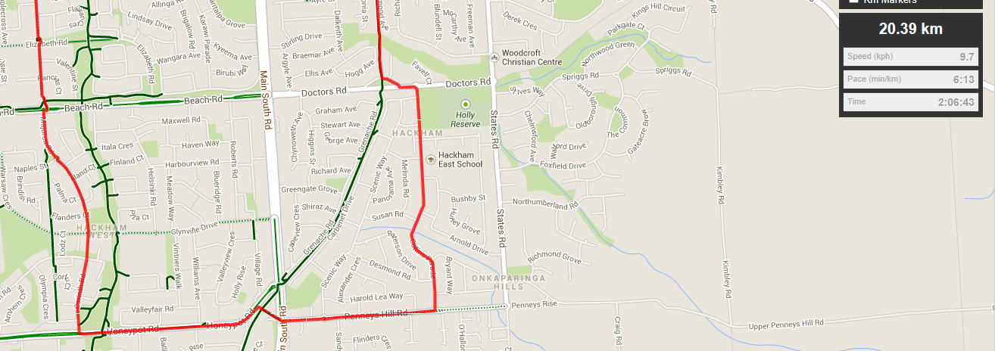

**Start & Finish**

**Directions**

1. Follow the bike track to Beach road and turn left then turn right at the roundabout into Collins Pde
2. At the T-Section turn right into Penney Hills Road and run until the traffic lights (Hungry Jacks)
3. Continue across the lights and follow the track up the hill to Honeypot road and turn left
4. Follow Honeypot over the hill and past the parklands then turn right into Corinth Road – continuing at the end T-Section along the grass track then straight ahead along Majorca road till Beach road
5. Cross Beach road and continue straight ahead, crossing Flaxmill road (Ambulance Station) and onto Brodie road till the wetlands
6. Turn right at the park entry and follow the track through the wetlands then join the Christies creek trail and follow all the way to the park
7. Continue past the park along the track to Bains Road and turn right
8. Cross States Road and continue past Woodcroft shopping centre and Panatalinga road till Knox Drive
9. Turn left into Knox and follow till Pimpala Road (the next main road) and turn left
10. Cross Pimpala till States road (small shops on right) and turn left
11. Pass Sporting clubs on left then at Christies Creek, turn right into Duval Drive
12. Take the first left into John Street and at the end turn right onto Service road (alongside Wheatsheaf road)
13. At the end, near park turn right into Marita Street and follow to the end and continue to the right until the footbridge
14. Take the footbridge to the left then left again and follow the track back to the park