**Run # 7 – 5.4km Southern Expressway run**

**8**

1. Follow track to Emu Hotel, Under Main South Rd and to park
2. After the park, pass footbridge then take gravel track to the left
3. Follow path alongside lagoon until Brodie Rd
4. Go 75m along Brodie Rd then cross Brodie Rd and follow to Freeway track
5. Turn right onto freeway track up hill
6. Take exit path and go to O’Sullivan Beach Rd roundabout
7. Follow O’Sullivan Beach Rd up hill then cross Main South Rd and (up the next hill) until the bike track
8. Turn right onto bike track and follow back to park

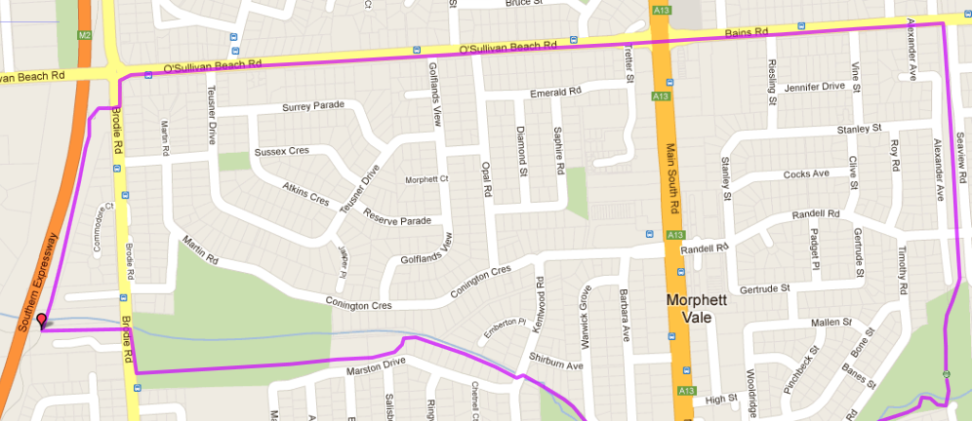 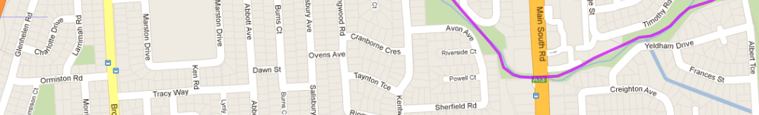

**7**

**6**

**4**

**5**

**3**

**Start**

**1**

**2**

➊

**Run # 7 – 10.0km Southern Expressway run**

1. Follow track to Wheatsheaf road & turn right
2. go to Main South Rd and turn right (towards Reynella)
3. continue past all shops and up the hill
4. *Follow main Sth rd when it swings toward the right over the hill to McDonalds*
5. *Turn left at McDonalds into Sherriffs Rd up the hill. Turn right at the intersection /lights (Westpac/GE Money) along Hillier Rd*
6. *Turn left at the roundabout into Moore Rd and follow it till the freeway*
7. *DON’T CROSS FREEWAY – Take right side windy track and then turn left to follow the freeway*
8. *Continue to follow track across Sherriffs rd & continue along freeway*
9. *Just after O’Sullivan’s Beach Rd, take exit path and follow O’Sullivan’s Beach Rd to the right (all the way till the bike track)*
10. *Turn right onto Bike track and back to park*

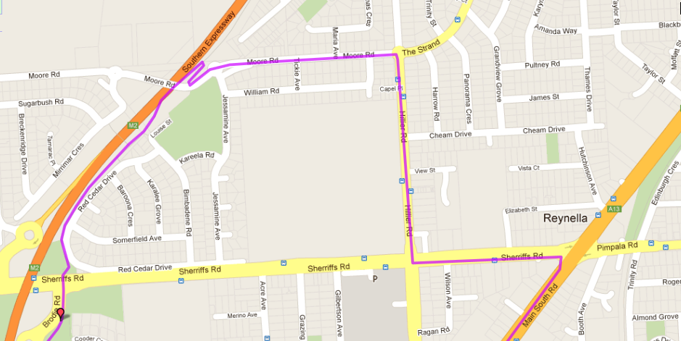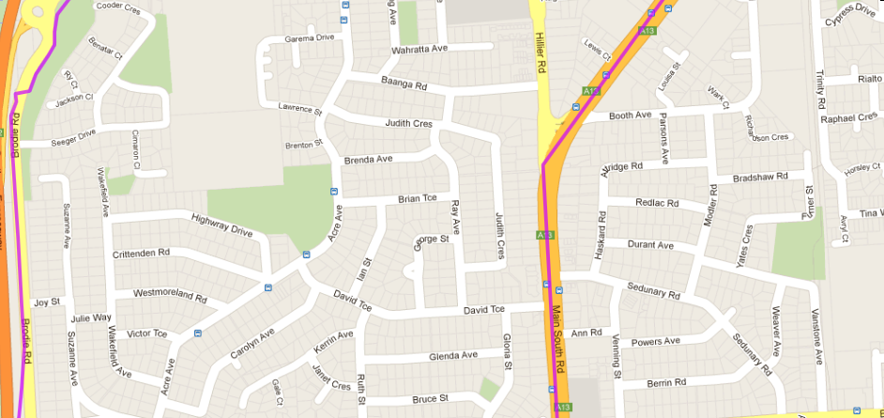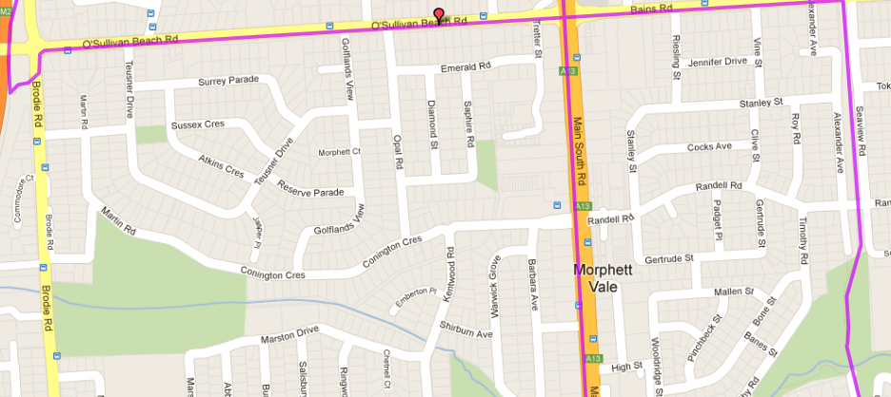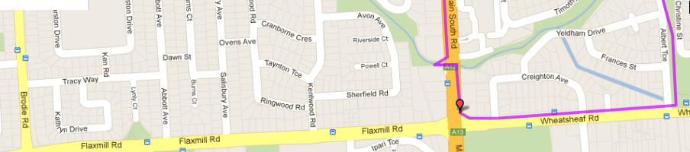

➊

➓

➒

➑

➐

➏

➎

➍

➌

➋

**Run # 7 - 20.7km Southern Expressway run**

**Directions:**

1. Follow track to Wheatsheaf road & continue along track, across Doctors road until Main South Road crossing
2. Turn left down the hill to Hungry Jack’s then left at the lights into Penney Hills road
3. When you reach States Road (G-Shop) turn left and follow until Wheatsheaf road large roundabout
4. Turn right onto Wheatshead road and follow till Panatalinga road and turn left
5. Follow Panatalinga all the way to the Reynella interchange traffic lights and turn left onto expressway track entry path
6. Turn left again onto the main track and follow down the hill, past Young St and to Moors road bridge
7. Continue past all shops and up the hill
8. *Continue to follow track across Sheriffs Rd & continue along freeway*
9. *Just after O’Sullivan’s Beach Rd, take exit path and follow O’Sullivan’s Beach Rd to the right (all the way till the bike track)*
10. *Turn right onto Bike track and back to park*

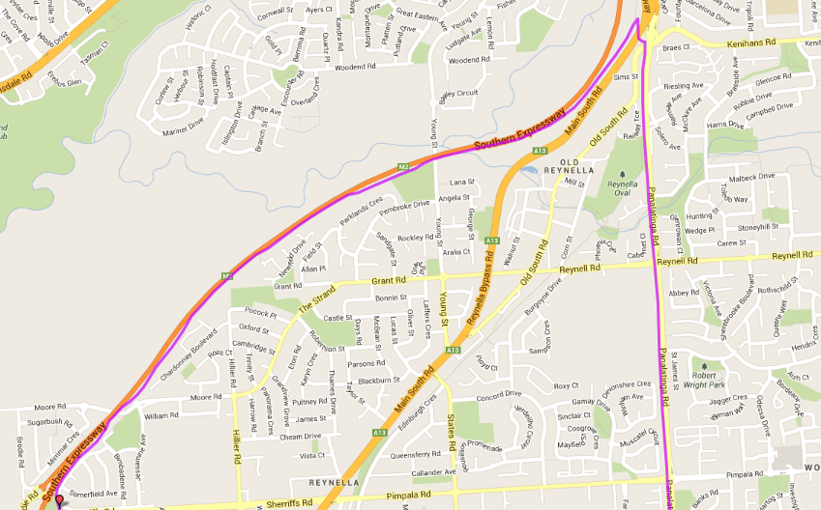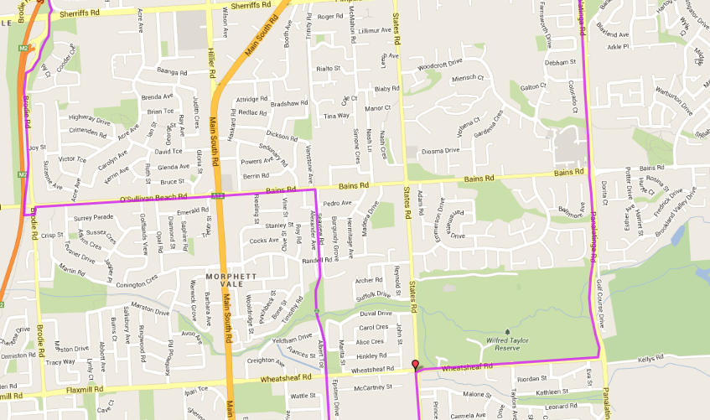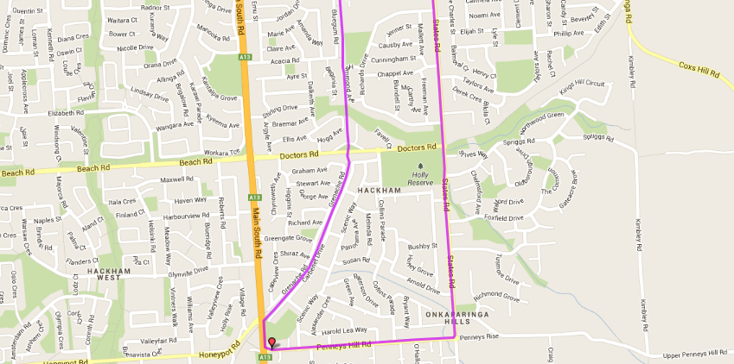

**Start**

**Start**