**Run # 49 – 5.6km Onkaparinga Hills Run**

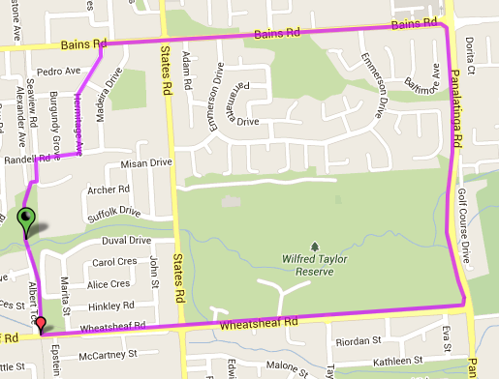

**Directions**

1. From the park run to Wheatsheaf road and turn left, continuing across States road to Panatalinga Road
2. Turn left into Panatalinga Rd until Bains Rd (Woodcroft shops) and turn left
3. After States Rd, take 2nd left into Tokay Cres and go to end
4. Turn right into Randell Rd and follow till bridge cross the bike track
5. Turn left and follow back to the park

**2**

**5**

**3**

**4**

**Start & Finish**

**1**

**Directions**

1. ##

**3**

**Run # 49 – 9.9km Onkaparinga Hills Run**

**Directions**

1. From the park head to Wheatsheaf Road and cross, continuing until Beach road pedestrian lights
2. Cross road and turn left until Collins Pde (park and football ground) then turn right
3. Take first left into Botanic Grove then right and left (John St) till you reach States Rd
4. Turn right into States road then first left into Foxfield Drive
5. At roundabout turn right and continue straight ahead (don’t turn off) into Stone Bridge Dr and Kings Hill Circuit
6. At end of circuit turn right into Parkgate Ct. At the end take track to left side of house and cross over to Taylors Ave (across open track area)
7. Turn right into Taylors Ave and at end (roundabout with Wheatsheaf rd) turn right
8. Turn left into Panatalinga Rd until Bains Rd (Woodcrooft shops) and turn left
9. After States Rd, take 2nd left into Tokay Cres and go to end
10. Turn right into Randell Rd and follow till bridge cross the bike track
11. Turn left and follow back to the park

**9**

**8**

**7**

**6**

**5**

**3**

**5**

**4**

**3**

**2**

**1**

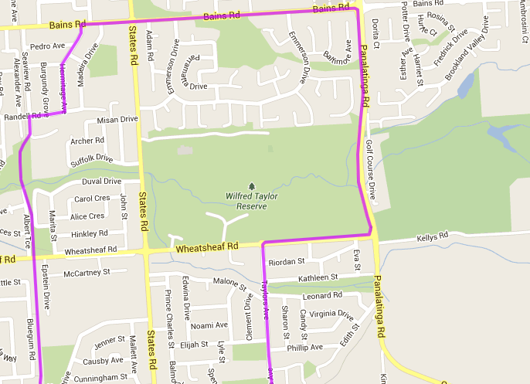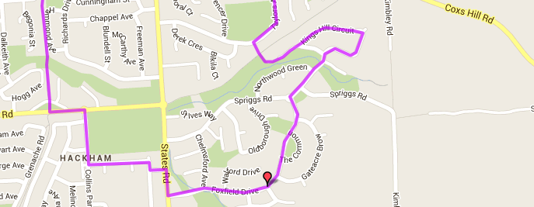

**Start & Finish**

**Run # 49 – 20.1km Onkaparinga Hills Run**

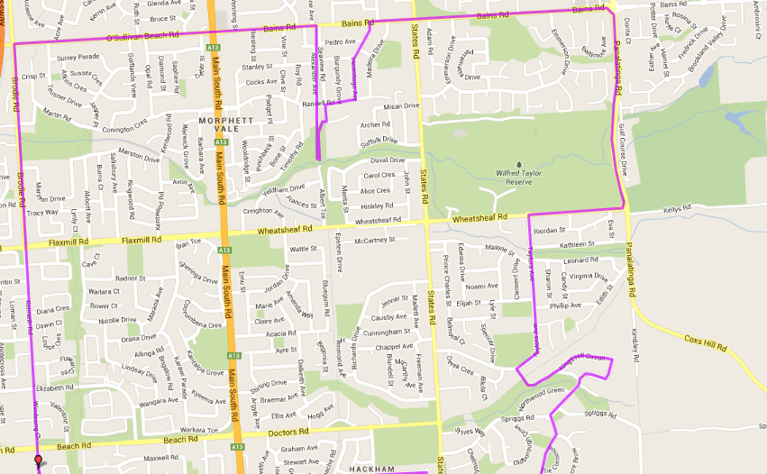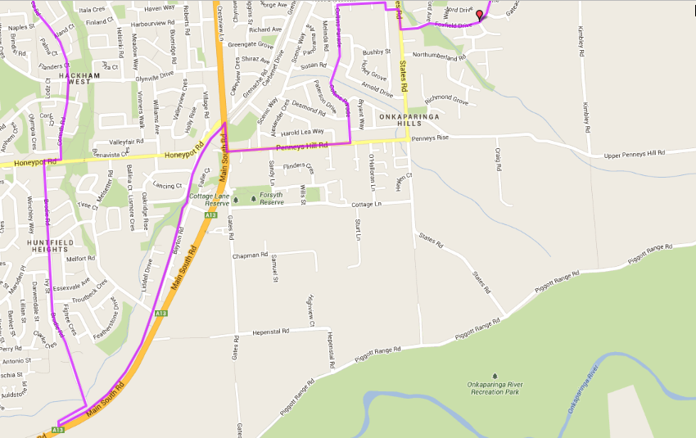

**Directions**

1. Run to Bains Road and turn left. Follow Bains/O’Sullivan’s Beach rods till Brodie Road (roundabout before Expressway) and turn left
2. Follow Brodie/Kenneth/Majorca roads all the way till Honeypot road T-Section

**Start & Finish**

1. Turn right at Honeypot then first left (Brodie Road) and continue straight ahead until the end where gravel road meets bike track at South Rd
2. Turn left onto bike track, across small bridge and follow till Honeypot/MS Road traffic lights then turn right and left at Hungry jacks (Penney Hills Rd)
3. Turn left into Collins Parade. Pass shops and school then turn right into Botanic Grove then right and left (John St) till you reach States Rd
4. Turn right into States road then first left into Foxfield Drive
5. At roundabout turn right and continue straight ahead (don’t turn off) into Stone Bridge Dr and Kings Hill Circuit
6. At end of circuit turn right into Parkgate Ct. At the end take track to left side of house and cross over to Taylors Ave (across open track area)
7. Turn right into Taylors Ave and at end (roundabout with Wheatsheaf rd) turn right
8. Turn left into Panatalinga Rd until Bains Rd (Woodcrooft shops) and turn left
9. After States Rd, take 2nd left into Tokay Cres and go to end
10. Turn right into Randell Rd and follow till bridge cross the bike track
11. Turn left and follow back to the park