Run A6 - 4.8km Willunga Loop
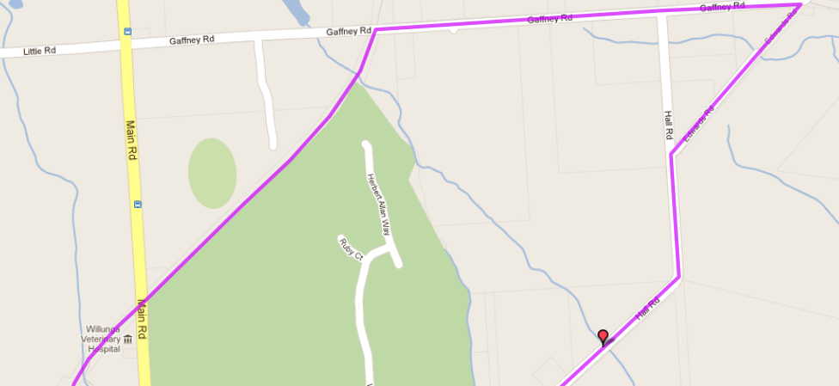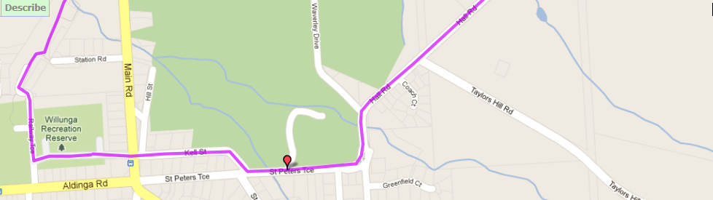
6
5
4
Directions
- Starting at the football ground, go through the gates and cross Main road and into Fell St
- At the end of Fell st turn left onto St Peters Tce and follow around the bend to the left (past golf course) and then to the right (road name is now Hall Rd)
- Pass Taylors Hill road and continue to follow the road for 1.5km
- When you reach the Kings Hill Road (right) and Gaffney Rd (Left) intersection (near electrical substation), turn left into Gaffney Rd
- Follow Gaffney Road for 900 metres till you reach the bike track and turn left
- Continue across main road and follow the bike track until you reach the football oval and return to the start point
3
2
1
Start & Finish
Run A6 - 9.9km Willunga Flat run
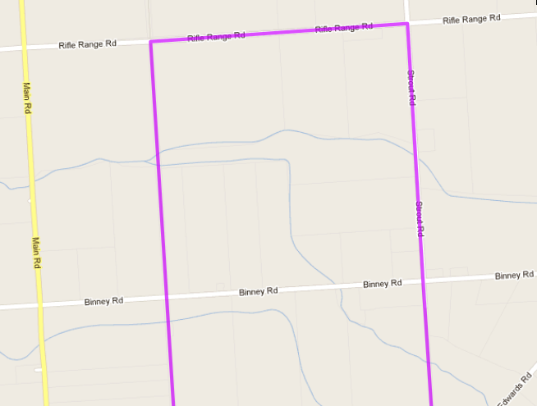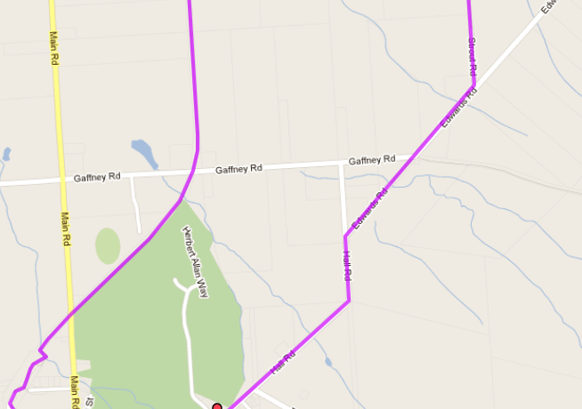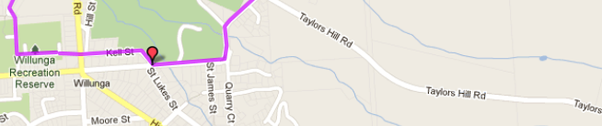
7
6
5
4
Directions
- Starting at the football ground, go through the gates and cross Main road and into Fell St
- At the end of Fell st turn left onto St Peters Tce and follow around the bend to the left (past golf course) and then to the right (road name is now Hall Rd)
- Pass Taylors Hill road and continue to follow the road
- Continue past the Kings Hill Road (right) and Gaffney Rd (Left) intersection (near electrical substation), for 400 metres then turn left into Strout Rd
- Cross Binney Road and continue until Rife Range Road – Turn left
- Follow Rifle Range Road for 1.2km till you reach the bike track and turn left
- Follow the bike track for the rest of the run, across Binney road and Gaffney Road then continue across Main road and follow the bike track until you reach the football oval and return to the start point
3
2
1
Start & Finish

Run A6 - 10.1km Willunga Hill run
Start & Finish
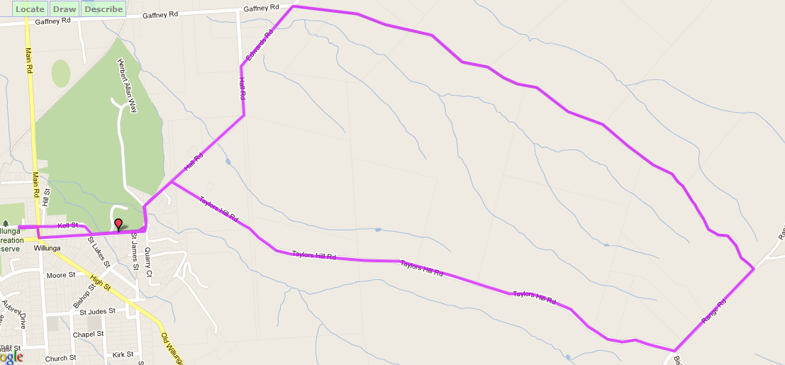
6
5
4
3
1
2
Directions

Start & Finish
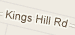
- Starting at the football ground, go through the gates and cross Main road and into Fell St  - At the end of Fell st turn left onto St Peters Tce and follow around the bend to the left (past golf course) and then to the right (road name is now Hall Rd) | - Turn right into Taylor’s Hill Road and follow for 3km till the intersection with Range Road (top of the hill!) then turn left  - After 700 metres take the next left into Kings Hill Road and follow down the hill for 3.1km till you reach Edwards Rd (Electrical substation) - turn left | - Follow Edwards Road until you pass Taylors Hill road (after 1.2km) and continue along the same road that you started on, past the golf course  - Continue straight ahead on St Peters Tce (don’t take Fell St) until the Main intersection, then turn right and left back into football ground & to start
2

