**Onkaparinga NP discovery 15.2km run**

**9**

**8**

Follow trail to the left near the top of the hill then continue along the trail (wooden trail marker) to the left until you reach the Sundews trail (road and track to lookout)

Follow track across open hill then take the track back to the main trail and continue uphill

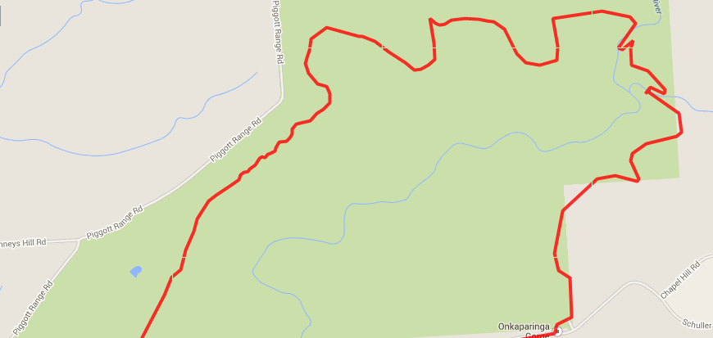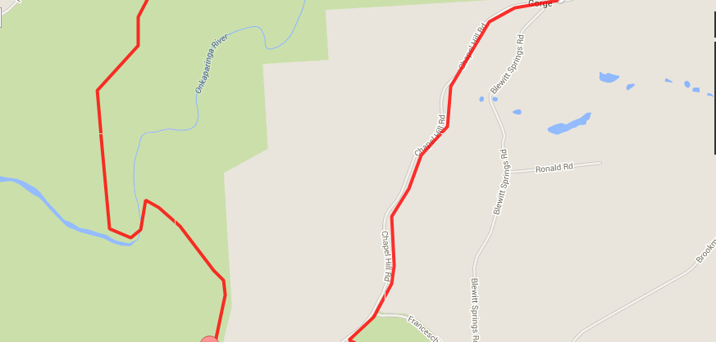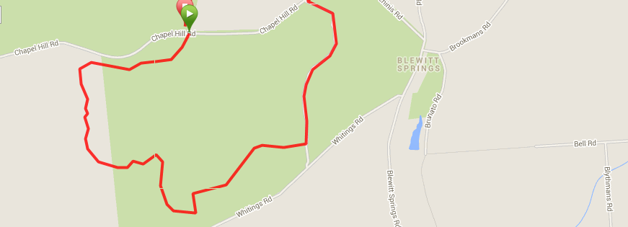

After the open hill crossing you come to a fire trail/road. Follow the fire trail (road) down the hill till the river then continue back up the other side and follow back to the start

**7**

Cross 2 x river crossings then follow the fire trail/track until you reach the Echidna trail sign ON THE LEFT and go to the left (if you get to the external park gates you’ve gone too far)

Turn onto Chapel Hill road and follow for approx. 2km then turn left back into Onkaparinga NP

**10**

**3**

**2**

After the stairs follow the main fire trail to the right

At the –T-Section of the trail turn to the left and follow the sandy track until you reach a (dirt) road

Enter the gates and take the track to the right, continuing past the broken Windmill and on the right side track again until you reach the river crossing

**6**

**5**

**4**

Turn left onto the dirt road and follow until it reaches the main (Chapel Hill) road

**1**

Start & Finish at Gate 20, Chapel Hill Road

Turn to the right where the track splits and follow the technical trail until you reach the stairs