**Run A3 – Woodcroft Tangari Park 5.2km run**  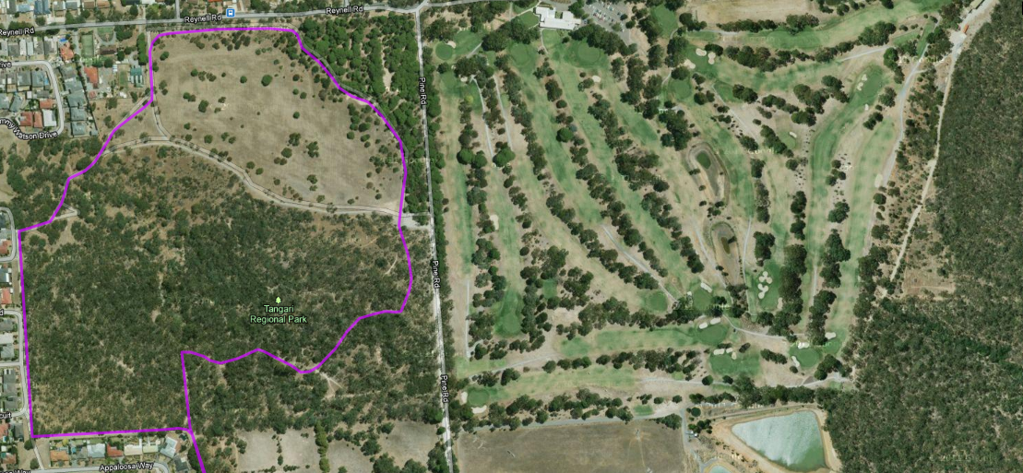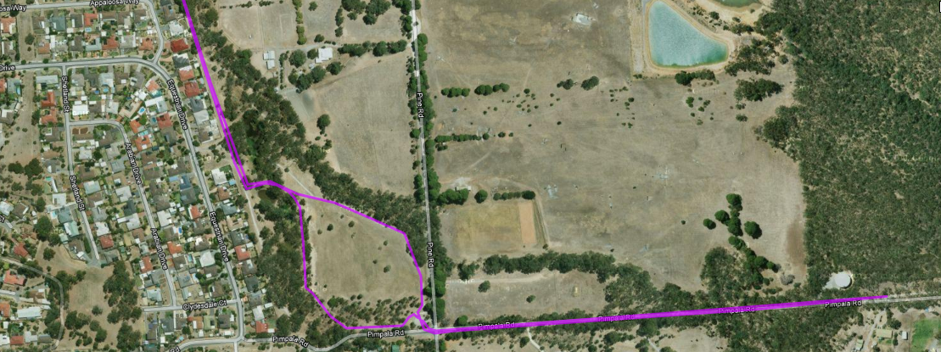

**Start & Finish**

**9**

**8**

**7**

**6**

**5**

**3**

**4**

**1**

**2**

**Directions**

1. Follow left hand path past waterhole and continue to the left and right alongside road near houses
2. Turn left along fence line and then continue to the right
3. Near end of road take track back into path
4. Continue to follow track around park boundary
5. After car park area, continue straight ahead then follow track to right then re-join track
6. Just after water hole, take track to left and follow back to car park
7. From car park, turn left and continue along Pimpala road and follow up the hill
8. Pass the water tank on the left and through reserve area
9. Turn-around at driveway entrance to first house on right and return to the park along the same road

**Start & Finish**

**Start & Finish**

**Run A3 - 9.8km Tangari Park Run**

**11**

Take track to left after houses & continue under foot -bridge and across road/driveway

Follow to the right up to road until Roundabout

**12**

Right at roundabout and follow Education road until top of hill

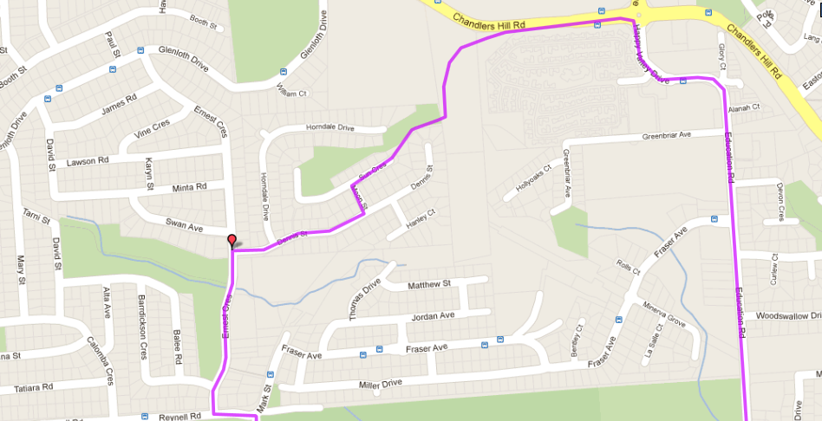 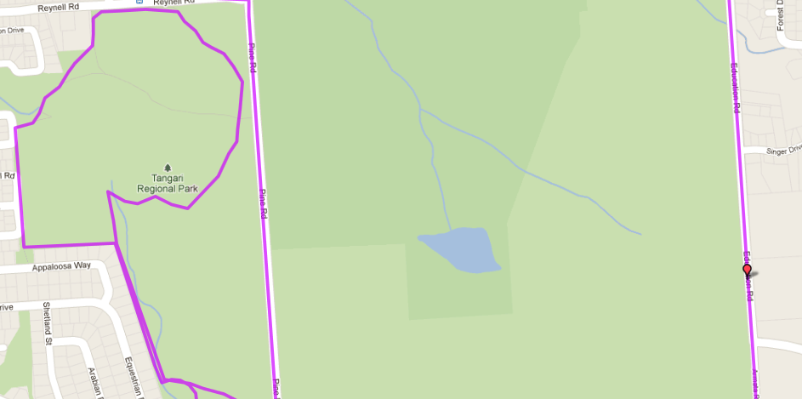 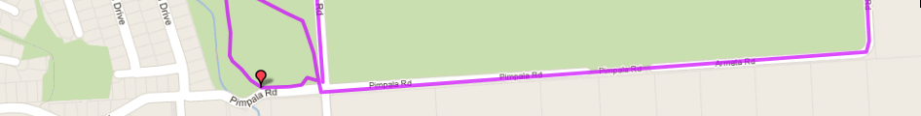

**Start & Finish**

First right into Dennis St

**1**

**2**

**3**

Near end of road take track back into path

Turn left along fence line and then continue to the right

**13**

**10**

**9**

**8**

**7**

Follow road to the right and continue straight ahead until road end and through reserve until back at the park

At end of Crescent, take pathway to left and follow along fence line behind houses and follow till end of street

Turn left into Moon St then right into Sun Cres

At T-Section take left into Reynell Rd then next right into Ernest Cres

From car park, follow Pine Rd till the end

**6**

**5**

**4**

Follow track to right then re-join track back to start

Continue to follow track around park boundary

Follow left hand path past waterhole and continue to the left and right alongside road near houses

**8**

**7**

**Run A3 - Run A3 - 22.7km Woodcroft Tangari Park & Happy Valley**

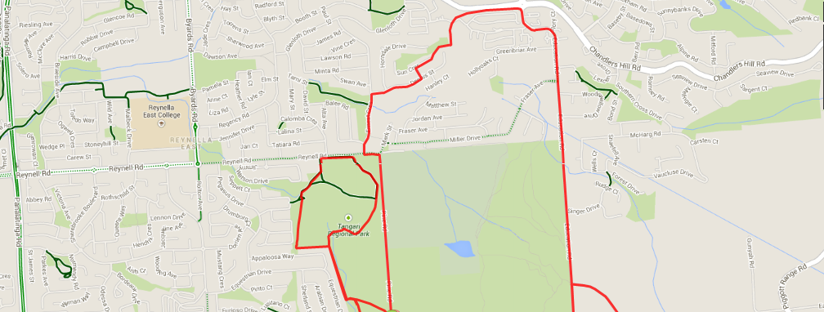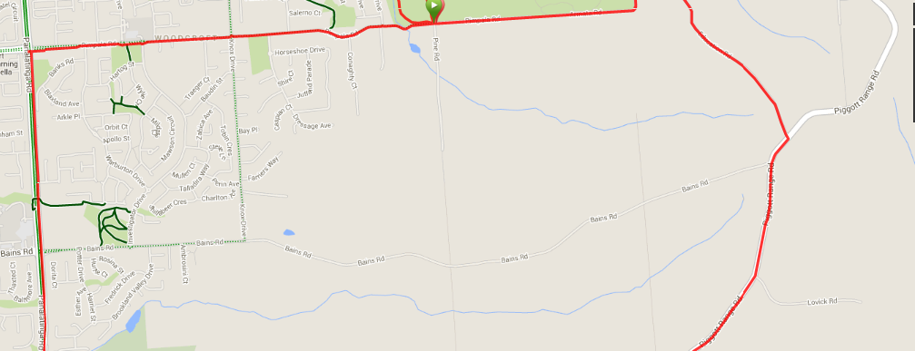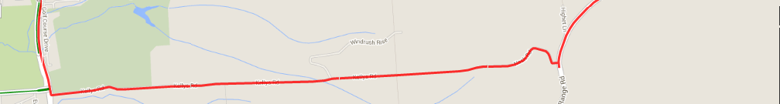

**Second section of run (9.8km)**

**Follow 10k course directions**

**First section of run (12.9km)**

**Start & Finish**

Directions (First 10km) - Starting at Car park on the cnr Pine road & Pimpala road Woodcroft: Tangari Park:

1. From carpark, follow Pimpala road back towards Reynella and Woodcroft until you reach Panatalinga road and turn left
2. Follow Panatalinga road until you pass the golf course and Wheatsheaf road then take the first left into Kelly road
3. At the end of Kelly road continue along the track, up the hill until you reach Piggot Range road
4. Turn left onto Piggot Range road until you pass Bains road, then turn left into Education road – follow until the T-Section and turn left into Armata road, turning to the right and continuing straight ahead (through the reserve) until you reach the carpark again

***### FOR REMAINDER OF RUN – FOLLOW 10KM COURSE DIRECTIONS ###***